**ФЕДЕРАЛЬНОЕ ГОСУДАРСТВЕННОЕ АВТОНОМНОЕ ОБРАЗОВАТЕЛЬНОЕ УЧРЕЖДЕНИЕ ВЫСШЕГО ОБРАЗОВАНИЯ**



**МОСКОВСКИЙ ПОЛИТЕХНИЧЕСКИЙ УНИВЕРСИТЕТ**

***Факультет Информационных технологий***

***Кафедра Информатики и информационных технологий***

**направление подготовки**

**09.03.02 «Информационные системы и технологии»**

**ЛАБОРАТОРНАЯ РАБОТА № 1**

**Дисциплина:** Инструменты визуализации данных

**Тема:** Визуализация данных с помощью языка R

**Выполнил: студентка группы** 231-338

Шаура Илья Максимович

(Фамилия И.О.)

**Дата, подпись** 12.04.2024

(Дата) (Подпись

**Проверил:**

(Фамилия И.О., степень, звание) (Оценка)

**Дата, подпись**

(Дата) (Подпись)

**Замечания:** _________________________________________________________

____________________________________________________________________

____________________________________________________________________

**Москва**

**2024**

> library(swirl)

| Hi! I see that you have some variables saved in your workspace. To

| keep things running smoothly, I recommend you clean up before

| starting swirl.

| Type ls() to see a list of the variables in your workspace. Then,

| type rm(list=ls()) to clear your workspace.

| Type swirl() when you are ready to begin.

> swirl()

| Welcome to swirl! Please sign in. If you've been here before, use the

| same name as you did then. If you are new, call yourself something

| unique.

What shall I call you? Ilya

| Thanks, Ilya. Let's cover a couple of quick housekeeping items before we

| begin our first lesson. First of all, you should know that when you see

| '...', that means you should press Enter when you are done reading and ready

| to continue.

| Please choose a course, or type 0 to exit swirl.

1: Exploratory Data Analysis

2: Take me to the swirl course repository!

Выбор:1

| Please choose a lesson, or type 0 to return to course menu.

**1.**

|=========                                                                                                                                                       |   6%

| As a warm-up, which of the following would NOT be a good use of analytic graphing?

1: To show multivariate data

2: To decide which horse to bet on at the track

3: To show causality, mechanism, explanation

4: To show comparisons

Выбор:2

| Great job!

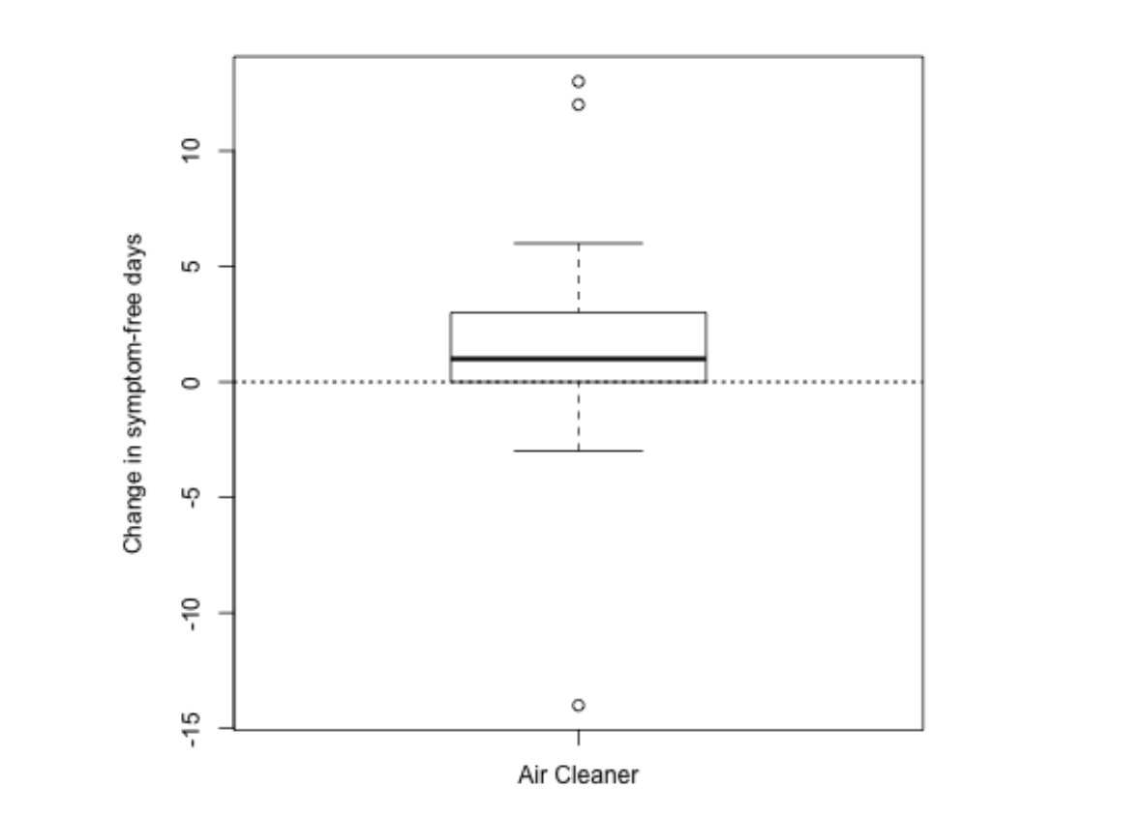

| How many days of improvement does the median correspond to?

1: 4

2: 1

3: 12

4: -2

Выбор:2

| Keep up the great work!

|

 |================================                                                                          |  19%

| While it's somewhat informative, it's also somewhat cryptic, since the y-axis is claiming to show a change in number of

| symptom-free days. Wouldn't it be better to show a comparison?

...

 |                                                                                                                                                                |====================================                                                                             |  22%

| Like this? Here's a graphic which shows two boxplots, the one on the left showing the results for a control group that

| doesn't use an air cleaner alongside the previously shown boxplot.

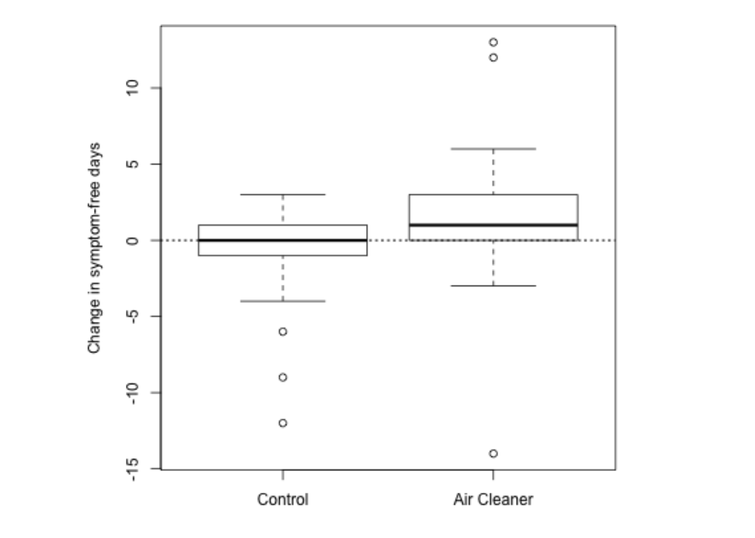

| What does this graph NOT show you?

1: Children in the control group had at most 3 symptom-free days

2: 75% of the children using the air cleaner had at most 3 symptom-free days

3: Using the air cleaner makes asthmatic children sicker

4: Half the chidren in the control group had no improvement

Selection: 3

| Nice work!

|====================== | 31%

| So the first principle was to show a comparison. The second principle

| is to show causality or a mechanism of how your theory of the data

| works. This explanation or systematic structure shows your causal

| framework for thinking about the question you're trying to answer.

|======================== | 33%

| Consider this plot which shows the dual boxplot we just showed, but next to it we

| have a corresponding plot of changes in measures of particulate matter.

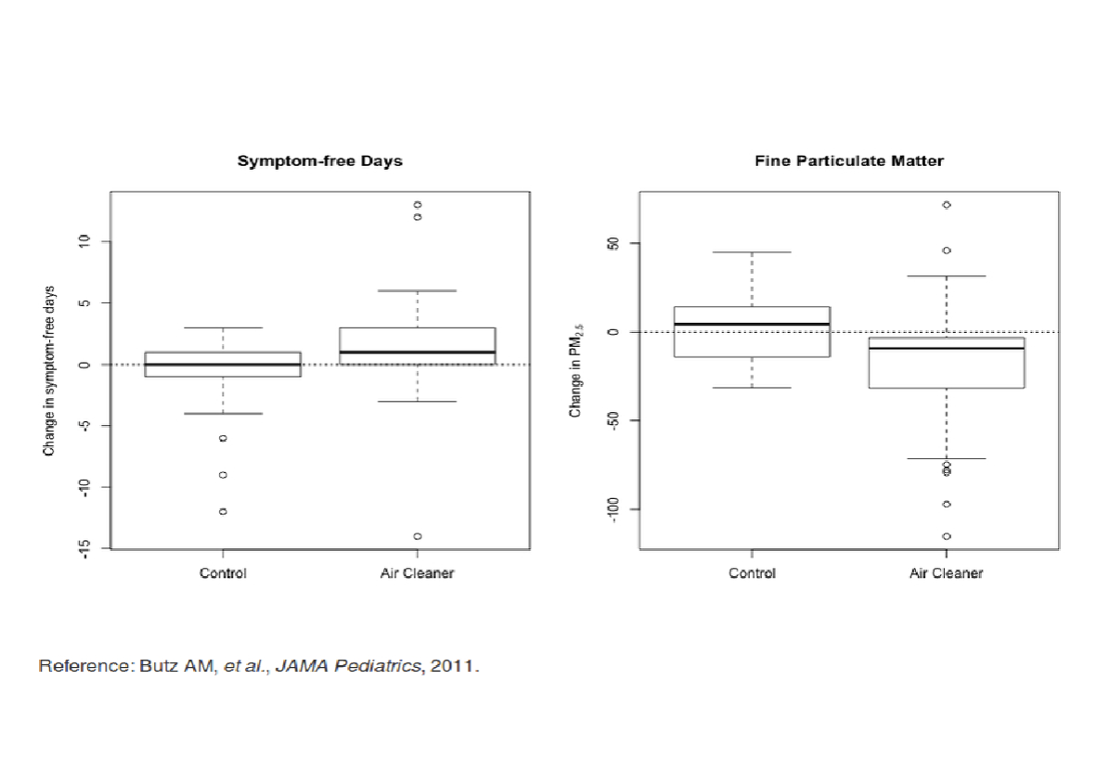

You are really on a roll!

|============================ | 39%

| By showing the two sets of boxplots side by side you're explaining your theory of why

| the air cleaner increases the number of symptom-free days. Onward!

...

|============================== | 42%

| So the first principle was to show some comparison, the second was to show a

| mechanism, so what will the third principle say to show?

...

|================================ | 44%

| Multivariate data!

...

|================================== | 47%

| What is multivariate data you might ask? In technical (scientific) literature this

| term means more than 2 variables. Two-variable plots are what you saw in high school

| algebra. Remember those x,y plots when you were learning about slopes and intercepts

| and equations of lines? They're valuable, but usually questions are more complicated

| and require more variables.

...

|==================================== | 50%

| Sometimes, if you restrict yourself to two variables you'll be misled and draw an

| incorrect conclusion.

...

|===================================== | 53%

| Consider this plot which shows the relationship between air pollution (x-axis) and

| mortality rates among the elderly (y-axis). The blue regression line shows a

| surprising result. (You'll learn about regression lines when you take the fabulous

| Regression Models course.)

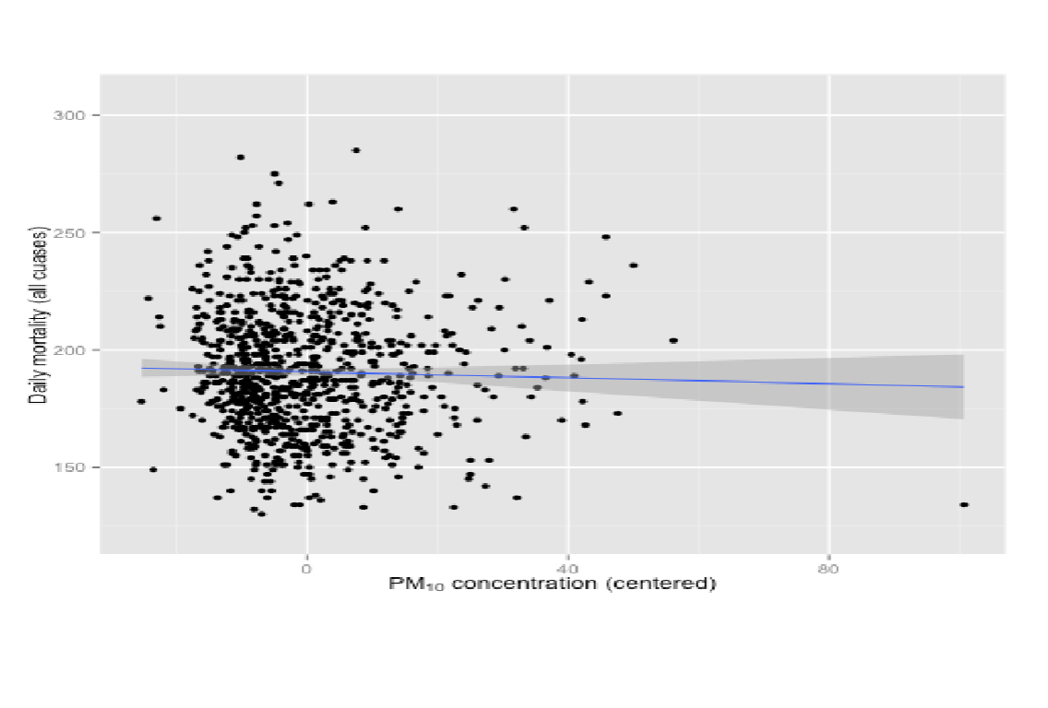

|======================================= | 56%

| What does the blue regression line indicate?

1: Pollution doesn't really increase, it just gets reported more

2: As pollution increases the number of deaths doesn't change

3: As pollution increases fewer people die

4: As pollution increases more people die

Selection: 3

| You nailed it! Good job!

|========================================= | 58%

| Fewer deaths with more pollution? That's a surprise! Something's gotta be wrong,

| right? In fact, this is an example of Simpson's paradox, or the Yule–Simpson effect.

| Wikipedia (http://en.wikipedia.org/wiki/Simpson%27s_paradox) tells us that this "is a

| paradox in probability and statistics, in which a trend that appears in different

| groups of data disappears when these groups are combined."

...

|=========================================== | 61%

| Suppose we divided this mortality/pollution data into the four seasons. Would we see

| different trends?

...

|============================================= | 64%

| Yes, we do! Plotting the same data for the 4 seasons individually we see a different

| result.

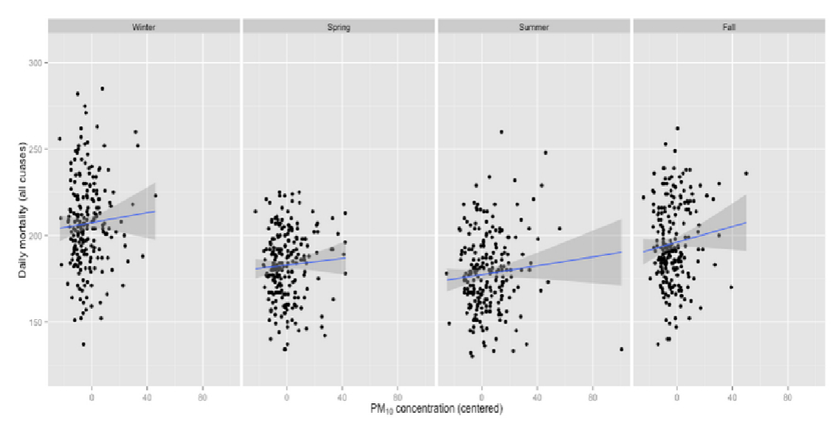

|=============================================== | 67%

| What does the new plot indicate?

1: As pollution increases the seasons change

2: Pollution doesn't really increase, it just gets reported more

3: As pollution increases fewer people die in all seasons

4: As pollution increases more people die in all seasons

Selection: 4

| You got it!

|================================================= | 69%

| The fourth principle of analytic graphing involves integrating evidence. This means

| not limiting yourself to one form of expression. You can use words, numbers, images

| as well as diagrams. Graphics should make use of many modes of data presentation.

| Remember, "Don't let the tool drive the analysis!"

...

|=================================================== | 72%

| To show you what we mean, here's an example of a figure taken from a paper published

| in the Journal of the AMA. It shows the relationship between pollution and

| hospitalization of people with heart disease. As you can see, it's a lot different

| from our previous plots. The solid circles in the center portion indicate point

| estimates of percentage changes in hospitalization rates for different levels of

| pollution. The lines through the circles indicate confidence intervals associated

| with these estimates. (You'll learn more about confidence intervals in another great

| course, the one on statistical inference.)

...

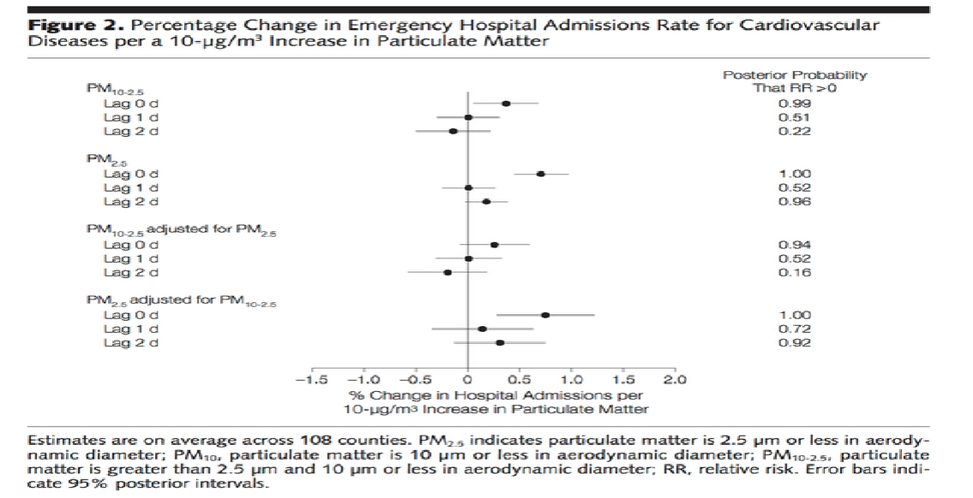

|===================================================== | 75%

| Note that on the right side of the figure is another column of numbers, one for each

| of the point estimates given. This column shows posterior probabilities that relative

| risk is greater than 0. This, in effect, is a measure of the strength of the evidence

| showing the correlation between pollution and hospitalization. The point here is

| that all of this information is located in one picture so that the reader can see the

| strength of not only the correlations but the evidence as well.

...

|======================================================= | 78%

| The fifth principle of graphing involves describing and documenting the evidence with

| sources and appropriate labels and scales. Credibility is important so the data

| graphics should tell a complete story. Also, using R, you want to preserve any code

| you use to generate your data and graphics so that the research can be replicated if

| necessary. This allows for easy verification or finding bugs in your analysis.

...

|========================================================= | 81%

| The sixth and final principle of analytic graphing is maybe the most important.

| Content is king! If you don't have something interesting to report, your graphs won't

| save you. Analytical presentations ultimately stand or fall depending on the quality,

| relevance, and integrity of their content.

...

|=========================================================== | 83%

| Review time!!!

|============================================================= | 86%

| Which of the following is NOT a good principle of graphing?

1: Content is king

2: To integrate multiple modes of evidence

3: Having unreadable labels

4: To describe and document evidence

Selection: 3

| Great job!

|=============================================================== | 89%

| Which of the following is NOT a good principle of graphing?

1: To demonstrate a causative mechanism underlying a correlation

2: To prove you're always right

3: Content is king

4: To show two competing hypotheses

Selection: 2

| Your dedication is inspiring!

|================================================================= | 92%

| Which of the following is NOT a good principle of graphing?

1: To show good labels and scales

2: To show that some fonts are better than others

3: Content is king

4: To integrate different types of evidence

Selection: 2

| You are quite good my friend!

|=================================================================== | 94%

| True or False? Color is king.

1: False

2: True

Selection: 1

| That's a job well done!

|===================================================================== | 97%

| Congrats! You've concluded exploring this lesson on principles of graphing. We hope

| you found it principally principled.

...

|=======================================================================| 100%

| Would you like to receive credit for completing this course on Coursera.org?

1: Yes

2: No

Selection: 2

| You are really on a roll!

| You've reached the end of this lesson! Returning to the main menu...

| Please choose a course, or type 0 to exit swirl.

1: Exploratory Data Analysis

2: Take me to the swirl course repository!

Selection: 1

| Please choose a lesson, or type 0 to return to course menu.

1: Principles of Analytic Graphs 2: Exploratory Graphs

3: Graphics Devices in R 4: Plotting Systems

5: Base Plotting System 6: Lattice Plotting System

7: Working with Colors 8: GGPlot2 Part1

9: GGPlot2 Part2 10: GGPlot2 Extras

11: Hierarchical Clustering 12: K Means Clustering

13: Dimension Reduction 14: Clustering Example

15: CaseStudy

Selection: 2

| | 0%

| Exploratory_Graphs. (Slides for this and other Data Science courses may be found at

| github https://github.com/DataScienceSpecialization/courses/. If you care to use

| them, they must be downloaded as a zip file and viewed locally. This lesson

| corresponds to 04_ExploratoryAnalysis/exploratoryGraphs.)

|= | 1%

| In this lesson, we'll discuss why graphics are an important tool for data scientists

| and the special role that exploratory graphs play in the field.

...

|== | 3%

| Which of the following would NOT be a good reason to use graphics in data science?

1: To find a color that best matches the shirt you're wearing

2: To suggest modeling strategies

3: To find patterns in data

4: To understand data properties

Selection: 1

| Excellent work!

|=== | 4%

| So graphics give us some visual form of data, and since our brains are very good at

| seeing patterns, graphs give us a compact way to present data and find or display any

| pattern that may be present.

...

|==== | 5%

| Which of the following cliches captures the essence of graphics?

1: To err is human, to forgive divine

2: A picture is worth a 1000 words

3: A rose by any other name smells as sweet

4: The apple doesn't fall far from the tree

Selection: 2

| You are quite good my friend!

|===== | 7%

| Exploratory graphs serve mostly the same functions as graphs. They help us find

| patterns in data and understand its properties. They suggest modeling strategies and

| help to debug analyses. We DON'T use exploratory graphs to communicate results.

...

|====== | 8%

| Instead, exploratory graphs are the initial step in an investigation, the "quick and

| dirty" tool used to point the data scientist in a fruitful direction. A scientist

| might need to make a lot of exploratory graphs in order to develop a personal

| understanding of the problem being studied. Plot details such as axes, legends, color

| and size are cleaned up later to convey more information in an aesthetically pleasing

| way.

...

|======= | 9%

| To demonstrate these ideas, we've copied some data for you from the U.S.

| Environmental Protection Agency (EPA) which sets national ambient air quality

| standards for outdoor air pollution. These Standards say that for fine particle

| pollution (PM2.5), the "annual mean, averaged over 3 years" cannot exceed 12 micro

| grams per cubic meter. We stored the data from the U.S. EPA web site in the data

| frame pollution. Use the R function head to see the first few entries of pollution.

>

>

> head(pollution)

pm25 fips region longitude latitude

1 9.771185 01003 east -87.74826 30.59278

2 9.993817 01027 east -85.84286 33.26581

3 10.688618 01033 east -87.72596 34.73148

4 11.337424 01049 east -85.79892 34.45913

5 12.119764 01055 east -86.03212 34.01860

6 10.827805 01069 east -85.35039 31.18973

| Nice work!

|======== | 11%

| We see right away that there's at least one county exceeding the EPA's standard of 12

| micrograms per cubic meter. What else do we see?

...

|========= | 12%

| We see 5 columns of data. The pollution count is in the first column labeled pm25.

| We'll work mostly with that. The other 4 columns are a fips code indicating the state

| (first 2 digits) and county (last 3 digits) with that count, the associated region

| (east or west), and the longitude and latitude of the area. Now run the R command dim

| with pollution as an argument to see how long the table is.

>

> dim(pollution)

[1] 576 5

| Your dedication is inspiring!

|========== | 13%

| So there are 576 entries in pollution. We'd like to investigate the question "Are

| there any counties in the U.S. that exceed that national standard (12 micro grams per

| cubic meter) for fine particle pollution?" We'll look at several one dimensional

| summaries of the data to investigate this question.

...

|=========== | 15%

| The first technique uses the R command summary, a 5-number summary which returns 6

| numbers. Run it now with the pm25 column of pollution as its argument. Recall that

| the construct for this is pollution$pm25.

> summary(pollution$pm25)

Min. 1st Qu. Median Mean 3rd Qu. Max.

3.383 8.549 10.047 9.836 11.356 18.441

| You got it right!

|============ | 16%

| This shows us basic info about the pm25 data, namely its Minimum (0 percentile) and

| Maximum (100 percentile) values, and three Quartiles of the data. These last indicate

| the pollution measures at which 25%, 50%, and 75% of the counties fall below. In

| addition to these 5 numbers we see the Mean or average measure of particulate

| pollution across the 576 counties.

...

|============== | 17%

| Half the measured counties have a pollution level less than or equal to what number

| of micrograms per cubic meter?

1: 11.360

2: 8.549

3: 9.836

4: 10.050

Selection: 4

| That's the answer I was looking for.

|=============== | 19%

| To save you a lot of typing we've saved off pollution$pm25 for you in the variable

| ppm. You can use ppm now in place of the longer expression. Try it now as the

| argument of the R command quantile. See how the results look a lot like the results

| of the output of the summary command.

> quantile(ppm)

0% 25% 50% 75% 100%

3.382626 8.548799 10.046697 11.356012 18.440731

| Great job!

|================ | 20%

| See how the results are similar to those returned by summary? Quantile gives the

| quartiles, right? What is the one value missing from this quantile output that

| summary gave you?

1: the mean

2: the median

3: the maximum value

4: the minimum value

Selection: 1

| You got it!

|================= | 21%

| Now we'll plot a picture, specifically a boxplot. Run the R command boxplot with ppm

| as an input. Also specify the color parameter col equal to "blue".

> boxplot(ppm, col = "blue")

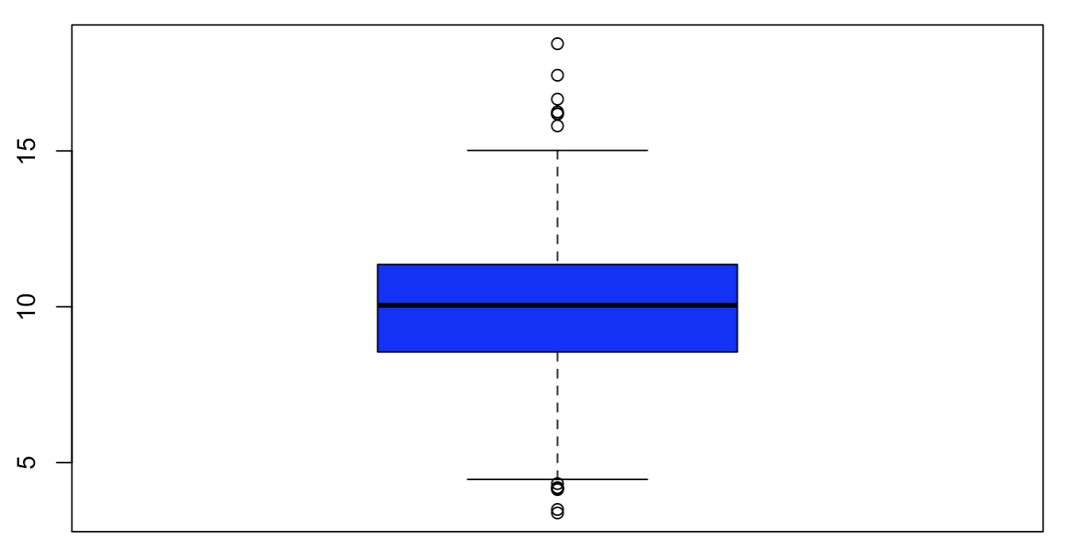

| Excellent job!

|================== | 23%

| The boxplot shows us the same quartile data that summary and quantile did. The lower

| and upper edges of the blue box respectively show the values of the 25% and 75%

| quantiles.

...

|=================== | 24%

| What do you think the horizontal line inside the box represents?

1: the maximum value

2: the minimum value

3: the mean

4: the median

Selection: 4

| You are quite good my friend!

|==================== | 25%

| The "whiskers" of the box (the vertical lines extending above and below the box)

| relate to the range parameter of boxplot, which we let default to the value 1.5 used

| by R. The height of the box is the interquartile range, the difference between the

| 75th and 25th quantiles. In this case that difference is 2.8. The whiskers are drawn

| to be a length of range*2.8 or 1.5*2.8. This shows us roughly how many, if any, data

| points are outliers, that is, beyond this range of values.

...

|===================== | 27%

| Note that boxplot is part of R's base plotting package. A nice feature that this

| package provides is its ability to overlay features. That is, you can add to

| (annotate) an existing plot.

...

|====================== | 28%

| To see this, run the R command abline with the argument h equal to 12. Recall that 12

| is the EPA standard for air quality.

> abline(h = 12)

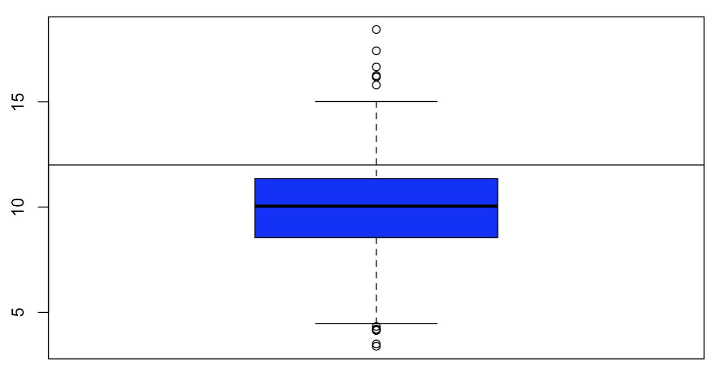

| All that hard work is paying off!

|======================= | 29%

| What do you think this command did?

1: nothing

2: hid 12 random data points

3: drew a horizontal line at 12

4: drew a vertical line at 12

Selection: 3

| You got it!

|======================== | 31%

| So abline "adds one or more straight lines through the current plot." We see from the

| plot that the bulk of the measured counties comply with the standard since they fall

| under the line marking that standard.

|========================= | 32%

| Now use the R command hist (another function from the base package) with the argument

| ppm. Specify the color parameter col equal to "green". This will plot a histogram of

| the data.

> hist(ppm, col = "green")

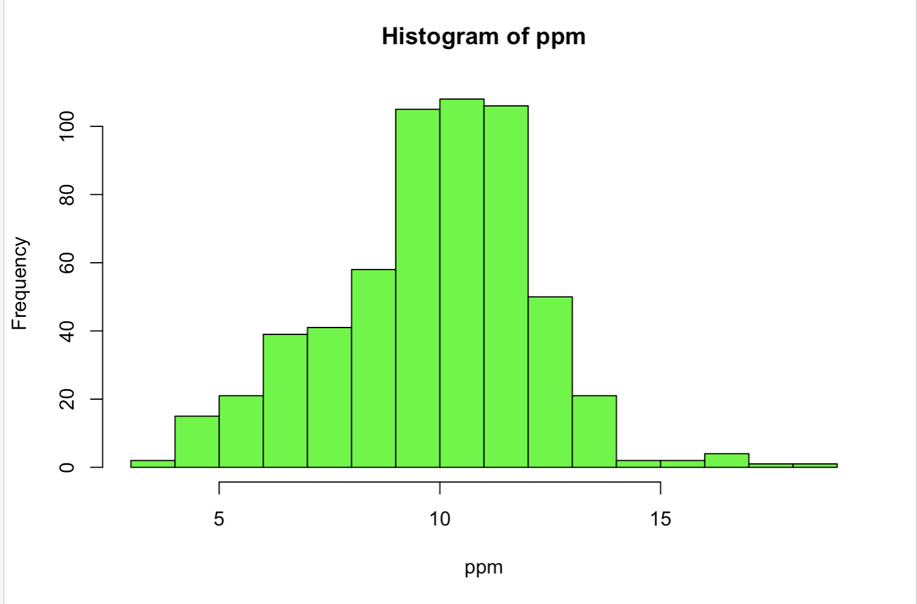

| You are amazing!

|========================== | 33%

| The histogram gives us a little more detailed information about our data,

| specifically the distribution of the pollution counts, or how many counties fall into

| each bucket of measurements.

|=========================== | 35%

| What are the most frequent pollution counts?

1: under 5

2: between 6 and 8

3: between 9 and 12

4: between 12 and 14

Selection: 3

| You are quite good my friend!

|============================ | 36%

| Now run the R command rug with the argument ppm.

> rug(ppm)

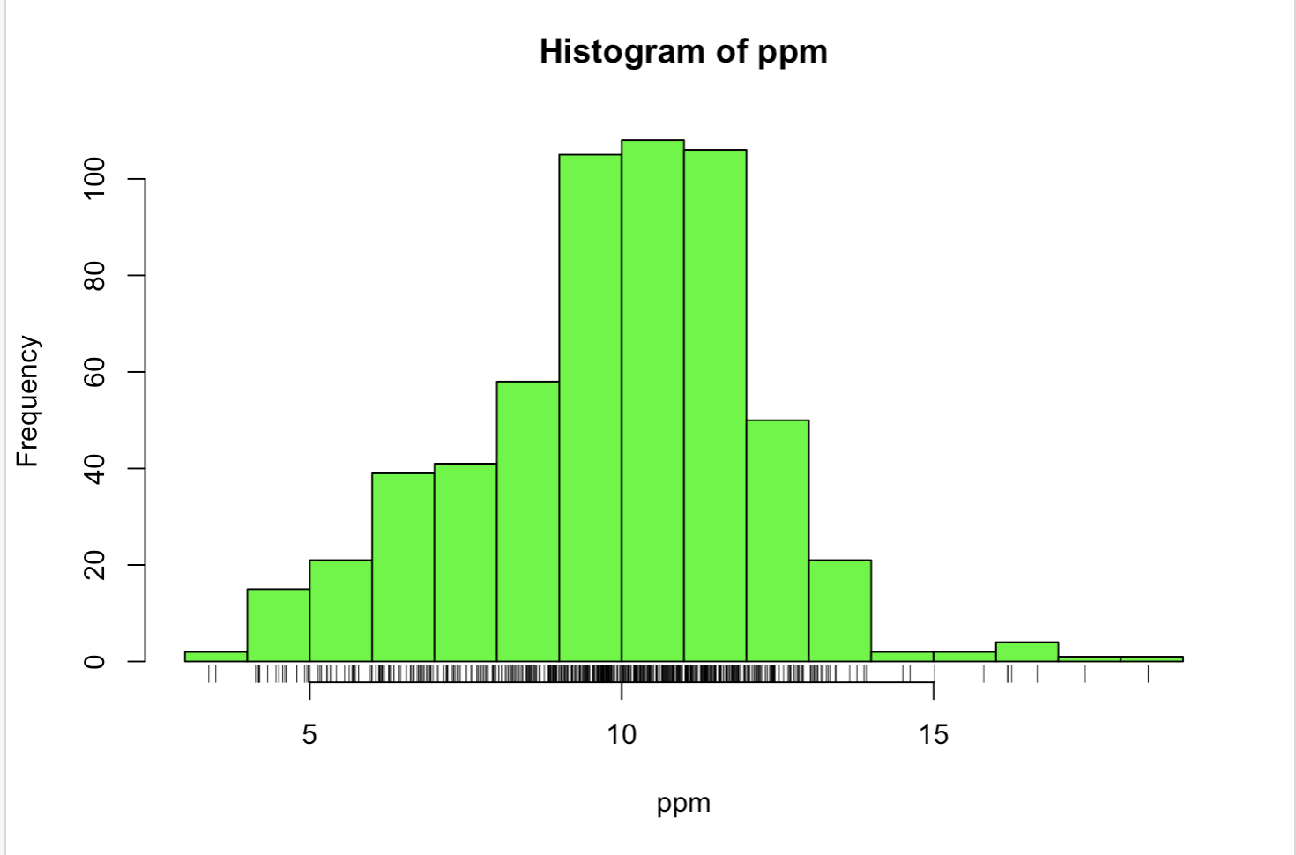

| That's correct!

|============================= | 37%

| This one-dimensional plot, with its grayscale representation, gives you a little more

| detailed information about how many data points are in each bucket and where they lie

| within the bucket. It shows (through density of tick marks) that the greatest

| concentration of counties has between 9 and 12 micrograms per cubic meter just as the

| histogram did.

|============================== | 39%

| To illustrate this a little more, we've defined for you two vectors, high and low,

| containing pollution data of high (greater than 15) and low (less than 5) values

| respectively. Look at low now and see how it relates to the output of rug.

> low

[1] 3.494351 4.186090 4.917140 4.504539 4.793644 4.601408 4.195688 4.625279 4.460193

[10] 4.978397 4.324736 4.175901 3.382626 4.132739 4.955570 4.565808

| You nailed it! Good job!

|=============================== | 40%

| It confirms that there are two data points between 3 and 4 and many between 4 and 5.

| Now look at high.

> high

[1] 16.19452 15.80378 18.44073 16.66180 15.01573 17.42905 16.25190 16.18358

| You got it!

|================================ | 41%

| Again, we see one data point greater than 18, one between 17 and 18, several between

| 16 and 17 and two between 15 and 16, verifying what rug indicated.

...

|================================= | 43%

| Now rerun hist with 3 arguments, ppm as its first, col equal to "green", and the

| argument breaks equal to 100.

> hist(ppm, col = "green", breaks = 100)

| You got it!

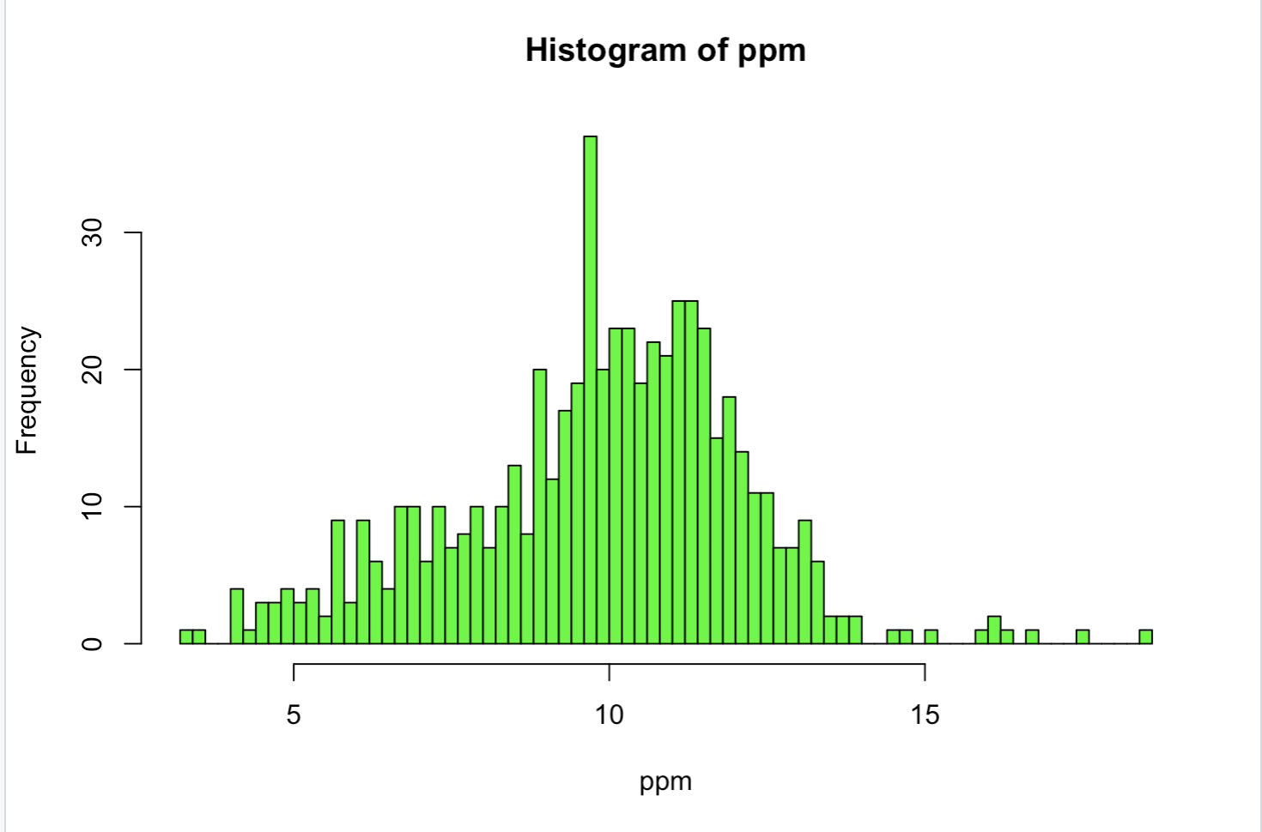

|================================== | 44%

| What do you think the breaks argument specifies in this case?

1: the number of data points to graph

2: the number of buckets to split the data into

3: the number of counties exceeding the EPA standard

4: the number of stars in the sky

Selection: 2

| Excellent work!

|=================================== | 45%

| So this histogram with more buckets is not nearly as smooth as the preceding one. In

| fact, it's a little too noisy to see the distribution clearly. When you're plotting

| histograms you might have to experiment with the argument breaks to get a good idea

| of your data's distribution. For fun now, rerun the R command rug with the argument

| ppm.

> rug(ppm)

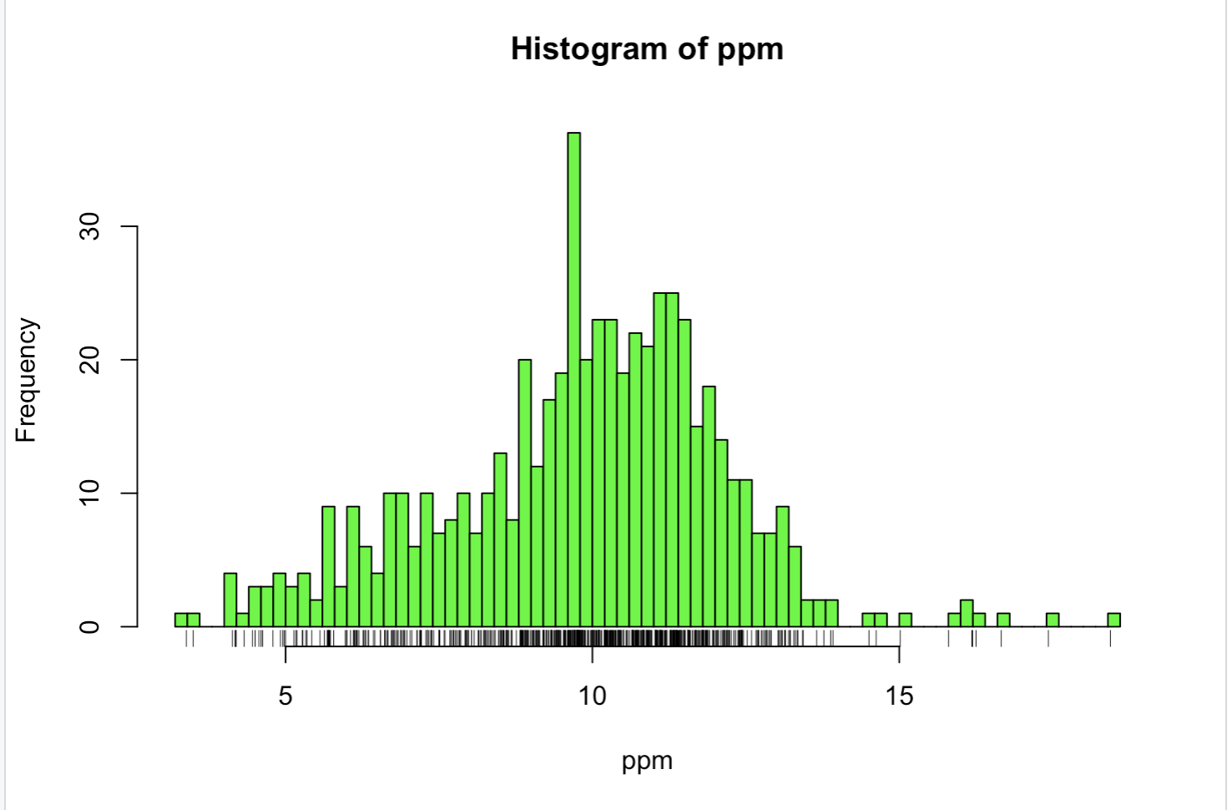

| That's a job well done!

|==================================== | 47%

| See how rug works with the existing plot? It automatically adjusted its pocket size

| to that of the last plot plotted.

|===================================== | 48%

| Now rerun hist with ppm as the data and col equal to "green".

> hist(ppm, col = "green")



| Excellent work!

|====================================== | 49%

| Now run the command abline with the argument v equal to 12 and the argument lwd equal

| to 2.

> abline(v = 12, lwd = 2)

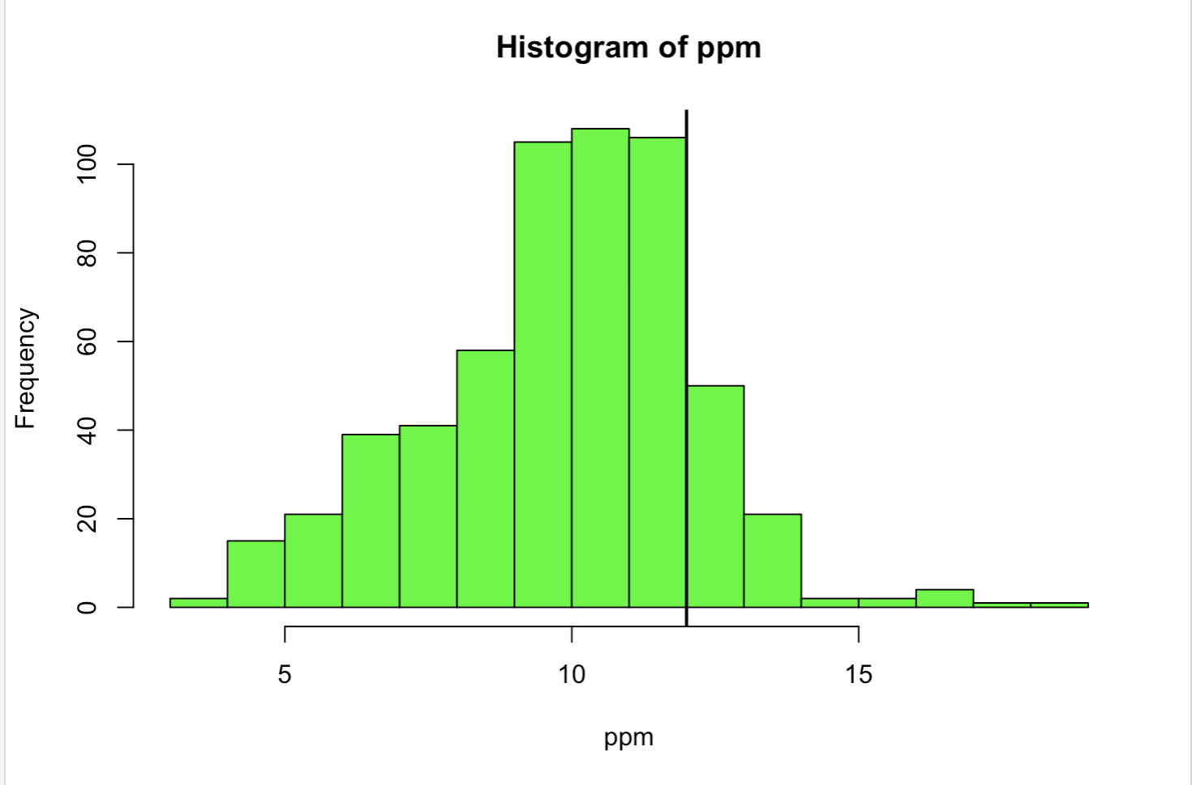

| You're the best!

|======================================== | 51%

| See the vertical line at 12? Not very visible, is it, even though you specified a

| line width of 2? Run abline with the argument v equal to median(ppm), the argument

| col equal to "magenta", and the argument lwd equal to 4.

> abline(v = median(ppm), col = "magenta", lwd = 4)

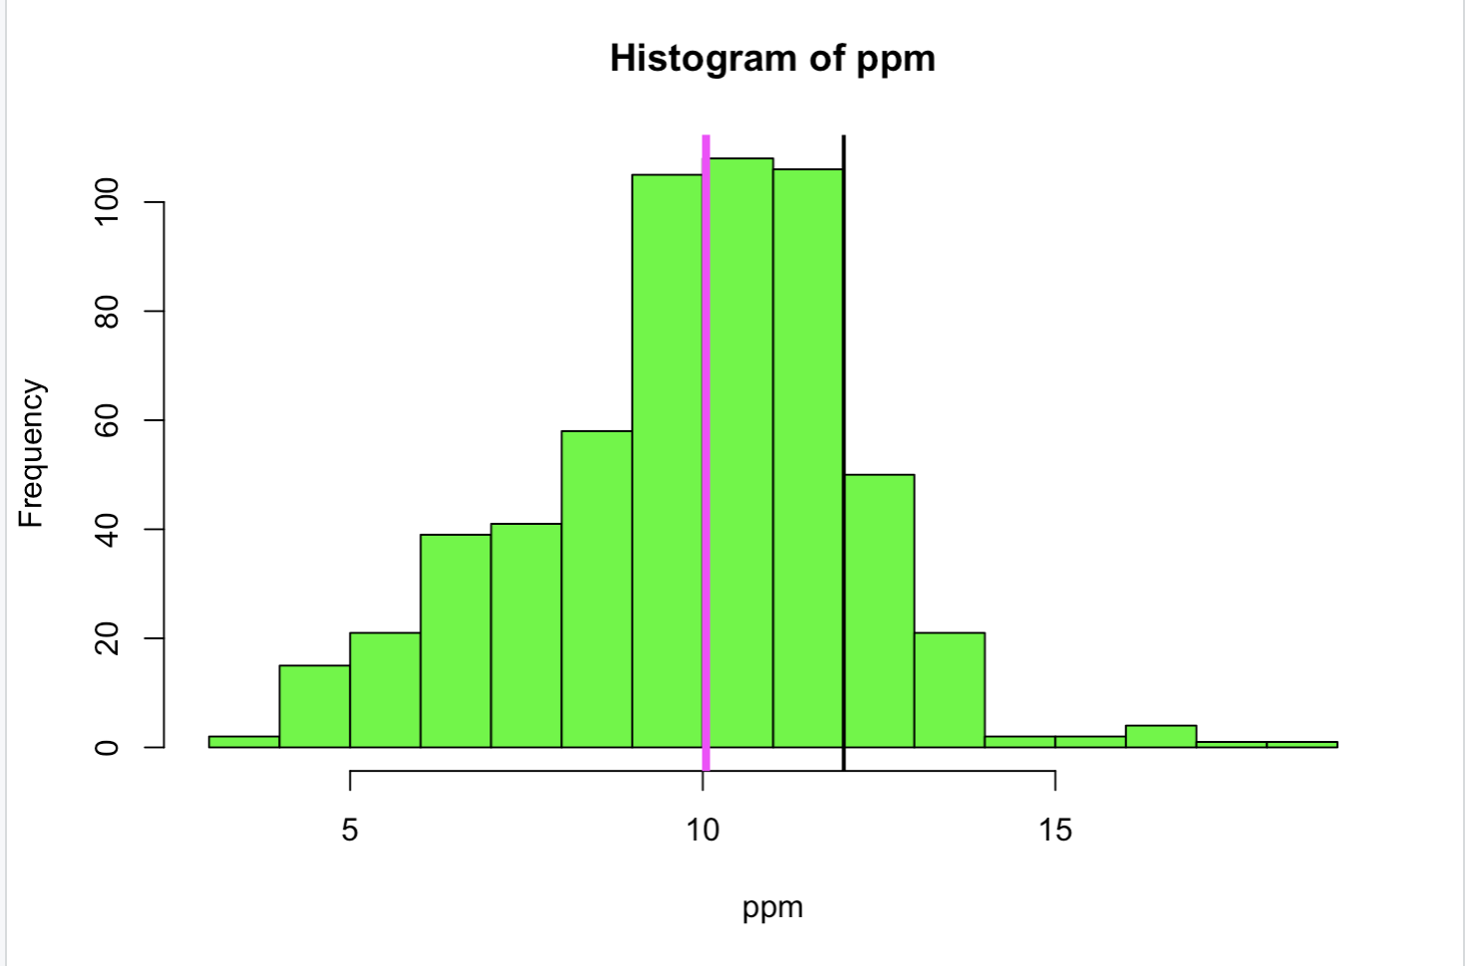

| Excellent job!

|========================================= | 52%

| Better, right? Thicker and more of a contrast in color. This shows that although the

| median (50%) is below the standard, there are a fair number of counties in the U.S

| that have pollution levels higher than the standard.

...

|========================================== | 53%

| Now recall that our pollution data had 5 columns of information. So far we've only

| looked at the pm25 column. We can also look at other information. To remind yourself

| what's there run the R command names with pollution as the argument.

> names(pollution)

[1] "pm25" "fips" "region" "longitude" "latitude"

| That's the answer I was looking for.

|=========================================== | 55%

| Longitude and latitude don't sound interesting, and each fips is unique since it

| identifies states (first 2 digits) and counties (last 3 digits). Let's look at the

| region column to see what's there. Run the R command table on this column. Use the

| construct pollution$region. Store the result in the variable reg.

> reg <- table(pollution$region)

| Your dedication is inspiring!

|============================================ | 56%

| Look at reg now.

> reg

east west

442 134

| Excellent job!

|============================================= | 57%

| Lot more counties in the east than west. We'll use the R command barplot (another

| type of one-dimensional summary) to plot this information. Call barplot with reg as

| its first argument, the argument col equal to "wheat", and the argument main equal to

| the string "Number of Counties in Each Region".

> barplot(reg, col = "wheat", main = "Number of Counties in Each Region")

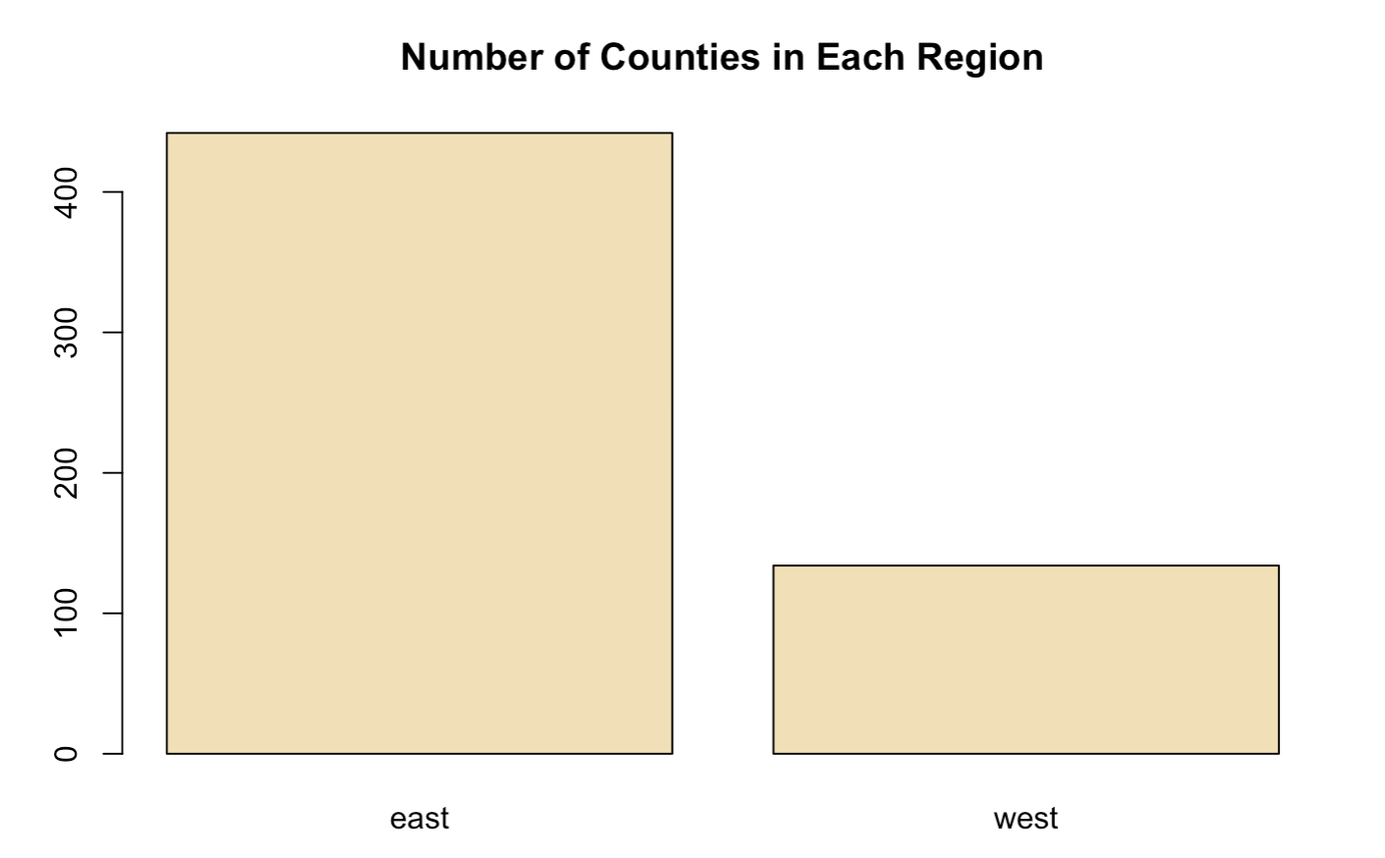

| You got it!

|============================================== | 59%

| What do you think the argument main specifies?

1: the y axis label

2: the x axis label

3: I can't tell

4: the title of the graph

Selection: 4

| You are doing so well!

|=============================================== | 60%

| So we've seen several examples of one-dimensional graphs that summarize data. Two

| dimensional graphs include scatterplots, multiple graphs which we'll see more

| examples of, and overlayed one-dimensional plots which the R packages such as lattice

| and ggplot2 provide.

...

|================================================ | 61%

| Some graphs have more than two-dimensions. These include overlayed or multiple

| two-dimensional plots and spinning plots. Some three-dimensional plots are tricky to

| understand so have limited applications. We'll see some examples now of more

| complicated graphs, in particular, we'll show two graphs together.

...

|================================================= | 63%

| First we'll show how R, in one line and using base plotting, can display multiple

| boxplots. We simply specify that we want to see the pollution data as a function of

| region. We know that our pollution data characterized each of the 576 entries as

| belonging to one of two regions (east and west).

...

|================================================== | 64%

| We use the R formula y ~ x to show that y (in this case pm25) depends on x (region).

| Since both come from the same data frame (pollution) we can specify a data argument

| set equal to pollution. By doing this, we don't have to type pollution$pm25 (or ppm)

| and pollution$region. We can just specify the formula pm25~region. Call boxplot now

| with this formula as its argument, data equal to pollution, and col equal to "red".

> boxplot(pm25~region, data = pollution, col = "red")

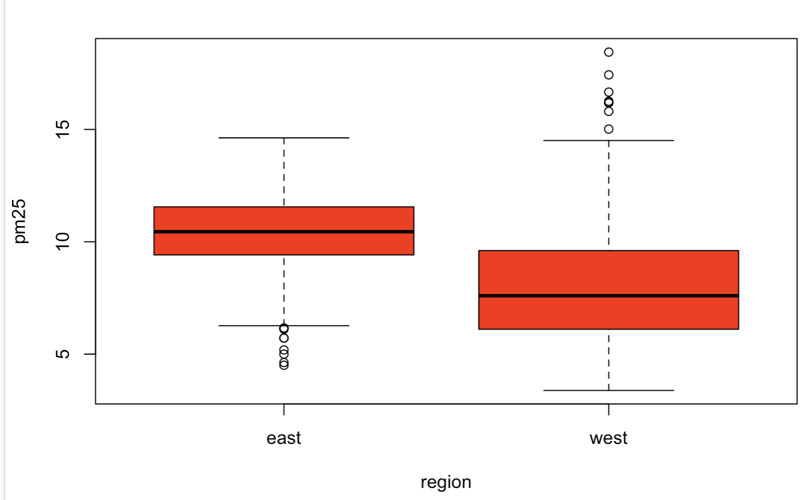

| Excellent work!

|=================================================== | 65%

| Two for the price of one! Similarly we can plot multiple histograms in one plot,

| though to do this we have to use more than one R command. First we have to set up the

| plot window with the R command par which specifies how we want to lay out the plots,

| say one above the other. We also use par to specify margins, a 4-long vector which

| indicates the number of lines for the bottom, left, top and right. Type the R command

| par(mfrow=c(2,1),mar=c(4,4,2,1)) now. Don't expect to see any new result.

> par(mfrow=c(2,1),mar=c(4,4,2,1))

| You are quite good my friend!

|==================================================== | 67%

| So we set up the plot window for two rows and one column with the mfrow argument. The

| mar argument set up the margins. Before we plot the histograms let's explore the R

| command subset which, not surprisingly, "returns subsets of vectors, matrices or data

| frames which meet conditions". We'll use subset to pull off the data we want to plot.

| Call subset now with pollution as its first argument and a boolean expression testing

| region for equality with the string "east". Put the result in the variable east.

> east <- subset(pollution, region == "east")

| All that hard work is paying off!

|===================================================== | 68%

| Use head to look at the first few entries of east.

> head(east)

pm25 fips region longitude latitude

1 9.771185 01003 east -87.74826 30.59278

2 9.993817 01027 east -85.84286 33.26581

3 10.688618 01033 east -87.72596 34.73148

4 11.337424 01049 east -85.79892 34.45913

5 12.119764 01055 east -86.03212 34.01860

6 10.827805 01069 east -85.35039 31.18973

| Perseverance, that's the answer.

|====================================================== | 69%

| So east holds more information than we need. We just want to plot a histogram with

| the pm25 portion. Call hist now with the pm25 portion of east as its first argument

| and col equal to "green" as its second.

> hist(east$pm25, col = "green")

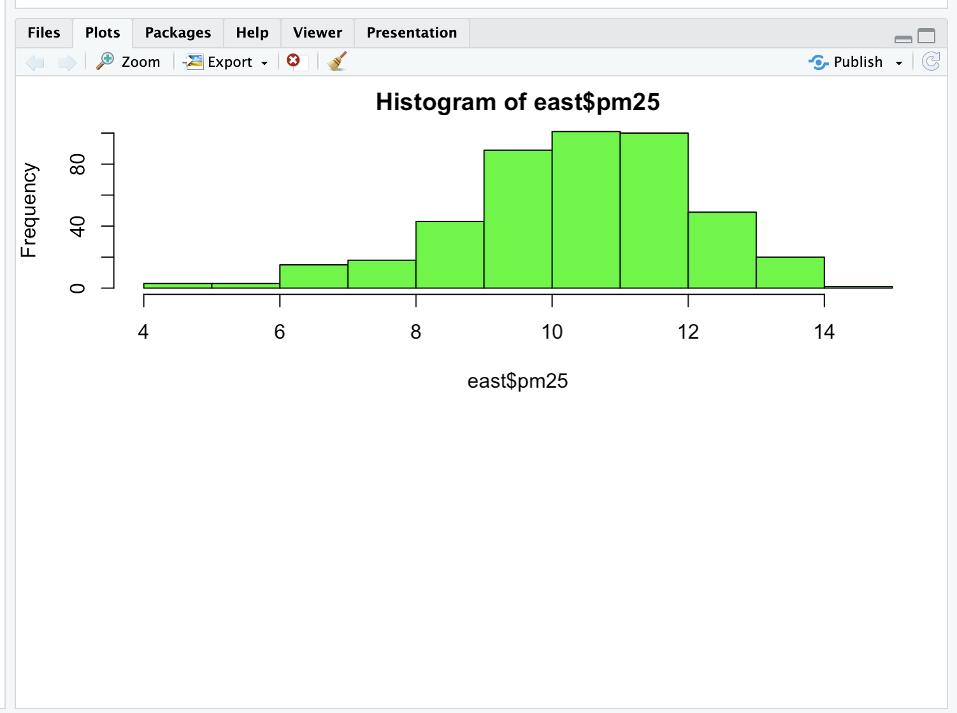

| Keep up the great work!

|======================================================= | 71%

| See? The command par told R we were going to have one column with 2 rows, so it

| placed this histogram in the top position.

...

|======================================================== | 72%

| Now, here's a challenge for you. Plot the histogram of the counties from the west

| using just one R command. Let the appropriate subset command (with the pm25 portion

| specified) be the first argument and col (equal to "green") the second. To cut down

| on your typing, use the up arrow key to get your last command and replace "east" with

| the subset command. Make sure the boolean argument checks for equality between region

| and "west".

> hist(subset(pollution, region == "west")$pm25, col = "green")

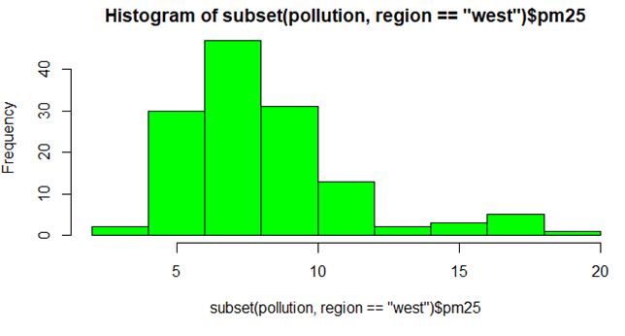

| All that hard work is paying off!

|========================================================= | 73%

| See how R does all the labeling for you? Notice that the titles are different since

| we used different commands for the two plots. Let's look at some scatter plots now.

...

|========================================================== | 75%

| Scatter plots are two-dimensional plots which show the relationship between two

| variables, usually x and y. Let's look at a scatterplot showing the relationship

| between latitude and the pm25 data. We'll use plot, a function from R's base plotting

| package.

...

|=========================================================== | 76%

| We've seen that we can use a function call as an argument when calling another

| function. We'll do this again when we call plot with the arguments latitude and pm25

| which are both from our data frame pollution. We'll call plot from inside the R

| command with which evaluates "an R expression in an environment constructed from

| data". We'll use pollution as the first argument to with and the call to plot as the

| second. This allows us to avoid typing "pollution$" before the arguments to plot, so

| it saves us some typing and adds to your base of R knowledge. Try this now.

> with(pollution, plot(latitide, pm25))

Error in plot(latitide, pm25) : object 'latitide' not found

> with(pollution, plot(latitude, pm25))

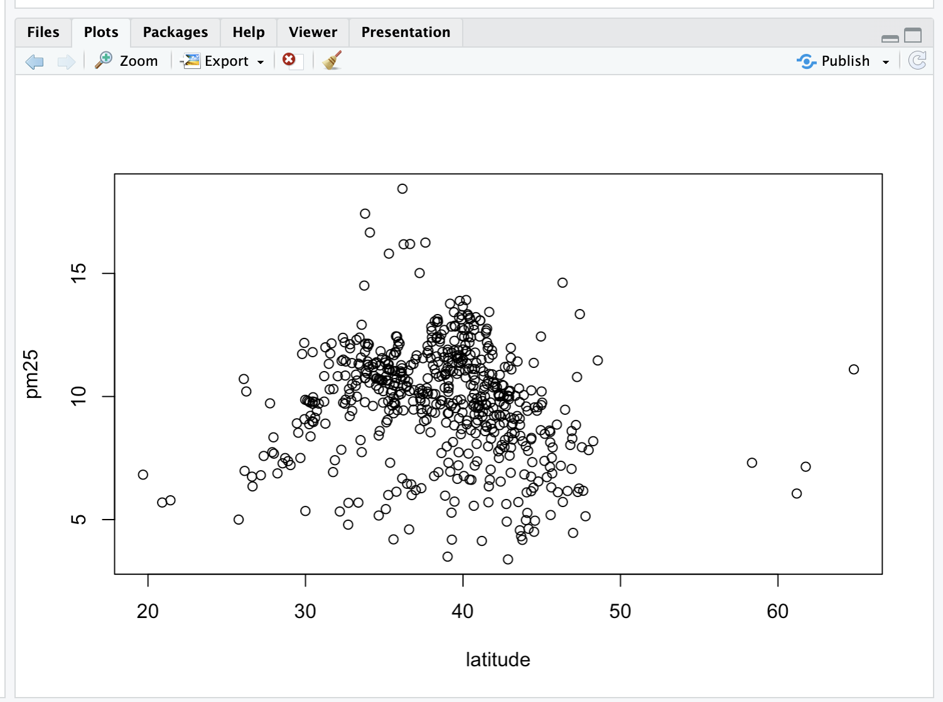

| Perseverance, that's the answer.

|============================================================ | 77%

| Note that the first argument is plotted along the x-axis and the second along the y.

| Now use abline to add a horizontal line at 12. Use two additional arguments, lwd

| equal to 2 and lty also equal to 2. See what happens.

> abline(h = 12, lwd = 2, lty = 2)

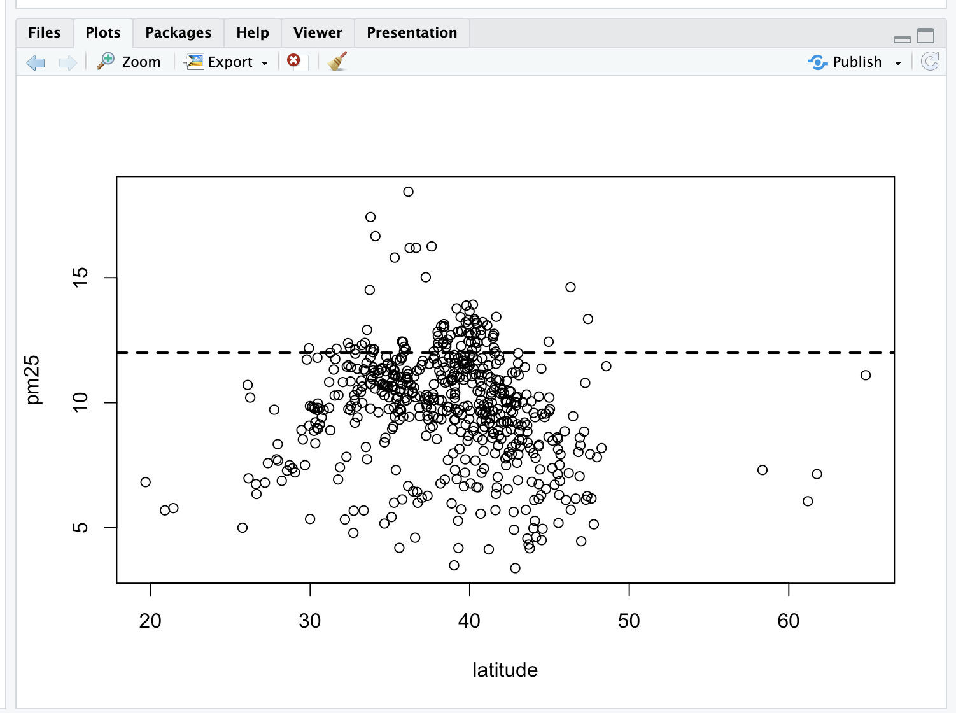

| That's correct!

|============================================================= | 79%

| See how lty=2 made the line dashed? Now let's replot the scatterplot. This time,

| instead of using with, call plot directly with 3 arguments. The first 2 are

| pollution$latitude and ppm. The third argument, col, we'll use to add color and more

| information to our plot. Set this argument (col) equal to pollution$region and see

| what happens.

> plot(pollution$latitude, ppm, col = pollution$region)

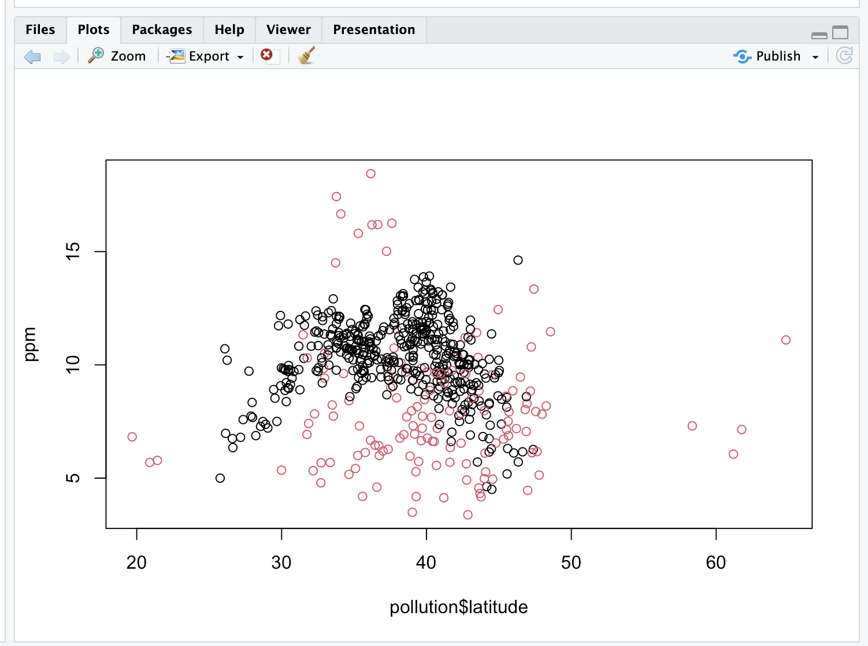

| You are doing so well!

|============================================================== | 80%

| We've got two colors on the map to distinguish between counties in the east and those

| in the west. Can we figure out which color is east and which west? See that the high

| (greater than 50) and low (less than 25) latitudes are both red. Latitudes indicate

| distance from the equator, so which half of the U.S. (east or west) has counties at

| the extreme north and south?

1: west

2: east

Selection: 1

| That's the answer I was looking for.

|=============================================================== | 81%

| As before, use abline to add a horizontal line at 12. Use two additional arguments,

| lwd equal to 2 and lty also equal to 2.

> abline(h = 12, lwd = 2, lty = 2)

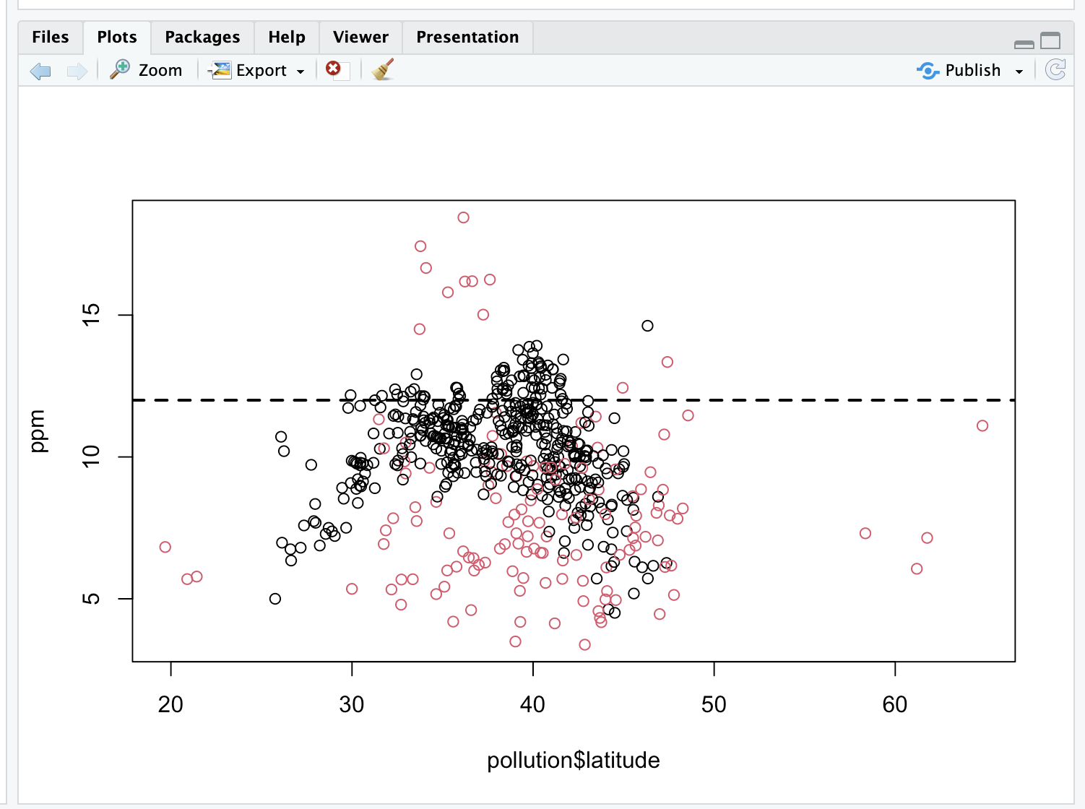

| All that hard work is paying off!

|================================================================ | 83%

| We see many counties are above the healthy standard set by the EPA, but it's hard to

| tell overall, which region, east or west, is worse.

|================================================================== | 84%

| Let's plot two scatterplots distinguished by region.

...

|=================================================================== | 85%

| As we did with multiple histograms, we first have to set up the plot window with the

| R command par. This time, let's plot the scatterplots side by side (one row and two

| columns). We also need to use different margins. Type the R command par(mfrow = c(1,

| 2), mar = c(5, 4, 2, 1)) now. Don't expect to see any new result.

> par(mfrow = c(1, 2), mar = c(5, 4, 2, 1))

| All that practice is paying off!

|==================================================================== | 87%

| For the first scatterplot, on the left, we'll plot the latitudes and pm25 counts from

| the west. We already pulled out the information for the counties in the east. Let's

| now get the information for the counties from the west. Create the variable west by

| using the subset command with pollution as the first argument and the appropriate

| boolean as the second.

> west <- subset(pollution, region == "west")

| Great job!

|===================================================================== | 88%

| Now call plot with three arguments. These are west$latitude (x-axis), west$pm25

| (y-axis), and the argument main equal to the string "West" (title). Do this now.

> plot(west$latitude, west$pm25, main = "West")

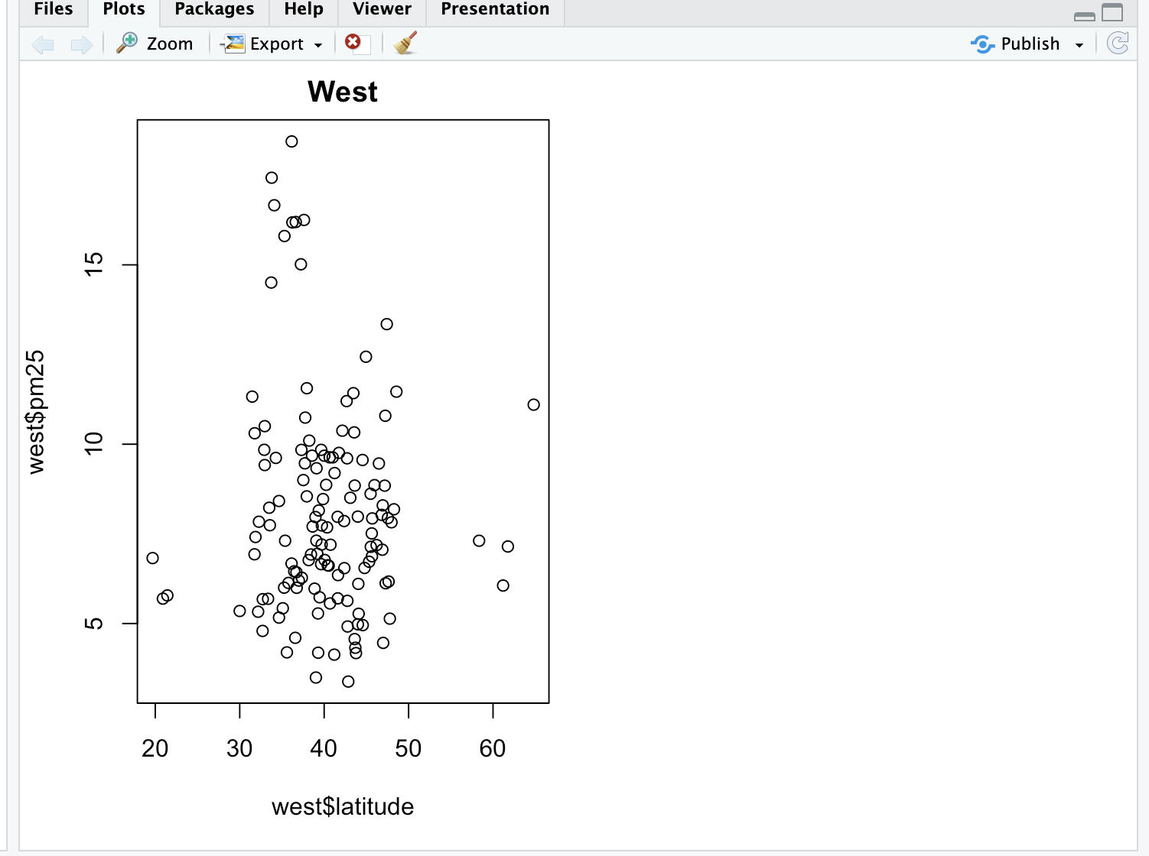

| Nice work!

|====================================================================== | 89%

| For the second scatterplot, on the right, we'll plot the latitudes and pm25 counts

| from the east.

|======================================================================= | 91%

| As before, use the up arrow key and change the 3 "West" strings to "East".

> plot(east$latitude, east$pm25, main = "East")

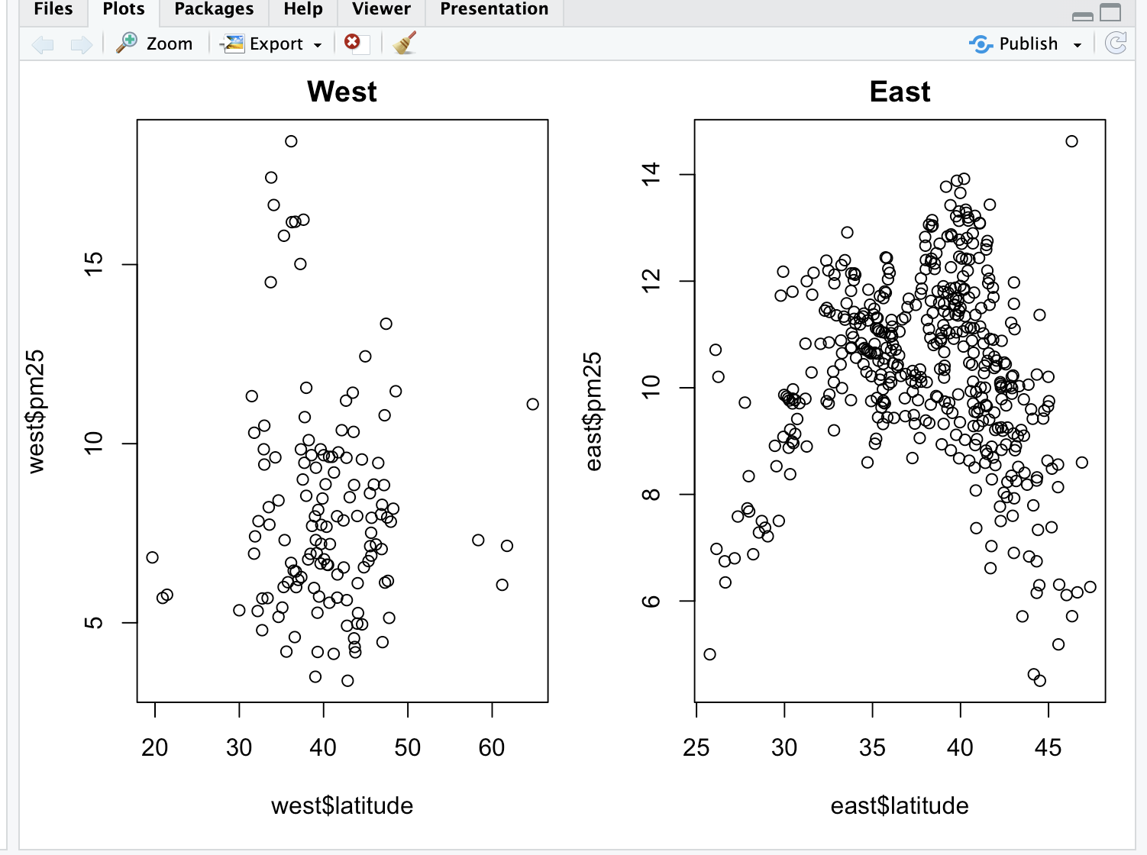

| You're the best!

|======================================================================== | 92%

| See how R took care of all the details for you? Nice, right? It looks like there are

| more dirty counties in the east but the extreme dirt (greater than 15) is in the

| west.

|========================================================================= | 93%

| Let's summarize and review.

...

|========================================================================== | 95%

| Which of the following characterizes exploratory plots?

1: quick and dead

2: slow and steady

3: quick and dirty

4: slow and clean

Selection: 3

| Keep up the great work!

|=========================================================================== | 96%

| True or false? Plots let you summarize the data (usually graphically) and highlight

| any broad features

1: False

2: True

Selection: 2

| Excellent work!

|============================================================================ | 97%

| Which of the following do plots NOT do?

1: Explore basic questions and hypotheses (and perhaps rule them out)

2: Suggest modeling strategies for the "next step"

3: Conclude that you are ALWAYS right

4: Summarize the data (usually graphically) and highlight any broad features

Selection: 3

| You are really on a roll!

|============================================================================= | 99%

| Congrats! You've concluded exploring this lesson on graphics. We hope you didn't find

| it too quick or dirty.

...

|==============================================================================| 100%

| Would you like to receive credit for completing this course on Coursera.org?

1: No

2: Yes

Selection: 1

| That's correct!

| You've reached the end of this lesson! Returning to the main menu...

| Please choose a course, or type 0 to exit swirl.

1: Exploratory Data Analysis

2: Take me to the swirl course repository!

Selection: 1

| Please choose a lesson, or type 0 to return to course menu.

1: Principles of Analytic Graphs 2: Exploratory Graphs

3: Graphics Devices in R 4: Plotting Systems

5: Base Plotting System 6: Lattice Plotting System

7: Working with Colors 8: GGPlot2 Part1

9: GGPlot2 Part2 10: GGPlot2 Extras

11: Hierarchical Clustering 12: K Means Clustering

13: Dimension Reduction 14: Clustering Example

15: CaseStudy

Selection: 3

| | 0%

| Graphics_Devices_in_R. (Slides for this and other Data Science courses may be found

| at github https://github.com/DataScienceSpecialization/courses/. If you care to use

| them, they must be downloaded as a zip file and viewed locally. This lesson

| corresponds to 04_ExploratoryAnalysis/Graphics_Devices_in_R.)

...

|== | 3%

| As the title suggests, this will be a short lesson introducing you to graphics

| devices in R. So, what IS a graphics device?

...

|===== | 6%

| Would you believe that it is something where you can make a plot appear, either a

| screen device, such as a window on your computer, OR a file device?

...

|======= | 9%

| There are several different kinds of file devices with particular characteristics and

| hence uses. These include PDF, PNG, JPEG, SVG, and TIFF. We'll talk more about these

| later.

...

|========= | 12%

| To be clear, when you make a plot in R, it has to be "sent" to a specific graphics

| device. Usually this is the screen (the default device), especially when you're doing

| exploratory work. You'll send your plots to files when you're ready to publish a

| report, make a presentation, or send info to colleagues.

...

|=========== | 15%

| How you access your screen device depends on what computer system you're using. On a

| Mac the screen device is launched with the call quartz(), on Windows you use the call

| windows(), and on Unix/Linux x11(). On a given platform (Mac, Windows, Unix/Linux)

| there is only one screen device, and obviously not all graphics devices are available

| on all platforms (i.e. you cannot launch windows() on a Mac).

...

|============== | 18%

| Run the R command ?Devices to see what graphics devices are available on your system.

> ?Devices

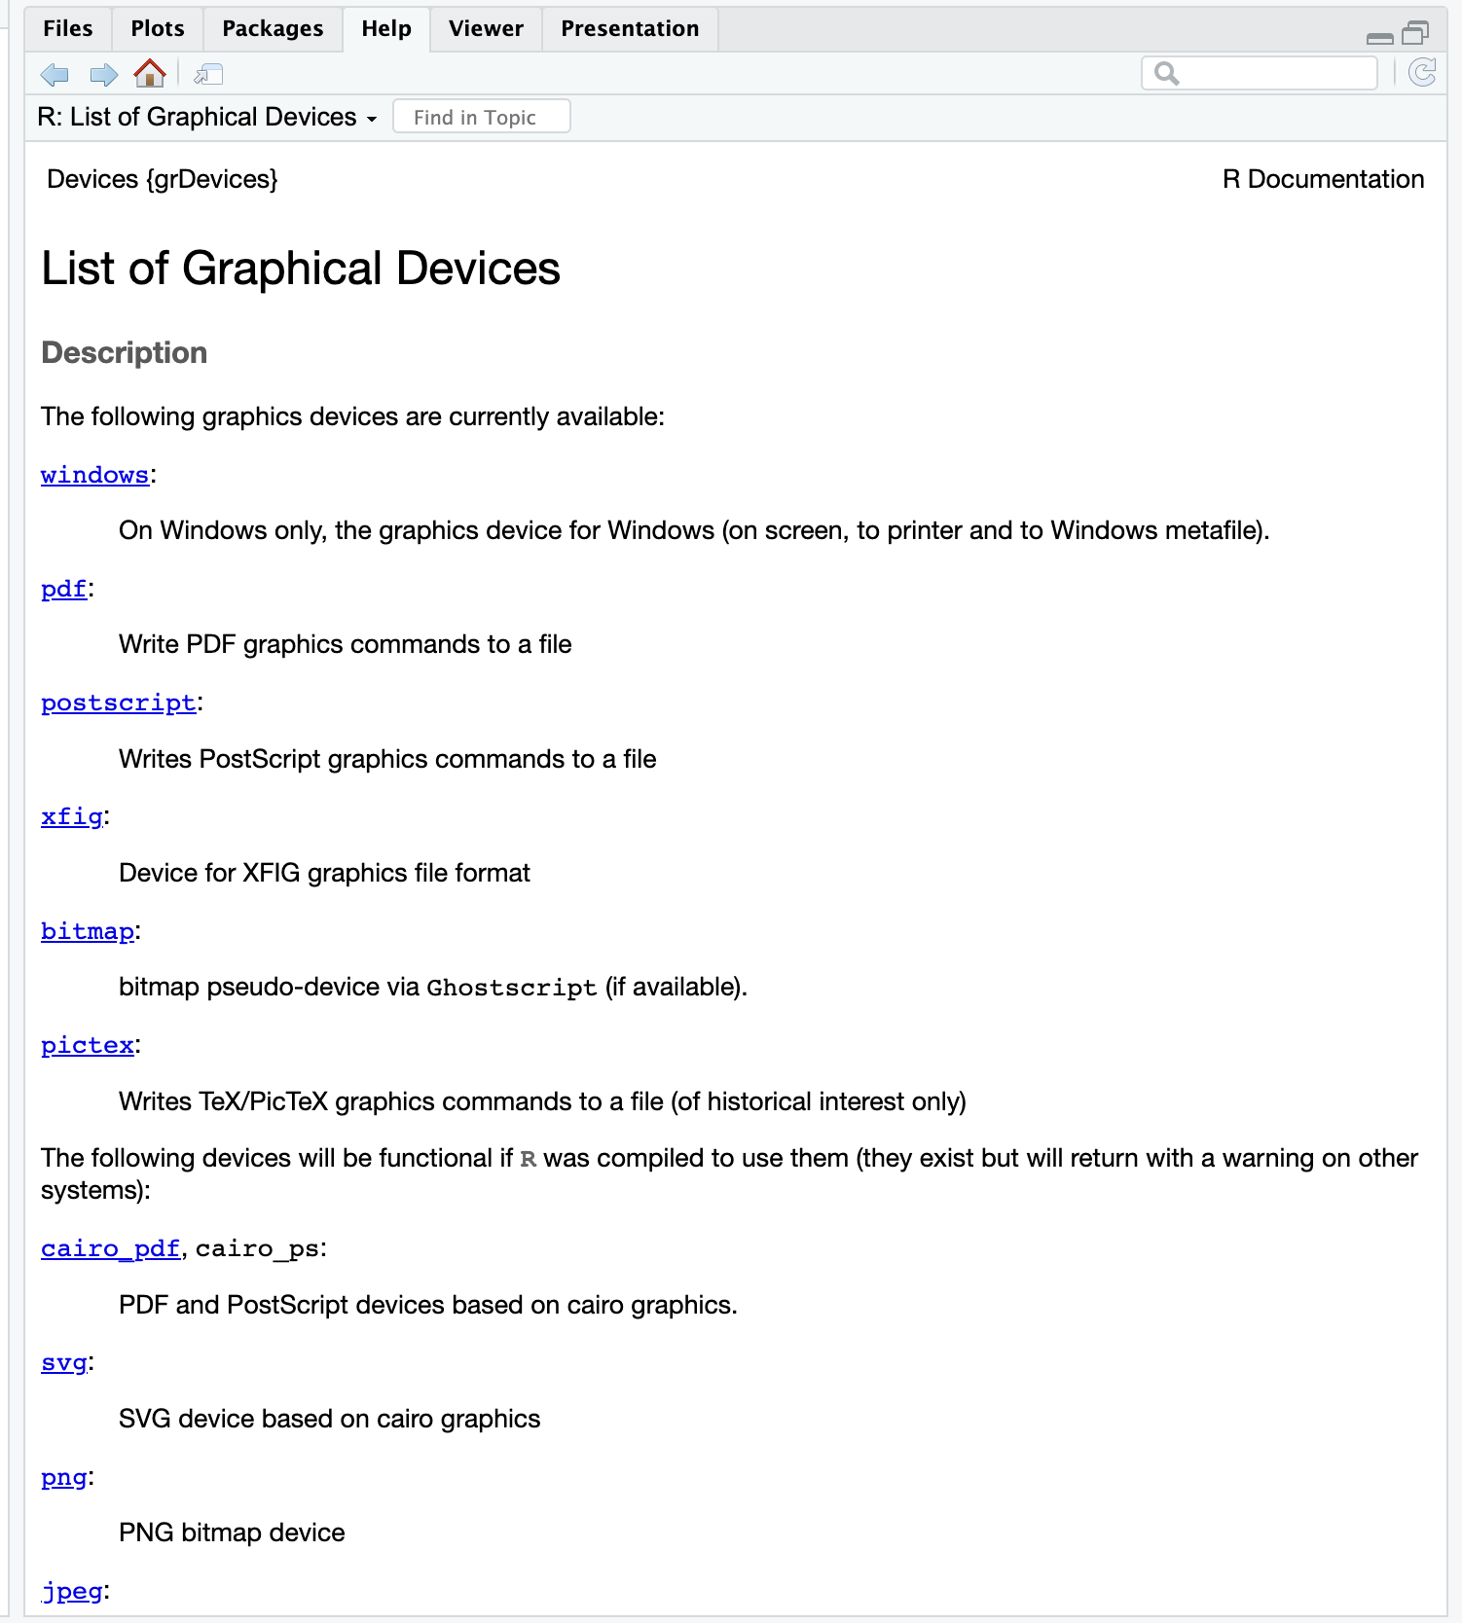

| Perseverance, that's the answer.

|================ | 21%

| R Documentation shows you what's available

|================== | 24%

| There are two basic approaches to plotting. The first, plotting to the screen, is the

| most common. It's simple - you call a plotting function like plot, xyplot, or qplot

| (which you call depends on the plotting system you favor, but that's another lesson),

| so that the plot appears on the screen. Then you annotate (add to) the plot if

| necessary.

...

|===================== | 26%

| As an example, run the R command with with 2 arguments. The first is a dataset,

| faithful, which comes with R, and the second is a call to the base plotting function

| plot. Your call to plot should have two arguments, eruptions and waiting. Try this

| now to see what happens.

>

> with(faithful, plot(eruptions, waiting))

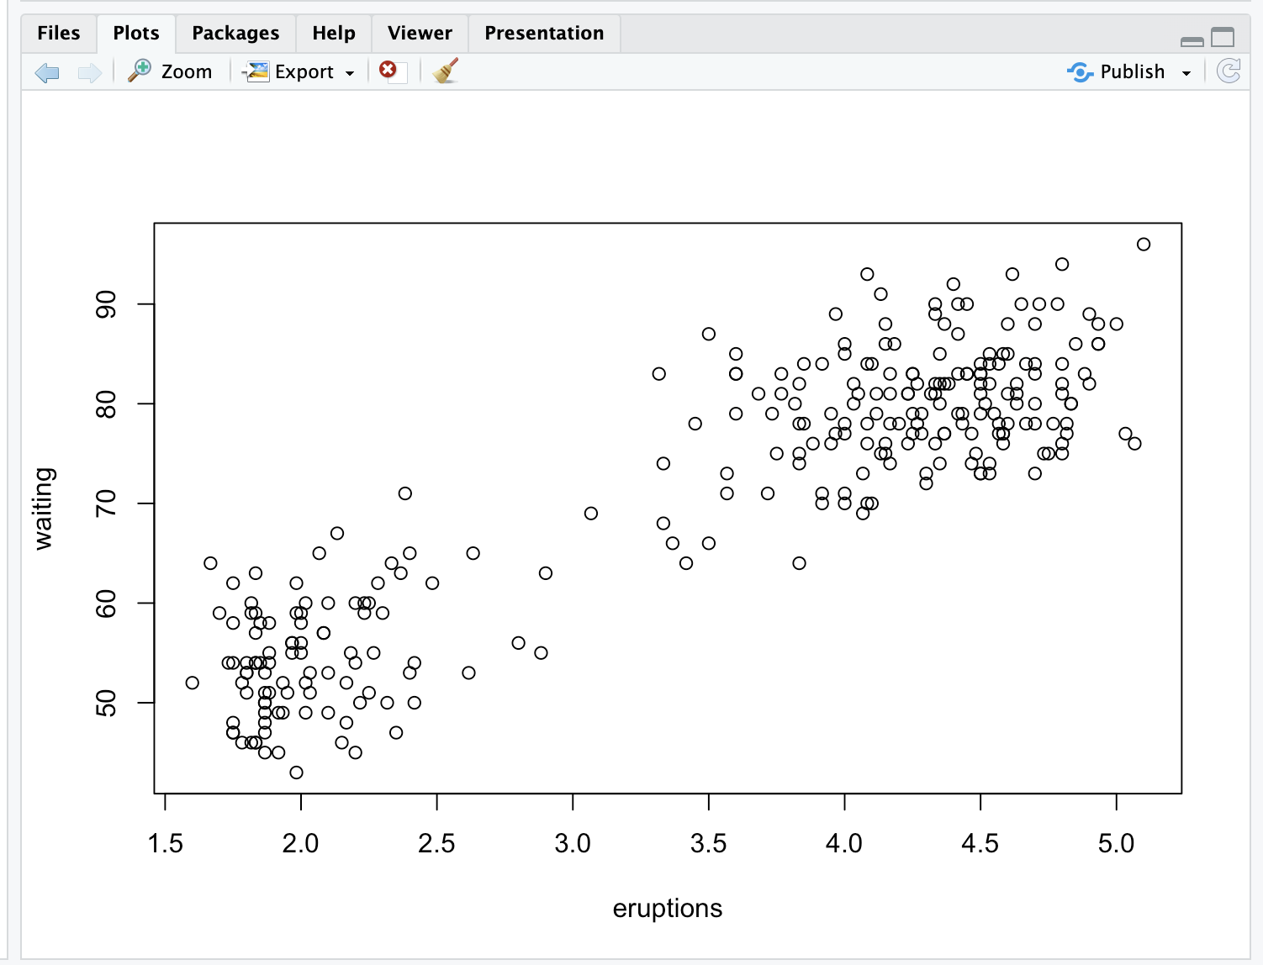

| Great job!

|======================= | 29%

| See how R created a scatterplot on the screen for you? This shows that relationship

| between eruptions of the geyser Old Faithful and waiting time. Now use the R function

| title with the argument main set equal to the string "Old Faithful Geyser data". This

| is an annotation to the plot.

> title(main = "Old Faithful Geyser data")

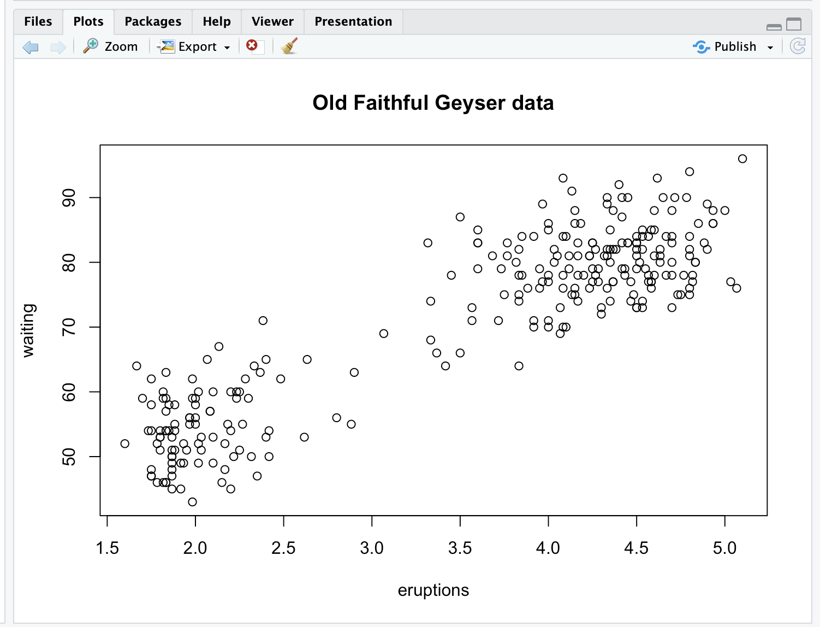

| You got it!

|========================= | 32%

| Simple, right? Now run the command dev.cur(). This will show you the current

| plotting device, the screen.

> dev.cur()

RStudioGD

2

| You are amazing!

|============================ | 35%

| The second way to create a plot is to send it to a file device. Depending on the type

| of plot you're making, you explicitly launch a graphics device, e.g., a pdf file.

| Type the command pdf(file="myplot.pdf") to launch the file device. This will create

| the pdf file myplot.pdf in your working directory.

> pdf(file="myplot.pdf")

| Excellent work!

|============================== | 38%

| You then call the plotting function (if you are using a file device, no plot will

| appear on the screen). Run the with command again to plot the Old Faithful data. Use

| the up arrow key to recover the command and save yourself some typing.

> with(faithful, plot(eruptions, waiting))

| Great job!

|================================ | 41%

| Now rerun the title command and annotate the plot. (Up arrow keys are great!)

> title(main = "Old Faithful Geyser data")

| Great job!

|================================== | 44%

| Finally, when plotting to a file device, you have to close the device with the

| command dev.off(). This is very important! Don't do it yet, though. After closing,

| you'll be able to view the pdf file on your computer.

...

|===================================== | 47%

| There are two basic types of file devices, vector and bitmap devices. These use

| different formats and have different characteristics. Vector formats are good for

| line drawings and plots with solid colors using a modest number of points, while

| bitmap formats are good for plots with a large number of points, natural scenes or

| web-based plots.

...

|======================================= | 50%

| We'll mention 4 specific vector formats. The first is pdf, which we've just used in

| our example. This is useful for line-type graphics and papers. It resizes well, is

| usually portable, but it is not efficient if a plot has many objects/points.

...

|========================================= | 53%

| The second is svg which is XML-based, scalable vector graphics. This supports

| animation and interactivity and is potentially useful for web-based plots.

...

|============================================ | 56%

| The last two vector formats are win.metafile, a Windows-only metafile format, and

| postscript (ps), an older format which also resizes well, is usually portable, and

| can be used to create encapsulated postscript files. Unfortunately, Windows systems

| often don’t have a postscript viewer.

...

|============================================== | 59%

| We'll also mention 4 different bitmap formats. The first is png (Portable Network

| Graphics) which is good for line drawings or images with solid colors. It uses

| lossless compression (like the old GIF format), and most web browsers can read this

| format natively. In addition, png is good for plots with many points, but it does not

| resize well.

...

|================================================ | 62%

| In contrast, jpeg files are good for photographs or natural scenes. They use lossy

| compression, so they're good for plots with many points. Files in jpeg format don't

| resize well, but they can be read by almost any computer and any web browser. They're

| not great for line drawings.

...

|================================================== | 65%

| The last two bitmap formats are tiff, an older lossless compression meta-format and

| bmp which is a native Windows bitmapped format.

...

|===================================================== | 68%

| Although it is possible to open multiple graphics devices (screen, file, or both),

| when viewing multiple plots at once, plotting can only occur on one graphics device

| at a time.

...

|======================================================= | 71%

| The currently active graphics device can be found by calling dev.cur(). Try it now to

| see what number is assigned to your pdf device.

> dev.cur()

pdf

4

| You got it right!

|========================================================= | 74%

| Now use dev.off() to close the device.

> dev.off()

RStudioGD

2

| Your dedication is inspiring!

|============================================================ | 76%

| Now rerun dev.cur() to see what integer your plotting window is assigned.

> dev.cur()

RStudioGD

2

| Perseverance, that's the answer.

|============================================================== | 79%

| The device is back to what it was when you started. As you might have guessed, every

| open graphics device is assigned an integer greater than or equal to 2. You can

| change the active graphics device with dev.set(<integer>) where <integer> is the

| number associated with the graphics device you want to switch to.

...

|================================================================ | 82%

| You can also copy a plot from one device to another. This can save you some time but

| beware! Copying a plot is not an exact operation, so the result may not be identical

| to the original. R provides some functions to help you do this. The function dev.copy

| copies a plot from one device to another, and dev.copy2pdf specifically copies a plot

| to a PDF file.

...

|=================================================================== | 85%

| Just for fun, rerun the with command again, with(faithful, plot(eruptions, waiting)),

| to plot the Old Faithful data. Use the up arrow key to recover the command if you

| don't feel like typing.

>

> with(faithful, plot(eruptions, waiting))

| Your dedication is inspiring!

|===================================================================== | 88%

| Now rerun the title command, title(main = "Old Faithful Geyser data"), to annotate

| the plot. (Up arrow keys are great!)

> title(main = "Old Faithful Geyser data")



| All that practice is paying off!

|======================================================================= | 91%

| Now run dev.copy with the 2 arguments. The first is png, and the second is file set

| equal to "geyserplot.png". This will copy your screen plot to a png file in your

| working directory which you can view AFTER you close the device.

> dev.copy(png, file = "geyserplot.png")

quartz_off_screen

4

| Your dedication is inspiring!

|========================================================================= | 94%

| Don't forget to close the PNG device! Do it NOW!!! Then you'll be able to view the

| file.

> dev.off()

RStudioGD

2

| You nailed it! Good job!

|============================================================================ | 97%

| Congrats! We hope you found this lesson deviced well!

...

|==============================================================================| 100%

| Would you like to receive credit for completing this course on Coursera.org?

1: Yes

2: No

Selection: 2

| All that hard work is paying off!

| You've reached the end of this lesson! Returning to the main menu...

| Please choose a course, or type 0 to exit swirl.

1: Exploratory Data Analysis

2: Take me to the swirl course repository!

Selection: 1

| Please choose a lesson, or type 0 to return to course menu.

1: Principles of Analytic Graphs 2: Exploratory Graphs

3: Graphics Devices in R 4: Plotting Systems

5: Base Plotting System 6: Lattice Plotting System

7: Working with Colors 8: GGPlot2 Part1

9: GGPlot2 Part2 10: GGPlot2 Extras

11: Hierarchical Clustering 12: K Means Clustering

13: Dimension Reduction 14: Clustering Example

15: CaseStudy

Selection: 4

| Attempting to load lesson dependencies...

| Package ‘ggplot2’ loaded correctly!

| Package ‘lattice’ loaded correctly!

| Package ‘jpeg’ loaded correctly!

| | 0%

| Plotting_Systems. (Slides for this and other Data Science courses may be found at

| github https://github.com/DataScienceSpecialization/courses/. If you care to use

| them, they must be downloaded as a zip file and viewed locally. This lesson

| corresponds to 04_ExploratoryAnalysis/PlottingSystems.)

...

|== | 3%

| In this lesson, we'll give you a brief overview of the three plotting systems in R,

| their differences, strengths, and weaknesses. We'll only cover the basics here to

| give you a general idea of the systems and in later lessons we'll cover each system

| in more depth.

...

|==== | 5%

| The first plotting system is the Base Plotting System which comes with R. It's the

| oldest system which uses a simple "Artist's palette" model. What this means is that

| you start with a blank canvas and build your plot up from there, step by step.

...

|====== | 8%

| Usually you start with a plot function (or something similar), then you use

| annotation functions to add to or modify your plot. R provides many annotating

| functions such as text, lines, points, and axis. R provides documentation for each of

| these. They all add to an already existing plot.

...

|======== | 11%

| What do you think is a disadvantage of the Base Plotting System?

1: A complicated plot is a series of simple R commands

2: It's intuitive and exploratory

3: You can't go back once a plot has started

4: It mirrors how we think of building plots and analyzing data

Selection: 3

| Keep up the great work!

|=========== | 14%

| Yes! The base system is very intuitive and easy to use when you're starting to do

| exploratory graphing and looking for a research direction. You can't go backwards,

| though, say, if you need to readjust margins or fix a misspelled a caption. A

| finished plot will be a series of R commands, so it's difficult to translate a

| finished plot into a different system.

...

|============= | 16%

| We've loaded the dataset cars for you to demonstrate how easy it is to plot. First,

| use the R command head with cars as an argument to see what the data looks like.

> head(cars)

speed dist

1 4 2

2 4 10

3 7 4

4 7 22

5 8 16

6 9 10

| All that hard work is paying off!

|=============== | 19%

| So the dataset collates the speeds and distances needed to stop for 50 cars. This

| data was recorded in the 1920's.

...

|================= | 22%

| We'll use the R command with which takes two arguments. The first specifies a dataset

| or environment in which to run the second argument, an R expression. This will save

| us a bit of typing. Try running the command with now using cars as the first argument

| and a call to plot as the second. The call to plot will take two arguments, speed and

| dist. Please specify them in that order.

> with(cars, plot(speed, dist))

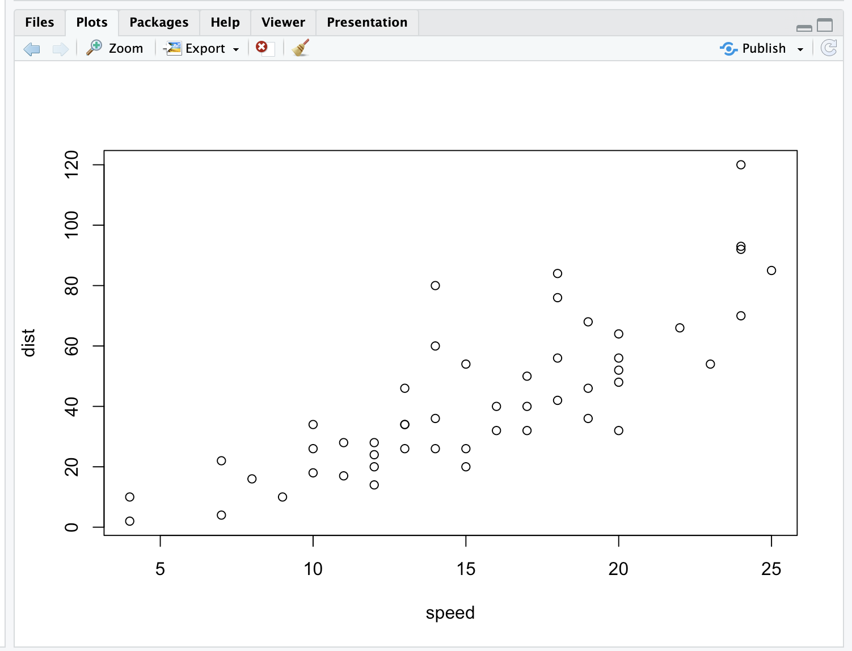

| You got it!

|=================== | 24%

| Simple, right? You can see the relationship between the two variables, speed and

| distance. The first variable is plotted along the x-axis and the second along the

| y-axis.

|===================== | 27%

| Now we'll show you what the function text does. Run the command text with three

| arguments. The first two, x and y coordinates, specify the placement of the third

| argument, the text to be added to the plot. Let the first argument be

| mean(cars$speed), the second max(cars$dist), and the third the string "SWIRL rules!".

| Try it now.

> text(mean(cars$speed), max(cars$dist), "SWIRL rules!")

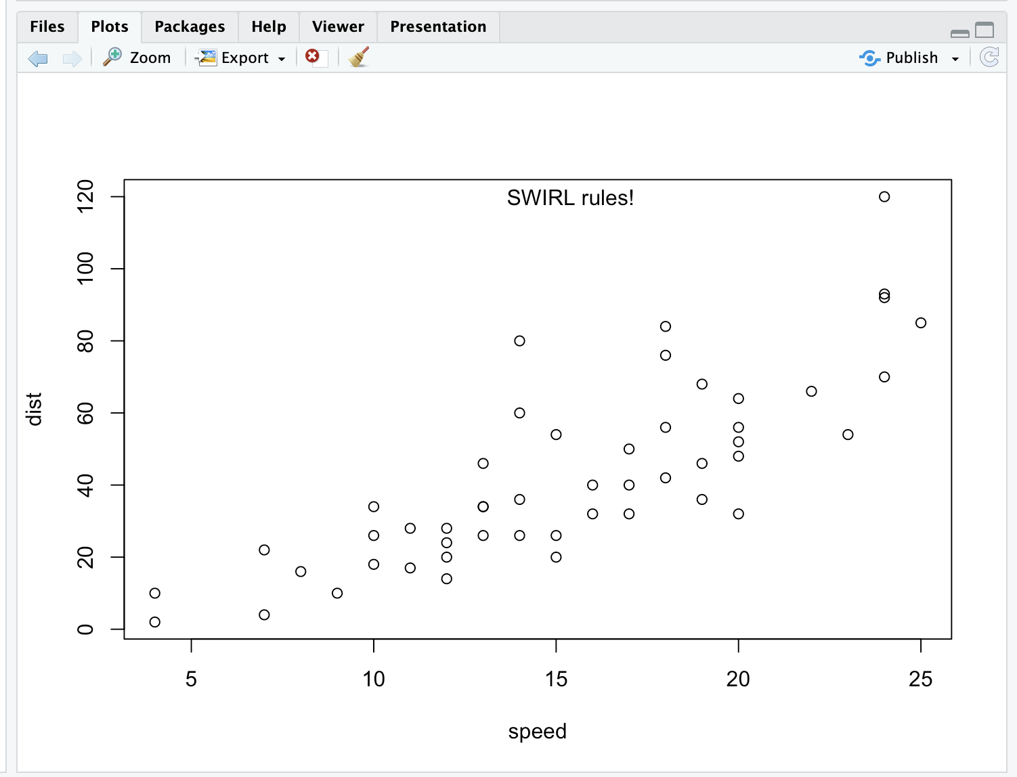

| Excellent job!

|======================= | 30%

| Ain't it the truth?

|========================= | 32%

| Now we'll move on to the second plotting system, the Lattice System which comes in

| the package of the same name. Unlike the Base System, lattice plots are created with

| a single function call such as xyplot or bwplot. Margins and spacing are set

| automatically because the entire plot is specified at once.

...

|=========================== | 35%

| The lattice system is most useful for conditioning types of plots which display how y

| changes with x across levels of z. The variable z might be a categorical variable of

| your data. This system is also good for putting many plots on a screen at once.

...

|============================== | 38%

| The lattice system has several disadvantages. First, it is sometimes awkward to

| specify an entire plot in a single function call. Annotating a plot may not be

| especially intuitive. Second, using panel functions and subscripts is somewhat

| difficult and requires preparation. Finally, you cannot "add" to the plot once it is

| created as you can with the base system.

...

|================================ | 41%

| As before, we've loaded some data for you in the variable state. This data comes with

| the lattice package and it concerns various characteristics of the 50 states in the

| U.S. Use the R command head to see the first few entries of state now.

> head(state)

Population Income Illiteracy Life.Exp Murder HS.Grad Frost Area region

Alabama 3615 3624 2.1 69.05 15.1 41.3 20 50708 South

Alaska 365 6315 1.5 69.31 11.3 66.7 152 566432 West

Arizona 2212 4530 1.8 70.55 7.8 58.1 15 113417 West

Arkansas 2110 3378 1.9 70.66 10.1 39.9 65 51945 South

California 21198 5114 1.1 71.71 10.3 62.6 20 156361 West

Colorado 2541 4884 0.7 72.06 6.8 63.9 166 103766 West

| You're the best!

|================================== | 43%

| As you can see state holds 9 pieces of information for each of the 50 states. The

| last variable, region, specifies a category for each state. Run the R command table

| with the argument state$region to see how many categories there are and how many

| states are in each.

> table(state$region)

Northeast South North Central West

9 16 12 13

| Excellent work!

|==================================== | 46%

| So there are 4 categories and the 50 states are sorted into them appropriately. Let's

| use the lattice command xyplot to see how life expectancy varies with income in each

| of the four regions.

...

|====================================== | 49%

| To do this we'll give xyplot 3 arguments. The first is the most complicated. It is

| this R formula, Life.Exp ~ Income | region, which indicates we're plotting life

| expectancy as it depends on income for each region. The second argument, data, is set

| equal to state. This allows us to use "Life.Exp" and "Income" in the formula instead

| of specifying the dataset state for each term (as in state$Income). The third

| argument, layout, is set equal to the two-long vector c(4,1). Run xyplot now with

| these three arguments.

> xyplot(Life.Exp ~ Income | region, data = state, layout = c(4, 1))

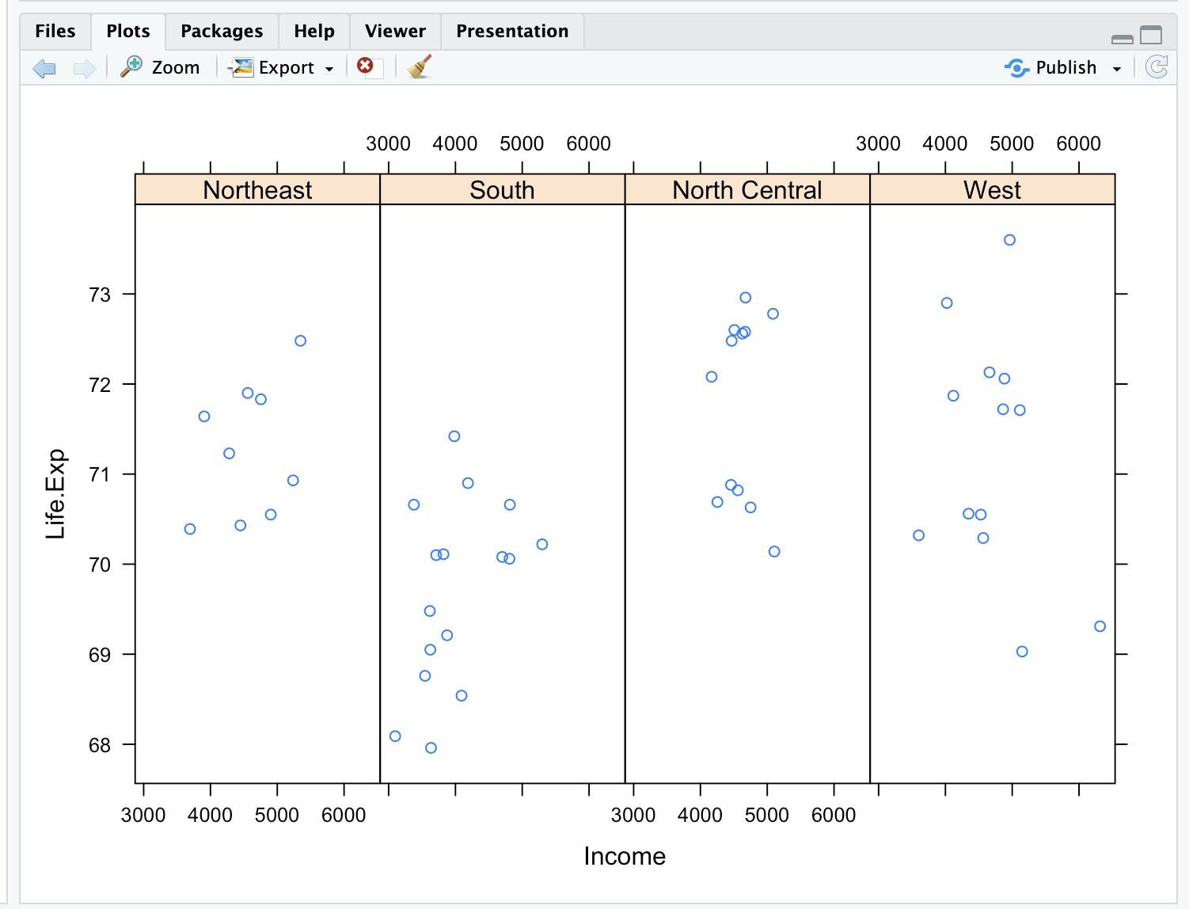

| Perseverance, that's the answer.

|======================================== | 51%

| We see the data for each of the 4 regions plotted in one row. Based on this plot,

| which region of the U.S. seems to have the shortest life expectancy?

1: West

2: Northeast

3: South

4: North Central

Selection: 3

| Your dedication is inspiring!

|========================================== | 54%

| Just for fun rerun the xyplot and this time set layout to the vector c(2,2). To save

| typing use the up arrow to recover the previous xyplot command.

> xyplot(Life.Exp ~ Income | region, data = state, layout = c(2, 2))

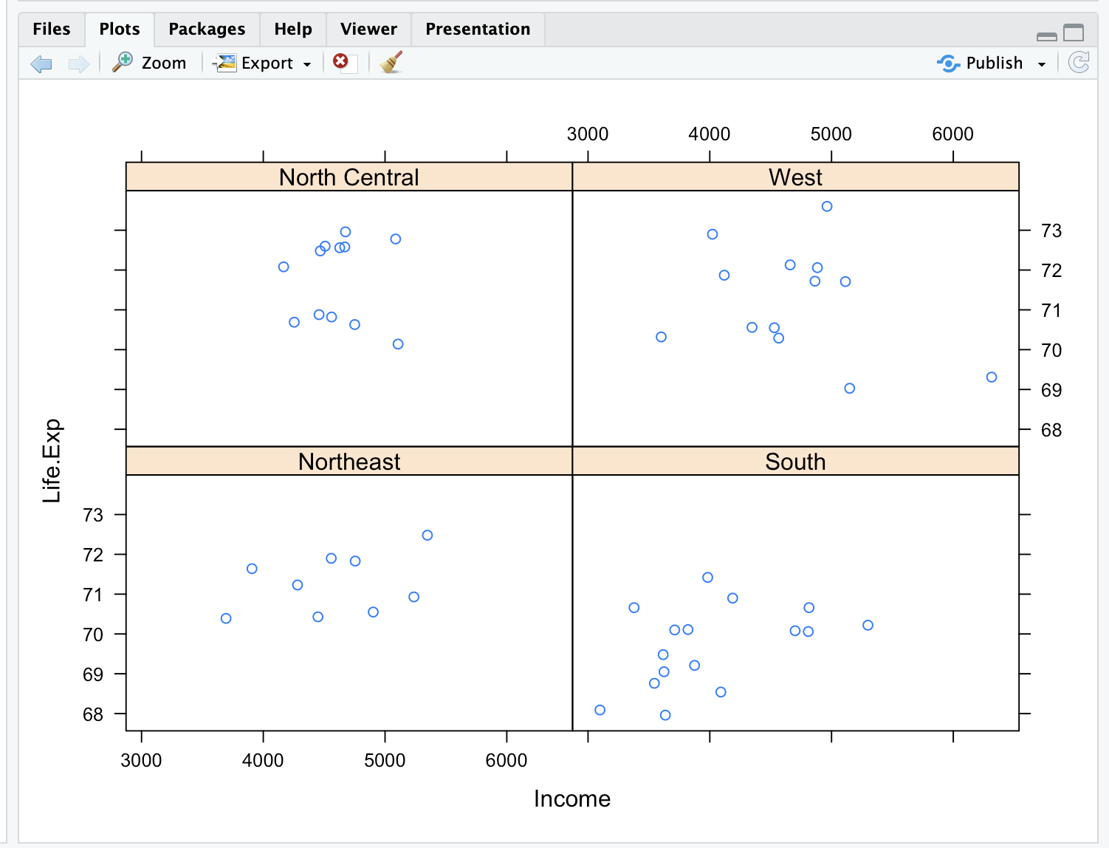

| Perseverance, that's the answer.

|============================================ | 57%

| See how the plot changed? No need for you to worry about margins or labels. The

| package took care of all that for you.

...

|============================================== | 59%

| Now for the last plotting system, ggplot2, which is a hybrid of the base and lattice

| systems. It automatically deals with spacing, text, titles (as Lattice does) but also

| allows you to annotate by "adding" to a plot (as Base does), so it's the best of both

| worlds.

...

|================================================ | 62%

| Although ggplot2 bears a superficial similarity to lattice, it's generally easier and

| more intuitive to use. Its default mode makes many choices for you but you can still

| customize a lot. The package is based on a "grammar of graphics" (hence the gg in the

| name), so you can control the aesthetics of your plots. For instance, you can plot

| conditioning graphs and panel plots as we did in the lattice example.

...

|=================================================== | 65%

| We'll see an example now of ggplot2 with a simple (single) command. As before, we've

| loaded a dataset for you from the ggplot2 package. This mpg data holds fuel economy

| data between 1999 and 2008 for 38 different models of cars. Run head with mpg as an

| argument so you get an idea of what the data looks like.

> head(mpg)

# A tibble: 6 × 11

manufacturer model displ year cyl trans drv cty hwy fl class

<chr> <chr> <dbl> <int> <int> <chr> <chr> <int> <int> <chr> <chr>

1 audi a4 1.8 1999 4 auto(l5) f 18 29 p compact

2 audi a4 1.8 1999 4 manual(m5) f 21 29 p compact

3 audi a4 2 2008 4 manual(m6) f 20 31 p compact

4 audi a4 2 2008 4 auto(av) f 21 30 p compact

5 audi a4 2.8 1999 6 auto(l5) f 16 26 p compact

6 audi a4 2.8 1999 6 manual(m5) f 18 26 p compact

| That's a job well done!

|===================================================== | 68%

| Looks complicated. Run dim with the argument mpg to see how big the dataset is.

> dim(mpg)

[1] 234 11

| That's correct!

|======================================================= | 70%

| Holy cow! That's a lot of information for just 38 models of cars. Run the R command

| table with the argument mpg$model. This will tell us how many models of cars we're

| dealing with.

> table(mpg$model)

4runner 4wd a4 a4 quattro

6 7 8

a6 quattro altima c1500 suburban 2wd

3 6 5

camry camry solara caravan 2wd

7 7 11

civic corolla corvette

9 5 5

dakota pickup 4wd durango 4wd expedition 2wd

9 7 3

explorer 4wd f150 pickup 4wd forester awd

6 7 6

grand cherokee 4wd grand prix gti

8 5 5

impreza awd jetta k1500 tahoe 4wd

8 9 4

land cruiser wagon 4wd malibu maxima

2 5 3

mountaineer 4wd mustang navigator 2wd

4 9 3

new beetle passat pathfinder 4wd

6 7 4

ram 1500 pickup 4wd range rover sonata

10 4 7

tiburon toyota tacoma 4wd

7 7

| That's correct!

|========================================================= | 73%

| Oh, there are 38 models. We're interested in the effect engine displacement (displ)

| has on highway gas mileage (hwy), so we'll use the ggplot2 command qplot to display

| this relationship. Run qplot now with three arguments. The first two are the

| variables displ and hwy we want to plot, and the third is the argument data set equal

| to mpg. As before, this allows us to avoid using the mpg$variable notation for the

| first two arguments.

> qplot(displ, hwy, data = mpg)

Warning message:

`qplot()` was deprecated in ggplot2 3.4.0.

This warning is displayed once every 8 hours.

Call `lifecycle::last_lifecycle_warnings()` to see where this warning was generated.

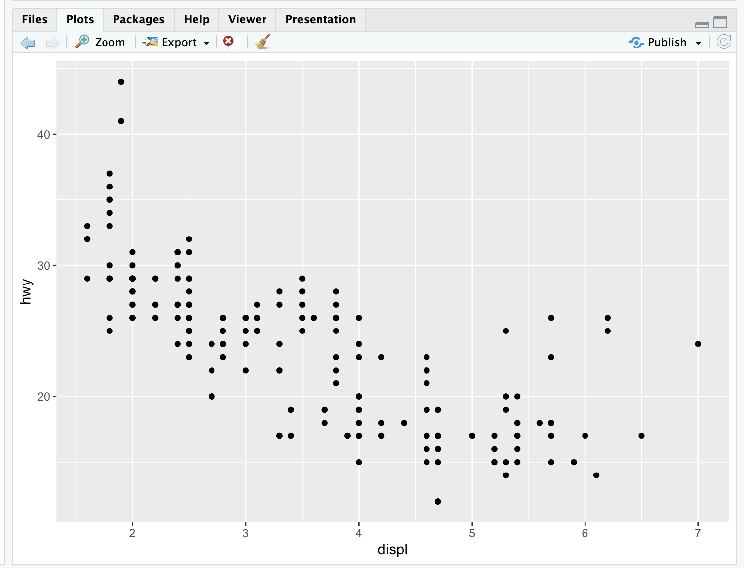

| That's correct!

|=========================================================== | 76%

| Not surprisingly we see that the bigger the engine displacement the lower the gas

| mileage.

...

|============================================================= | 78%

| Let's review!

...

|=============================================================== | 81%

| Which R plotting system is based on an artist's palette?

1: base

2: Winsor&Newton

3: lattice

4: ggplot2

Selection: 1

| You are doing so well!

|================================================================= | 84%

| Which R plotting system does NOT allow you to annotate plots with separate calls?

1: base

2: Winsor&Newton

3: lattice

4: ggplot2

Selection: 3

| Perseverance, that's the answer.

|=================================================================== | 86%

| Which R plotting system combines the best features of the other two?

1: lattice

2: Winsor&Newton

3: base

4: ggplot2

Selection: 4

| Keep working like that and you'll get there!

|====================================================================== | 89%

| Which R plotting system uses a graphics grammar?

1: lattice

2: Winsor&Newton

3: ggplot2

4: base

Selection: 3

| You got it!

|======================================================================== | 92%

| Which R plotting system forces you to make your entire plot with one call?

1: lattice

2: base

3: Winsor&Newton

4: ggplot2

Selection: 1

| Keep up the great work!

|========================================================================== | 95%

| Which of the following sells high quality artists' brushes?

1: lattice

2: Winsor&Newton

3: ggplot2

4: base

Selection: 2

| Keep working like that and you'll get there!

|============================================================================ | 97%

| Congrats! You've concluded this plotting lesson. We hope you didn't find it plodding.

...

|==============================================================================| 100%

| Would you like to receive credit for completing this course on Coursera.org?

1: No

2: Yes

Selection: 1

| Great job!

| You've reached the end of this lesson! Returning to the main menu...

| Please choose a course, or type 0 to exit swirl.

1: Exploratory Data Analysis

2: Take me to the swirl course repository!

Selection: 1

| Please choose a lesson, or type 0 to return to course menu.

1: Principles of Analytic Graphs 2: Exploratory Graphs

3: Graphics Devices in R 4: Plotting Systems

5: Base Plotting System 6: Lattice Plotting System

7: Working with Colors 8: GGPlot2 Part1

9: GGPlot2 Part2 10: GGPlot2 Extras

11: Hierarchical Clustering 12: K Means Clustering

13: Dimension Reduction 14: Clustering Example

15: CaseStudy

Selection: 5

| | 0%

| Base_Plotting_System. (Slides for this and other Data Science courses may be found at

| github https://github.com/DataScienceSpecialization/courses/. If you care to use

| them, they must be downloaded as a zip file and viewed locally. This lesson

| corresponds to 04_ExploratoryAnalysis/PlottingBase.)

...

|= | 2%

| In another lesson, we gave you an overview of the three plotting systems in R. In

| this lesson we'll focus on the base plotting system and talk more about how you can

| exploit all its many parameters to get the plot you want. We'll focus on using the

| base plotting system to create graphics on the screen device rather than another

| graphics device.

...

|== | 3%

| The core plotting and graphics engine in R is encapsulated in two packages. The first

| is the graphics package which contains plotting functions for the "base" system. The

| functions in this package include plot, hist, boxplot, barplot, etc. The second

| package is grDevices which contains all the code implementing the various graphics

| devices, including X11, PDF, PostScript, PNG, etc.

...

|==== | 5%

| Base graphics are often constructed piecemeal, with each aspect of the plot handled

| separately through a particular function call. Usually you start with a plot function

| (such as plot, hist, or boxplot), then you use annotation functions (text, abline,

| points) to add to or modify your plot.

...

|===== | 6%

| Before making a plot you have to determine where the plot will appear and what it

| will be used for. Is there a large amount of data going into the plot? Or is it just

| a few points? Do you need to be able to dynamically resize the graphic?

...

|====== | 8%

| What do you think is a disadvantage of the Base Plotting System?

1: You can't go back once a plot has started

2: It's intuitive and exploratory

3: A complicated plot is a series of simple R commands

4: It mirrors how we think of building plots and analyzing data

Selection: 1

| You nailed it! Good job!

|======= | 9%

| Yes! The base system is very intuitive and easy to use. You can't go backwards,

| though, say, if you need to readjust margins or have misspelled a caption. A finished

| plot will be a series of R commands, so it's difficult to translate a finished plot

| into a different system.

...

|======== | 11%

| Calling a basic routine such as plot(x, y) or hist(x) launches a graphics device (if

| one is not already open) and draws a new plot on the device. If the arguments to plot

| or hist are not of some special class, then the default method is called.

...

|========= | 12%

| As you'll see, most of the base plotting functions have many arguments, for example,

| setting the title, labels of axes, plot character, etc. Some of the parameters can be

| set when you call the function or they can be added later in a separate function

| call.

...

|=========== | 14%

| Now we'll go through some quick examples of basic plotting before we delve into gory

| details. We'll use the dataset airquality (part of the library datasets) which we've

| loaded for you. This shows ozone and other air measurements for New York City for 5

| months in 1973.

...

|============ | 15%

| Use the R command head with airquality as an argument to see what the data looks

| like.

> head(airquality)

Ozone Solar.R Wind Temp Month Day

1 41 190 7.4 67 5 1

2 36 118 8.0 72 5 2

3 12 149 12.6 74 5 3

4 18 313 11.5 62 5 4

5 NA NA 14.3 56 5 5

6 28 NA 14.9 66 5 6

| Keep up the great work!

|============= | 17%

| We see the dataset contains 6 columns of data. Run the command range with two

| arguments. The first is the ozone column of airquality, specified by

| airquality$Ozone, and the second is the boolean na.rm set equal to TRUE. If you don't

| specify this second argument, you won't get a meaningful result.

> range(airquality$Ozone, na.rm = TRUE)

[1] 1 168

| All that practice is paying off!

|============== | 18%

| So the measurements range from 1 to 168. First we'll do a simple histogram of this

| ozone column to show the distribution of measurements. Use the R command hist with

| the argument airquality$Ozone.

> hist(airquality$Ozone)

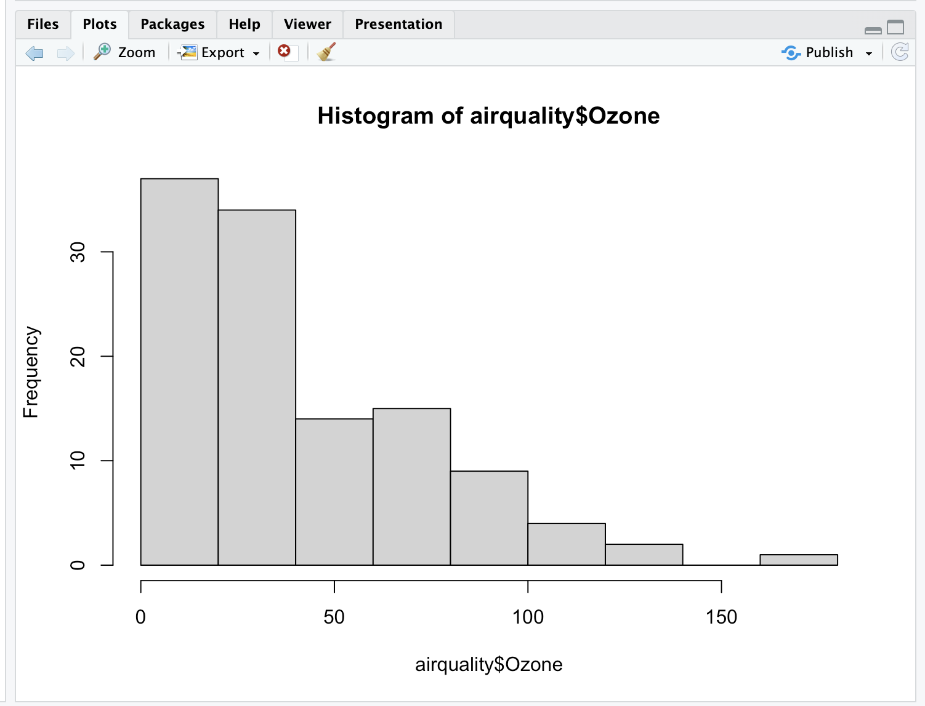

| Nice work!

|=============== | 20%

| Simple, right? R put a title on the histogram and labeled both axes for you. What is

| the most frequent count?

1: Over 100

2: Over 150

3: Between 60 and 75

4: Under 25

Selection: 4

| You're the best!

|================= | 21%

| Next we'll do a boxplot. First, though, run the R command table with the argument

| airquality$Month.

> table(airquality$Month)

5 6 7 8 9

31 30 31 31 30

| Great job!

|================== | 23%

| We see that the data covers 5 months, May through September. We'll want a boxplot of

| ozone as a function of the month in which the measurements were taken so we'll use

| the R formula Ozone~Month as the first argument of boxplot. Our second argument will

| be airquality, the dataset from which the variables of the first argument are taken.

| Try this now.

> boxplot(Ozone~Month, airquality)

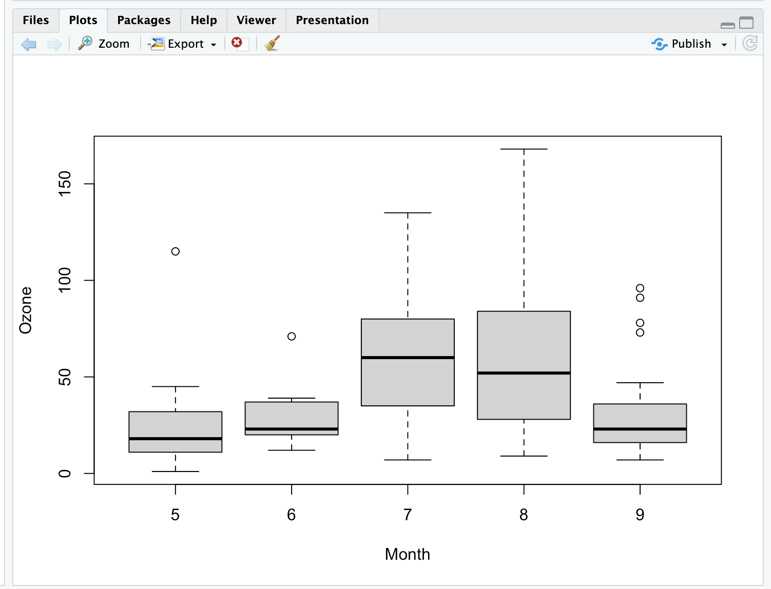

| Excellent work!

|=================== | 24%

| Note that boxplot, unlike hist, did NOT specify a title and axis labels for you

| automatically.

|==================== | 26%

Let's call boxplot again to specify labels. (Use the up arrow to recover the previous

| command and save yourself some typing.) We'll add more arguments to the call to

| specify labels for the 2 axes. Set xlab equal to "Month" and ylab equal to "Ozone

| (ppb)". Specify col.axis equal to "blue" and col.lab equal to "red". Try this now.

> boxplot(Ozone~Month, airquality, xlab = "Month", ylab = "Ozone (ppb)", col.axis = "blue", col.lab = "red")

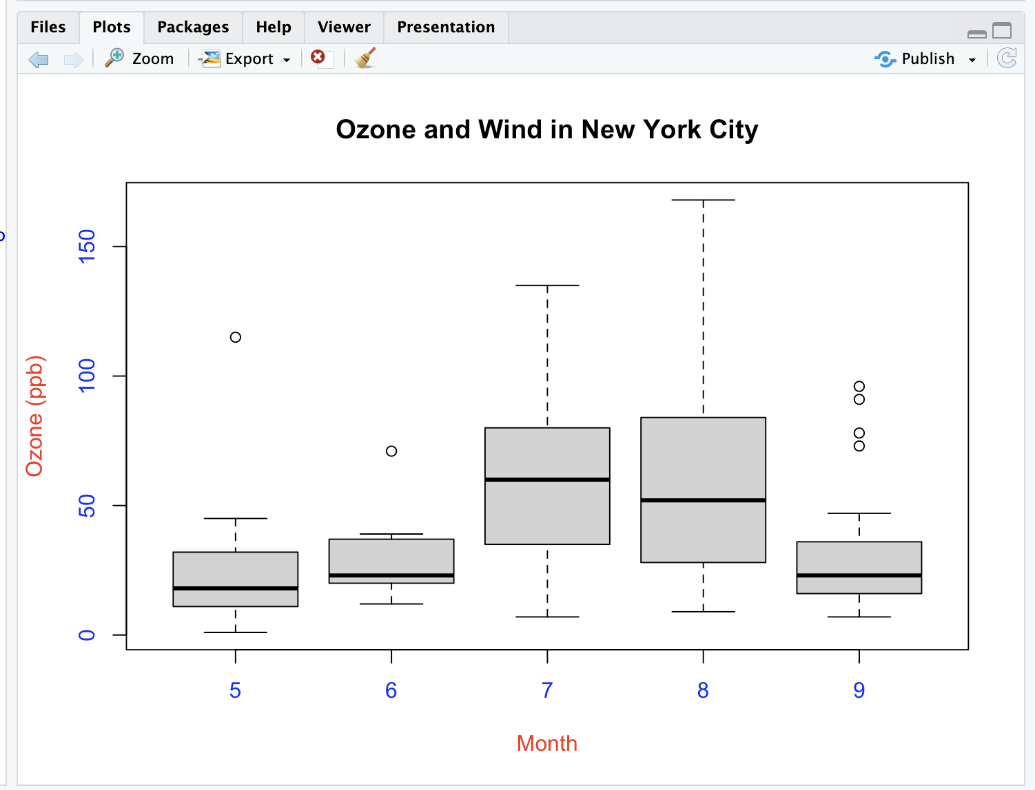

| Perseverance, that's the answer.

|===================== | 27%

| Nice colors, but still no title. Let's add one with the R command title. Use the

| argument main set equal to the string "Ozone and Wind in New York City".

> title(main = "Ozone and Wind in New York City")



| You are doing so well!

|====================== | 29%

| Now we'll show you how to plot a simple two-dimensional scatterplot using the R

| function plot. We'll show the relationship between Wind (x-axis) and Ozone (y-axis).

| We'll use the function plot with those two arguments (Wind and Ozone, in that order).

| To save some typing, though, we'll call the R command with using 2 arguments. The

| first argument of with will be airquality, the dataset containing Wind and Ozone; the

| second argument will be the call to plot. Doing this allows us to avoid using the

| longer notation, e.g., airquality$Wind. Try this now.

> with(airquality, plot(Wind, Ozone))

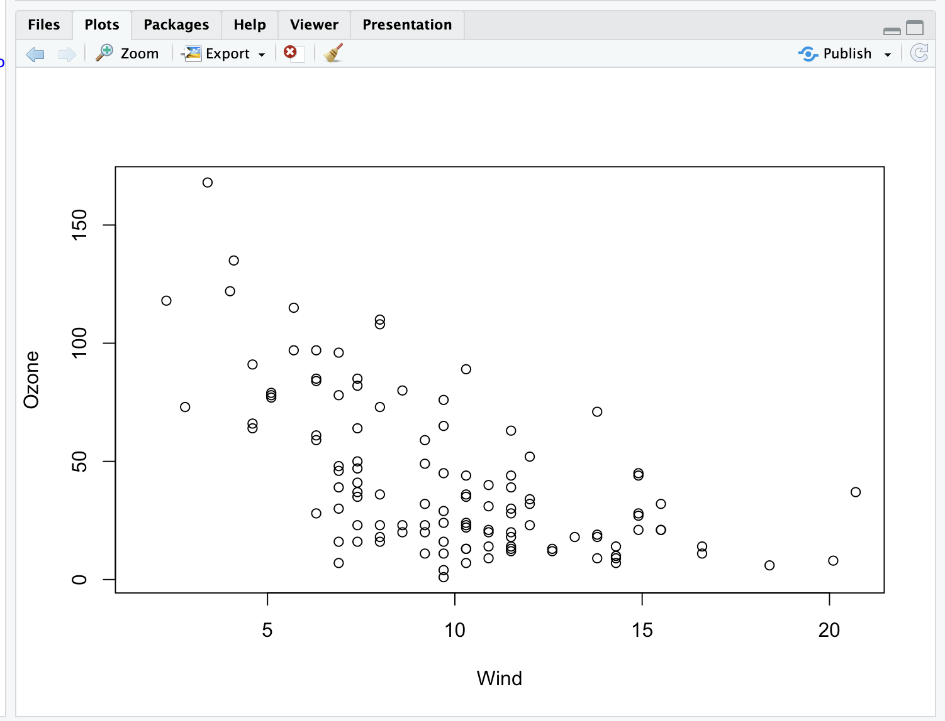

| Excellent work!

|======================== | 30%

| Note that plot generated labels for the x and y axes but no title.

|========================= | 32%

| Add one now with the R command title. Use the argument main set equal to the string

| "Ozone and Wind in New York City". (You can use the up arrow to recover the command

| if you don't want to type it.)

> title(main = "Ozone and Wind in New York City")

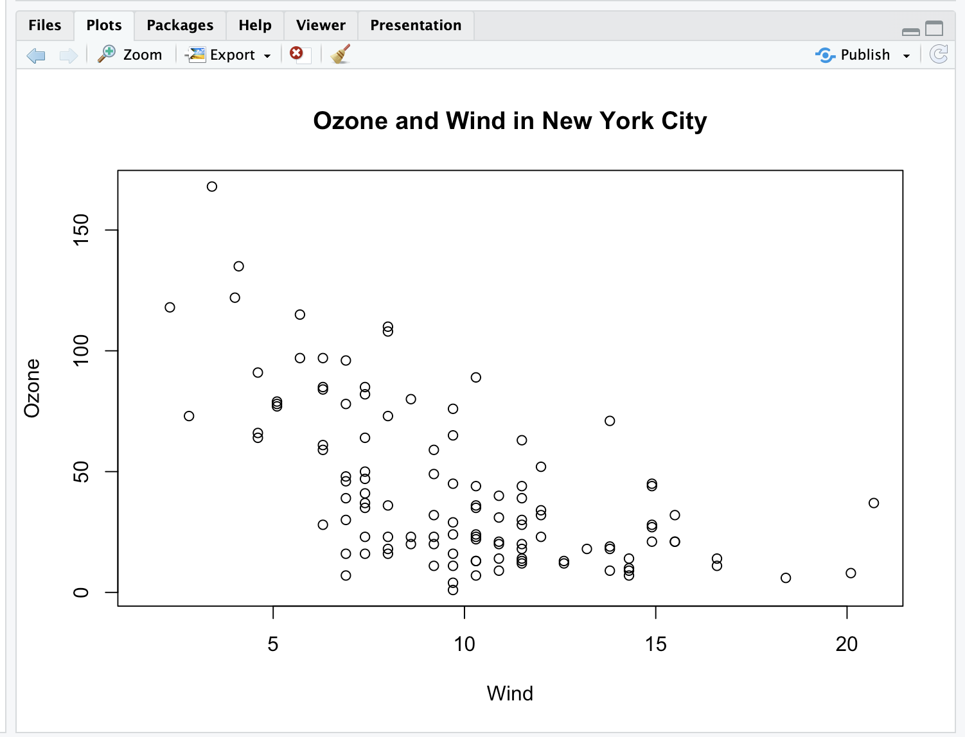

| That's correct!

|========================== | 33%

| The basic plotting parameters are documented in the R help page for the function par.

| You can use par to set parameters OR to find out what values are already set. To see

| just how much flexibility you have, run the R command length with the argument par()

| now.

> lenth(par())

Error in lenth(par()) : could not find function "lenth"

> length(par())

[1] 72

| All that practice is paying off!

|=========================== | 35%

| So there are a boatload (72) of parameters that par() gives you access to. Run the R

| function names with par() as its argument to see what these parameters are.

> names(par())

[1] "xlog" "ylog" "adj" "ann" "ask" "bg" "bty"

[8] "cex" "cex.axis" "cex.lab" "cex.main" "cex.sub" "cin" "col"

[15] "col.axis" "col.lab" "col.main" "col.sub" "cra" "crt" "csi"

[22] "cxy" "din" "err" "family" "fg" "fig" "fin"

[29] "font" "font.axis" "font.lab" "font.main" "font.sub" "lab" "las"

[36] "lend" "lheight" "ljoin" "lmitre" "lty" "lwd" "mai"

[43] "mar" "mex" "mfcol" "mfg" "mfrow" "mgp" "mkh"

[50] "new" "oma" "omd" "omi" "page" "pch" "pin"

[57] "plt" "ps" "pty" "smo" "srt" "tck" "tcl"

[64] "usr" "xaxp" "xaxs" "xaxt" "xpd" "yaxp" "yaxs"

[71] "yaxt" "ylbias"

| Great job!

|============================ | 36%

| Variety is the spice of life. You might recognize some of these such as col and lwd

| from previous swirl lessons. You can always run ?par to see what they do. For now,

| run the command par()$pin and see what you get.

> par()$pin

[1] 6.364167 3.535000

| You are really on a roll!

|============================== | 38%

| Alternatively, you could have gotten the same result by running par("pin") or

| par('pin')). What do you think these two numbers represent?

1: Plot dimensions in inches

2: Coordinates of the center of the plot window

3: Random numbers

4: A confidence interval

Selection: 1

| That's the answer I was looking for.

|=============================== | 39%

| Now, run the command par("fg") or or par('fg') or par()$fg and see what you get.

> par("fg")

[1] "black"

| All that practice is paying off!

|================================ | 41%

| It gave you a color, right? Since par()$fg specifies foreground color, what do you

| think par()$bg specifies?

1: Beautiful color

2: Better color

3: blue-green

4: Background color

Selection: 4

| That's the answer I was looking for.

|================================= | 42%

| Many base plotting functions share a set of parameters. We'll go through some of the

| more commonly used ones now. See if you can tell what they do from their names.

...

|================================== | 44%

| What do you think the graphical parameter pch controls?

1: picture characteristics

2: point control height

3: pc help

4: plot character

Selection: 1

| Not quite, but you're learning! Try again.

| The p stands for plot.

1: point control height

2: picture characteristics

3: pc help

4: plot character

Selection: 4

| That's the answer I was looking for.

|=================================== | 45%

| The plot character default is the open circle, but it "can either be a single

| character or an integer code for one of a set of graphics symbols." Run the command

| par("pch") to see the integer value of the default. When you need to, you can use R's

| Documentation (?pch) to find what the other values mean.

> par("pch")

[1] 1

| You got it right!

|===================================== | 47%

| So 1 is the code for the open circle. What do you think the graphical parameters lty

| and lwd control respectively?

1: line slope and intercept

2: line type and width

3: line length and width

4: line width and type

Selection: 2

| Keep working like that and you'll get there!

|====================================== | 48%

| Run the command par("lty") to see the default line type.

> par(lty)

Error in par(lty) : object 'lty' not found

> par("lty")

[1] "solid"

| All that practice is paying off!

|======================================= | 50%

| So the default line type is solid, but it can be dashed, dotted, etc. Once again, R's

| ?par documentation will tell you what other line types are available. The line width

| is a positive integer; the default value is 1.

...

|======================================== | 52%

| We've seen a lot of examples of col, the plotting color, specified as a number,

| string, or hex code; the colors() function gives you a vector of colors by name.

...

|========================================= | 53%

| What do you think the graphical parameters xlab and ylab control respectively?

1: labels for the y- and x- axes

2: labels for the x- and y- axes

Selection: 2

| You nailed it! Good job!

|=========================================== | 55%

| The par() function is used to specify global graphics parameters that affect all

| plots in an R session. (Use dev.off or plot.new to reset to the defaults.) These

| parameters can be overridden when specified as arguments to specific plotting

| functions. These include las (the orientation of the axis labels on the plot), bg

| (background color), mar (margin size), oma (outer margin size), mfrow and mfcol

| (number of plots per row, column).

...

|============================================ | 56%

| The last two, mfrow and mfcol, both deal with multiple plots in that they specify the

| number of plots per row and column. The difference between them is the order in which

| they fill the plot matrix. The call mfrow will fill the rows first while mfcol fills

| the columns first.

...

|============================================= | 58%

| So to reiterate, first call a basic plotting routine. For instance, plot makes a

| scatterplot or other type of plot depending on the class of the object being plotted.

...

|============================================== | 59%

| As we've seen, R provides several annotating functions. Which of the following is NOT

| one of them?

1: text

2: title

3: points

4: lines

5: hist

Selection: 5

| Keep up the great work!

|=============================================== | 61%

| So you can add text, title, points, and lines to an existing plot. To add lines, you

| give a vector of x values and a corresponding vector of y values (or a 2-column

| matrix); the function lines just connects the dots. The function text adds text

| labels to a plot using specified x, y coordinates.

...

|================================================ | 62%

| The function title adds annotations. These include x- and y- axis labels, title,

| subtitle, and outer margin. Two other annotating functions are mtext which adds

| arbitrary text to either the outer or inner margins of the plot and axis which adds

| axis ticks and labels. Another useful function is legend which explains to the reader

| what the symbols your plot uses mean.

...

|================================================== | 64%

| Before we close, let's test your ability to make a somewhat complicated scatterplot.

| First run plot with 3 arguments. airquality$Wind, airquality$Ozone, and type set

| equal to "n". This tells R to set up the plot but not to put the data in it.

> plot(airquality$Wind, airquality$Ozone, type = "n")

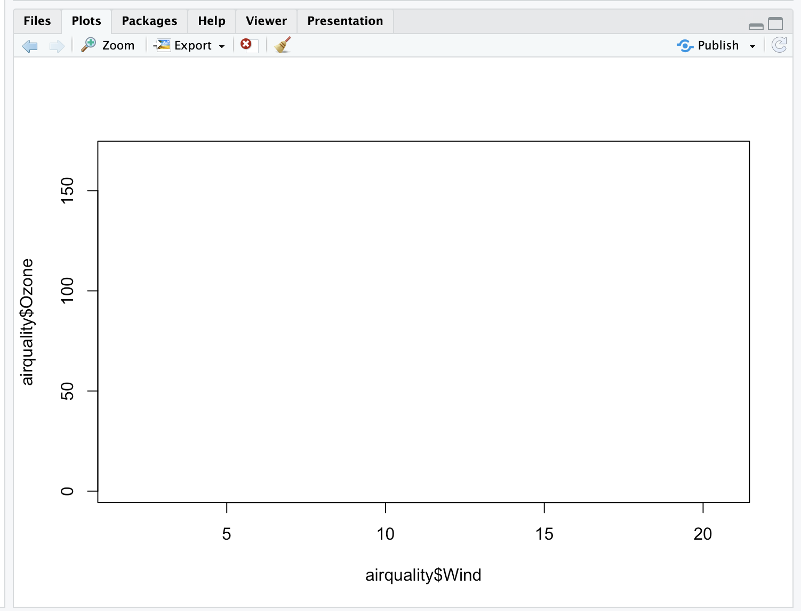

| You're the best!

|=================================================== | 65%

| Now for the test. (You might need to check R's documentation for some of these.) Add

| a title with the argument main set equal to the string "Wind and Ozone in NYC"

> title(main = "Wind and Ozone in NYC")

| That's correct!

|==================================================== | 67%

| Now create a variable called may by subsetting airquality appropriately. (Recall that

| the data specifies months by number and May is the fifth month of the year.)

> may <- subset(airquality, Month == 5)

| That's the answer I was looking for.

|===================================================== | 68%

| Now use the R command points to plot May's wind and ozone (in that order) as solid

| blue triangles. You have to set the color and plot character with two separate

| arguments. Note we use points because we're adding to an existing plot.

> ?pch

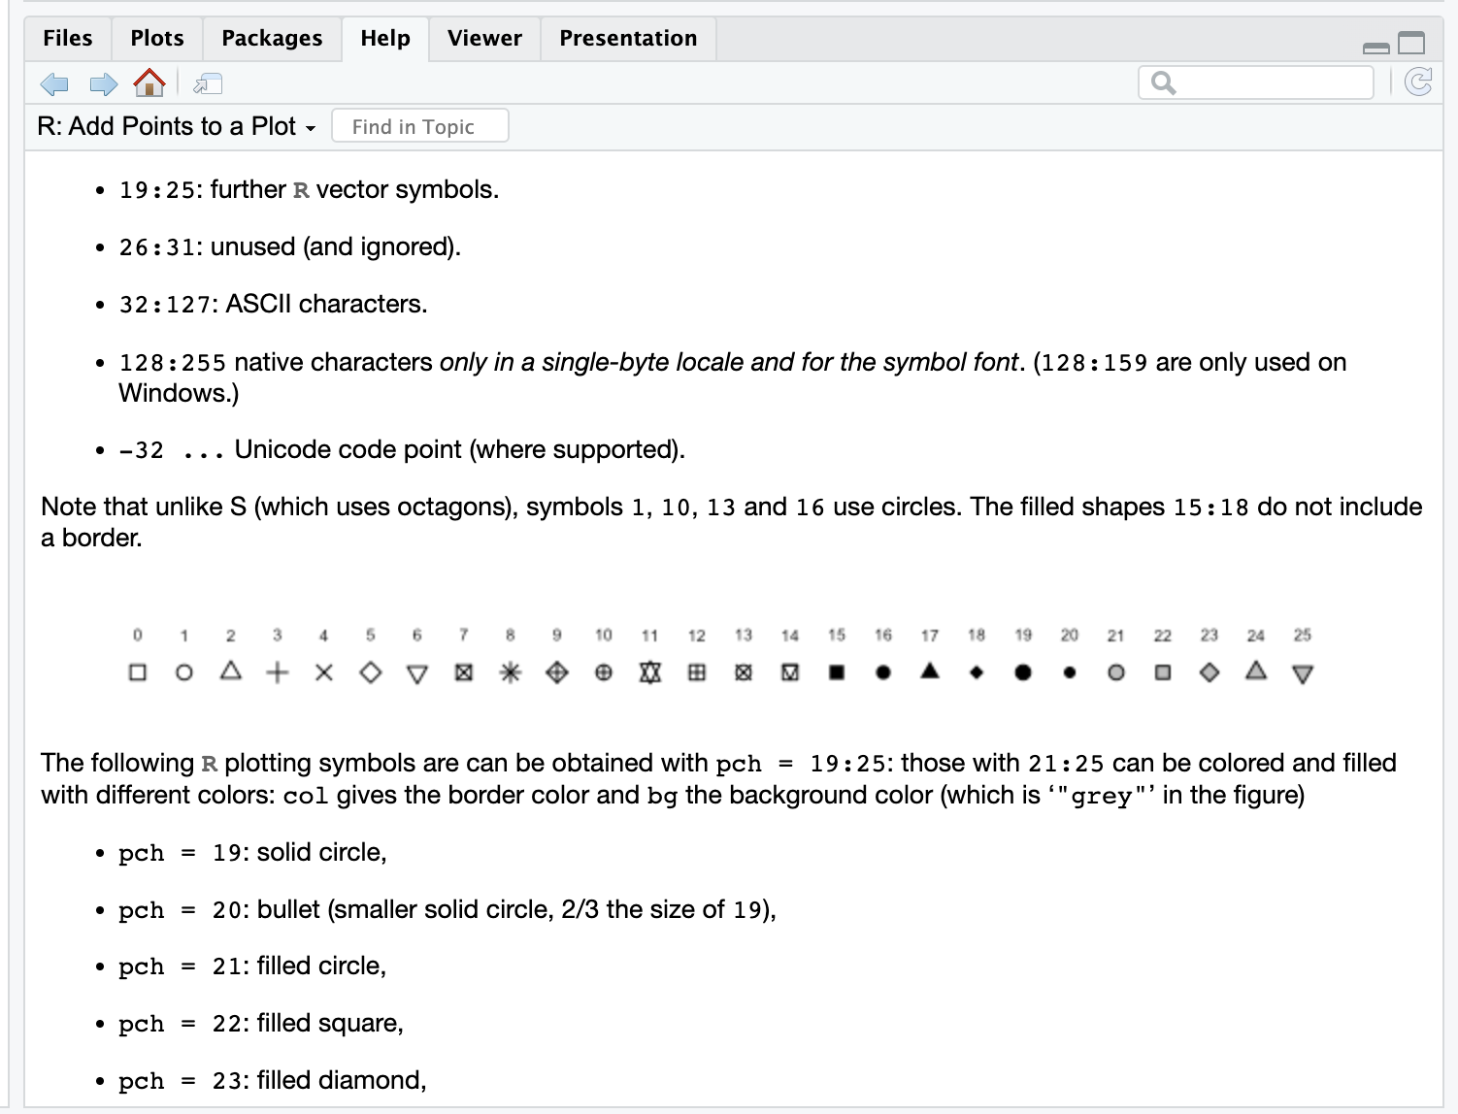

> points(may$Wind, may$Ozone, pch = 17, col = "blue")

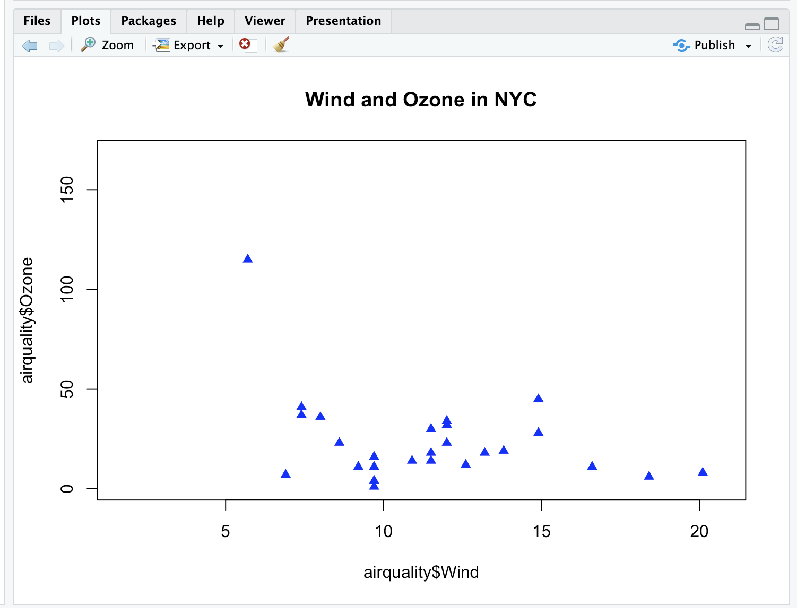

| One more time. You can do it! Or, type info() for more options.

| The code for solid blue trianges is 17 so typing

| points(may$Wind,may$Ozone,col="blue",pch=17) at the prompt should work.

> points(may$Wind,may$Ozone,col="blue",pch=17)

| You are really on a roll!

|====================================================== | 70%

| Now create the variable notmay by subsetting airquality appropriately.

> notmay <= subset(airquality, Month != 5)

Error: object 'notmay' not found

> notmay <- subset(airquality, Month != 5)

| You are quite good my friend!

|======================================================== | 71%

| Now use the R command points to plot these notmay's wind and ozone (in that order) as

| red snowflakes.

> points(notmay$Wind, notmay$Ozone, col = "red", pch = 8)

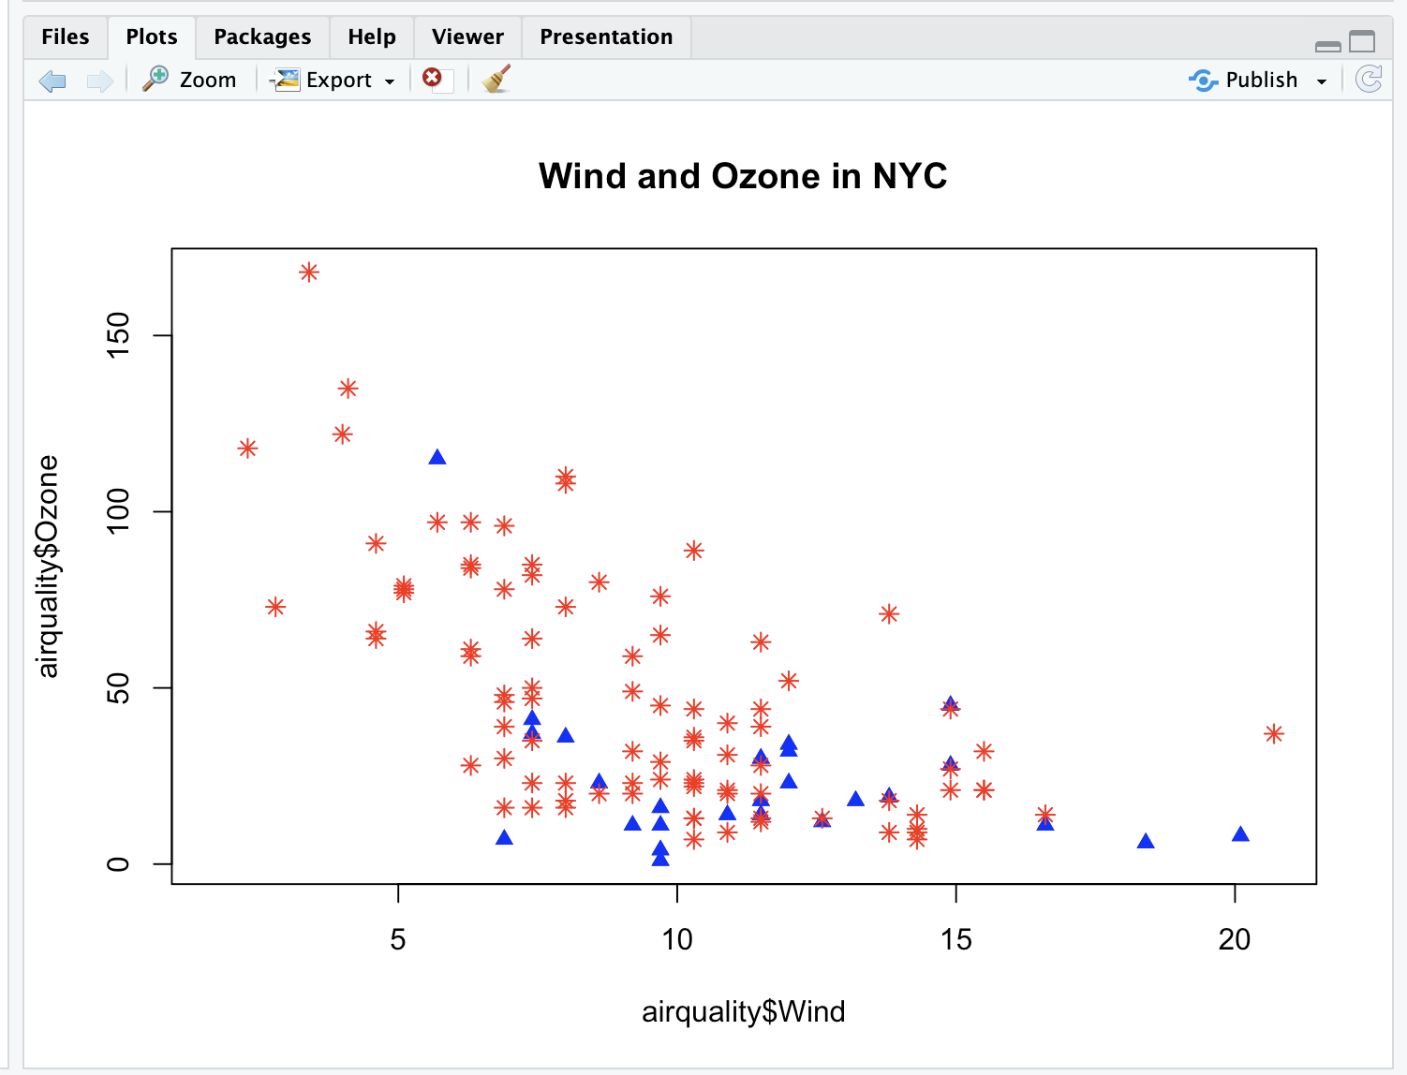

| Keep working like that and you'll get there!

|========================================================= | 73%

| Now we'll use the R command legend to clarify the plot and explain what it means. The

| function has a lot of arguments, but we'll only use 4. The first will be the string

| "topright" to tell R where to put the legend. The remaining 3 arguments will each be

| 2-long vectors created by R's concatenate function, e.g., c(). These arguments are

| pch, col, and legend. The first is the vector (17,8), the second ("blue","red"), and

| the third ("May","Other Months"). Try it now.

> legend("topright", pch = c(17, 8), col = c("blue", "red"), legend = c("May","Other Months"))

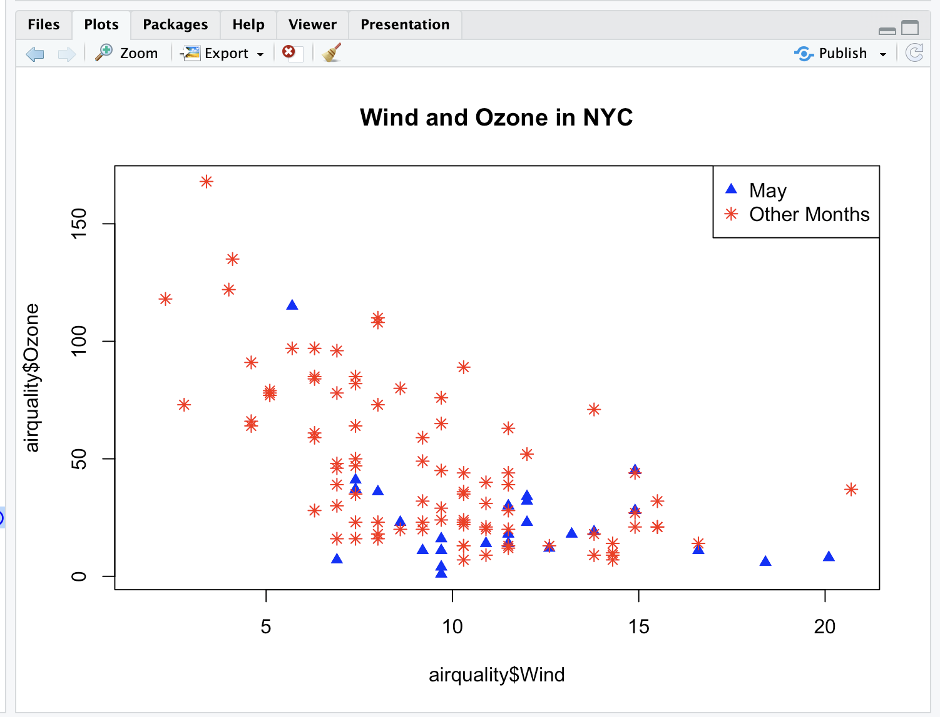

| Perseverance, that's the answer.

|========================================================== | 74%

| Now add a vertical line at the median of airquality$Wind. Make it dashed (lty=2) with

| a width of 2.

> abline(v = median(airquality$Wind), lty = 2, lwd = 2)

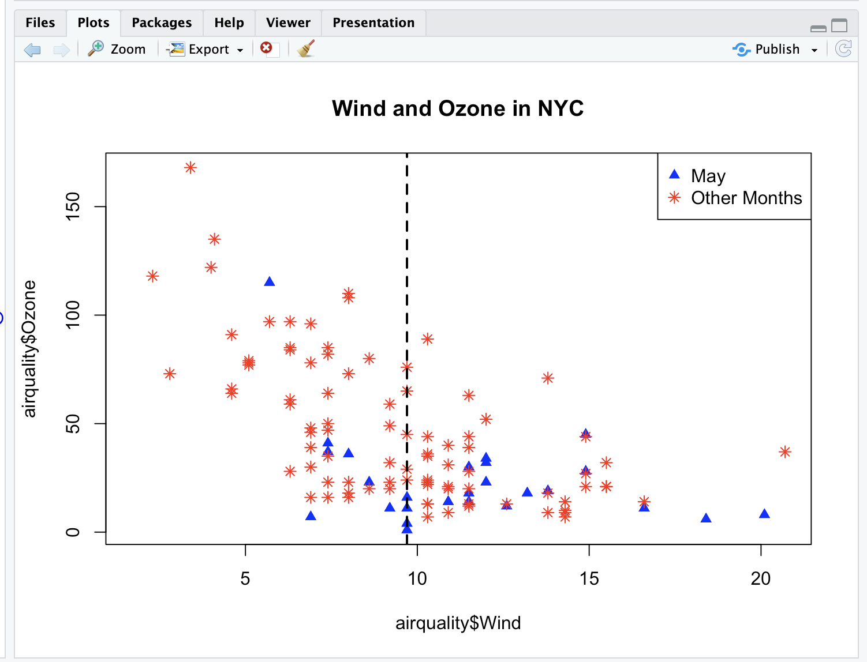

| Keep up the great work!

|=========================================================== | 76%

| Use par with the parameter mfrow set equal to the vector (1,2) to set up the plot

| window for two plots side by side. You won't see a result.

> par(mfrow = c(1, 2))

| Keep up the great work!

|============================================================ | 77%

| Now plot airquality$Wind and airquality$Ozone and use main to specify the title

| "Ozone and Wind".

> plot(airquality$Wind, airquality$Ozone, main = "Ozone and Wind")

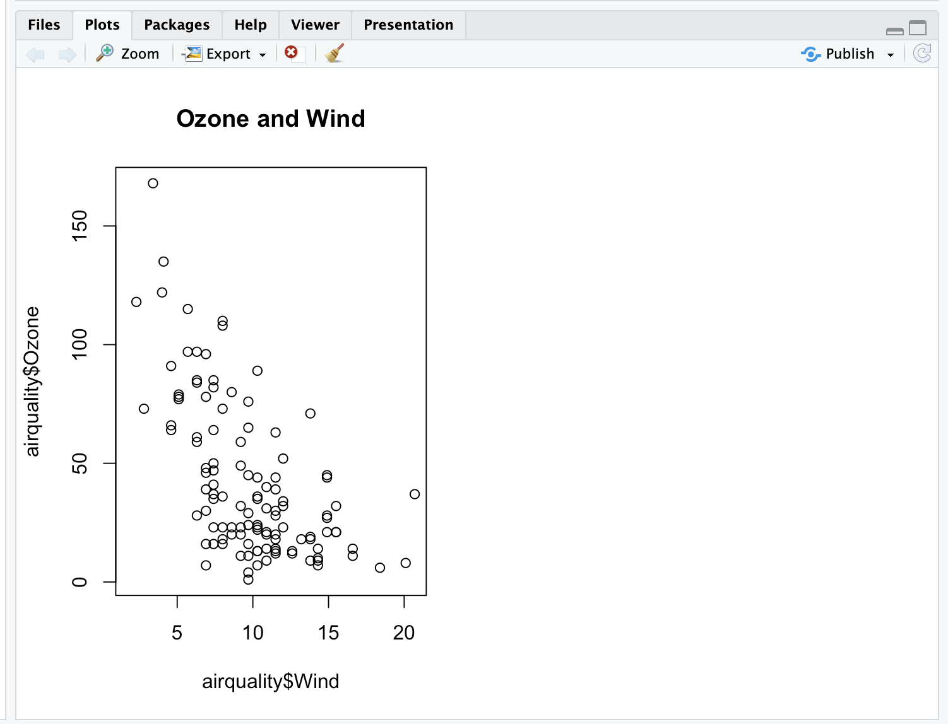

| Great job!

|============================================================= | 79%

| Now for the second plot.

...

|=============================================================== | 80%

| Plot airquality$Ozone and airquality$Solar.R and use main to specify the title "Ozone

| and Solar Radiation".

> plot(airquality$Ozone, airquality$Solar.R, main = "Ozone and Solar Radiation")

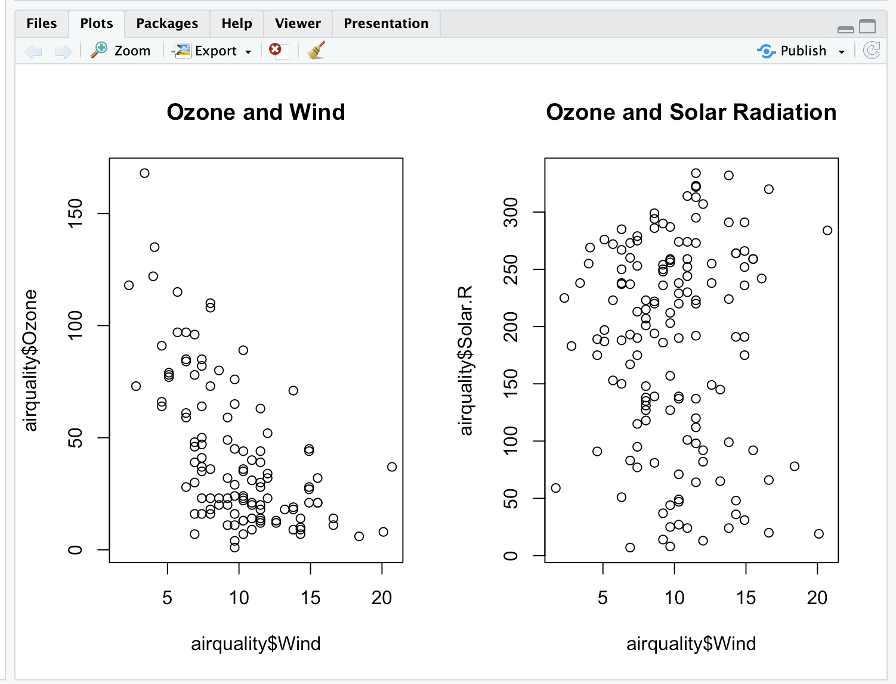

| All that practice is paying off!

|================================================================ | 82%

| Now for something more challenging.

|================================================================= | 83%

| This one with 3 plots, to illustrate inner and outer margins. First, set up the plot

| window by typing par(mfrow = c(1, 3), mar = c(4, 4, 2, 1), oma = c(0, 0, 2, 0))

> par(mfrow = c(1, 3), mar = c(4, 4, 2, 1), oma = c(0, 0, 2, 0))

| Excellent work!

|================================================================== | 85%

| Margins are specified as 4-long vectors of integers. Each number tells how many lines

| of text to leave at each side. The numbers are assigned clockwise starting at the

| bottom. The default for the inner margin is c(5.1, 4.1, 4.1, 2.1) so you can see we

| reduced each of these so we'll have room for some outer text.

...

|=================================================================== | 86%

| The first plot should be familiar. Plot airquality$Wind and airquality$Ozone with the

| title (argument main) as "Ozone and Wind".

> plot(airquality$Wind, airquality$Ozone, main = "Ozone and Wind")

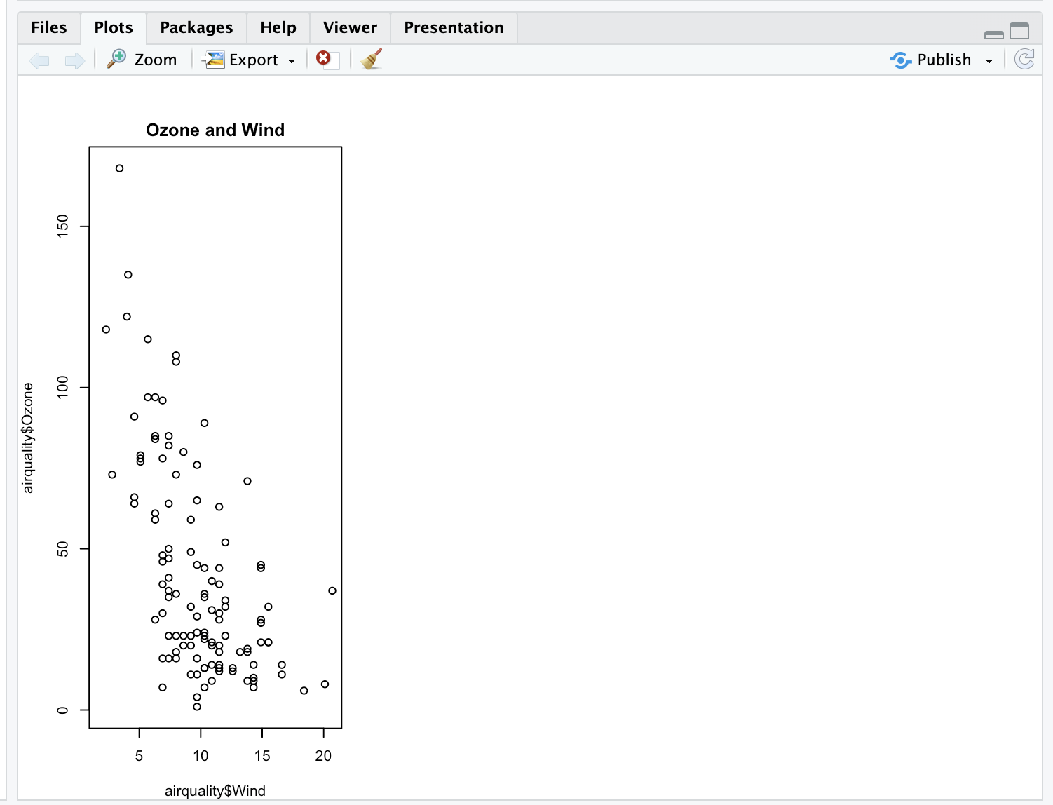

| That's a job well done!

|===================================================================== | 88%

| The second plot is similar.

> plot(airquality$Solar.R, airquality$Ozone, main = "Ozone and Solar Radiation")

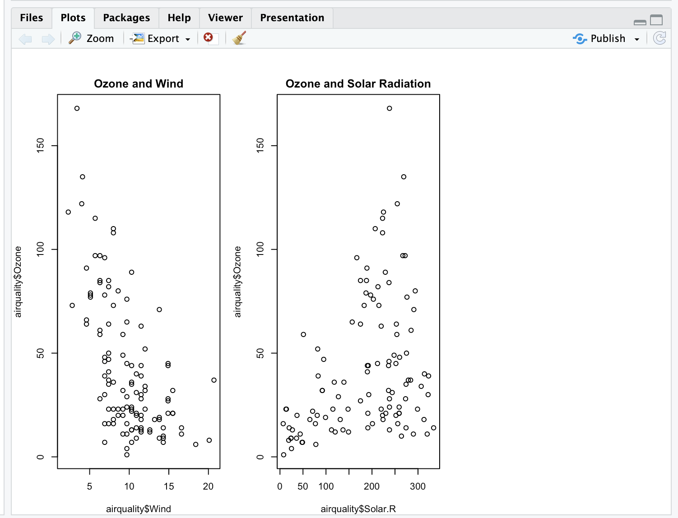

| Nice work!

|======================================================================= | 91%

| Now for the final panel.

|======================================================================== | 92%

| Plot airquality$Temp and airquality$Ozone with the title (argument main) as "Ozone

| and Temperature".

> plot(airquality$Temp, airquality$Ozone, main = "Ozone and Temperature")

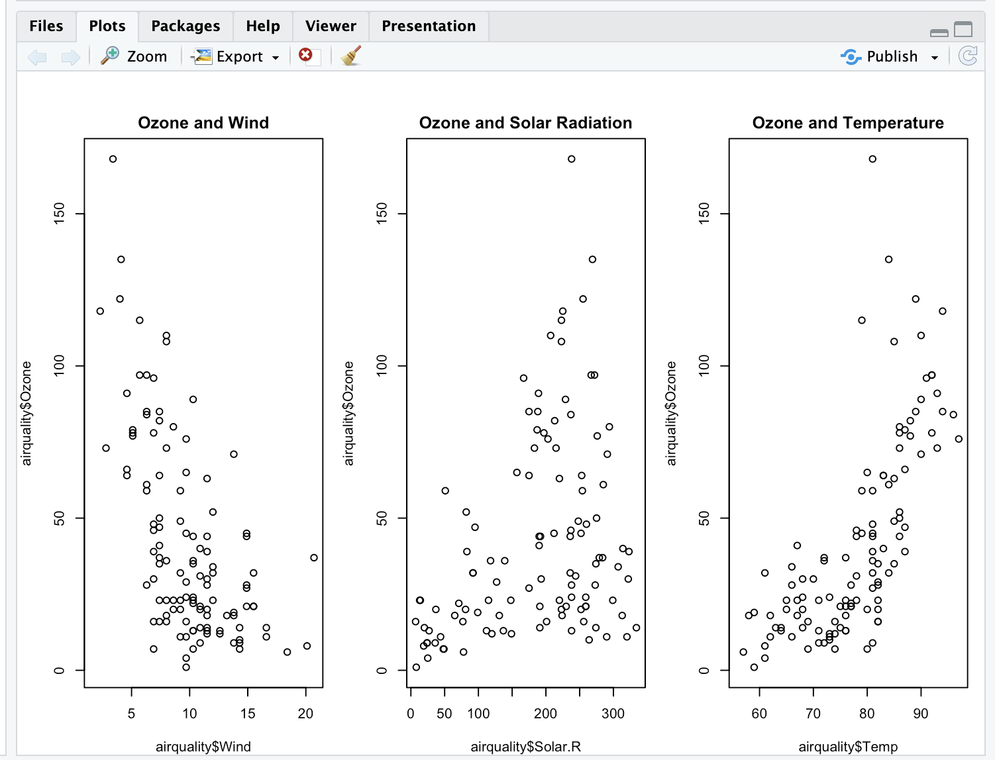

| Nice work!

|========================================================================= | 94%

| Now we'll put in a title.

...

|========================================================================== | 95%

| Since this is the main title, we specify it with the R command mtext. Call mtext with

| the string "Ozone and Weather in New York City" and the argument outer set equal to

| TRUE.

>

> mtext("Ozone and Weather in New York City", outer = TRUE)

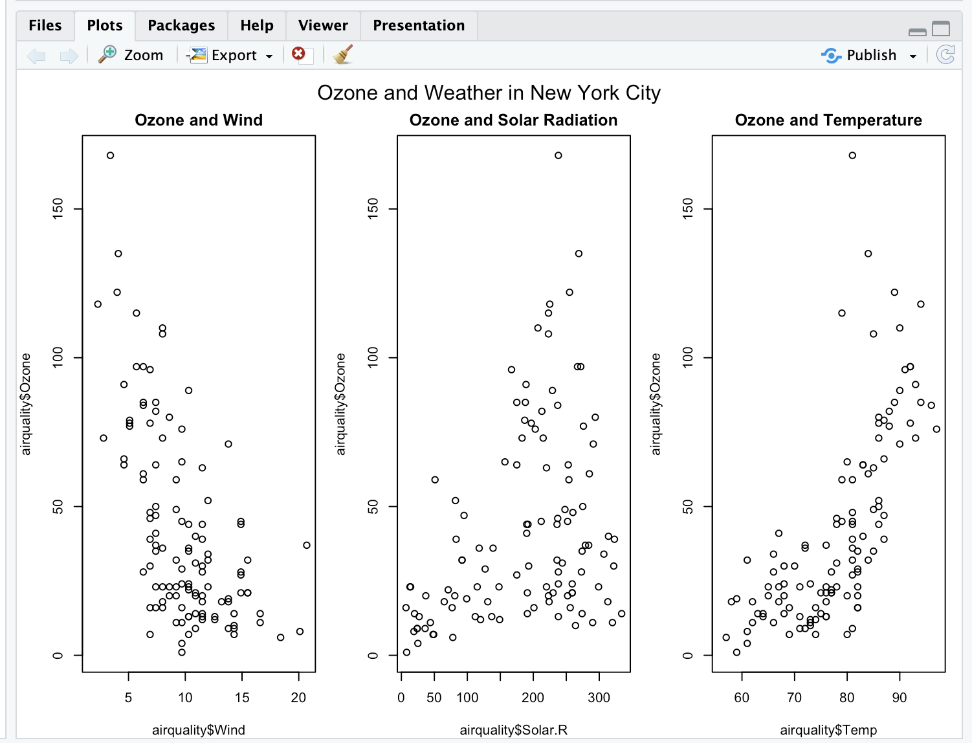

| You are really on a roll!

|============================================================================ | 97%

| Voila! Beautiful, right?

...

|============================================================================= | 98%

| Congrats! You've weathered this lesson nicely and passed out of the No!zone.

...

|==============================================================================| 100%

| Would you like to receive credit for completing this course on Coursera.org?

1: No

2: Yes

Selection: 1

| That's a job well done!

| You've reached the end of this lesson! Returning to the main menu...

| Please choose a course, or type 0 to exit swirl.

1: Exploratory Data Analysis

2: Take me to the swirl course repository!

Selection: 1

| Please choose a lesson, or type 0 to return to course menu.

1: Principles of Analytic Graphs 2: Exploratory Graphs

3: Graphics Devices in R 4: Plotting Systems

5: Base Plotting System 6: Lattice Plotting System

7: Working with Colors 8: GGPlot2 Part1

9: GGPlot2 Part2 10: GGPlot2 Extras

11: Hierarchical Clustering 12: K Means Clustering

13: Dimension Reduction 14: Clustering Example

15: CaseStudy

Selection: 6

| Attempting to load lesson dependencies...

| Package ‘lattice’ loaded correctly!

| Package ‘ggplot2’ loaded correctly!

| | 0%

| Lattice_Plotting_System. (Slides for this and other Data Science courses may be found

| at github https://github.com/DataScienceSpecialization/courses/. If you care to use

| them, they must be downloaded as a zip file and viewed locally. This lesson

| corresponds to 04_ExploratoryAnalysis/PlottingLattice.)

|= | 1%

| In another lesson, we gave you an overview of the three plotting systems in R. In

| this lesson we'll focus on the lattice plotting system. As we did with the base

| plotting system, we'll focus on using lattice to create graphics on the screen device

| rather than another graphics device.

...

|== | 3%

| The lattice plotting system is completely separate and independent of the base

| plotting system. It's an add-on package so it has to be explicitly loaded with a call

| to the R function library. We've done this for you. The R Documentation tells us that

| lattice "is an implementation of Trellis graphics for R. It is a powerful and elegant

| high-level data visualization system with an emphasis on multivariate data."

...

|=== | 4%

| Lattice is implemented using two packages. The first is called, not surprisingly,

| lattice, and it contains code for producing Trellis graphics. Some of the functions

| in this package are the higher level functions which you, the user, would call. These

| include xyplot, bwplot, and levelplot.

...

|===== | 6%

| If xyplot produces a scatterplot, what kind of plot does bwplot produce?

1: box and whisker

2: big and whittle

3: bad and wonderful

4: black and white

Selection: 1

| That's a job well done!

|====== | 7%

| The second package in the lattice system is grid which contains the low-level

| functions upon which the lattice package is built. You, the user, seldom call

| functions from the grid package directly.

...

|======= | 9%

| Unlike base plotting, the lattice system does not have a "two-phase" aspect with

| separate plotting and annotation. Instead all plotting and annotation is done at once

| with a single function call.

...

|======== | 10%

| The lattice system, as the base does, provides several different plotting functions.

| These include xyplot for creating scatterplots, bwplot for box-and-whiskers plots or

| boxplots, and histogram for histograms. There are several others (stripplot, dotplot,

| splom and levelplot), which we won't cover here.

...

|========= | 12%

| Lattice functions generally take a formula for their first argument, usually of the

| form y ~ x. This indicates that y depends on x, so in a scatterplot y would be

| plotted on the y-axis and x on the x-axis.

...

|========== | 13%

| Here's an example of typical lattice plot call, xyplot(y ~ x | f * g, data). The f

| and g represent the optional conditioning variables. The * represents interaction

| between them. Remember when we said that lattice is good for plotting multivariate

| data? That's where these conditioning variables come into play.

...

|============ | 15%

| The second argument is the data frame or list from which the variables in the formula

| should be looked up. If no data frame or list is passed, then the parent frame is

| used. If no other arguments are passed, the default values are used.

...

|============= | 16%

| Recall the airquality data we've used before. We've loaded it again for you. To

| remind yourself what it looks like run the R command head with airquality as an

| argument to see what the data looks like.

>

> head(airquality)

Ozone Solar.R Wind Temp Month Day

1 41 190 7.4 67 5 1

2 36 118 8.0 72 5 2

3 12 149 12.6 74 5 3

4 18 313 11.5 62 5 4

5 NA NA 14.3 56 5 5

6 28 NA 14.9 66 5 6

| You got it right!

|============== | 18%

| Now try running xyplot with the formula Ozone~Wind as the first argument and the

| second argument data set equal to airquality.

> xyplot(Ozone~Wind, data = airquality)

| That's a job well done!

|=============== | 19%

| Look vaguely familiar? The dots are blue, instead of black, but lattice labeled the

| axes for you. You can use some of the same graphical parameters (e.g., pch and col)

| that you used in the base package in calls to lattice functions.

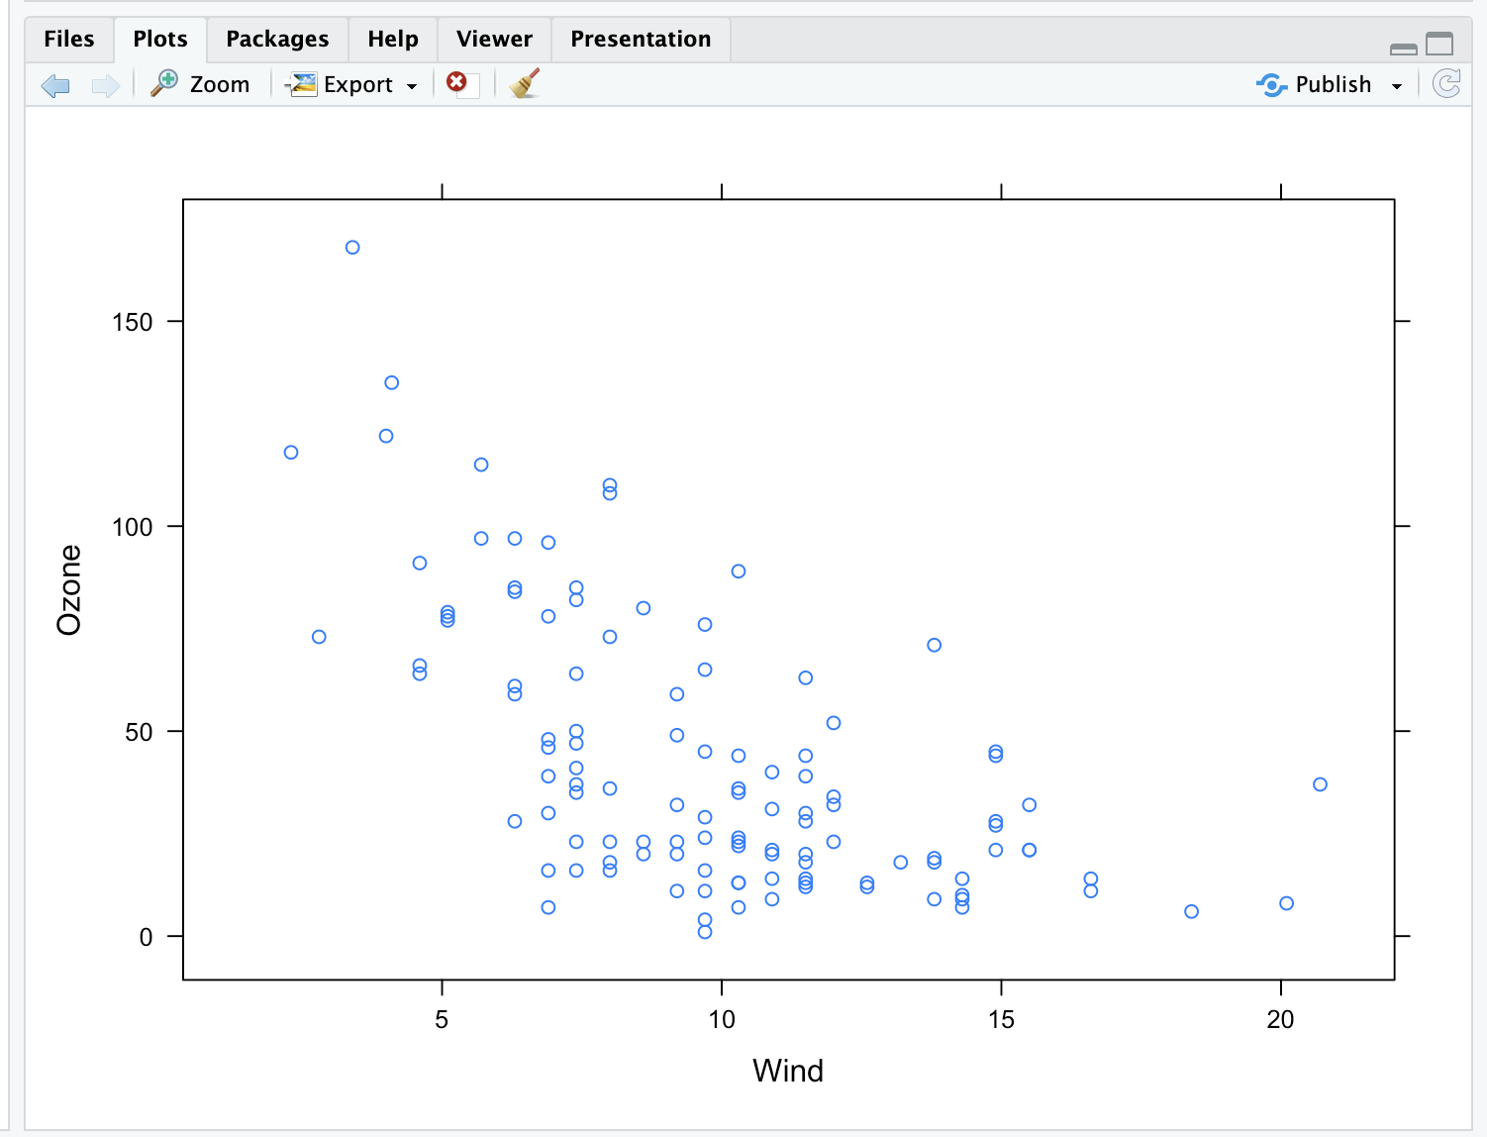

|================ | 21%

| Now rerun xyplot with the formula Ozone~Wind as the first argument and the second

| argument data set equal to airquality (use the up arrow to save typing). This time

| add the arguments col set equal to "red", pch set equal to 8, and main set equal to

| "Big Apple Data".

>

> xyplot(Ozone~Wind, data = air)

Error in eval(substitute(groups), data, environment(x)) :

object 'air' not found

> xyplot(Ozone~Wind, data = airquality, col = "red", pch = 8, main = "Big Apple Data")

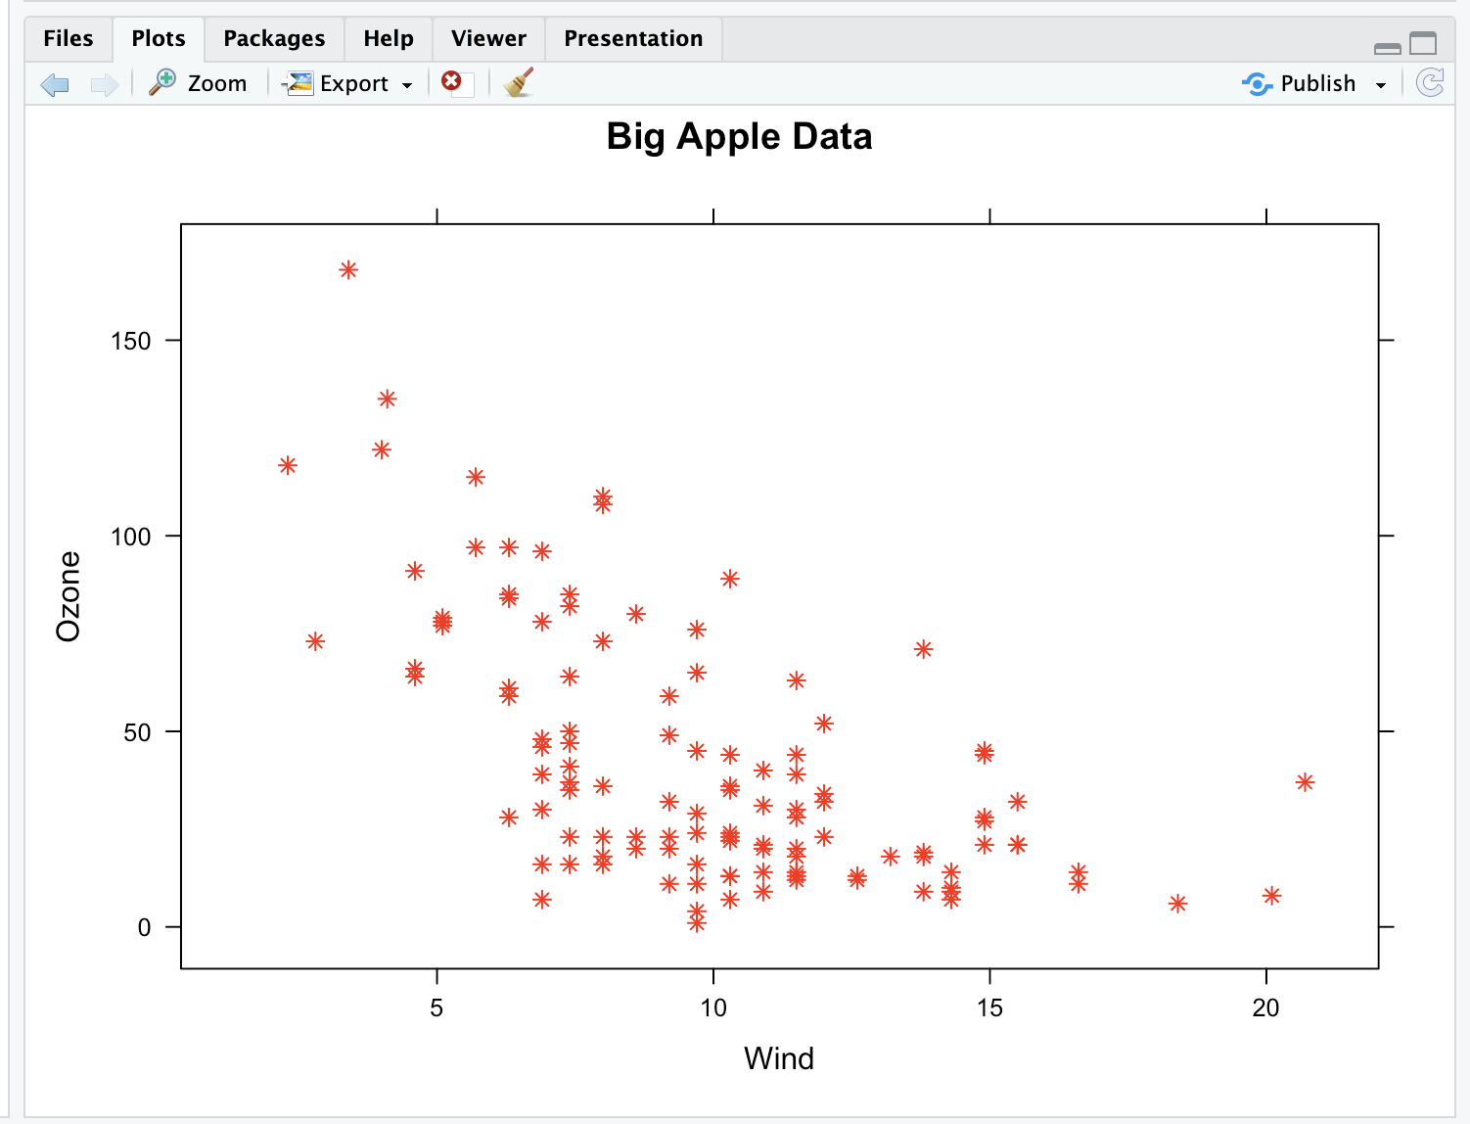

| Not quite! Try again. Or, type info() for more options.

| Type xyplot(Ozone ~ Wind, data = airquality, pch=8, col="red", main="Big Apple Data")

| at the command prompt.

> xyplot(Ozone ~ Wind, data = airquality, pch=8, col="red", main="Big Apple Data")

| You are really on a roll!

|================= | 22%

| Red snowflakes are cool, right? Now that you’ve seen the basic xyplot() and some of

| its arguments, you might want to experiment more by yourself when you're done with

| the lesson to discover what other arguments and colors are available. (If you can't

| wait to experiment, recall that swirl has play() and nxt() functions. At a command

| prompt, typing play() allows you to leave swirl temporarily so you can try different

| R commands at the console. Typing nxt() when you’re done playing brings you back to

| swirl and you can resume your lesson.)

Red snowflakes are cool, right? Now that you’ve seen the basic xyplot() and some of

| its arguments, you might want to experiment more by yourself when you're done with

| the lesson to discover what other arguments and colors are available. (If you can't

| wait to experiment, recall that swirl has play() and nxt() functions. At a command

| prompt, typing play() allows you to leave swirl temporarily so you can try different

| R commands at the console. Typing nxt() when you’re done playing brings you back to

| swirl and you can resume your lesson.)

...

|=================== | 24%

| Now you'll see how easy it is to generate a multipanel plot using a single lattice

| command.

...

|==================== | 25%

| Run xyplot with the formula Ozone~Wind | as.factor(Month) as the first argument and

| the second argument data set equal to airquality (use the up arrow to save typing).

| So far, not much is different, right? Add a third argument, layout, set equal to

| c(5,1).

>

> xyplot(Ozone~Wind | as.factor(Month), data = airquality, layout = c(5, 1))

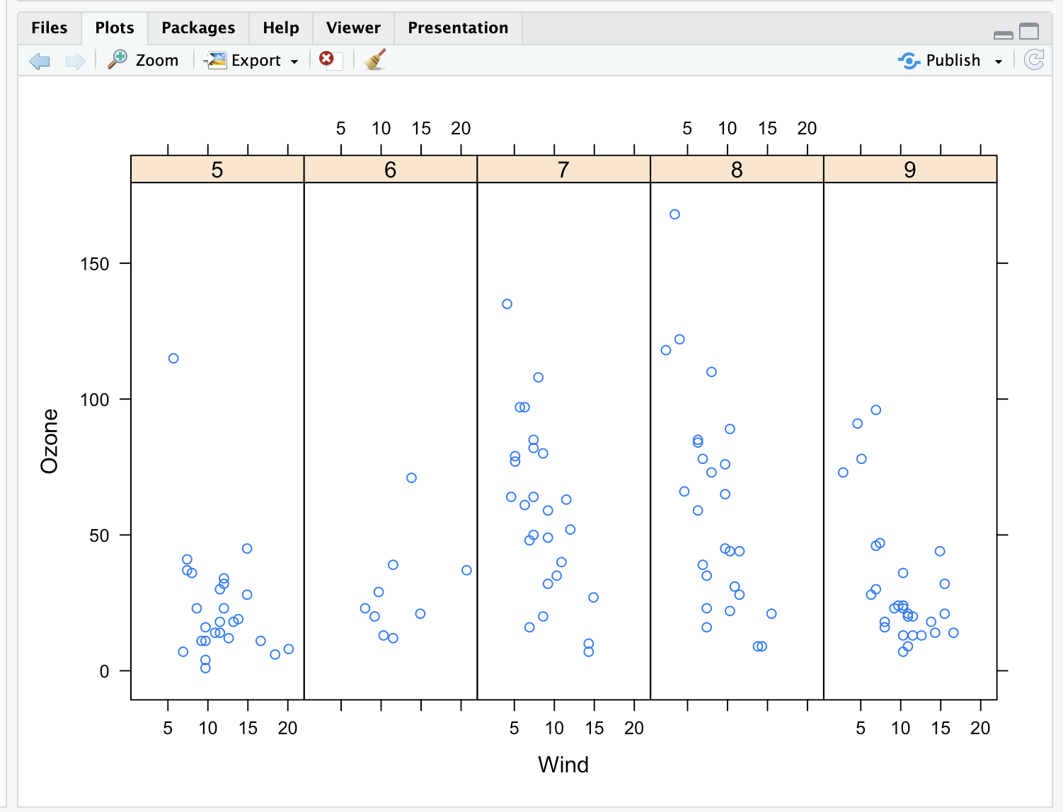

| Great job!

|===================== | 27%

| Note that the default color and plotting character are back. What did the

| as.factor(Month) do?

1: Randomly divided the data into 5 panels

2: Huh?

3: Displayed and labeled each subplot with the month's integer

4: Displayed the data by individual months

Selection: 3

| Perseverance, that's the answer.

|====================== | 28%

| Since Month is a named column of the airquality dataframe we had to tell R to treat

| it as a factor. To see how this affects the plot, rerun the xyplot command you just

| ran, but use Ozone ~ Wind | Month instead of Ozone ~ Wind | as.factor(Month) as the

| first argument.

> xyplot(Ozone ~ Wind | Month, data = airquality, layout=c(5,1))

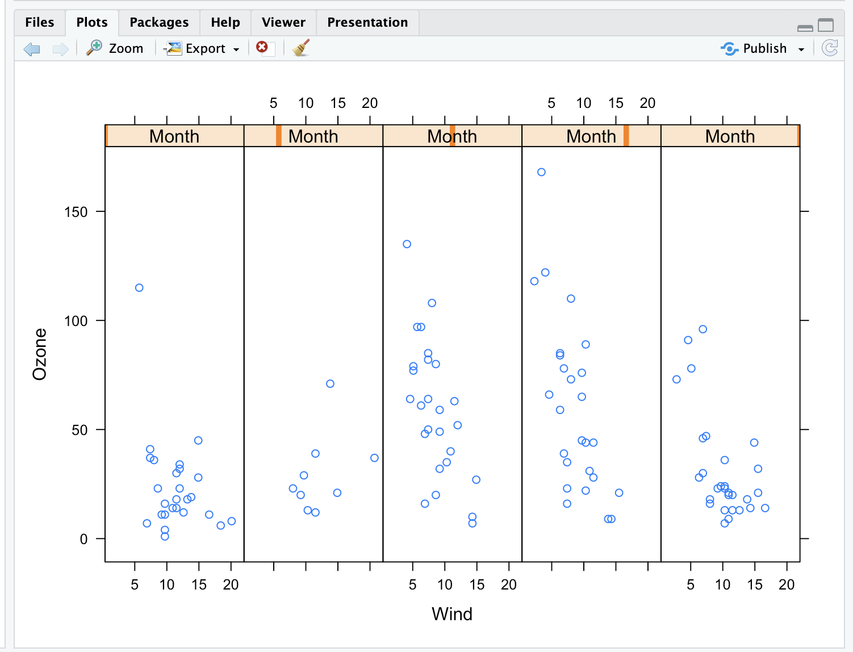

| Keep working like that and you'll get there!

|======================= | 30%

| Not as informative, right? The word Month in each panel really doesn't tell you much

| if it doesn't identify which month it's plotting. Notice that the actual data is the

| same between the two plots, though.

|======================== | 31%

| Lattice functions behave differently from base graphics functions in one critical

| way. Recall that base graphics functions plot data directly to the graphics device

| (e.g., screen, or file such as a PDF file). In contrast, lattice graphics functions

| return an object of class trellis.

...

|========================== | 33%

| The print methods for lattice functions actually do the work of plotting the data on

| the graphics device. They return "plot objects" that can be stored (but it’s usually

| better to just save the code and data). On the command line, trellis objects are

| auto-printed so that it appears the function is plotting the data.

...

|=========================== | 34%

| To see this, create a variable p which is assigned the output of this simple call to

| xyplot, xyplot(Ozone~Wind,data=airquality).

> p <- xyplot(Ozone~Wind,data=airquality)

| You are amazing!

|============================ | 36%

| Nothing plotted, right? But the object p is around.

...

|============================= | 37%

| Type p or print(p) now to see it.

> p



| Excellent job!

|============================== | 39%

| Like magic, it appears. Now run the R command names with p as its argument.

> names(p)

[1] "formula" "as.table" "aspect.fill" "legend"

[5] "panel" "page" "layout" "skip"

[9] "strip" "strip.left" "xscale.components" "yscale.components"

[13] "axis" "xlab" "ylab" "xlab.default"

[17] "ylab.default" "xlab.top" "ylab.right" "main"

[21] "sub" "x.between" "y.between" "par.settings"

[25] "plot.args" "lattice.options" "par.strip.text" "index.cond"

[29] "perm.cond" "condlevels" "call" "x.scales"

[33] "y.scales" "panel.args.common" "panel.args" "packet.sizes"

[37] "x.limits" "y.limits" "x.used.at" "y.used.at"

[41] "x.num.limit" "y.num.limit" "aspect.ratio" "prepanel.default"

[45] "prepanel"

| All that practice is paying off!

|=============================== | 40%

| We see that the trellis object p has 45 named properties, the first of which is

| "formula" which isn't too surprising. A lot of these properties are probably NULL in

| value. We've done some behind-the-scenes work for you and created two vectors. The

| first, mynames, is a character vector of the names in p. The second is a boolean

| vector, myfull, which has TRUE values for nonnull entries of p. Run mynames[myfull]

| to see which entries of p are not NULL.

> mynames[myfull]

[1] "formula" "as.table" "aspect.fill" "panel"

[5] "skip" "strip" "strip.left" "xscale.components"

[9] "yscale.components" "axis" "xlab" "ylab"

[13] "xlab.default" "ylab.default" "x.between" "y.between"

[17] "index.cond" "perm.cond" "condlevels" "call"

[21] "x.scales" "y.scales" "panel.args.common" "panel.args"

[25] "packet.sizes" "x.limits" "y.limits" "aspect.ratio"

[29] "prepanel.default"

| That's the answer I was looking for.

|================================= | 42%

| Wow! 29 nonNull values for one little plot. Note that a lot of them are like the ones

| we saw in the base plotting system. Let's look at the values of some of them. Type

| p[["formula"]] now.

> p[["formula"]]

Ozone ~ Wind

| You are amazing!

|================================== | 43%

| Not surprising, is it? It's a familiar formula. Now look at p's x.limits. Remember

| the double square brackets and quotes.

> p[["x.limits"]]

[1] 0.37 22.03

| Keep up the great work!

|=================================== | 45%

| They match the plot, right? The x values are indeed between .37 and 22.03.

...

|==================================== | 46%

| Again, not surprising. Before we wrap up, let's talk about lattice's panel functions

| which control what happens inside each panel of the plot. The ease of making

| multi-panel plots makes lattice very appealing. The lattice package comes with

| default panel functions, but you can customize what happens in each panel.

...

|===================================== | 48%

| Panel functions receive the x and y coordinates of the data points in their panel

| (along with any optional arguments). To see this, we've created some data for you -

| two 100-long vectors, x and y. For its first 50 values y is a function of x, for the

| last 50 values, y is random. We've also defined a 100-long factor vector f which

| distinguishes between the first and last 50 elements of the two vectors. Run the R

| command table with f as it argument.

> table(f)

f

Group 1 Group 2

50 50

| That's a job well done!

|====================================== | 49%

| The first 50 entries of f are "Group 1" and the last 50 are "Group 2". Run xyplot

| with two arguments. The first is the formula y~x|f, and the second is layout set

| equal to c(2,1). Note that we're not providing an explicit data argument, so xyplot

| will look in the environment and see the x and y that we've generated for you.

> xyplot(y ~ x | f, layout = c(2, 1))

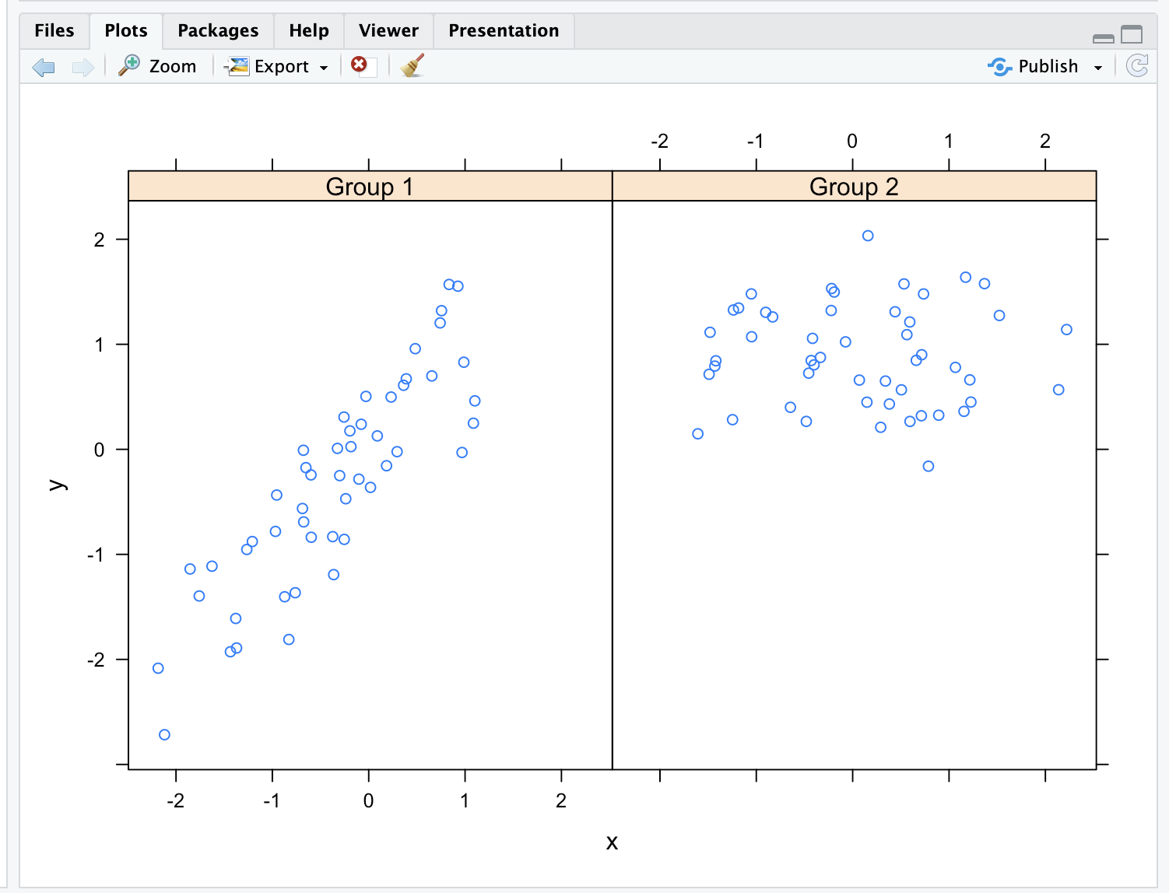

| You nailed it! Good job!

|======================================== | 51%

| To understand this a little better look at the variable v1 we've created for you.

> v1

[1] -2.185287 1.101780 -2.716851 1.569850

| You're the best!

|========================================= | 52%

| The first two numbers are the range of the x values of Group 1 and the last two

| numbers are the range of y values of Group 1. See how they match the values of the

| left panel (Group 1) in the plot. Now look at v2 which holds the comparable numbers

| for Group 2.

> v2

[1] -1.6066772 2.2205197 -0.1605085 2.0341048

| You nailed it! Good job!

|========================================== | 54%

| Again, the values match the plot. That's reassuring. We've copied some code from the

| slides for you. To see it, type myedit("plot1.R"). This will open your editor and

| display the R code in it.

> myedit("plot1.R")

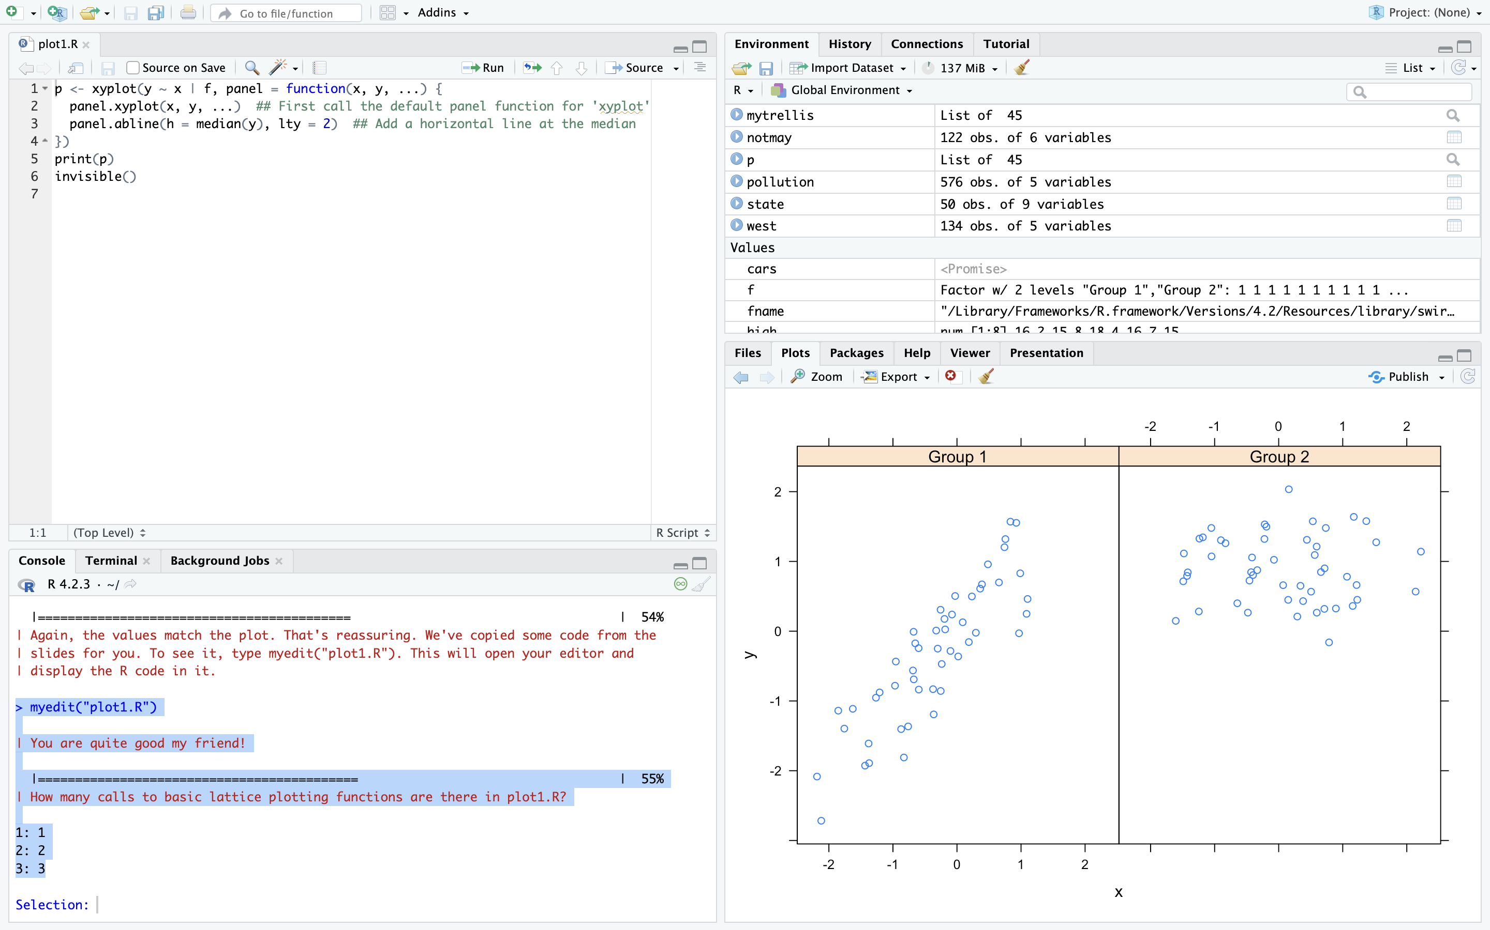

| You are quite good my friend!

|=========================================== | 55%

| How many calls to basic lattice plotting functions are there in plot1.R?

1: 1

2: 2

3: 3

Selection: 1

| You got it!

|============================================ | 57%

| Note the panel function. How many formal arguments does it have?

1: 2

2: 3

3: 1

Selection: 2

| That's a job well done!

|============================================= | 58%

| The panel function has 3 arguments, x, y and ... . This last stands for all other

| arguments (such as graphical parameters) you might want to include. There are 2 lines

| in the panel function. Each invokes a panel method, the first to plot the data in

| each panel (panel.xyplot), the second to draw a horizontal line in each panel

| (panel.abline). Note the similarity of this last call to that of the base plotting

| function of the same name.

...

|=============================================== | 60%

| We've defined a function for you, pathtofile, which takes a filename as its argument.

| This makes sure R can find the file on your computer. Now run the R command source

| with two arguments. The first is the call to pathtofile with the string "plot1.R" as

| its argument and the second is the argument local set equal to TRUE. This command

| will run the code contained in plot1.R within the swirl environment so you can see

| what it does.

> source(pathtofile("plot1.R"),local=TRUE)

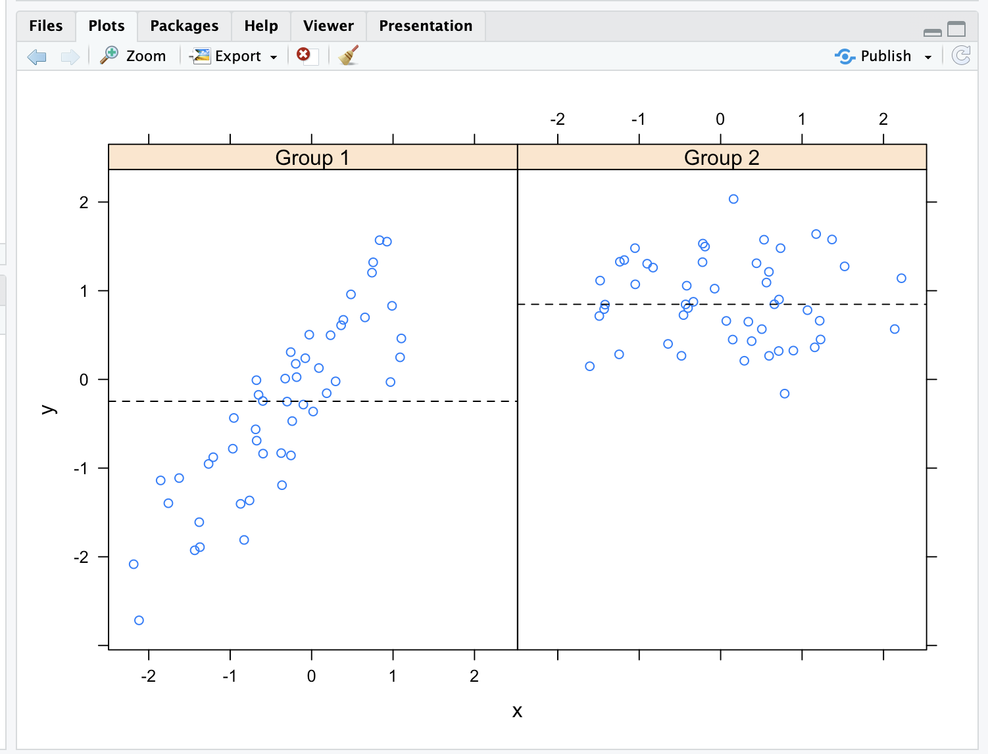

| You got it!

|================================================ | 61%

| See how the lines appear. The plot shows two panels because...?

1: lattice can handle at most 2 panels

2: there are 2 variables

3: f contains 2 factors

4: there are 2 calls to panel methods

Selection: 3

| That's the answer I was looking for.

|================================================= | 63%

| We've copied another piece of similar code, i.e., a call to xyplot with a custom

| panel function, from the slides. To see it, type myedit("plot2.R"). This will open

| your editor and display the R code in it.

> myedit("plot2.R")

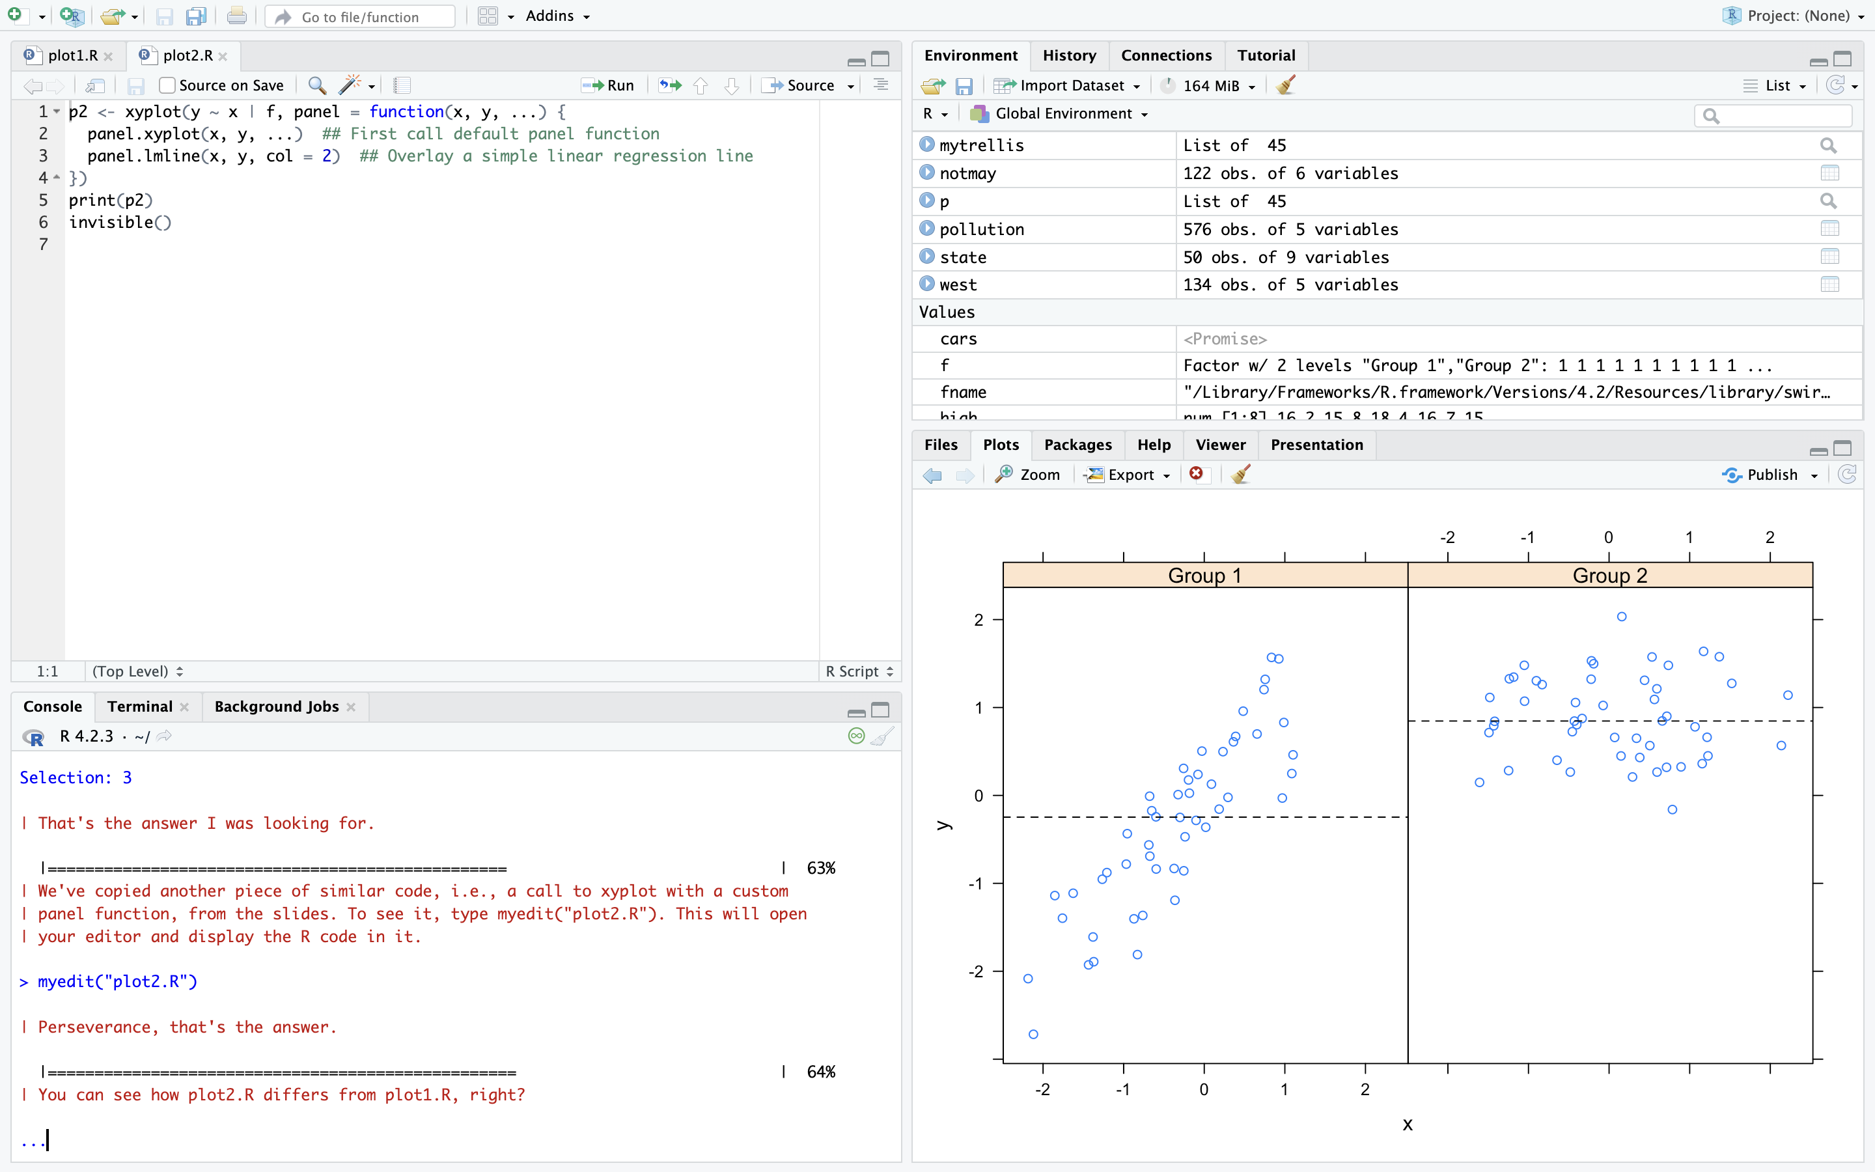

| Perseverance, that's the answer.

|================================================== | 64%

| You can see how plot2.R differs from plot1.R, right?

|=================================================== | 66%

| Again, run the R command source with the two arguments pathtofile("plot2.R") and

| local=TRUE. This will run the code in plot2.R.

> source(pathtofile("plot2.R"),local=TRUE)

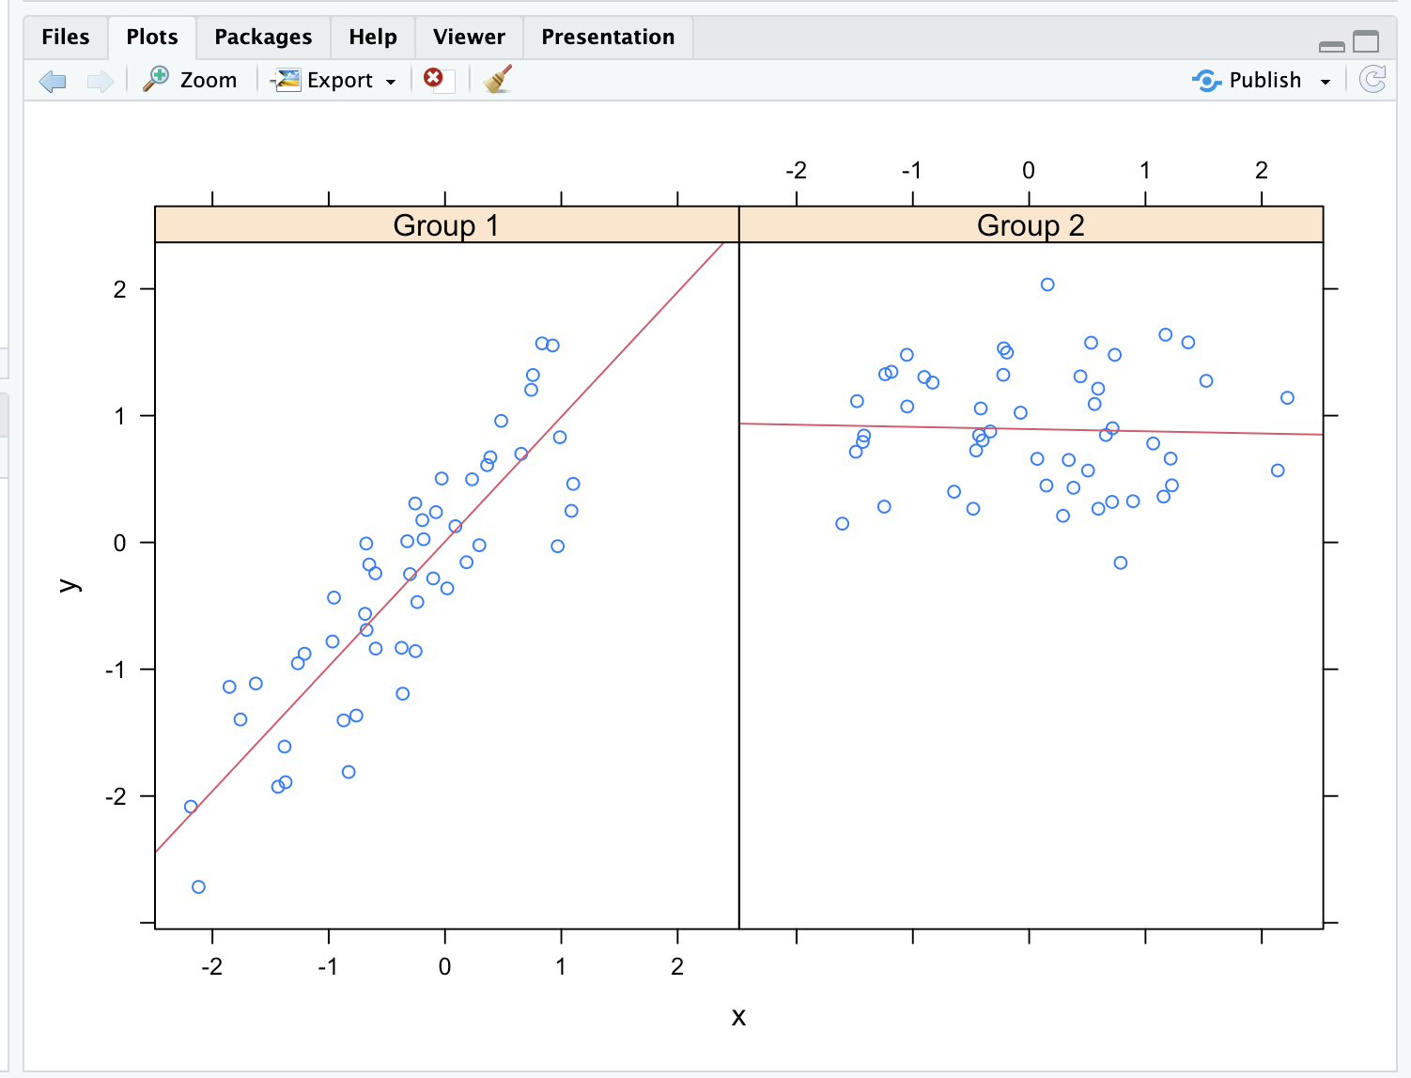

| Your dedication is inspiring!

|==================================================== | 67%

| The regression lines are red because ...?

1: R is the first letter of the word red

2: R always plots regression lines in red

3: the custom panel function specified a col argument

Selection: 3

| You nailed it! Good job!

|====================================================== | 69%

| Before we close we'll look at how easily lattice can handle a plot with a great many

| panels. (The sky's the limit.) We've loaded some diamond data for you. It comes with

| the ggplot2 package. We'll use it just to show off lattice's panel plotting

| capability.

...

|======================================================= | 70%

| The data is in the data frame diamonds. Use the R command str to see what it looks

| like.

> str(diamonds)

tibble [53,940 × 10] (S3: tbl_df/tbl/data.frame)

$ carat : num [1:53940] 0.23 0.21 0.23 0.29 0.31 0.24 0.24 0.26 0.22 0.23 ...

$ cut : Ord.factor w/ 5 levels "Fair"<"Good"<..: 5 4 2 4 2 3 3 3 1 3 ...

$ color : Ord.factor w/ 7 levels "D"<"E"<"F"<"G"<..: 2 2 2 6 7 7 6 5 2 5 ...

$ clarity: Ord.factor w/ 8 levels "I1"<"SI2"<"SI1"<..: 2 3 5 4 2 6 7 3 4 5 ...

$ depth : num [1:53940] 61.5 59.8 56.9 62.4 63.3 62.8 62.3 61.9 65.1 59.4 ...

$ table : num [1:53940] 55 61 65 58 58 57 57 55 61 61 ...

$ price : int [1:53940] 326 326 327 334 335 336 336 337 337 338 ...

$ x : num [1:53940] 3.95 3.89 4.05 4.2 4.34 3.94 3.95 4.07 3.87 4 ...

$ y : num [1:53940] 3.98 3.84 4.07 4.23 4.35 3.96 3.98 4.11 3.78 4.05 ...

$ z : num [1:53940] 2.43 2.31 2.31 2.63 2.75 2.48 2.47 2.53 2.49 2.39 ...

| You are doing so well!

|======================================================== | 72%

| So the data frame contains 10 pieces of information for each of 53940 diamonds. Run

| the R command table with diamonds$color as an argument.

> table(diamonds$color)

D E F G H I J

6775 9797 9542 11292 8304 5422 2808

| You nailed it! Good job!

|========================================================= | 73%

| We see 7 colors each represented by a letter. Now run the R command table with two

| arguments, diamonds$color and diamonds$cut.

> table(diamonds$color, diamonds$cut)

Fair Good Very Good Premium Ideal

D 163 662 1513 1603 2834

E 224 933 2400 2337 3903

F 312 909 2164 2331 3826

G 314 871 2299 2924 4884

H 303 702 1824 2360 3115

I 175 522 1204 1428 2093

J 119 307 678 808 896

| Keep working like that and you'll get there!

|========================================================== | 75%

| We see a 7 by 5 array with counts indicating how many diamonds in the data frame have

| a particular color and cut. From the table, which is the most frequent combination?

1: Premium cut of color G

2: Ideal color of cut G

3: Ideal cut of color F.

4: Ideal cut of color G

Selection: 4

| That's a job well done!

|=========================================================== | 76%

| To save you some trouble we've defined three character strings for you, labels for

| the x- and y-axes and a main title. They're in the file myLabels.R, so run myedit on

| this file to see them. Remember to put the file name in quotes when you call myedit.

> myedit("myLabels.R")

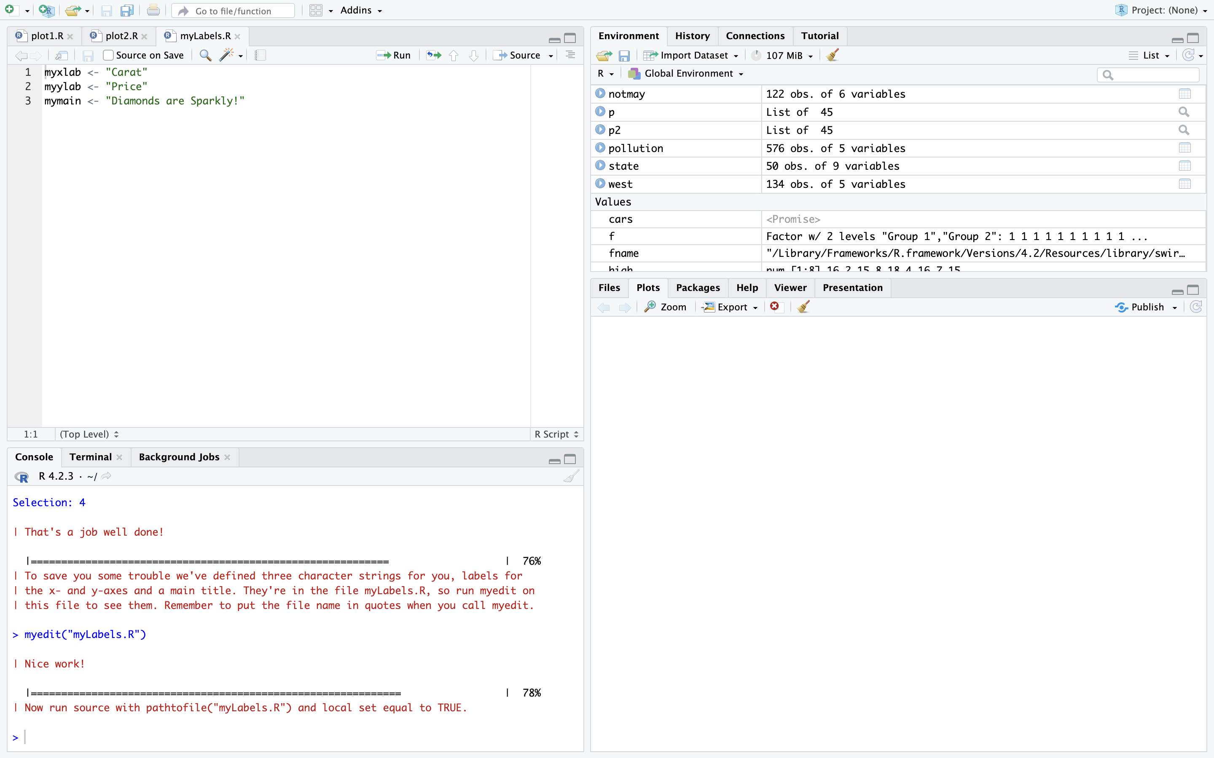

| Nice work!

|============================================================= | 78%

| Now run source with pathtofile("myLabels.R") and local set equal to TRUE.

> source(pathtofile("myLabels.R"),local=TRUE)

| All that hard work is paying off!

|============================================================== | 79%

| Now call xyplot with the formula price~carat | color*cut and data set equal to

| diamonds. In addition, set the argument strip equal to FALSE, pch set equal to 20,

| xlab to myxlab, ylab to myylab, and main to mymain. The plot may take longer than

| previous plots because it is bigger.

> xyplot(price~carat|color*cut,data=diamonds,strip=FALSE,pch=20,xlab=myxlab,ylab=myylab,main=mymain)

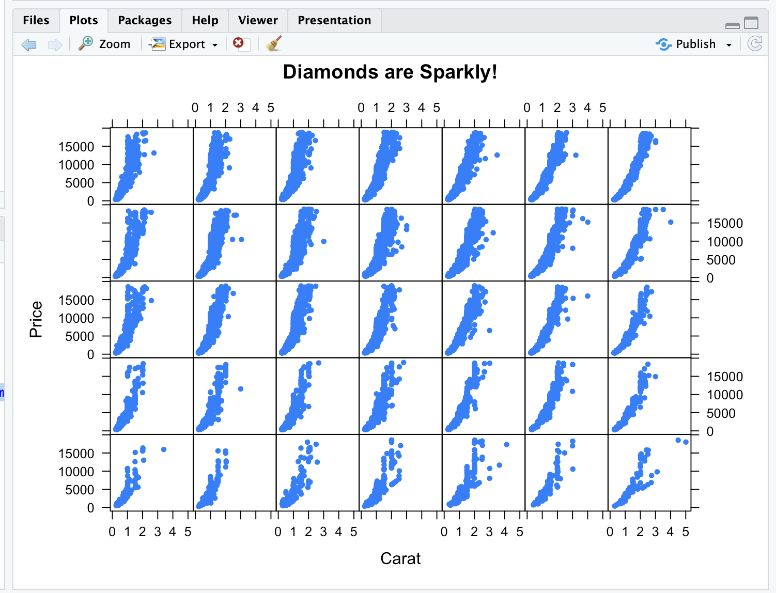

| That's the answer I was looking for.

|=============================================================== | 81%

| Pretty cool, right? 35 panels, one for each combination of color and cut. The dots

| (pch=20) show how prices for the diamonds in each category (panel) vary depending on

| carat.

|================================================================ | 82%

| Are colors defining the rows or columns of the plot?

1: rows

2: columns

Selection: 2

| Excellent job!

|================================================================= | 84%

| Were you curious about that argument strip? I know I was. Now rerun the xyplot

| command you just ran (use the up arrow key to retrieve it), this time without the

| strip argument.

> xyplot(price~carat|color*cut,data=diamonds,pch=20,xlab=myxlab,ylab=myylab,main=mymain)

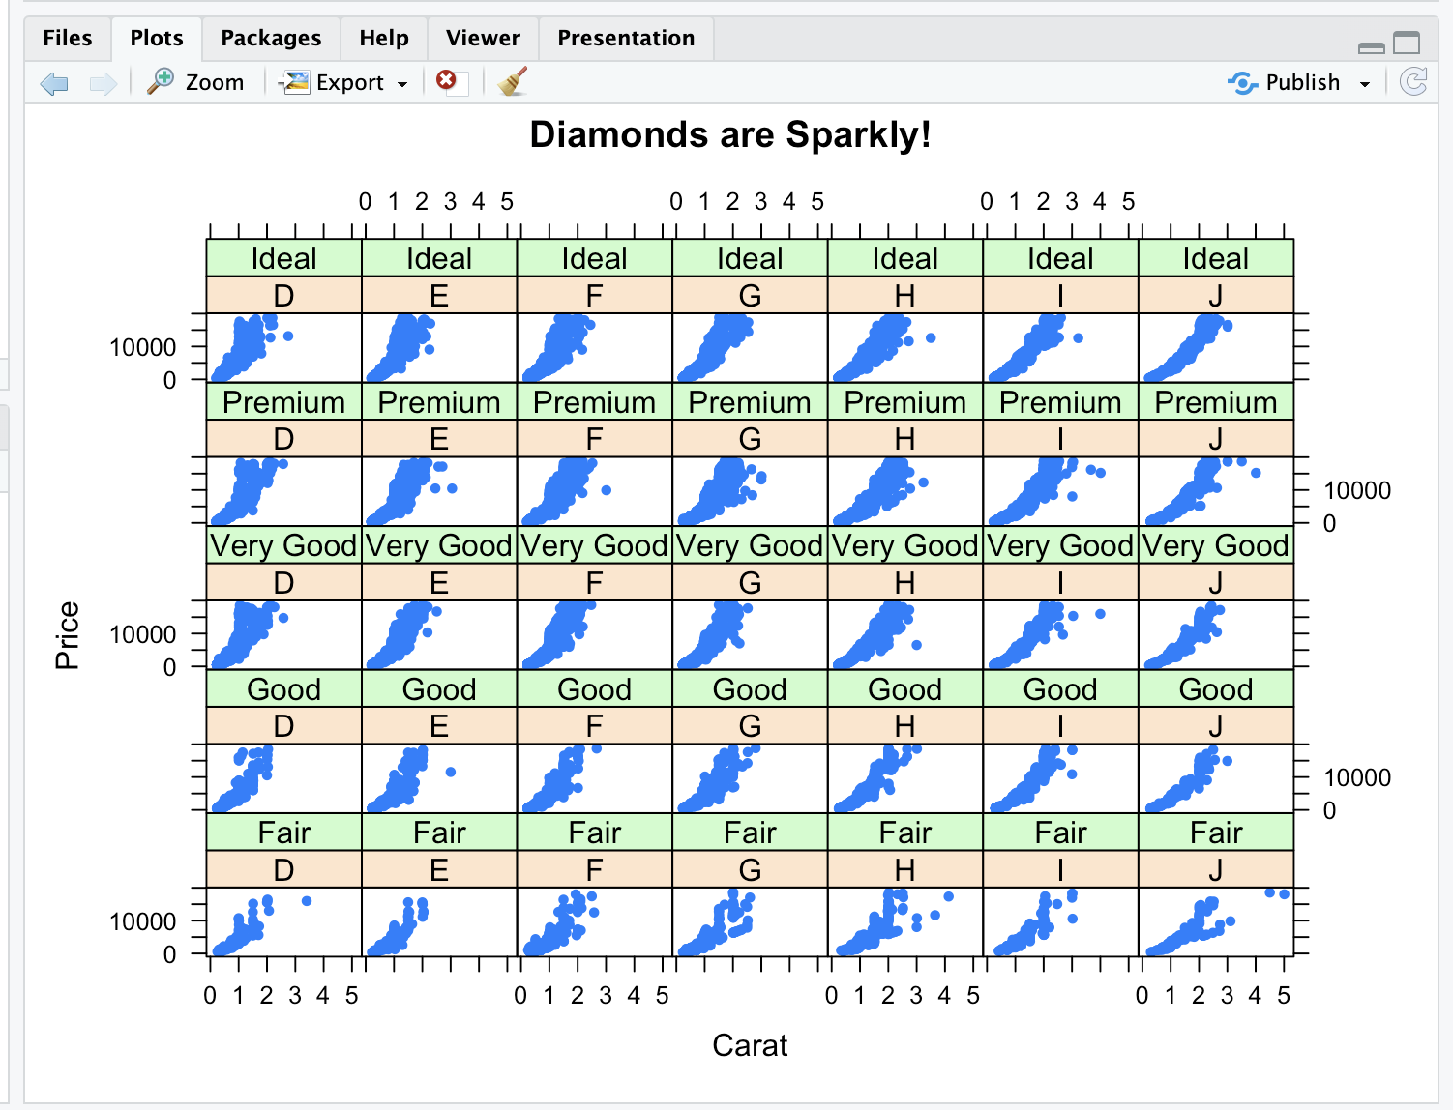

| Perseverance, that's the answer.

|================================================================== | 85%

| The plot shows that the strip argument ....

1: labels each panel

2: has a default value of FALSE

3: removes information from the plot

4: makes the plot less intelligible

Selection: 1

| You got it right!

|==================================================================== | 87%

| Review time!!!

...

|===================================================================== | 88%

| True or False? Lattice plots are constructed by a series of calls to core functions.

1: False

2: True

Selection: 1

| All that hard work is paying off!

|====================================================================== | 90%

| True or False? Lattice plots are constructed with a single function call to a core

| lattice function (e.g. xyplot)

1: True

2: False

Selection: 1

| You are doing so well!

|======================================================================= | 91%

| True or False? Aspects like margins and spacing are automatically handled and

| defaults are usually sufficient.

1: False

2: True

Selection: 2

| You are quite good my friend!

|======================================================================== | 93%

| True or False? The lattice system is ideal for creating conditioning plots where you

| examine the same kind of plot under many different conditions.

1: False

2: True

Selection: 2

| You are quite good my friend!

|========================================================================= | 94%

| True or False? The lattice system, like the base plotting system, returns a trellis

| plot object.

1: False

2: True

Selection: 1

| Nice work!

|=========================================================================== | 96%

| True or False? Panel functions can NEVER be customized to modify what is plotted in

| each of the plot panels.

1: False

2: True

Selection: 1

| You are doing so well!

|============================================================================ | 97%

| True or False? Lattice plots can display at most 20 panels in a single plot.

1: False

2: True

Selection: 1

| That's a job well done!

|============================================================================= | 99%

| Congrats! We hope this lesson didn't leave you climbing the trellis.

...

|==============================================================================| 100%

| Would you like to receive credit for completing this course on Coursera.org?

1: Yes

2: No

Selection: 2

| You're the best!

| You've reached the end of this lesson! Returning to the main menu...

| Please choose a course, or type 0 to exit swirl.

1: Exploratory Data Analysis

2: Take me to the swirl course repository!

Selection: 1

| Please choose a lesson, or type 0 to return to course menu.

1: Principles of Analytic Graphs 2: Exploratory Graphs

3: Graphics Devices in R 4: Plotting Systems

5: Base Plotting System 6: Lattice Plotting System

7: Working with Colors 8: GGPlot2 Part1

9: GGPlot2 Part2 10: GGPlot2 Extras

11: Hierarchical Clustering 12: K Means Clustering

13: Dimension Reduction 14: Clustering Example

15: CaseStudy

Selection: 7

| Attempting to load lesson dependencies...

| Package ‘jpeg’ loaded correctly!

| Package ‘RColorBrewer’ loaded correctly!

| Package ‘datasets’ loaded correctly!

| | 0%

| Working_with_Colors. (Slides for this and other Data Science courses may be found at

| github https://github.com/DataScienceSpecialization/courses/. If you care to use

| them, they must be downloaded as a zip file and viewed locally. This lesson

| corresponds to 04_ExploratoryAnalysis/Colors.)

...

|= | 1%

| This lesson is about using colors in R. It really supplements the lessons on plotting

| with the base and lattice packages which contain functions that are able to take the

| argument col. We'll discuss ways to set this argument more colorfully.

...

|== | 3%

| Of course, color choice is secondary to your data and how you analyze it, but

| effectively using colors can enhance your plots and presentations, emphasizing the

| important points you're trying to convey.

...

|=== | 4%

| The motivation for this lesson is that the default color schemes for most plots in R

| are not optimal. Fortunately there have been recent developments to improve the

| handling and specification of colors in plots and graphs. We'll cover some functions

| in R as well as in external packages that are very handy. If you know how to use some

| of these then you'll have more options when you create your displays.

...

|===== | 6%

| We'll begin with a motivating example - a typical R plot using 3 default colors.

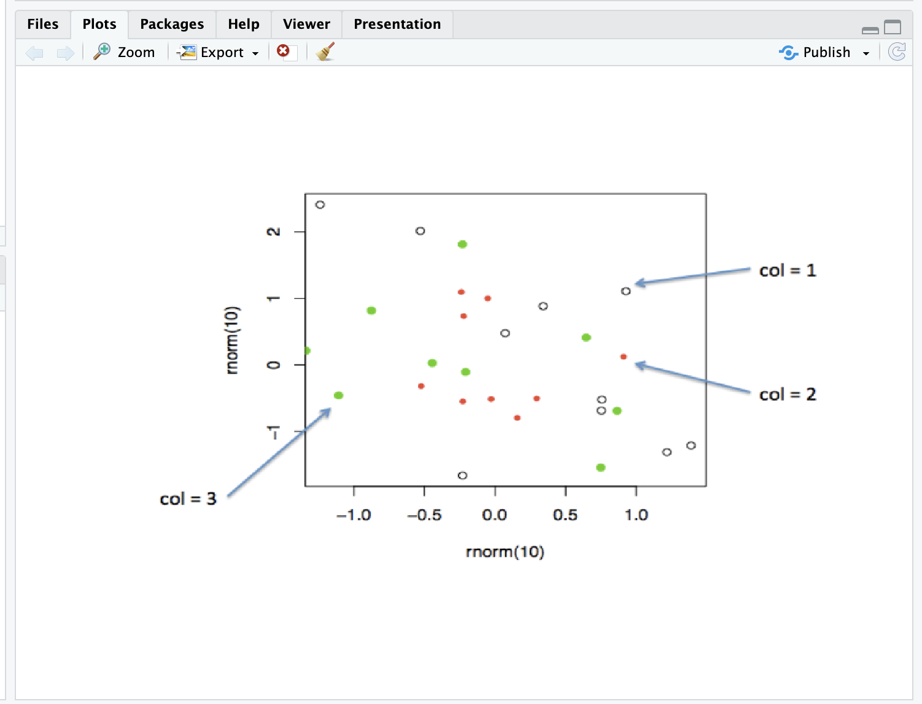

...

|====== | 7%

| According to the plot, what is color 2?

1: Empty black circles

2: Blue

3: Red

4: Green

Selection: 3

| Nice work!

|======= | 9%

| So these are the first 3 default values. If you were plotting and just specified

| col=c(1:3) as one of your arguments, these are colors you'd get. Maybe you like them,

| but they might not be the best choice for your application.

...

|======== | 10%

| To show you some options, here's a display of two color palettes that come with the

| grDevices package available to you. The left shows you some colors from the function

| heat.colors. Here low values are represented in red and as the values increase the

| colors move through yellow towards white. This is consistent with the physical

| properties of fire. The right display is from the function topo.colors which uses

| topographical colors ranging from blue (low values) towards brown (higher values).

...

|========= | 12%

| So we'll first discuss some functions that the grDevices package offers. The function

| colors() lists the names of 657 predefined colors you can use in any plotting

| function. These names are returned as strings. Run the R command sample with

| colors() as its first argument and 10 as its second to give you an idea of the

| choices you have.

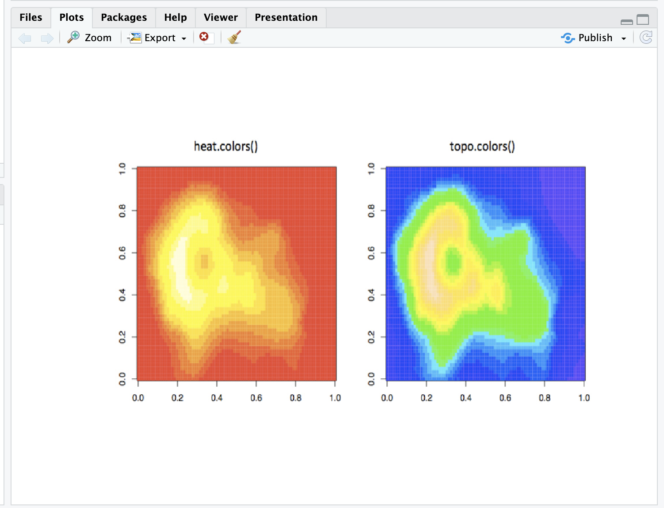

> sample(colors(), 10)

[1] "gray76" "mediumslateblue" "limegreen" "gray70"

[5] "moccasin" "orange" "red1" "thistle2"

[9] "grey53" "grey74"

| Excellent job!

|========== | 13%

| We see a lot of variety in the colors, some of which are names followed by numbers

| indicating that there are multiple forms of that particular color.

...

|=========== | 14%

| So you're free to use any of these 600+ colors listed by the colors function.

| However, two additional functions from grDevices, colorRamp and colorRampPalette,

| give you more options. Both of these take color names as arguments and use them as

| "palettes", that is, these argument colors are blended in different proportions to

| form new colors.

...

|============ | 16%

| The first, colorRamp, takes a palette of colors (the arguments) and returns a

| function that takes values between 0 and 1 as arguments. The 0 and 1 correspond to

| the extremes of the color palette. Arguments between 0 and 1 return blends of these

| extremes.

...

|============== | 17%

| Let's see what this means. Assign to the variable pal the output of a call to

| colorRamp with the single argument, c("red","blue").

> pal <- colorRamp(c("red", "blue"))

| Keep working like that and you'll get there!

|=============== | 19%

| We don't see any output, but R has created the function pal which we can call with a

| single argument between 0 and 1. Call pal now with the argument 0.

> pal(0)

[,1] [,2] [,3]

[1,] 255 0 0

| Keep up the great work!

|================ | 20%

| We see a 1 by 3 array with 255 as the first entry and 0 in the other 2. This 3 long

| vector corresponds to red, green, blue (RGB) color encoding commonly used in

| televisions and monitors. In R, 24 bits are used to represent colors. Think of these

| 24 bits as 3 sets of 8 bits, each of which represents an intensity for one of the

| colors red, green, and blue.

...

|================= | 22%

| The 255 returned from the pal(0) call corresponds to the largest possible number

| represented with 8 bits, so the vector (255,0,0) contains only red (no green or

| blue), and moreover, it's the highest possible value of red.

...

|================== | 23%

| Given that you created pal with the palette containing "red" and "blue", what color

| do you think will be represented by the vector that pal(1) returns? Recall that pal

| will only take arguments between 0 and 1, so 1 is the largest argument you can pass

| it.

1: red

2: blue

3: yellow

4: green

Selection: 2

| That's the answer I was looking for.

|=================== | 25%

| Check your answer now by calling pal with the argument 1.

> pol(1)

Error in pol(1) : could not find function "pol"

> pal(1)

[,1] [,2] [,3]

[1,] 0 0 255

| Keep working like that and you'll get there!

|==================== | 26%

| You see the vector (0,0,255) which represents the highest intensity of blue. What

| vector do you think the call pal(.5) will return?

1: (127.5,0,127.5)

2: (255,0,255)

3: (255,255,255)

4: (0,255,0)

Selection: 1

| You are really on a roll!

|===================== | 28%

| The function pal can take more than one argument. It returns one 3-long (or 4-long,

| but more about this later) vector for each argument. To see this in action, call pal

| with the argument seq(0,1,len=6).

> pal(seq(0,1,len=6))

[,1] [,2] [,3]

[1,] 255 0 0

[2,] 204 0 51

[3,] 153 0 102

[4,] 102 0 153

[5,] 51 0 204

[6,] 0 0 255

| All that practice is paying off!

|======================= | 29%

| Six vectors (each of length 3) are returned. The i-th vector is identical to output

| that would be returned by the call pal(i/5) for i=0,...5. We see that the i-th row

| (for i=1,...6) differs from the (i-1)-st row in the following way. Its red entry is

| 51 = 255/5 points lower and its blue entry is 51 points higher.

...

|======================== | 30%

| So pal creates colors using the palette we specified when we called colorRamp. In

| this example none of pal's outputs will ever contain green since it wasn't in our

| initial palette.

...

|========================= | 32%

| We'll turn now to colorRampPalette, a function similar to colorRamp. It also takes a

| palette of colors and returns a function. This function, however, takes integer

| arguments (instead of numbers between 0 and 1) and returns a vector of colors each of

| which is a blend of colors of the original palette.

...

|========================== | 33%

| The argument you pass to the returned function specifies the number of colors you

| want returned. Each element of the returned vector is a 24 bit number, represented as

| 6 hexadecimal characters, which range from 0 to F. This set of 6 hex characters

| represents the intensities of red, green, and blue, 2 characters for each color.

...

|=========================== | 35%

| To see this better, assign to the variable p1 the output of a call to

| colorRampPalette with the single argument, c("red","blue"). We'll compare it to our

| experiments using colorRamp.

> p1 <- colorRampPalette(c("red", "blue"))

| That's the answer I was looking for.

|============================ | 36%

| Now call p1 with the argument 2.

> p1(2)

[1] "#FF0000" "#0000FF"

| Perseverance, that's the answer.

|============================= | 38%

| We see a 2-long vector is returned. The first entry FF0000 represents red. The FF is

| hexadecimal for 255, the same value returned by our call pal(0). The second entry

| 0000FF represents blue, also with intensity 255.

...

|=============================== | 39%

| Now call p1 with the argument 6. Let's see if we get the same result as we did when

| we called pal with the argument seq(0,1,len=6).

> p1(6)

[1] "#FF0000" "#CC0033" "#990066" "#650099" "#3200CC" "#0000FF"

| Great job!

|================================ | 41%

| Now we get the 6-long vector (FF0000, CC0033, 990066, 650099, 3200CC, 0000FF). We see

| the two ends (FF0000 and 0000FF) are consistent with the colors red and blue. How

| about CC0033? Type 0xcc or 0xCC at the command line to see the decimal equivalent of

| this hex number. You must include the 0 before the x to specify that you're entering

| a hexadecimal number.

> 0xcc

[1] 204

| That's correct!

|================================= | 42%

| So 0xCC equals 204 and we can easily convert hex 33 to decimal, as in 0x33=3*16+3=51.

| These were exactly the numbers we got in the second row returned from our call to

| pal(seq(0,1,len=6)). We see that 4 of the 6 numbers agree with our earlier call to

| pal. Two of the 6 differ slightly.

...

|================================== | 43%

| We can also form palettes using colors other than red, green and blue. Form a

| palette, p2, by calling colorRampPalette with the colors "red" and "yellow". Remember

| to concatenate them into a single argument.

>

> p2 <- colorRampPalette(c("red","yellow"))

| All that practice is paying off!

|=================================== | 45%

| Now call p2 with the argument 2. This will show us the two extremes of the blends of

| colors we'll get.

> p2(2)

[1] "#FF0000" "#FFFF00"

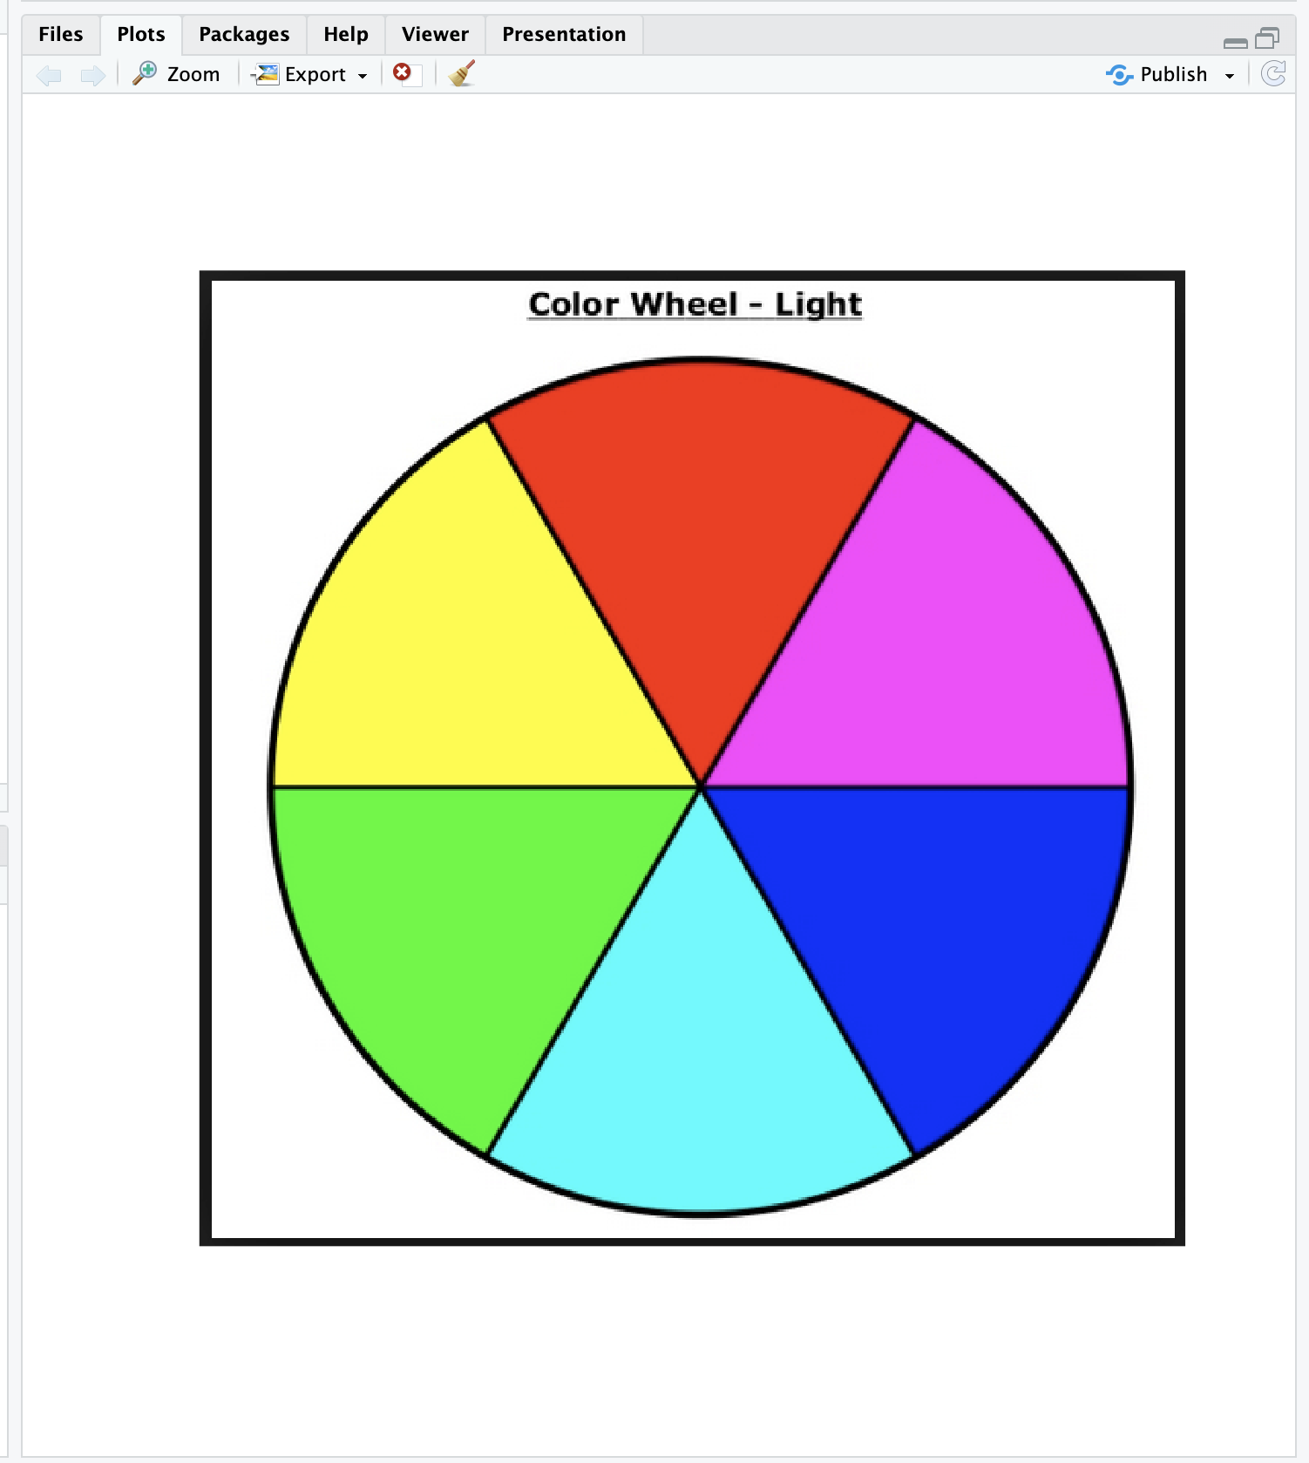

| You nailed it! Good job!

|==================================== | 46%

| Not surprisingly the first color we see is FF0000, which we know represents red. The

| second color returned, FFFF00, must represent yellow, a combination of full intensity

| red and full intensity green. This makes sense, since yellow falls between red and

| green on the color wheel as we see here. (We borrowed this image from

| lucaskrech.com.)

|===================================== | 48%

| Let's now call p2 with the argument 10. This will show us how the two extremes, red

| and yellow, are blended together.

>

> p2(10)

[1] "#FF0000" "#FF1C00" "#FF3800" "#FF5500" "#FF7100" "#FF8D00" "#FFAA00" "#FFC600"

[9] "#FFE200" "#FFFF00"

| That's the answer I was looking for.

|====================================== | 49%

| So we see the 10-long vector. For each element, the red component is fixed at FF, and

| the green component grows from 00 (at the first element) to FF (at the last).

...

|======================================== | 51%

| This is all fine and dandy but you're probably wondering when you can see how all

| these colors show up in a display. We copied some code from the R documentation pages

| (color.scale if you're interested) and created a function for you, showMe. This takes

| as an argument, a color vector, which as you know, is precisely what calls to p1 and

| p2 return to you. Call showMe now with p1(20).

> shiwMe(p1(20))

Error in shiwMe(p1(20)) : could not find function "shiwMe"

> showMe(p1(20))

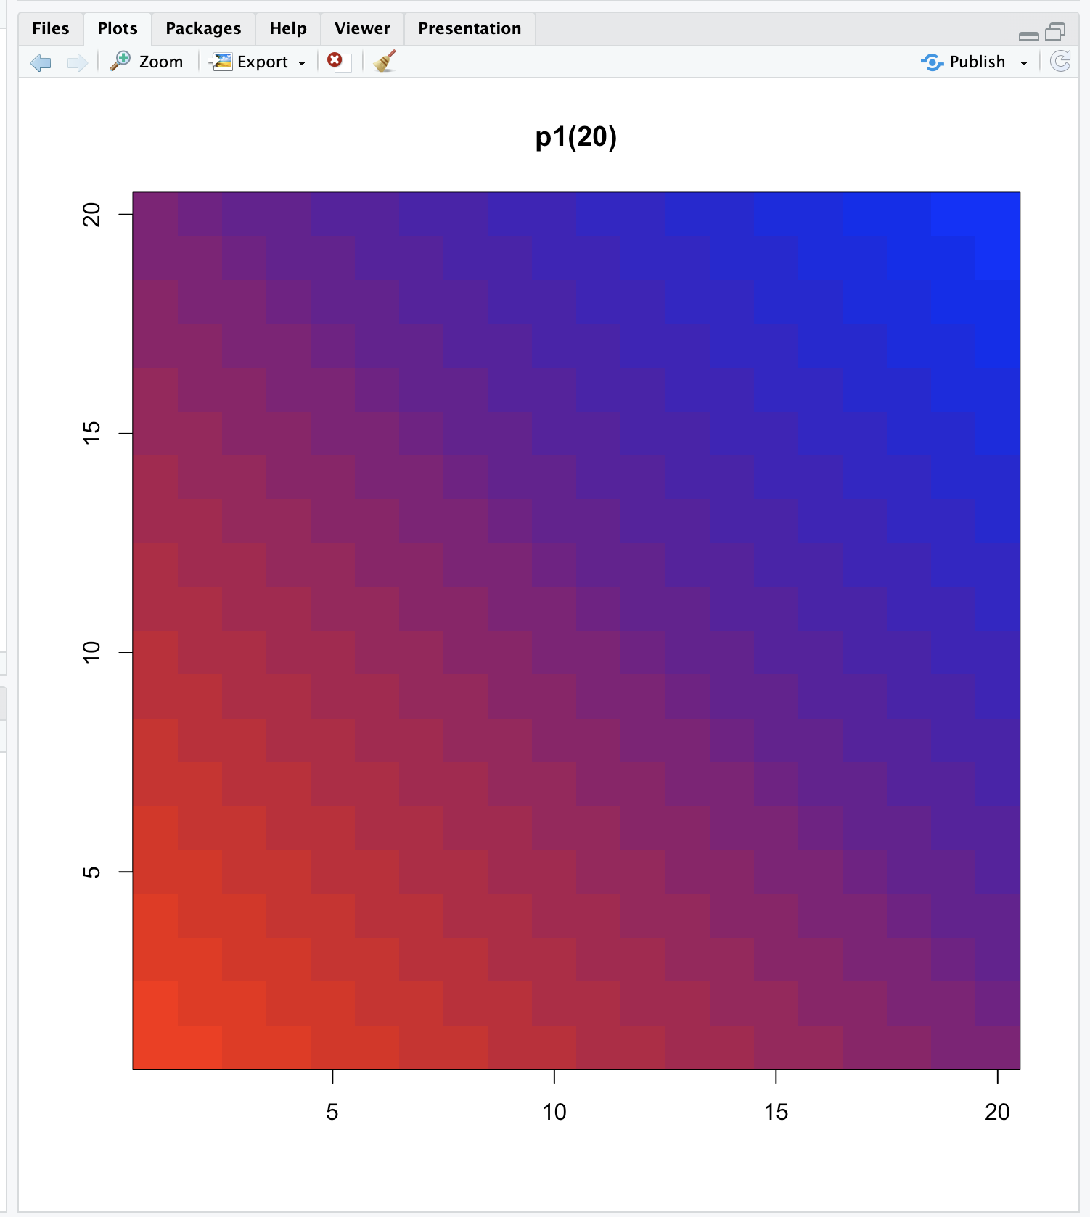

| You are amazing!

|========================================= | 52%

| We see the interpolated palette here. Low values in the lower left corner are red and

| as you move to the upper right, the colors move toward blue. Now call showMe with

| p2(20) as its argument.

> showMe(p2(20))

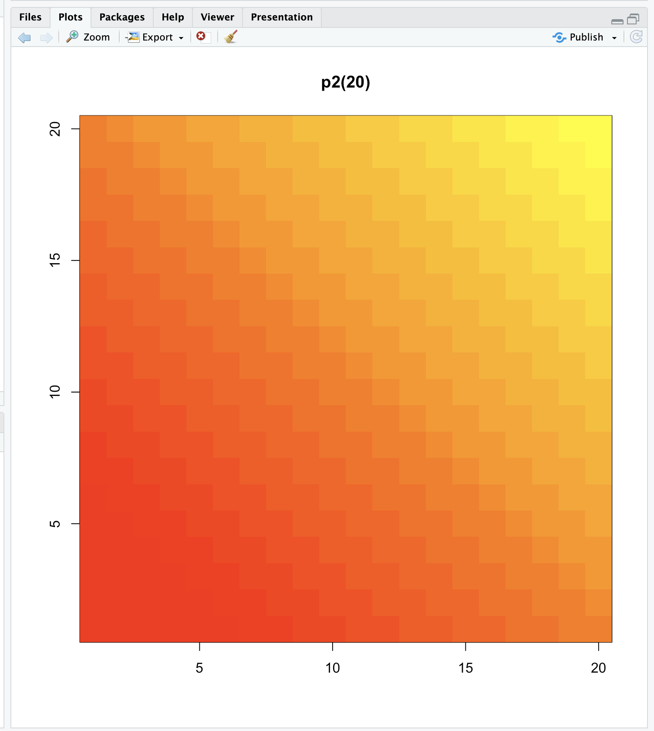

| Perseverance, that's the answer.

|========================================== | 54%

| Here we see a similar display, the colors moving from red to yellow, the base colors

| of our p2 palette. For fun, see what p2(2) looks like using showMe.

> showMe(p2(2))

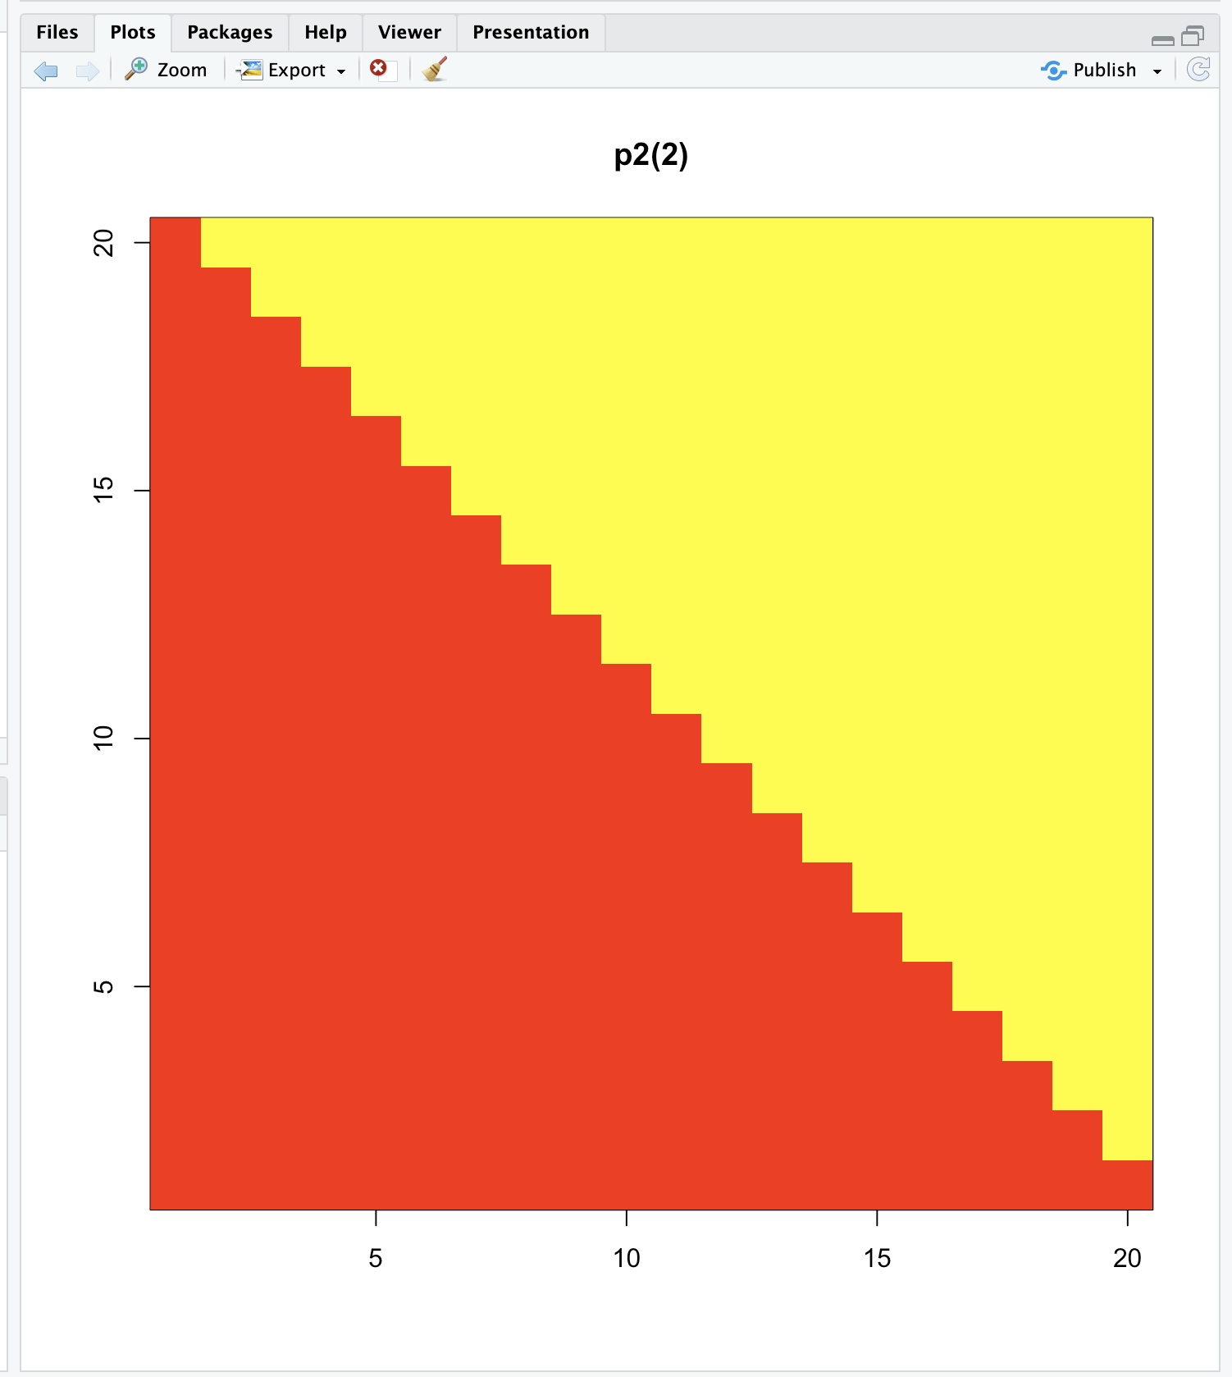

| You are quite good my friend!

|=========================================== | 55%

| A much more basic pattern, simple but elegant.

|============================================ | 57%

| We mentioned before that colorRamp (and colorRampPalette) could return a 3 or 4 long

| vector of colors. We saw 3-long vectors returned indicating red, green, and blue

| intensities. What would the 4th entry be?

...

|============================================= | 58%

| We'll answer this indirectly. First, look at the function p1 that colorRampPalette

| returned to you. Just type p1 at the command prompt.

> p1

function (n)

{

x <- ramp(seq.int(0, 1, length.out = n))

if (ncol(x) == 4L)

rgb(x[, 1L], x[, 2L], x[, 3L], x[, 4L], maxColorValue = 255)

else rgb(x[, 1L], x[, 2L], x[, 3L], maxColorValue = 255)

}

<bytecode: 0x7fccf06e0800>

<environment: 0x7fcce4ab2d78>

| Perseverance, that's the answer.

|============================================== | 59%

| We see that p1 is a short function with one argument, n. The argument n is used as

| the length in a call to the function seq.int, itself an argument to the function

| ramp. We can infer that ramp is just going to divide the interval from 0 to 1 into n

| pieces.

...

|=============================================== | 61%

| The heart of p1 is really the call to the function rgb with either 4 or 5 arguments.

| Use the ?fun construct to look at the R documentation for rgb now.

> ?fun

No documentation for ‘fun’ in specified packages and libraries:

you could try ‘??fun’

| You almost had it, but not quite. Try again. Or, type info() for more options.

| Type ?rgb at the command prompt.

> ?rgb

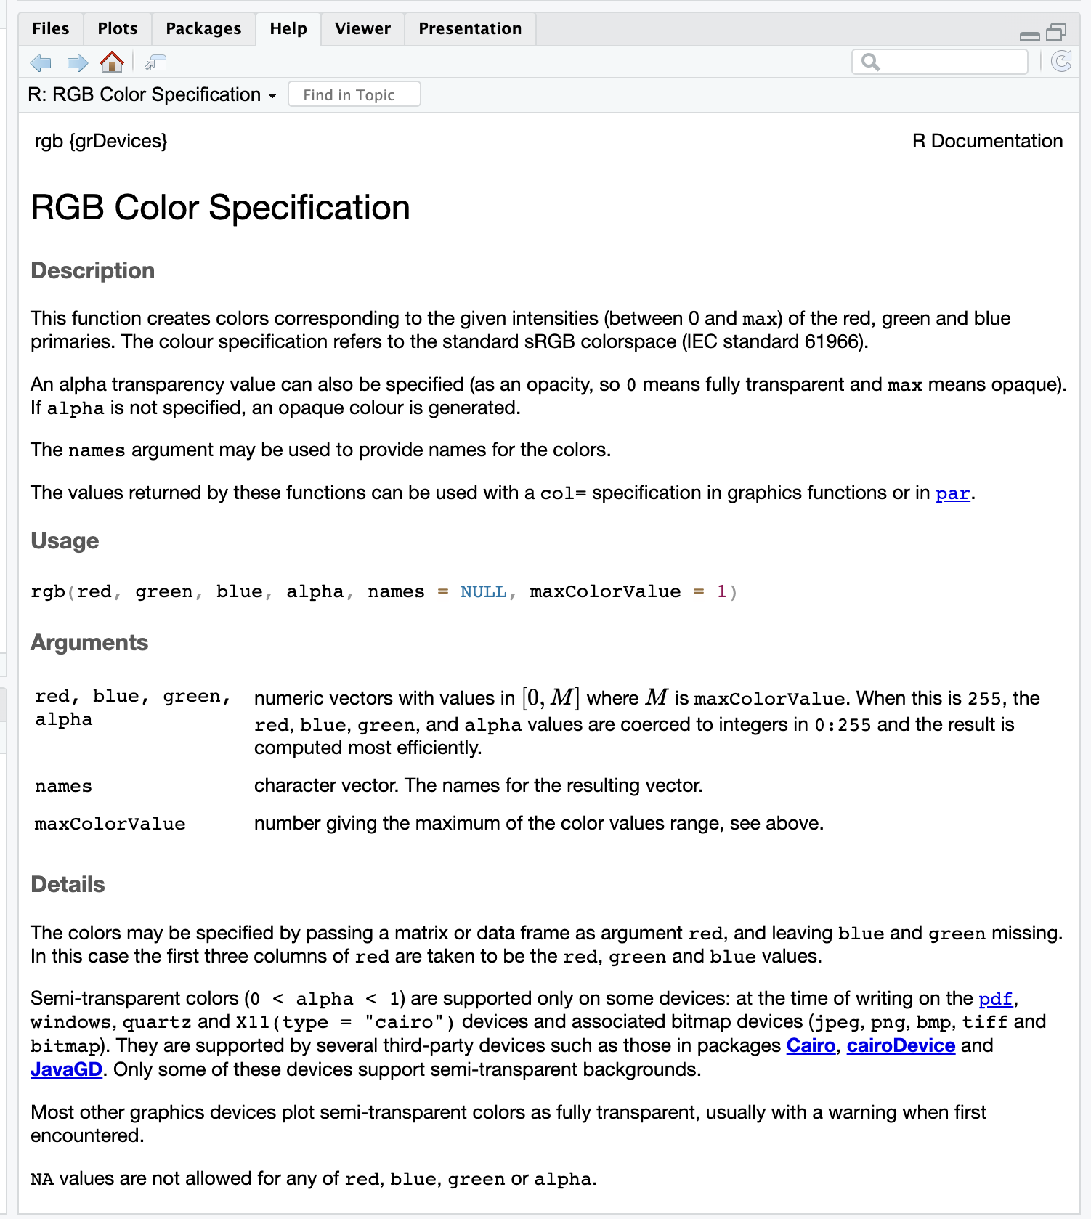

| That's correct!

|================================================= | 62%

| We see that rgb is a color specification function that can be used to produce any

| color with red, green, blue proportions. We see the maxColorValue is 1 by default, so

| if we called rgb with values for red, green and blue, we would specify numbers at

| most 1 (assuming we didn't change the default for maxColorValue). According to the

| documentation, what is the maximum number of arguments rgb can have?

1: 5

2: 4

3: 3

4: 6

Selection: 4

| You're the best!

|================================================== | 64%

| So the fourth argument is alpha which can be a logical, i.e., either TRUE or FALSE,

| or a numerical value. Create the function p3 now by calling colorRampPalette with the

| colors blue and green (remember to concatenate them into a single argument) and

| setting the alpha argument to .5.

> p3 <- colorRampPalette(c("blue","green"),alpha=.5)

| Nice work!

|=================================================== | 65%

| Now call p3 with the argument 5.

> p3(5)

[1] "#0000FFFF" "#003FBFFF" "#007F7FFF" "#00BF3FFF" "#00FF00FF"

| You are doing so well!

|==================================================== | 67%

| We see that in the 5-long vector that the call returned, each element has 32 bits, 4

| groups of 8 bits each. The last 8 bits represent the value of alpha. Since it was NOT

| ZERO in the call to colorRampPalette, it gets the maximum FF value. (The same result

| would happen if alpha had been set to TRUE.) When it was 0 or FALSE (as in previous

| calls to colorRampPalette) it was given the value 00 and wasn't shown. The leftmost

| 24 bits of each element are the same RGB encoding we previously saw.

...

|===================================================== | 68%

| So what is alpha? Alpha represents an opacity level, that is, how transparent should

| the colors be. We can add color transparency with the alpha parameter to calls to

| rgb. We haven't seen any examples of this yet, but we will now.

...

|====================================================== | 70%

| We generated 1000 random normal pairs for you in the variables x and y. We'll plot

| them in a scatterplot by calling plot with 4 arguments. The variables x and y are the

| first 2. The third is the print character argument pch. Set this equal to 19 (filled

| circles). The final argument is col which should be set equal to a call to rgb. Give

| rgb 3 arguments, 0, .5, and .5.

> plot(x,y,pch=19,col=rgb(0,.5,.5))

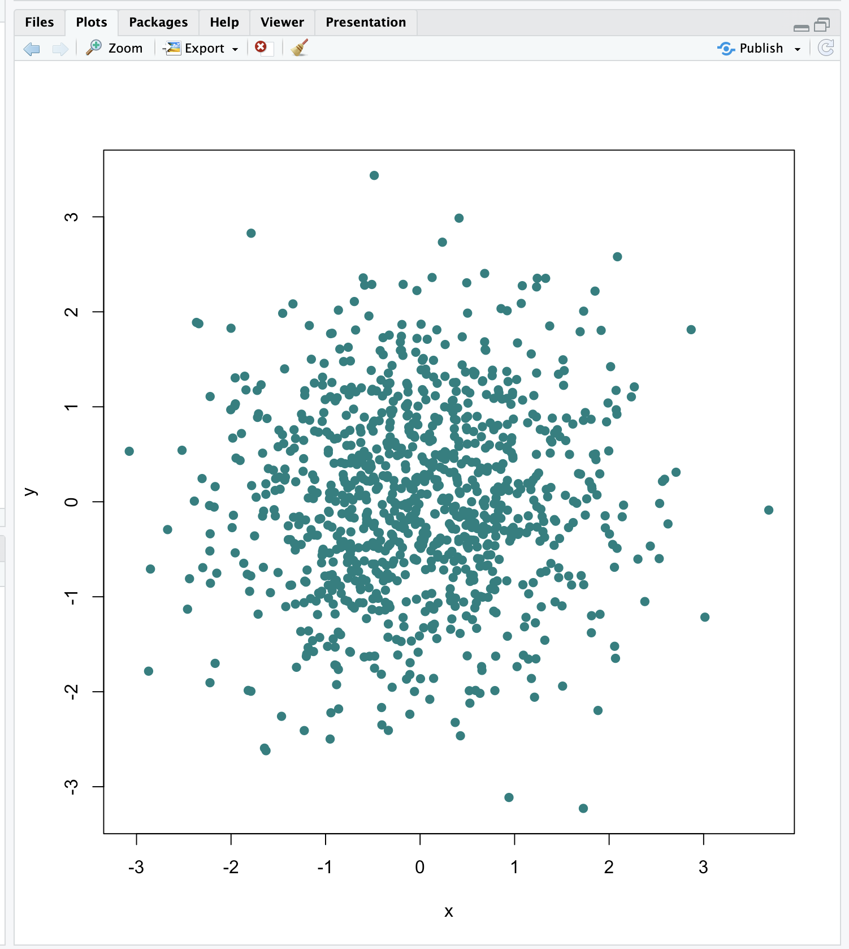

| You're the best!

|======================================================= | 71%

| Well this picture is okay for a scatterplot, a nice mix of blue and green, but it

| really doesn't tell us too much information in the center portion, since the points

| are so thick there. We see there are a lot of points, but is one area more filled

| than another? We can't really discriminate between different point densities. This is

| where the alpha argument can help us. Recall your plot command (use the up arrow) and

| add a 4th argument, .3, to the call to rgb. This will be our value for alpha.

> plot(x,y,pch=19,col=rgb(0,.5,.5, .3))

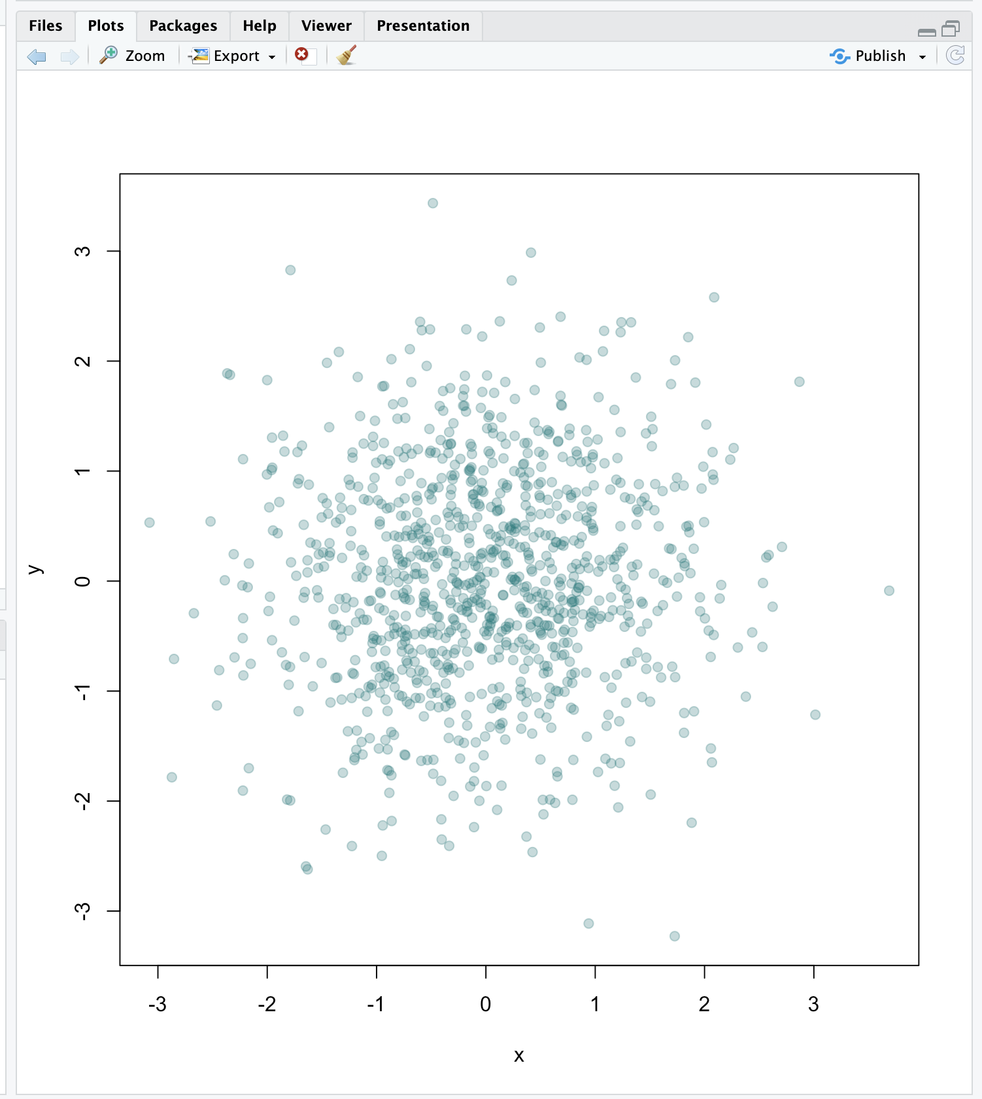

| All that practice is paying off!

|========================================================= | 72%

| Clearly this is better. It shows us where, specifically, the densest areas of the

| scatterplot really are.

|========================================================== | 74%

| Our last topic for this lesson is the RColorBrewer Package, available on CRAN, that

| contains interesting and useful color palettes, of which there are 3 types,

| sequential, divergent, and qualitative. Which one you would choose to use depends on

| your data.

...

|=========================================================== | 75%

| Here's a picture of the palettes available from this package. The top section shows

| the sequential palettes in which the colors are ordered from light to dark. The

| divergent palettes are at the bottom. Here the neutral color (white) is in the

| center, and as you move from the middle to the two ends of each palette, the colors

| increase in intensity. The middle display shows the qualitative palettes which look

| like collections of random colors. These might be used to distinguish factors in your

| data.

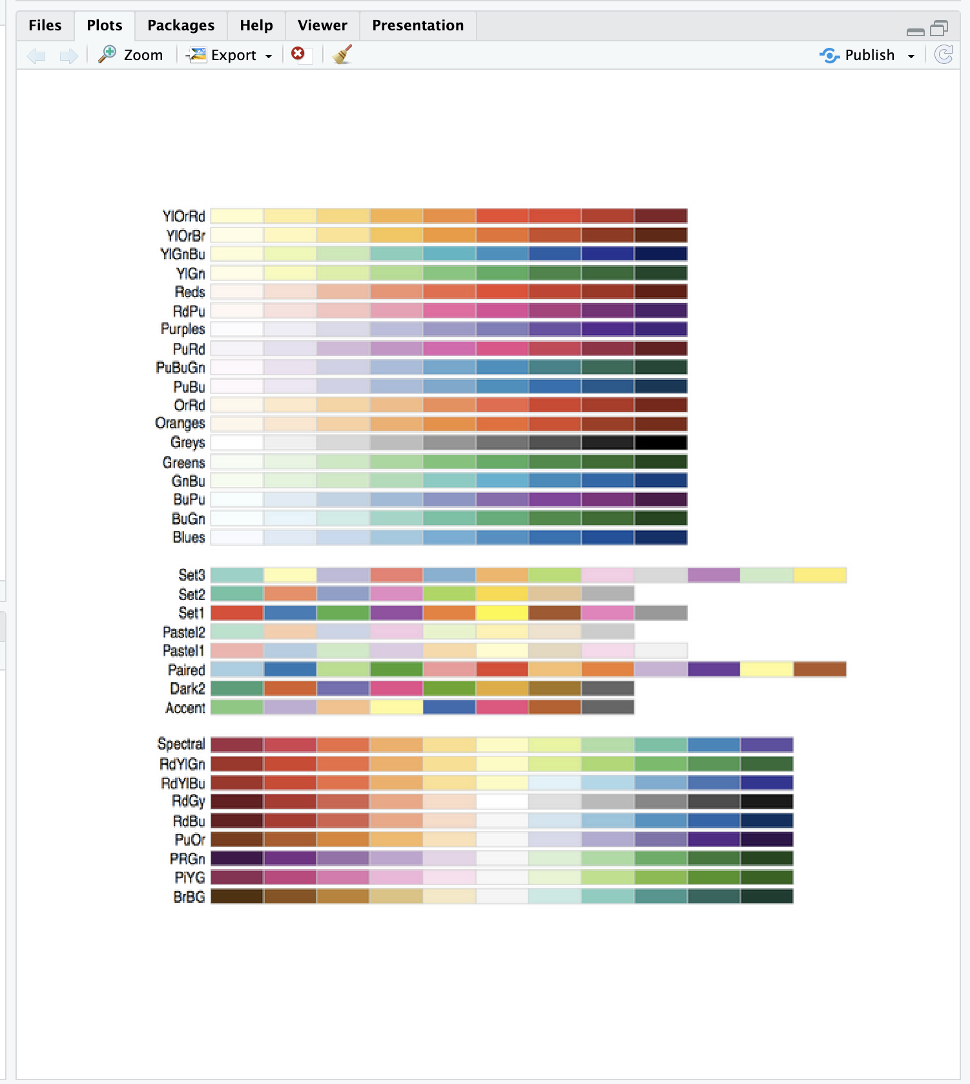

|============================================================ | 77%

| These colorBrewer palettes can be used in conjunction with the colorRamp() and

| colorRampPalette() functions. You would use colors from a colorBrewer palette as your

| base palette,i.e., as arguments to colorRamp or colorRampPalette which would

| interpolate them to create new colors.

|============================================================= | 78%

| As an example of this, create a new object, cols by calling the function brewer.pal

| with 2 arguments, 3 and "BuGn". The string "BuGn" is the second last palette in the

| sequential display. The 3 tells the function how many different colors we want.

> cols <- brewer.pal(3, "BuGn")

| Keep working like that and you'll get there!

|============================================================== | 80%

| Use showMe to look at cols now.

> showMe(cols)

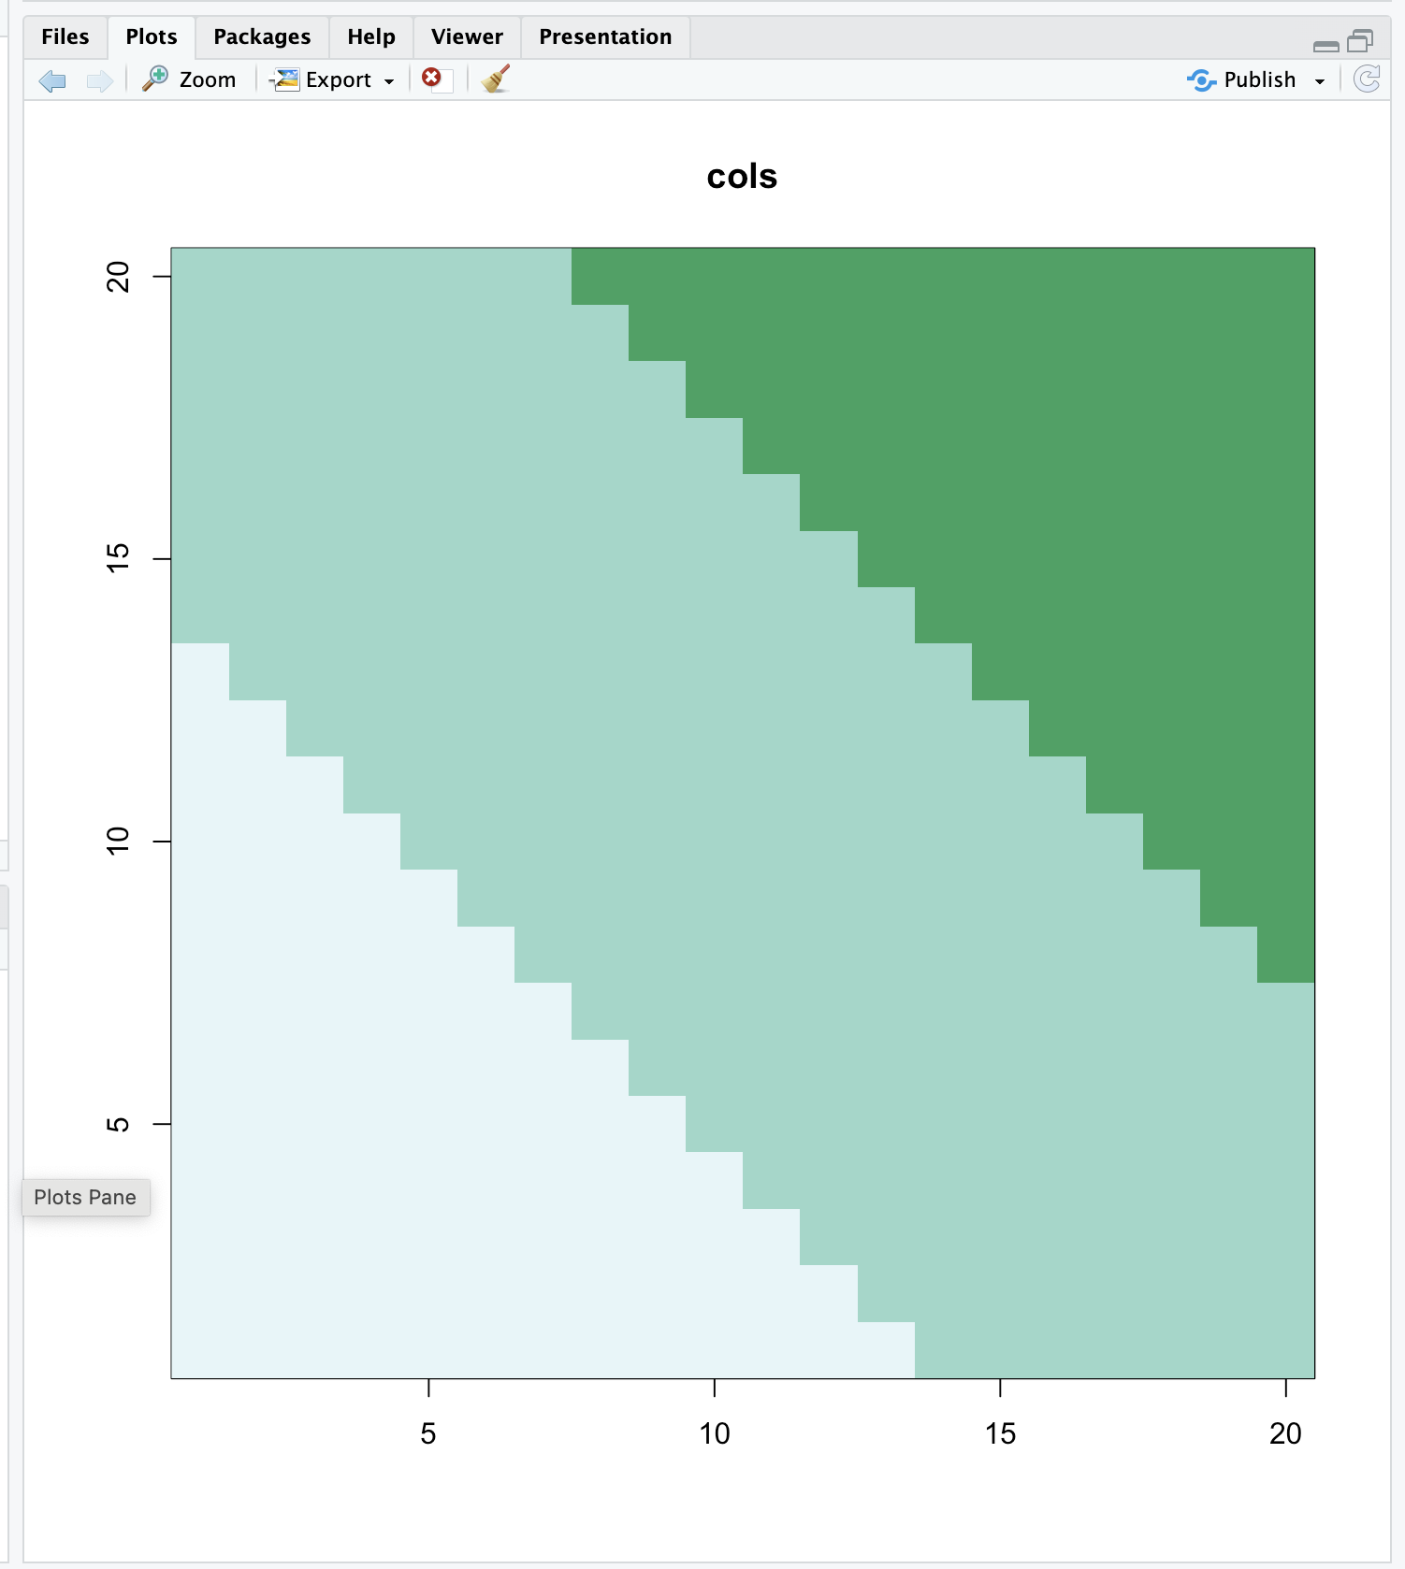

| You're the best!

|=============================================================== | 81%

| We see 3 colors, mixes of blue and green. Now create the variable pal by calling

| colorRampPalette with cols as its argument.

> pal <- colorRampPalette(cols)

| All that hard work is paying off!

|================================================================ | 83%

| The call showMe(pal(3)) would be identical to the showMe(cols) call. So use showMe to

| look at pal(20).

> showMe(pal(20))

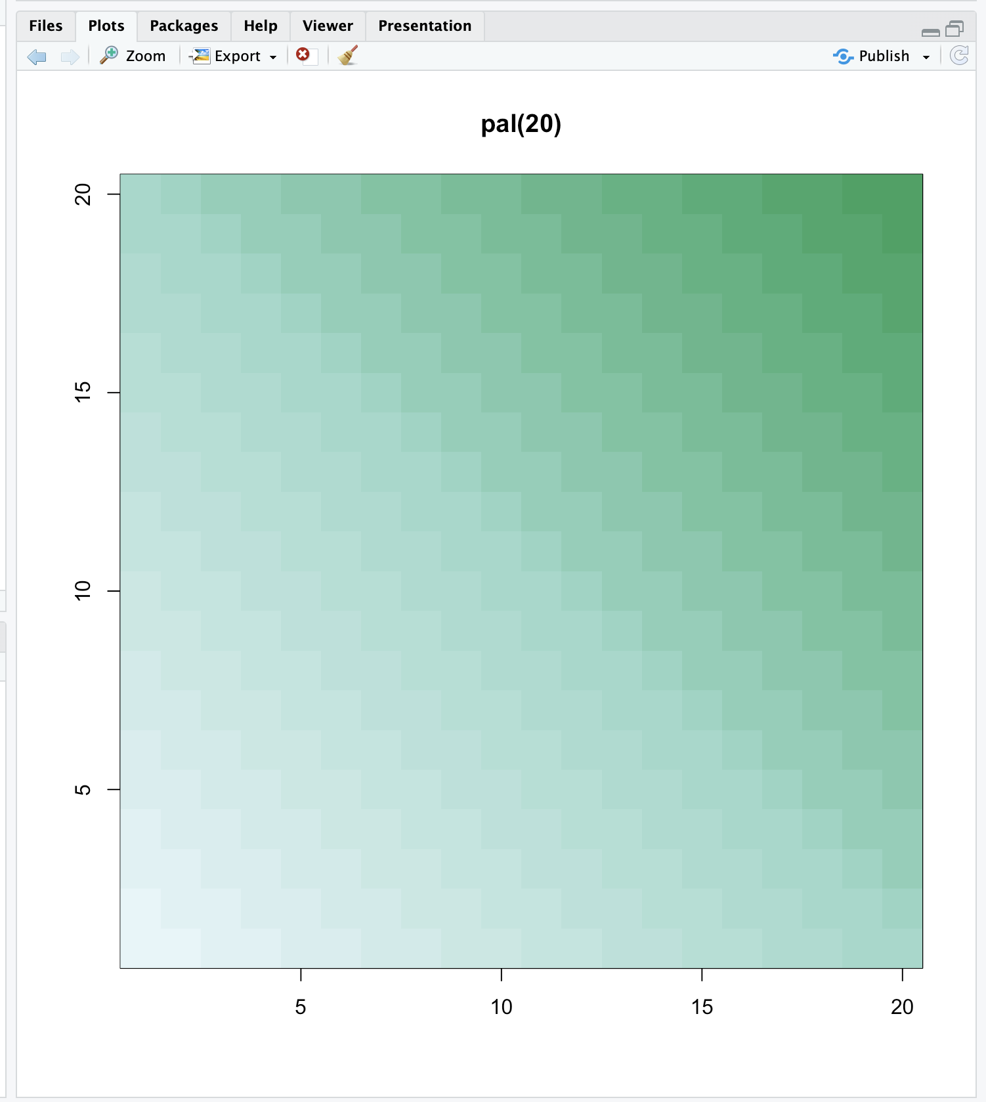

| Keep working like that and you'll get there!

|================================================================== | 84%

| Now we can use the colors in pal(20) to display topographic information on Auckland's

| Maunga Whau Volcano. R provides this information in a matrix called volcano which is

| included in the package datasets. Call the R function image with volcano as its

| first argument and col set equal to pal(20) as its second.

> image(volcano, col = pal(20))

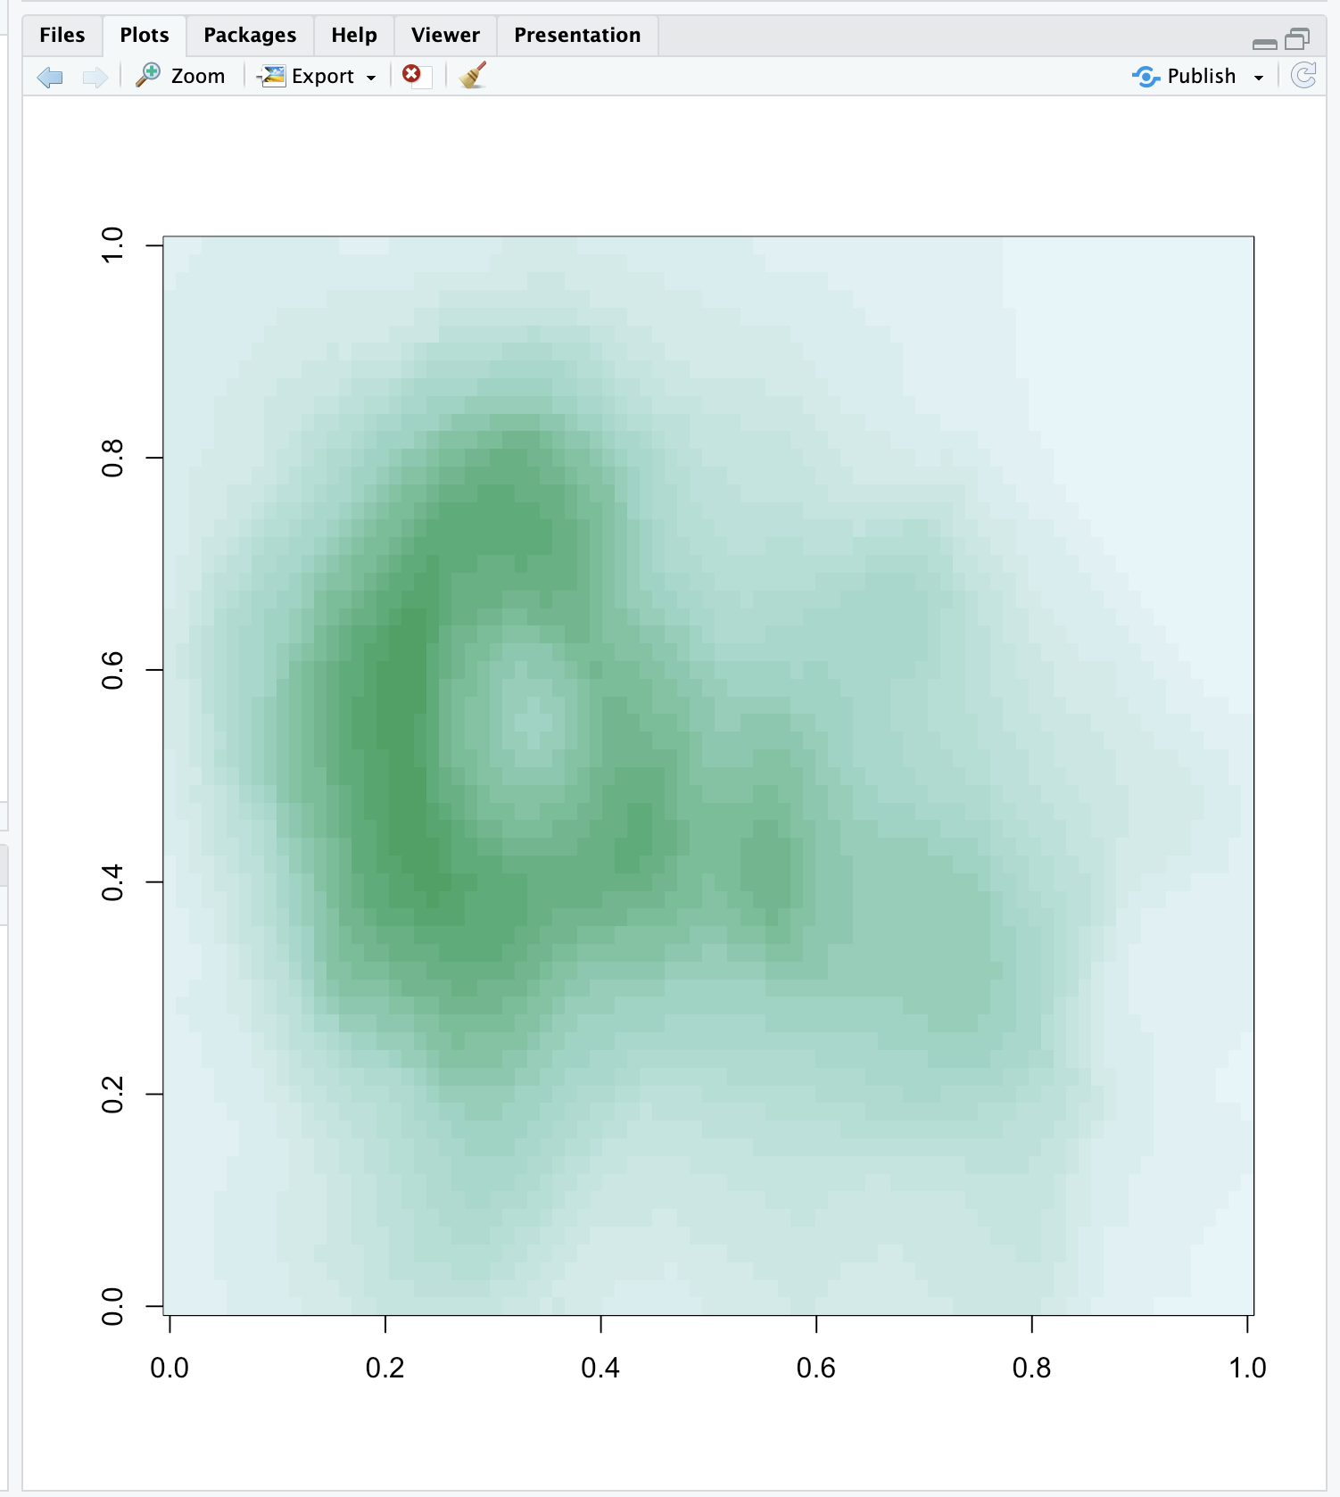

| You are quite good my friend!

|=================================================================== | 86%

| We see that the colors here of the sequential palette clue us in on the topography.

| The darker colors are more concentrated than the lighter ones. Just for fun, recall

| your last command calling image and instead of pal(20), use p1(20) as the second

| argument.

> image(volcano, col = p1(20))

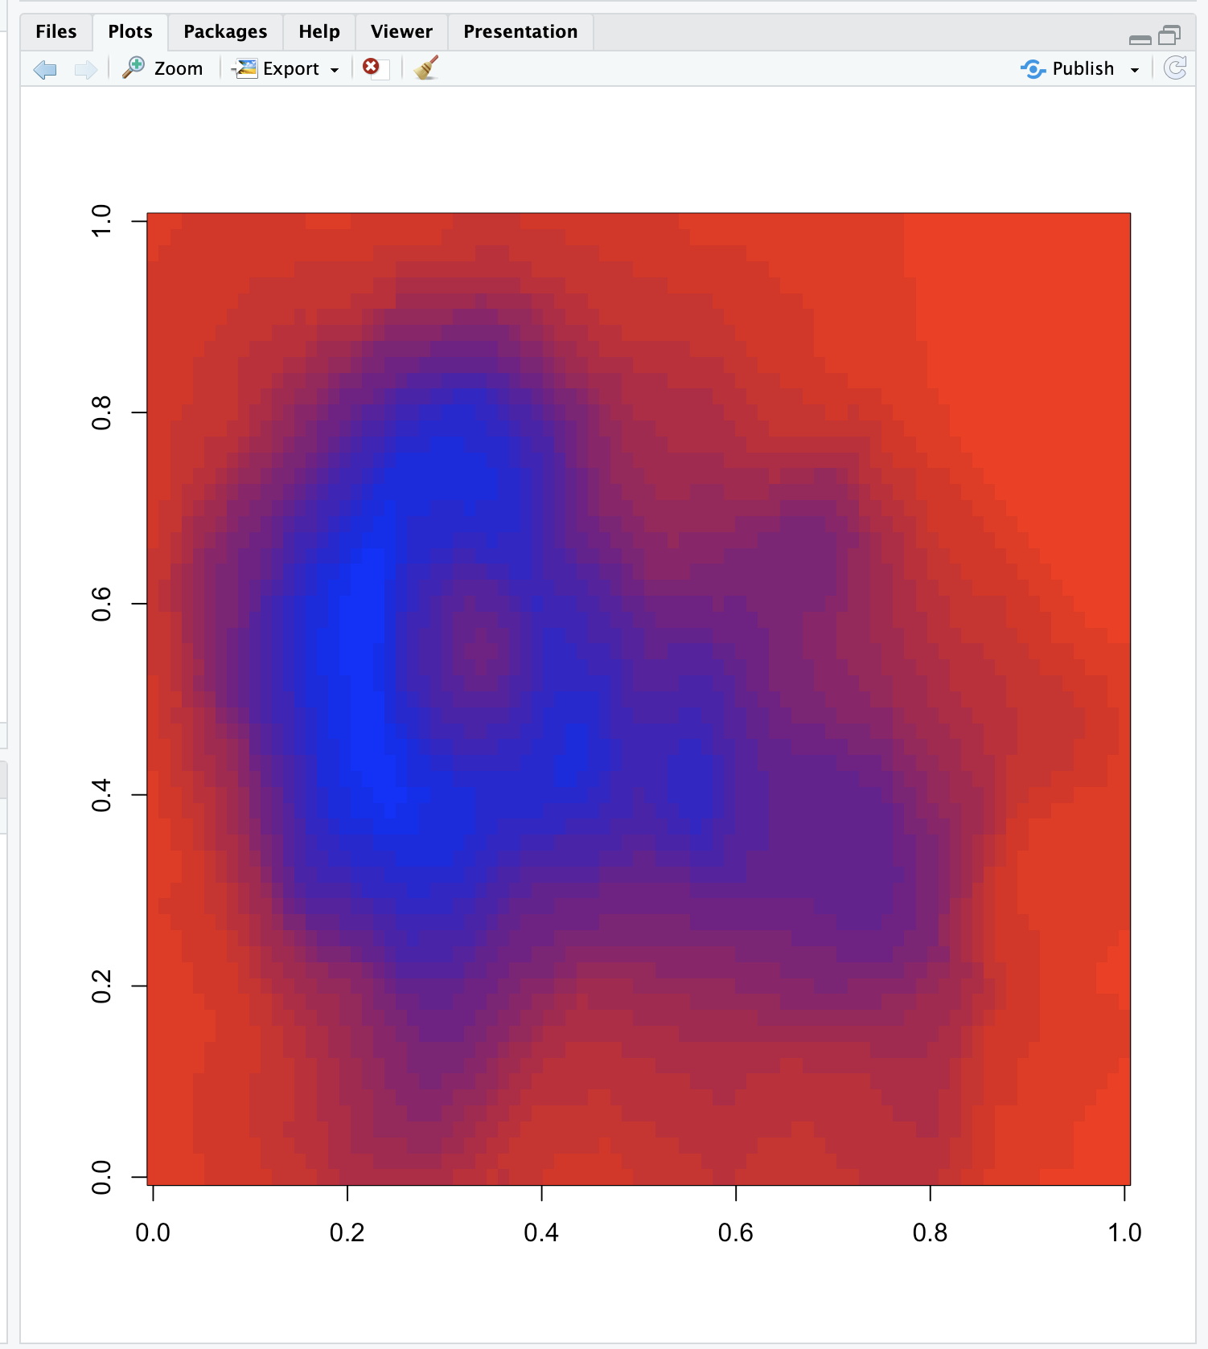

| Great job!

|==================================================================== | 87%

| Not as nice a picture since the palette isn't as well suited to this data, but that's

| okay. It's review time!!!!

|===================================================================== | 88%

| True or False? Careful use of colors in plots/maps/etc. can make it easier for the

| reader to understand what points you're trying to convey.

1: False

2: True

Selection: 2

| You nailed it! Good job!

|====================================================================== | 90%

| Which of the following is an R package that provides color palettes for sequential,

| categorical, and diverging data?

1: RColorStewer

2: RColorBrewer

3: RColorBluer

4: RColorVintner

Selection: 2

| You nailed it! Good job!

|======================================================================= | 91%

| True or False? The colorRamp and colorRampPalette functions can be used in

| conjunction with color palettes to connect data to colors.

1: False

2: True

Selection: 2

| Perseverance, that's the answer.

|======================================================================== | 93%

| True or False? Transparency can NEVER be used to clarify plots with many points

1: True

2: False

Selection: 2

| All that hard work is paying off!

|========================================================================= | 94%

| True or False? The call p7 <- colorRamp("red","blue") would work (i.e., not generate

| an error).

1: False

2: True

Selection: 1

| Excellent work!

|=========================================================================== | 96%

| True or False? The function colors returns only 10 colors.

1: True

2: False

Selection: 2

| You are really on a roll!

|============================================================================ | 97%

| Transparency is determined by which parameter of the rgb function?

1: gamma

2: alpha

3: delta

4: beta

5: it's all Greek to me

Selection: 2

| Your dedication is inspiring!

|============================================================================= | 99%

| Congratulations! We hope this lesson didn't make you see red. We're green with envy

| that you blue through it.

...

|==============================================================================| 100%

| Would you like to receive credit for completing this course on Coursera.org?

1: No

2: Yes

Selection: 1

| Perseverance, that's the answer.

| You've reached the end of this lesson! Returning to the main menu...

| Please choose a course, or type 0 to exit swirl.

1: Exploratory Data Analysis

2: Take me to the swirl course repository!

Selection: 1

| Please choose a lesson, or type 0 to return to course menu.

1: Principles of Analytic Graphs 2: Exploratory Graphs

3: Graphics Devices in R 4: Plotting Systems

5: Base Plotting System 6: Lattice Plotting System

7: Working with Colors 8: GGPlot2 Part1

9: GGPlot2 Part2 10: GGPlot2 Extras

11: Hierarchical Clustering 12: K Means Clustering

13: Dimension Reduction 14: Clustering Example

15: CaseStudy

Selection: 8

| Attempting to load lesson dependencies...

| Package ‘ggplot2’ loaded correctly!

| | 0%

| GGPlot2_Part1. (Slides for this and other Data Science courses may be found at github

| https://github.com/DataScienceSpecialization/courses/. If you care to use them, they

| must be downloaded as a zip file and viewed locally. This lesson corresponds to

| 04_ExploratoryAnalysis/ggplot2.)

|== | 2%

| In another lesson, we gave you an overview of the three plotting systems in R. In

| this lesson we'll focus on the third and newest plotting system in R, ggplot2. As we

| did with the other two systems, we'll focus on creating graphics on the screen device

| rather than another graphics device.

...

|==== | 5%

| The ggplot2 package is an add-on package available from CRAN via install.packages().

| (Don't worry, we've installed it for you already.) It is an implementation of The

| Grammar of Graphics, an abstract concept (as well as book) authored and invented by

| Leland Wilkinson and implemented by Hadley Wickham while he was a graduate student at

| Iowa State. The web site http://ggplot2.org provides complete documentation.

...

|====== | 7%

| A grammar of graphics represents an abstraction of graphics, that is, a theory of

| graphics which conceptualizes basic pieces from which you can build new graphics and

| graphical objects. The goal of the grammar is to “Shorten the distance from mind to

| page”. From Hadley Wickham's book we learn that

...

|======== | 10%

| The ggplot2 package "is composed of a set of independent components that can be

| composed in many different ways. ... you can create new graphics that are precisely

| tailored for your problem." These components include aesthetics which are attributes

| such as colour, shape, and size, and geometric objects or geoms such as points,

| lines, and bars.

...

|========== | 12%

| Before we delve into details, let's review the other 2 plotting systems.

...

|=========== | 15%

| Recall what you know about R's base plotting system. Which of the following does NOT

| apply to it?

1: Start with plot (or similar) function

2: It is convenient and mirrors how we think of building plots and analyzing data

3: Use annotation functions to add/modify (text, lines, points, axis)

4: Can easily go back once the plot has started (e.g., to adjust margins or correct a typo)

Selection: 4

| Your dedication is inspiring!

|============= | 17%

| Recall what you know about R's lattice plotting system. Which of the following does

| NOT apply to it?

1: Most useful for conditioning types of plots and putting many panels on one plot

2: Margins and spacing are set automatically because entire plot is specified at once

3: Can always add to the plot once it is created

4: Plots are created with a single function call (xyplot, bwplot, etc.)

Selection: 3

| Keep up the great work!

|=============== | 20%

| If we told you that ggplot2 combines the best of base and lattice, that would mean it

| ...?

1: Automatically deals with spacings, text, titles but also allows you to annotate

2: Like lattice it allows for multipanels but more easily and intuitively

3: Its default mode makes many choices for you (but you can customize!)

4: All of the others

Selection: 4

| Great job!

|================= | 22%

| Yes, ggplot2 combines the best of base and lattice. It allows for multipanel

| (conditioning) plots (as lattice does) but also post facto annotation (as base does),

| so you can add titles and labels. It uses the low-level grid package (which comes

| with R) to draw the graphics. As part of its grammar philosophy, ggplot2 plots are

| composed of aesthetics (attributes such as size, shape, color) and geoms (points,

| lines, and bars), the geometric objects you see on the plot.

...

|=================== | 24%

| The ggplot2 package has 2 workhorse functions. The more basic workhorse function is

| qplot, (think quick plot), which works like the plot function in the base graphics

| system. It can produce many types of plots (scatter, histograms, box and whisker)

| while hiding tedious details from the user. Similar to lattice functions, it looks

| for data in a data frame or parent environment.

...

|===================== | 27%

| The more advanced workhorse function in the package is ggplot, which is more flexible

| and can be customized for doing things qplot cannot do. In this lesson we'll focus on

| qplot.

...

|======================= | 29%

| We'll start by showing how easy and versatile qplot is. First, let's look at some

| data which comes with the ggplot2 package. The mpg data frame contains fuel economy

| data for 38 models of cars manufactured in 1999 and 2008. Run the R command str with

| the argument mpg. This will give you an idea of what mpg contains.

> str(mpg)

tibble [234 × 11] (S3: tbl_df/tbl/data.frame)

$ manufacturer: chr [1:234] "audi" "audi" "audi" "audi" ...

$ model : chr [1:234] "a4" "a4" "a4" "a4" ...

$ displ : num [1:234] 1.8 1.8 2 2 2.8 2.8 3.1 1.8 1.8 2 ...

$ year : int [1:234] 1999 1999 2008 2008 1999 1999 2008 1999 1999 2008 ...

$ cyl : int [1:234] 4 4 4 4 6 6 6 4 4 4 ...

$ trans : chr [1:234] "auto(l5)" "manual(m5)" "manual(m6)" "auto(av)" ...

$ drv : chr [1:234] "f" "f" "f" "f" ...

$ cty : int [1:234] 18 21 20 21 16 18 18 18 16 20 ...

$ hwy : int [1:234] 29 29 31 30 26 26 27 26 25 28 ...

$ fl : chr [1:234] "p" "p" "p" "p" ...

$ class : chr [1:234] "compact" "compact" "compact" "compact" ...

| Your dedication is inspiring!

|========================= | 32%

| We see that there are 234 points in the dataset concerning 11 different

| characteristics of the cars. Suppose we want to see if there's a correlation between

| engine displacement (displ) and highway miles per gallon (hwy). As we did with the

| plot function of the base system we could simply call qplot with 3 arguments, the

| first two are the variables we want to examine and the third argument data is set

| equal to the name of the dataset which contains them (in this case, mpg). Try this

| now.

> qplot(displ, hwy, data = mpg)

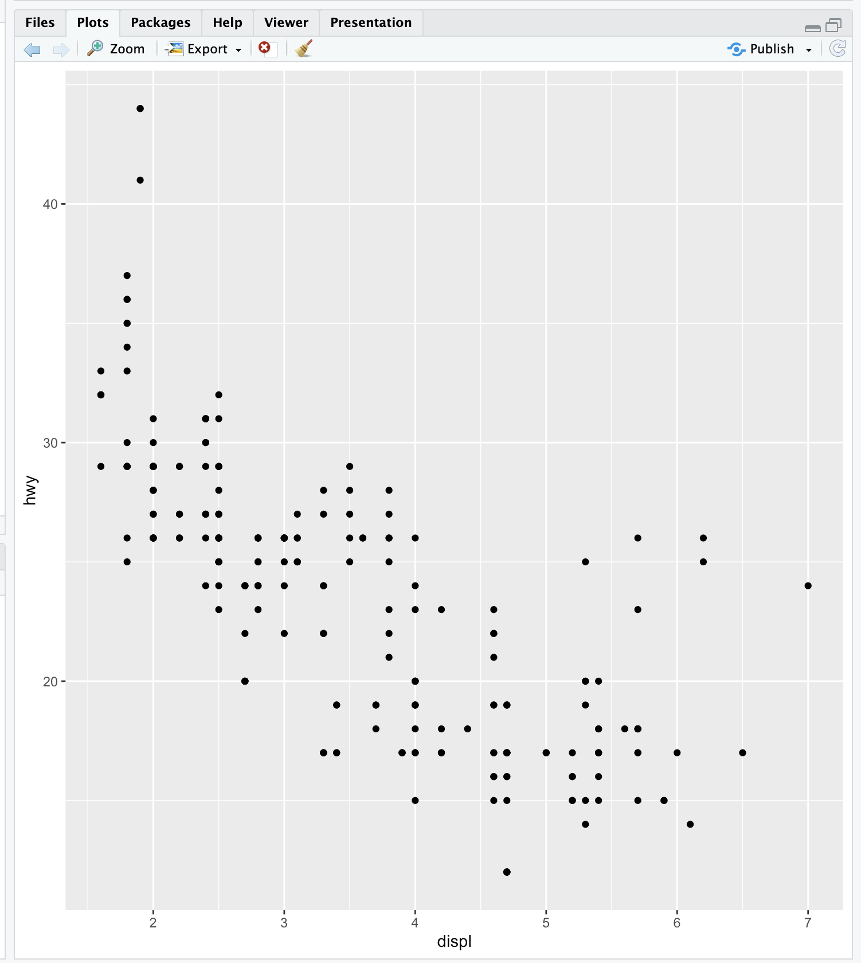

| Excellent work!

|=========================== | 34%

| A nice scatterplot done simply, right? All the labels are provided. The first

| argument is shown along the x-axis and the second along the y-axis. The negative

| trend (increasing displacement and lower gas mileage) is pretty clear. Now suppose we

| want to do the same plot but this time use different colors to distinguish between

| the 3 factors (subsets) of different types of drive (drv) in the data (front-wheel,

| rear-wheel, and 4-wheel). Again, qplot makes this very easy. We'll just add what

| ggplot2 calls an aesthetic, a fourth argument, color, and set it equal to drv. Try

| this now. (Use the up arrow key to save some typing.)

> qplot(displ, hwy, data = mpg, color = drv)

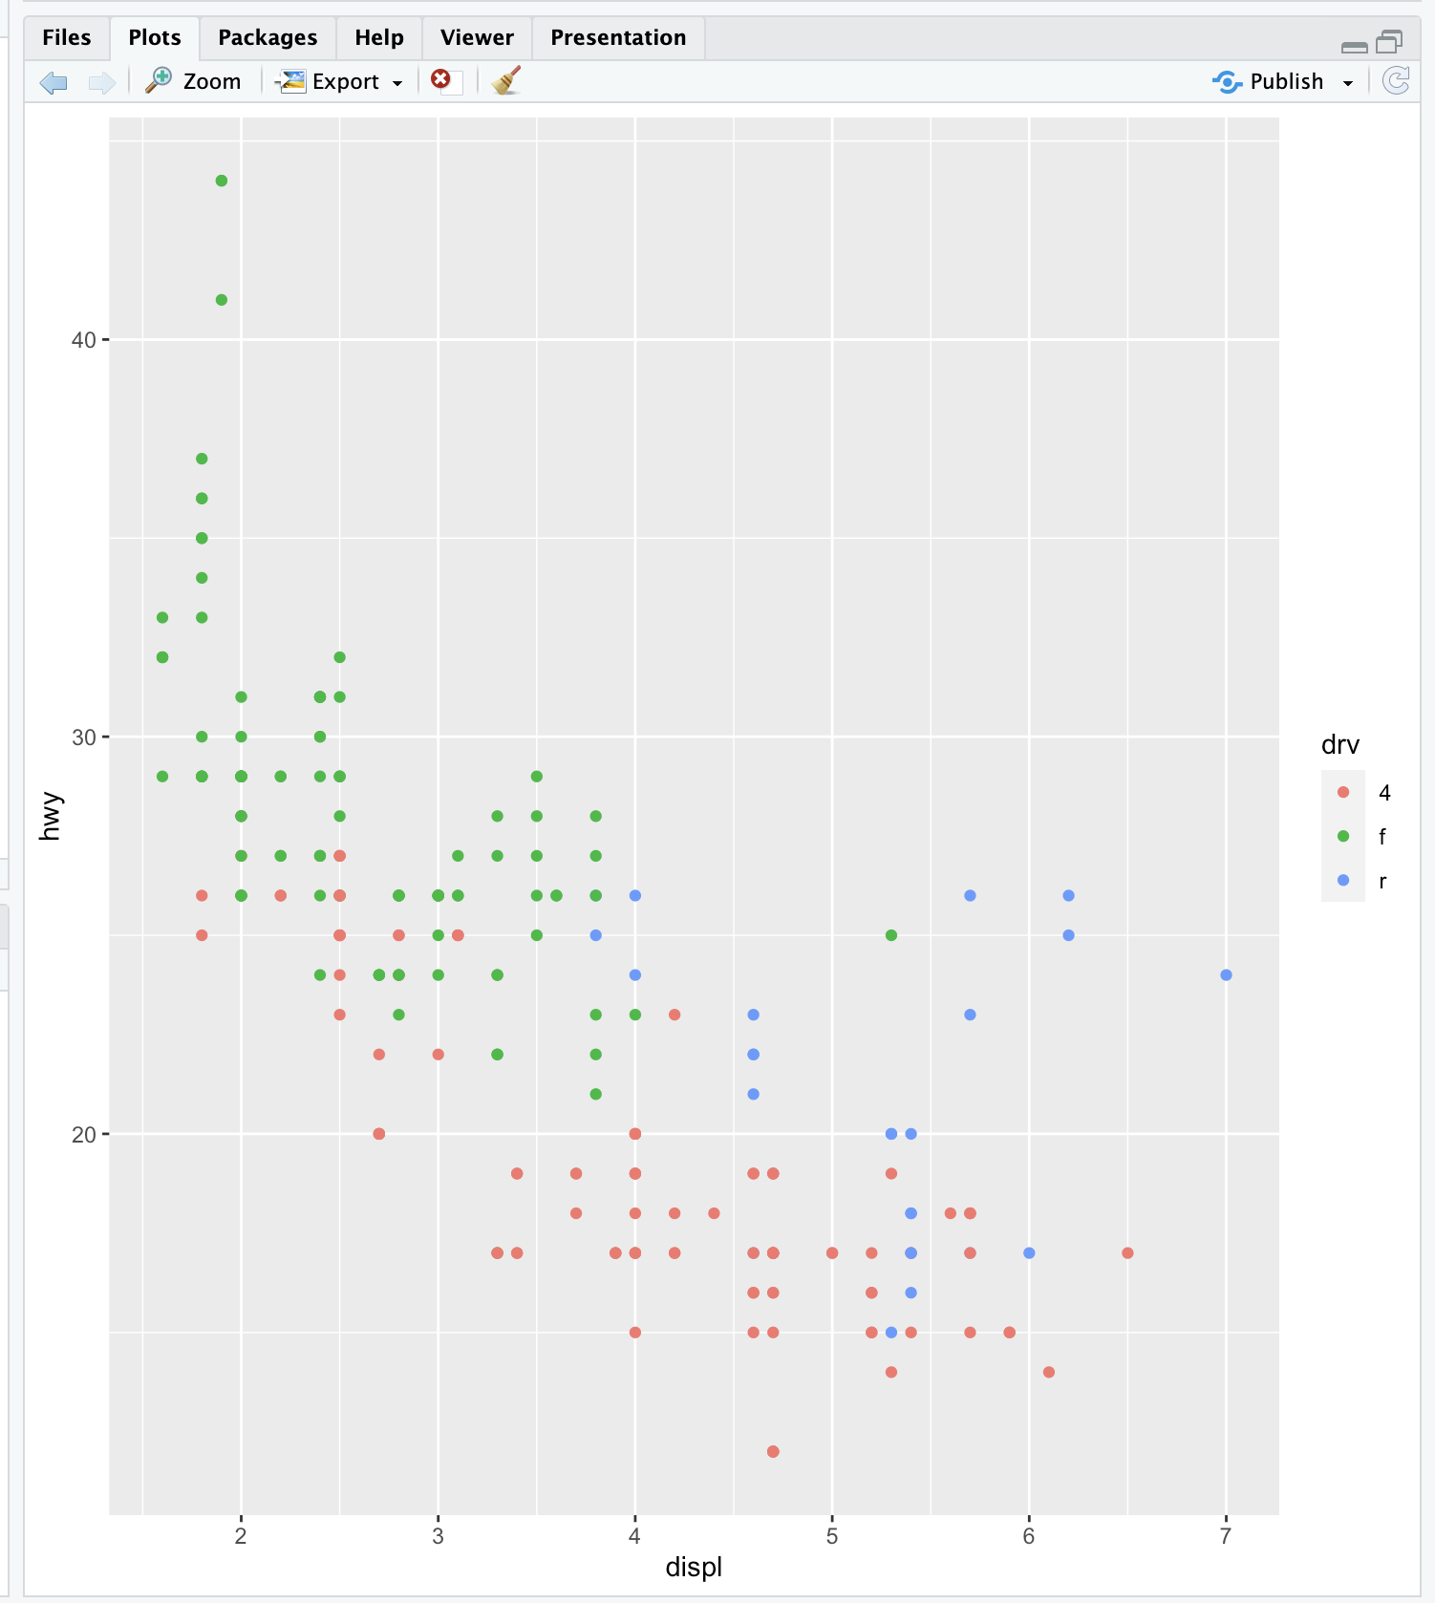

| Your dedication is inspiring!

|============================= | 37%

| Pretty cool, right? See the legend to the right which qplot helpfully supplied? The

| colors were automatically assigned by qplot so the legend decodes the colors for you.

| Notice that qplot automatically used dots or points to indicate the data. These

| points are geoms (geometric objects). We could have used a different aesthetic, for

| instance shape instead of color, to distinguish between the drive types.

|============================== | 39%

| Now let's add a second geom to the default points. How about some smoothing function

| to produce trend lines, one for each color? Just add a fifth argument, geom, and

| using the R function c(), set it equal to the concatenation of the two strings

| "point" and "smooth". The first refers to the data points and second to the trend

| lines we want plotted. Try this now.

> qplot(displ, hwy, data = mpg, color=drv, geom = c("point", "smooth"))

`geom_smooth()` using method = 'loess' and formula = 'y ~ x'

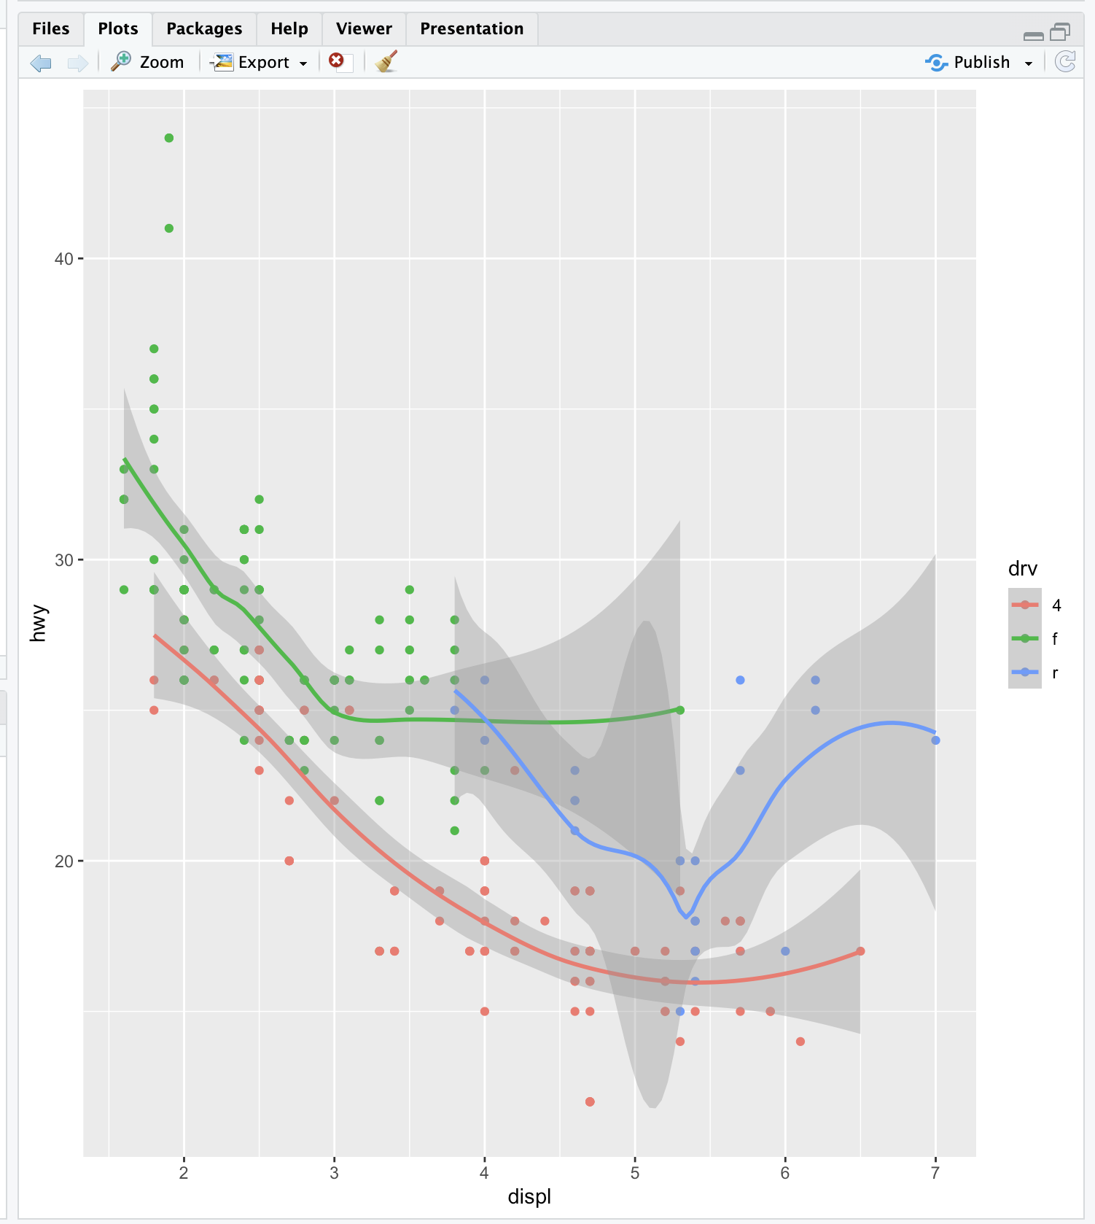

| You are really on a roll!

|================================ | 41%

| Notice the gray areas surrounding each trend lines. These indicate the 95% confidence

| intervals for the lines.

|================================== | 44%

| Before we leave qplot's scatterplotting ability, call qplot again, this time with 3

| arguments. The first is y set equal to hwy, the second is data set equal to mpg, and

| the third is color set equal to drv. Try this now.

> qplot(y=hwy, data = mpg, color = drv)

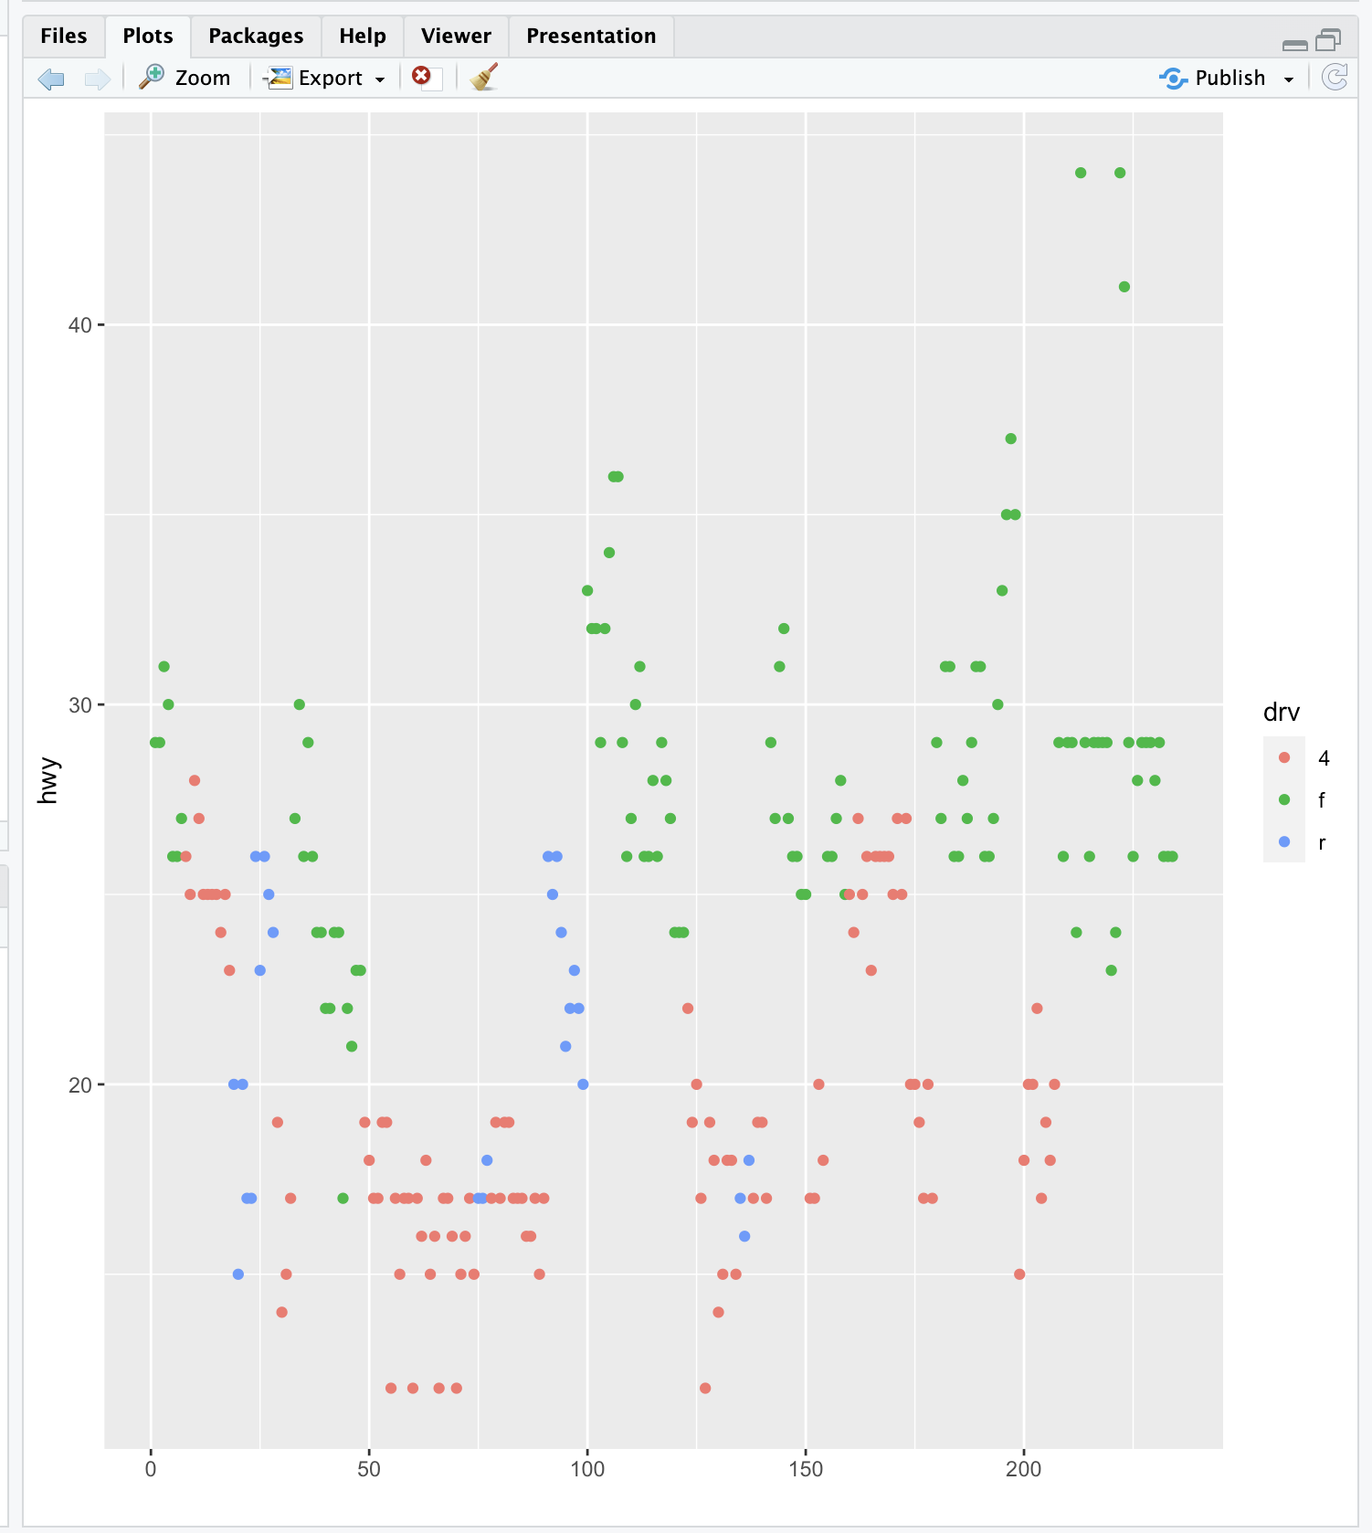

| Nice work!

|==================================== | 46%

| What's this plot showing? We see the x-axis ranges from 0 to 250 and we remember that

| we had 234 data points in our set, so we can infer that each point in the plot

| represents one of the hwy values (indicated by the y-axis). We've created the vector

| myhigh for you which contains the hwy data from the mpg dataset. Look at myhigh now.

> myhigh

[1] 29 29 31 30 26 26 27 26 25 28 27 25 25 25 25 24 25 23 20 15 20 17 17 26 23 26 25

[28] 24 19 14 15 17 27 30 26 29 26 24 24 22 22 24 24 17 22 21 23 23 19 18 17 17 19 19

[55] 12 17 15 17 17 12 17 16 18 15 16 12 17 17 16 12 15 16 17 15 17 17 18 17 19 17 19

[82] 19 17 17 17 16 16 17 15 17 26 25 26 24 21 22 23 22 20 33 32 32 29 32 34 36 36 29

[109] 26 27 30 31 26 26 28 26 29 28 27 24 24 24 22 19 20 17 12 19 18 14 15 18 18 15 17

[136] 16 18 17 19 19 17 29 27 31 32 27 26 26 25 25 17 17 20 18 26 26 27 28 25 25 24 27

[163] 25 26 23 26 26 26 26 25 27 25 27 20 20 19 17 20 17 29 27 31 31 26 26 28 27 29 31

[190] 31 26 26 27 30 33 35 37 35 15 18 20 20 22 17 19 18 20 29 26 29 29 24 44 29 26 29

[217] 29 29 29 23 24 44 41 29 26 28 29 29 29 28 29 26 26 26

| Excellent job!

|====================================== | 49%

| Comparing the values of myhigh with the plot, we see the first entries in the vector

| (29, 29, 31, 30,...) correspond to the leftmost points in the the plot (in order),

| and the last entries in myhigh (28, 29, 26, 26, 26) correspond to the rightmost

| plotted points. So, specifying the y parameter only, without an x argument, plots the

| values of the y argument in the order in which they occur in the data.

...

|======================================== | 51%

| The all-purpose qplot can also create box and whisker plots. Call qplot now with 4

| arguments. First specify the variable by which you'll split the data, in this case

| drv, then specify the variable which you want to examine, in this case hwy. The third

| argument is data (set equal to mpg), and the fourth, the geom, set equal to the

| string "boxplot"

> qplot(drv,hwy,data=mpg,geom="boxplot")

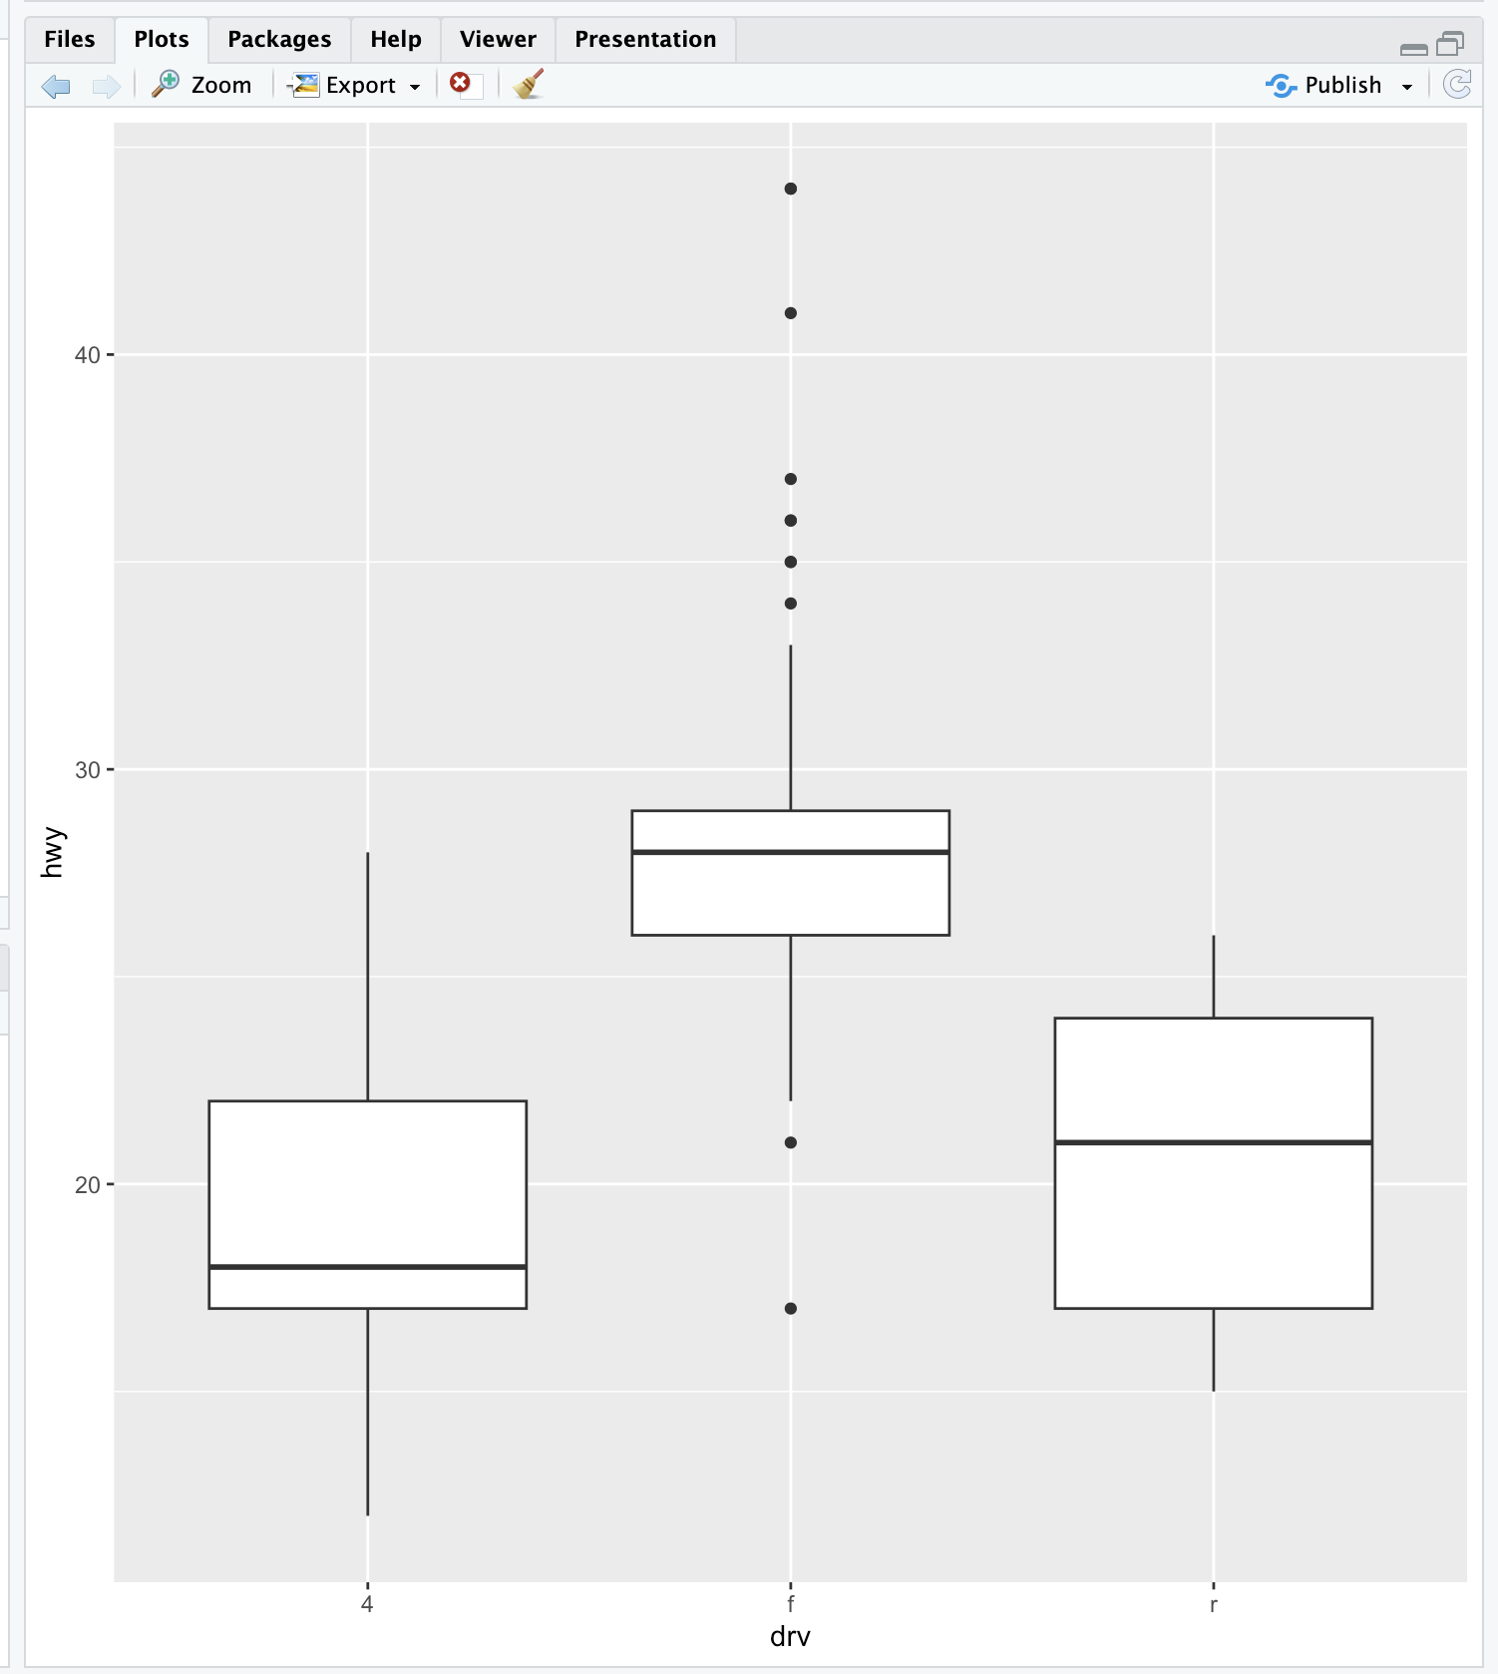

| You nailed it! Good job!

|========================================== | 54%

| We see 3 boxes, one for each drive. Now to impress you, call qplot with 5 arguments.

| The first 4 are just as you used previously, (drv, hwy, data set equal to mpg, and

| geom set equal to the string "boxplot"). Now add a fifth argument, color, equal to

| manufacturer.

> qplot(drv,hwy,data=mpg,geom="boxplot",color=manufacturer)

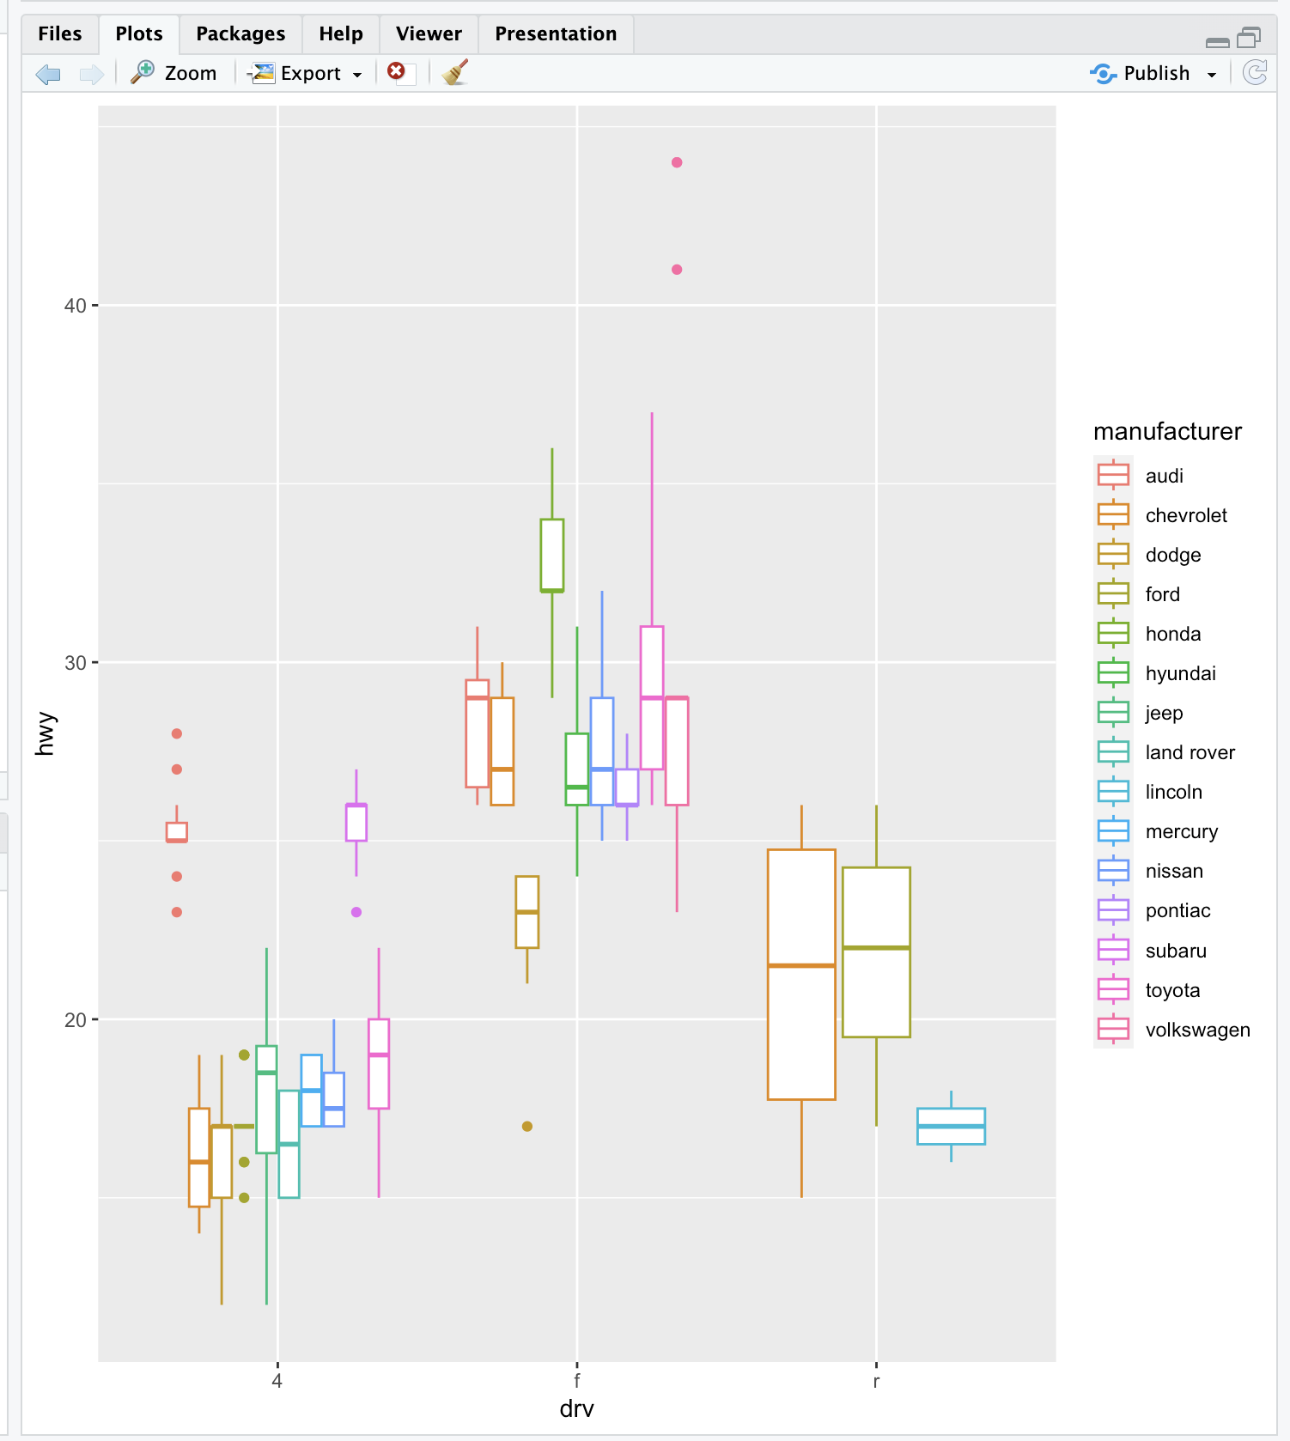

| Nice work!

|============================================ | 56%

| It's a little squished but we just wanted to illustrate qplot's capabilities. Notice

| that there are still 3 regions of the plot (determined by the factor drv). Each is

| subdivided into several boxes depicting different manufacturers.

|============================================== | 59%

| Now, on to histograms. These display frequency counts for a single variable. Let's

| start with an easy one. Call qplot with 3 arguments. First specify the variable for

| which you want the frequency count, in this case hwy, then specify the data (set

| equal to mpg), and finally, the aesthetic, fill, set equal to drv. Instead of a plain

| old histogram, this will again use colors to distinguish the 3 different drive

| factors.

> qplot(hwy, data = mpg, fill = drv)

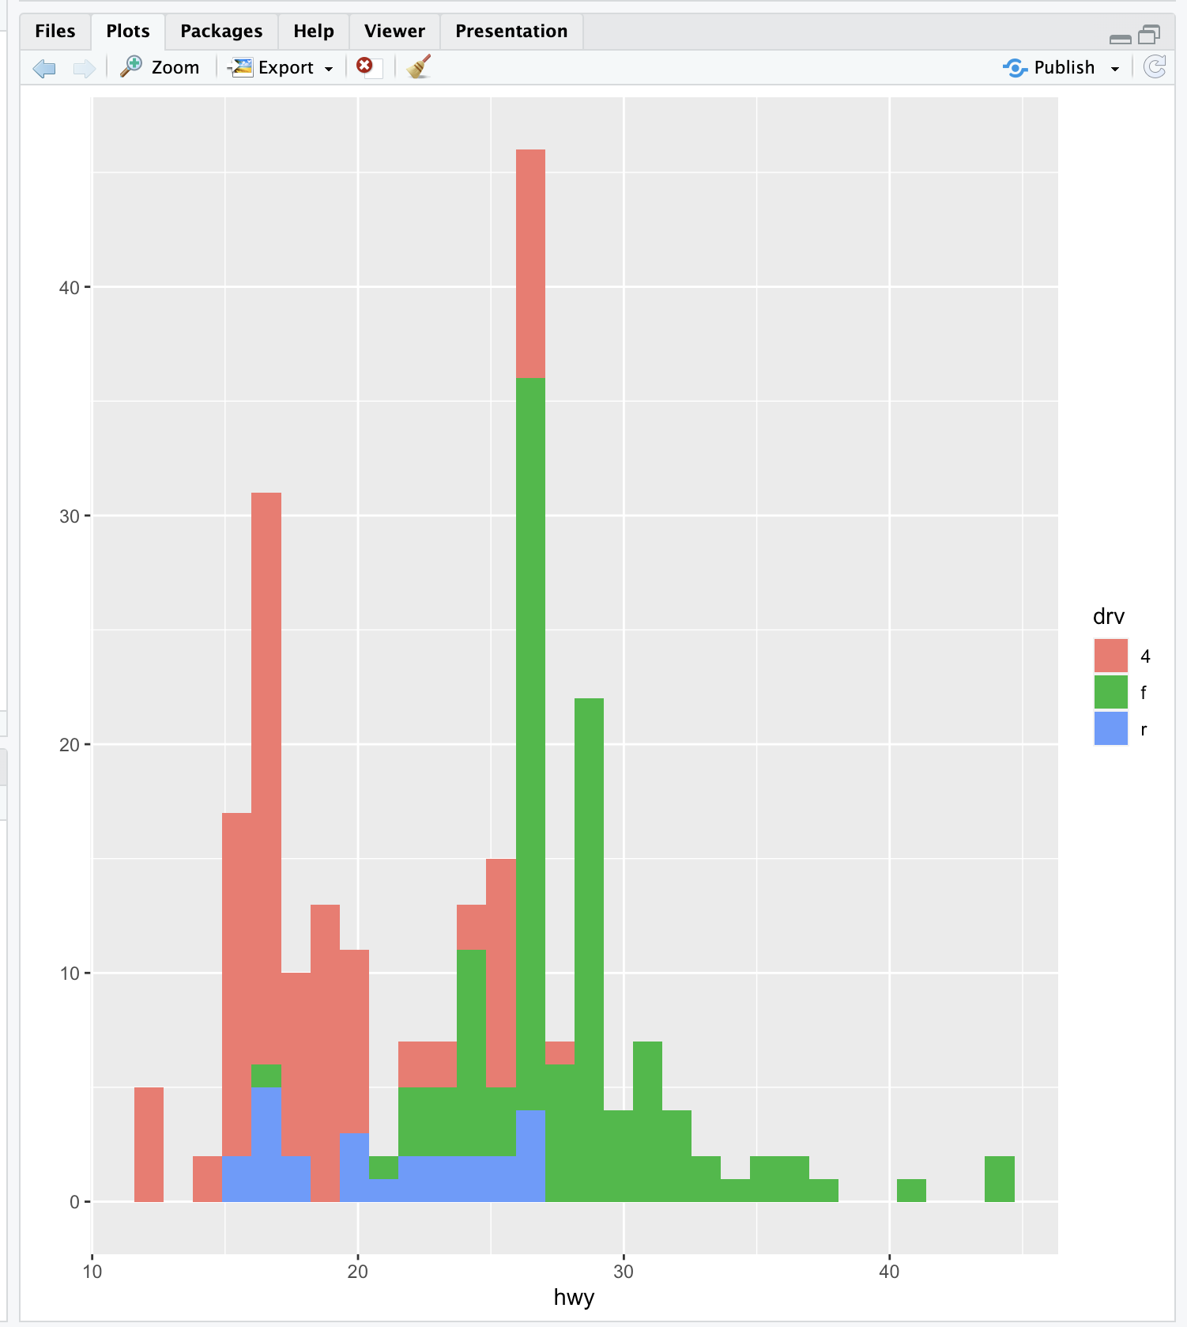

`stat_bin()` using `bins = 30`. Pick better value with `binwidth`.

| Keep working like that and you'll get there!

|================================================ | 61%

| See how qplot consistently uses the colors. Red (if 4-wheel drv is in the bin) is at

| the bottom of the bin, then green on top of it (if present), followed by blue (rear

| wheel drv). The color lets us see right away that 4-wheel drive vehicles in this

| dataset don't have gas mileages exceeding 30 miles per gallon.

|================================================= | 63%

| It's cool that qplot can do this so easily, but some people may find this multi-color

| histogram hard to interpret. Instead of using colors to distinguish between the drive

| factors let's use facets or panels. (That's what lattice called them.) This just

| means we'll split the data into 3 subsets (according to drive) and make 3 smaller

| individual plots of each subset in one plot (and with one call to qplot).

...

|=================================================== | 66%

| Remember that with base plot we had to do each subplot individually. The lattice

| system made plotting conditioning plots easier. Let's see how easy it is with qplot.

...

|===================================================== | 68%

| We'll do two plots, a scatterplot and then a histogram, each with 3 facets. For the

| scatterplot, call qplot with 4 arguments. The first two are displ and hwy and the

| third is the argument data set equal to mpg. The fourth is the argument facets which

| will be set equal to the expression . ~ drv which is ggplot2's shorthand for number

| of rows (to the left of the ~) and number of columns (to the right of the ~). Here

| the . indicates a single row and drv implies 3, since there are 3 distinct drive

| factors. Try this now.

> qplot(displ, hwy, data = mpg, facets = . ~ drv)

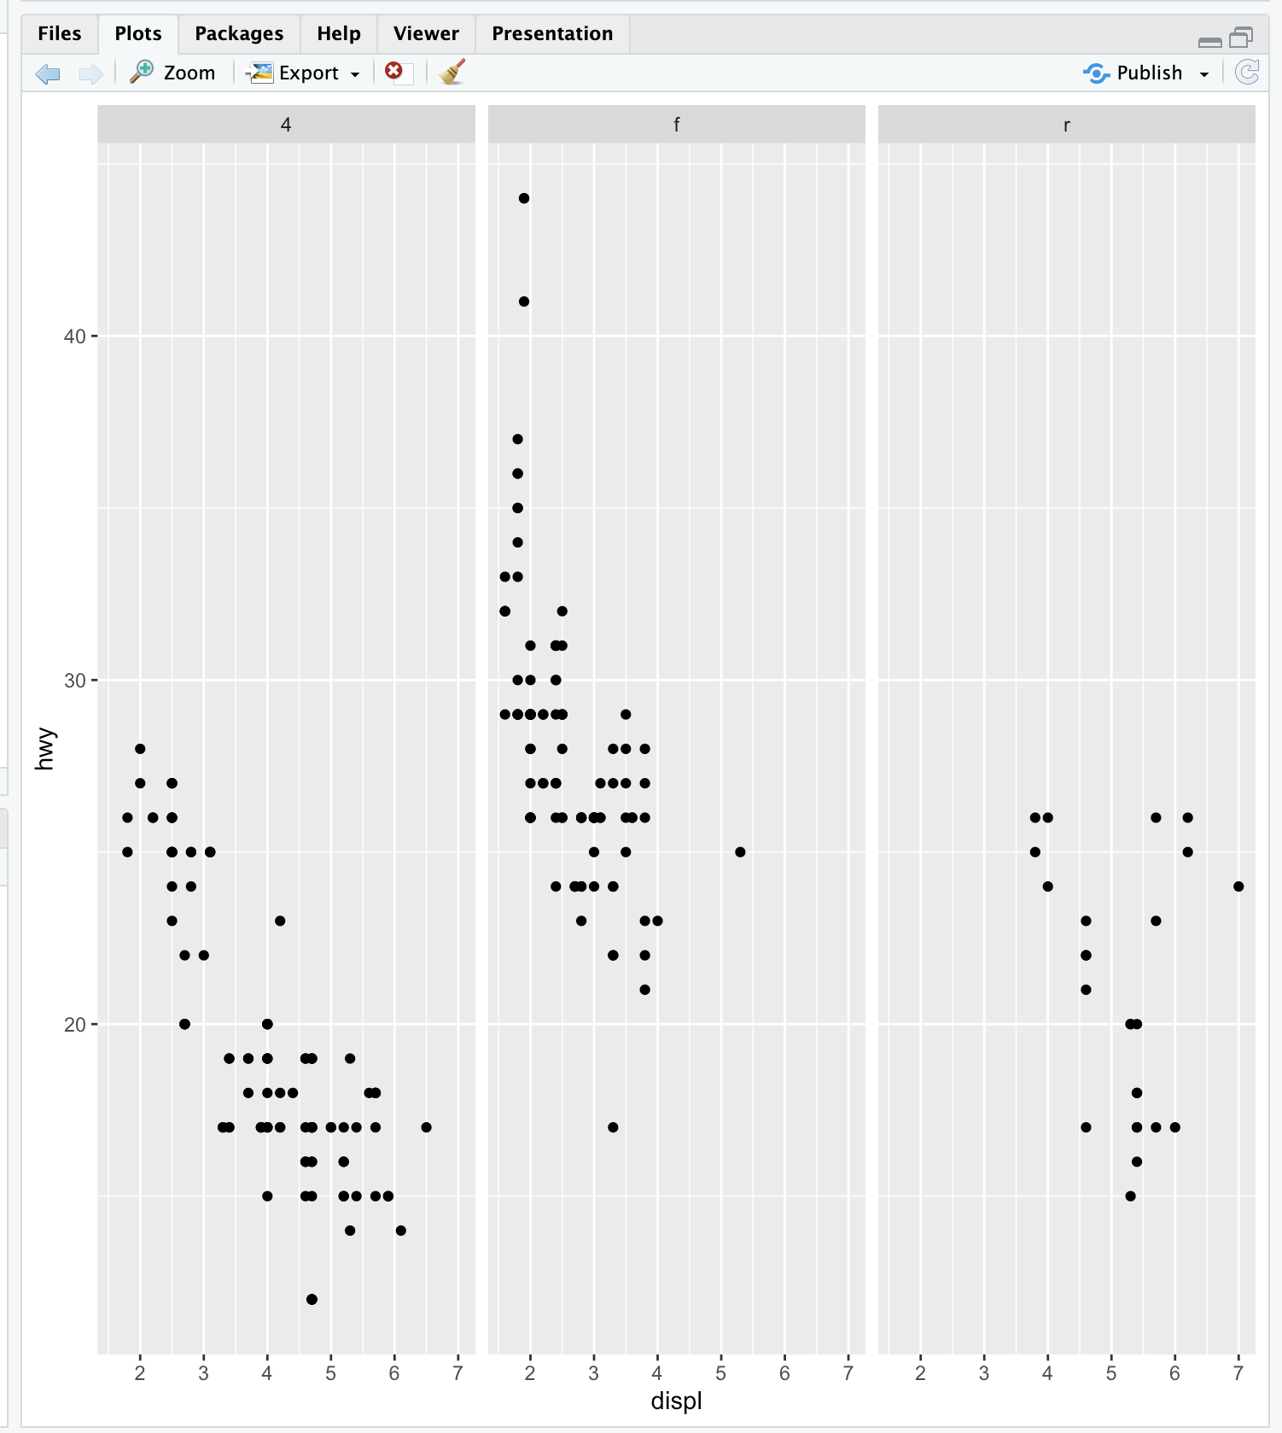

| You are doing so well!

|======================================================= | 71%

| The result is a 1 by 3 array of plots. Note how each is labeled at the top with the

| factor label (4,f, or r). This shows us more detailed information than the histogram.

| We see the relationship between displacement and highway mileage for each of the 3

| drive factors.

|========================================================= | 73%

| Now we'll do a histogram, again calling qplot with 4 arguments. This time, since we

| need only one variable for a histogram, the first is hwy and the second is the

| argument data set equal to mpg. The third is the argument facets which we'll set

| equal to the expression drv ~ . . This will give us a different arrangement of the

| facets. The fourth argument is binwidth. Set this equal to 2. Try this now.

>

> qplot(hwy, data = mpg, facets = drv ~ ., binwidth = 2)

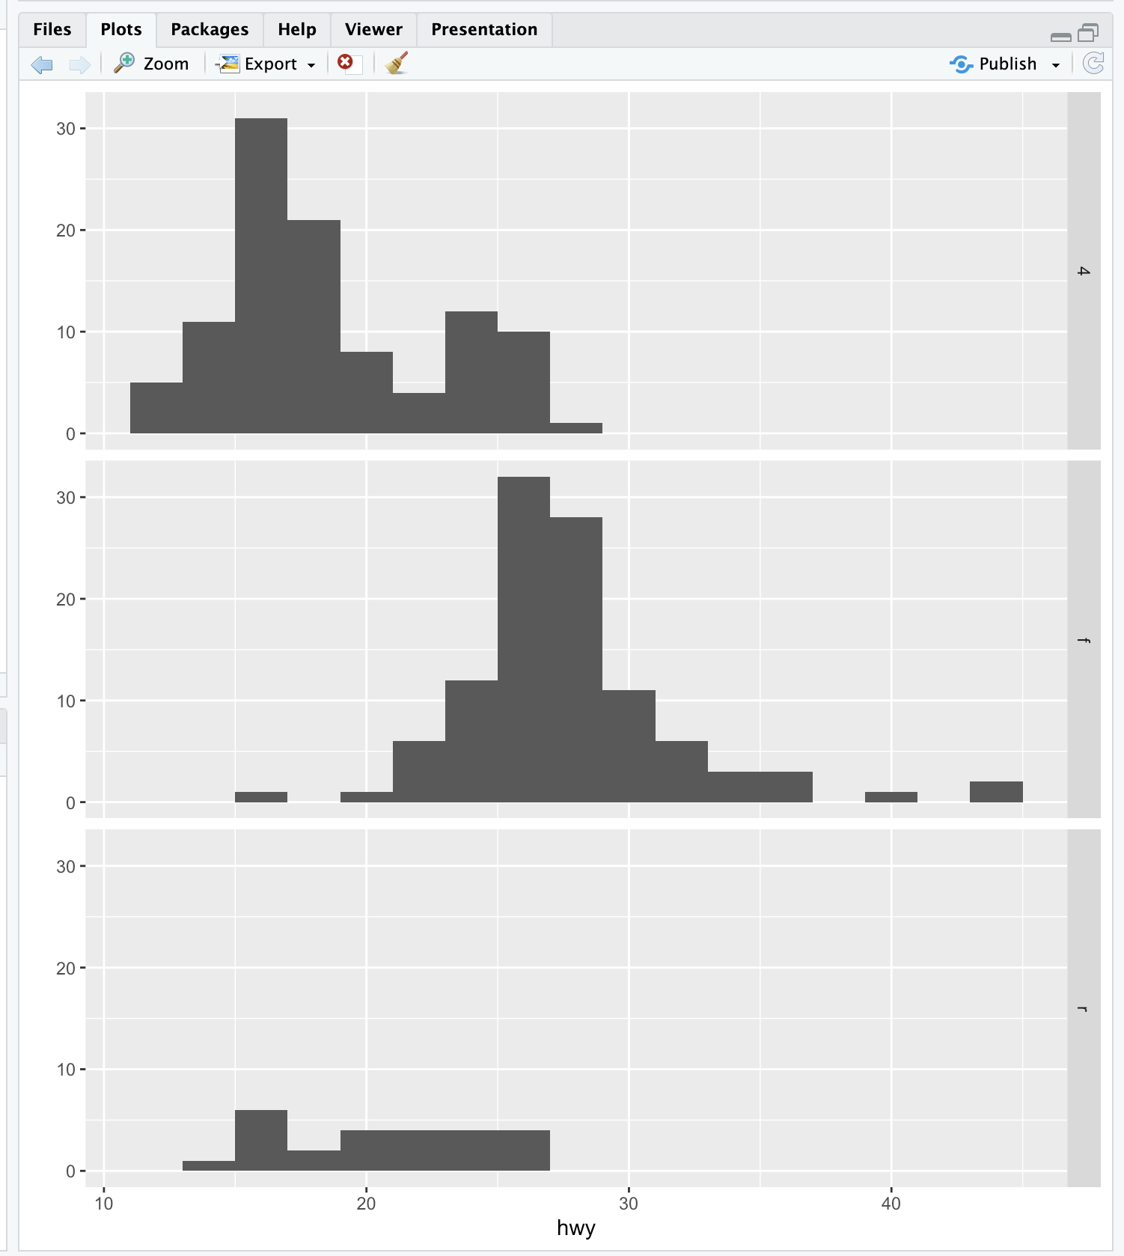

| Your dedication is inspiring!

|=========================================================== | 76%

| The facets argument, drv ~ ., resulted in what arrangement of facets?

1: 1 by 3

2: 3 by 1

3: 2 by 2

4: huh?

Selection: 2

| All that practice is paying off!

|============================================================= | 78%

| Pretty good, right? Not too difficult either. Let's review what we learned!

...

|=============================================================== | 80%

| Which of the following is a basic workhorse function of ggplot2?

1: scatterplot

2: qplot

3: hist

4: gplot

5: xyplot

Selection: 2

| All that hard work is paying off!

|================================================================= | 83%

| Which types of plot does qplot plot?

1: scatterplots

2: histograms

3: all of the others

4: box and whisker plots

Selection: 3

| You nailed it! Good job!

|=================================================================== | 85%

| What does the gg in ggplot2 stand for?

1: grammar of graphics

2: good graphics

3: good grief

4: goto graphics

Selection: 1

| Great job!

|==================================================================== | 88%

| True or False? The geom argument takes a string for a value.

1: False

2: True

Selection: 2

| You are really on a roll!

|====================================================================== | 90%

| True or False? The data argument takes a string for a value.

1: False

2: True

Selection: 1

| Great job!

|======================================================================== | 93%

| True or False? The binwidth argument takes a string for a value.

1: False

2: True

Selection: 1

| You are doing so well!

|========================================================================== | 95%

| True or False? The user must specify x- and y-axis labels when using qplot.

1: False

2: True

Selection: 1

| You nailed it! Good job!

|============================================================================ | 98%

| Congrats! You've finished plot 1 of ggplot2. In the next lesson the plot thickens.

...

|==============================================================================| 100%

| Would you like to receive credit for completing this course on Coursera.org?

1: No

2: Yes

Selection: 1

| You nailed it! Good job!

| You've reached the end of this lesson! Returning to the main menu...

| Please choose a course, or type 0 to exit swirl.

1: Exploratory Data Analysis

2: Take me to the swirl course repository!

Selection: 1

| Please choose a lesson, or type 0 to return to course menu.

1: Principles of Analytic Graphs 2: Exploratory Graphs

3: Graphics Devices in R 4: Plotting Systems

5: Base Plotting System 6: Lattice Plotting System

7: Working with Colors 8: GGPlot2 Part1

9: GGPlot2 Part2 10: GGPlot2 Extras

11: Hierarchical Clustering 12: K Means Clustering

13: Dimension Reduction 14: Clustering Example

15: CaseStudy

Selection: 9

| Attempting to load lesson dependencies...

| Package ‘ggplot2’ loaded correctly!

| | 0%

| GGPlot2_Part2. (Slides for this and other Data Science courses may be found at github

| https://github.com/DataScienceSpecialization/courses/. If you care to use them, they

| must be downloaded as a zip file and viewed locally. This lesson corresponds to

| 04_ExploratoryAnalysis/ggplot2.)

...

|== | 2%

| In a previous lesson we showed you the vast capabilities of qplot, the basic

| workhorse function of the ggplot2 package. In this lesson we'll focus on some

| fundamental components of the package. These underlie qplot which uses default values

| when it calls them. If you understand these building blocks, you will be better able

| to customize your plots. We'll use the second workhorse function in the package,

| ggplot, as well as other graphing functions.

...

|=== | 4%

| Do you remember what the gg of ggplot2 stands for?

1: goto graphics

2: grammar of graphics

3: good grief

4: great graphics

Selection: 2

| You are really on a roll!

|===== | 6%

| A "grammar" of graphics means that ggplot2 contains building blocks with which you

| can create your own graphical objects. What are these basic components of ggplot2

| plots? There are 7 of them.

...

|====== | 8%

| Obviously, there's a DATA FRAME which contains the data you're trying to plot. Then

| the AESTHETIC MAPPINGS determine how data are mapped to color, size, etc. The GEOMS

| (geometric objects) are what you see in the plot (points, lines, shapes) and FACETS

| are the panels used in conditional plots. You've used these or seen them used in the

| first ggplot2 (qplot) lesson.

...

|======== | 10%

| There are 3 more. STATS are statistical transformations such as binning, quantiles,

| and smoothing which ggplot2 applies to the data. SCALES show what coding an aesthetic

| map uses (for example, male = red, female = blue). Finally, the plots are depicted on

| a COORDINATE SYSTEM. When you use qplot these were taken care of for you.

...

|========== | 12%

| Do you remember what the "artist's palette" model means in the context of plotting?

1: things get messy

2: plots are built up in layers

3: we mix paints

4: we draw pictures

Selection: 2

| You are amazing!

|=========== | 15%

| As in the base plotting system (and in contrast to the lattice system), when building

| plots with ggplot2, the plots are built up in layers, maybe in several steps. You can

| plot the data, then overlay a summary (for instance, a regression line or smoother)

| and then add any metadata and annotations you need.

...

|============= | 17%

| We'll keep using the mpg data that comes with the ggplot2 package. Recall the

| versatility of qplot. Just as a refresher, call qplot now with 5 arguments. The first

| 3 deal with data - displ, hwy, and data=mpg. The fourth is geom set equal to the

| concatenation of the two strings, "point" and "smooth". The fifth is facets set equal

| to the formula .~drv. Try this now.

> qplot(displ, hwy, data=mpg, geom = c("point", "smooth"), facets = .~drv)

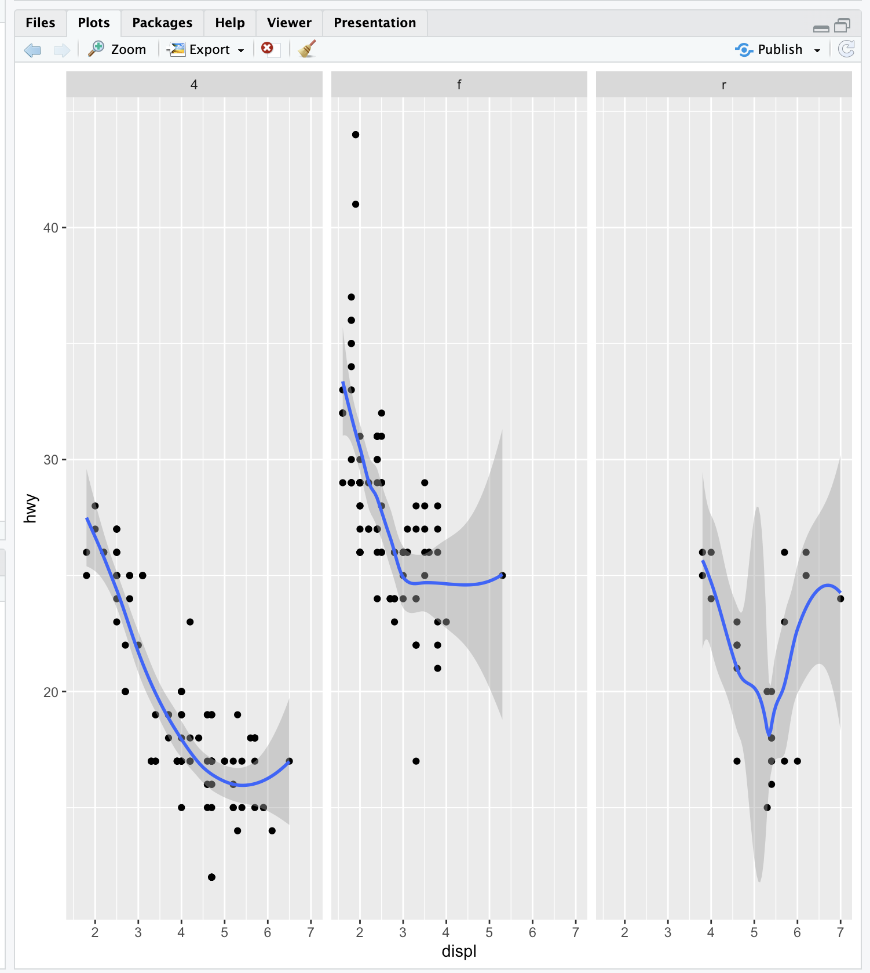

`geom_smooth()` using method = 'loess' and formula = 'y ~ x'

| Great job!

|=============== | 19%

| We see a 3 facet plot, one for each drive type (4, f, and r). Now we'll see how

| ggplot works. We'll build up a similar plot using the basic components of the

| package. We'll do this in a series of steps.

|================ | 21%

| First we'll create a variable g by assigning to it the output of a call to ggplot

| with 2 arguments. The first is mpg (our dataset) and the second will tell ggplot what

| we want to plot, in this case, displ and hwy. These are what we want our aesthetics

| to represent so we enclose these as two arguments to the function aes. Try this now.

> g <- ggplot(mpg, aes(displ, hwy))

| Great job!

|================== | 23%

| Notice that nothing happened? As in the lattice system, ggplot created a graphical

| object which we assigned to the variable g.

...

|==================== | 25%

| Run the R command summary with g as its argument to see what g contains.

> summary(g)

data: manufacturer, model, displ, year, cyl, trans, drv, cty, hwy, fl, class

[234x11]

mapping: x = ~displ, y = ~hwy

faceting: <ggproto object: Class FacetNull, Facet, gg>

compute_layout: function

draw_back: function

draw_front: function

draw_labels: function

draw_panels: function

finish_data: function

init_scales: function

map_data: function

params: list

setup_data: function

setup_params: function

shrink: TRUE

train_scales: function

vars: function

super: <ggproto object: Class FacetNull, Facet, gg>

| You got it right!

|===================== | 27%

| So g contains the mpg data with all its named components in a 234 by 11 matrix. It

| also contains a mapping, x (displ) and y (hwy) which you specified, and no faceting.

...

|======================= | 29%

| Note that if you tried to print g with the expressions g or print(g) you'd get an

| error! Even though it's a great package, ggplot doesn't know how to display the data

| yet since you didn't specify how you wanted to see it. Now type g+geom_point() and

| see what happens.

> g+geom_point()



| Excellent work!

|======================== | 31%

| By calling the function geom_point you added a layer. By not assigning the expression

| to a variable you displayed a plot. Notice that you didn't have to pass any arguments

| to the function geom_point. That's because the object g has all the data stored in

| it. (Remember you saw that when you ran summary on g before.) Now use the expression

| you just typed (g + geom_point()) and add to it another layer, a call to

| geom_smooth(). Notice the red message R gives you.

> g+geom_point()+geom_smooth()

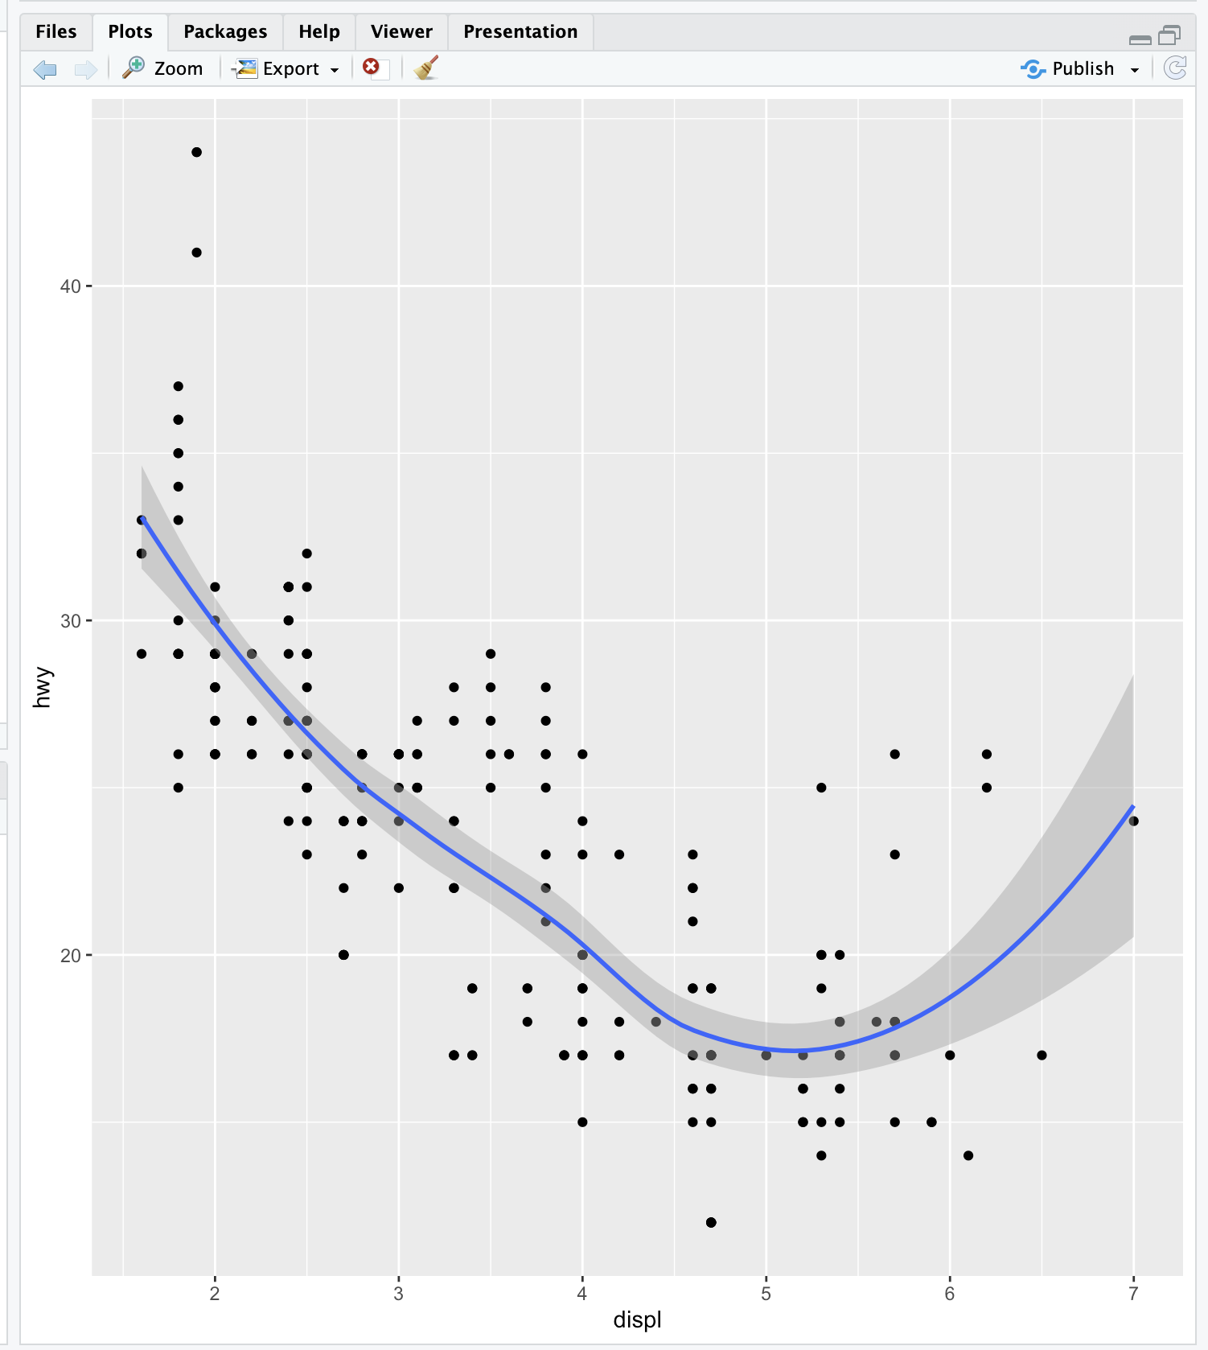

`geom_smooth()` using method = 'loess' and formula = 'y ~ x'

| Keep up the great work!

|========================== | 33%

| The gray shadow around the blue line is the confidence band. See how wide it is at

| the right? Let's try a different smoothing function. Use the up arrow to recover the

| expression you just typed, and instead of calling geom_smooth with no arguments, call

| it with the argument method set equal to the string "lm".

> g+geom_point()+geom_smooth(method="lm")

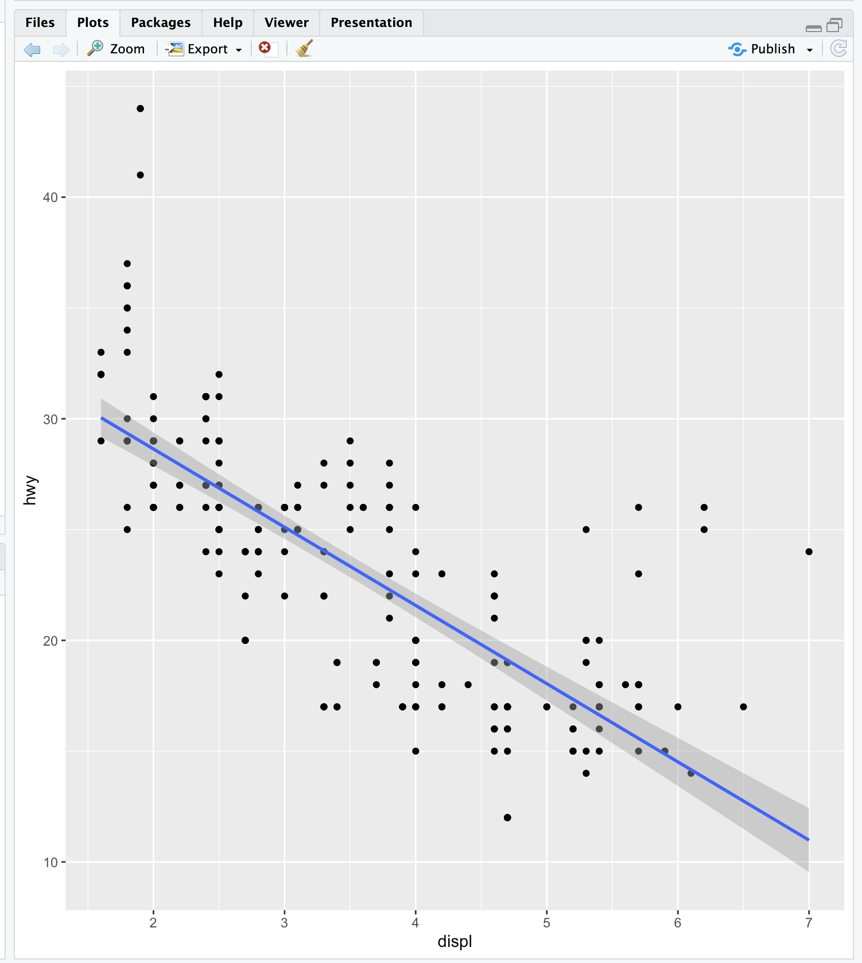

`geom_smooth()` using formula = 'y ~ x'

| That's correct!

|============================ | 35%

| By changing the smoothing function to "lm" (linear model) ggplot2 generated a

| regression line through the data. Now recall the expression you just used and add to

| it another call, this time to the function facet_grid. Use the formula . ~ drv as it

| argument. Note that this is the same type of formula used in the calls to qplot.

> g+geom_point()+geom_smooth(method="lm") + facet_grid(.~drv)

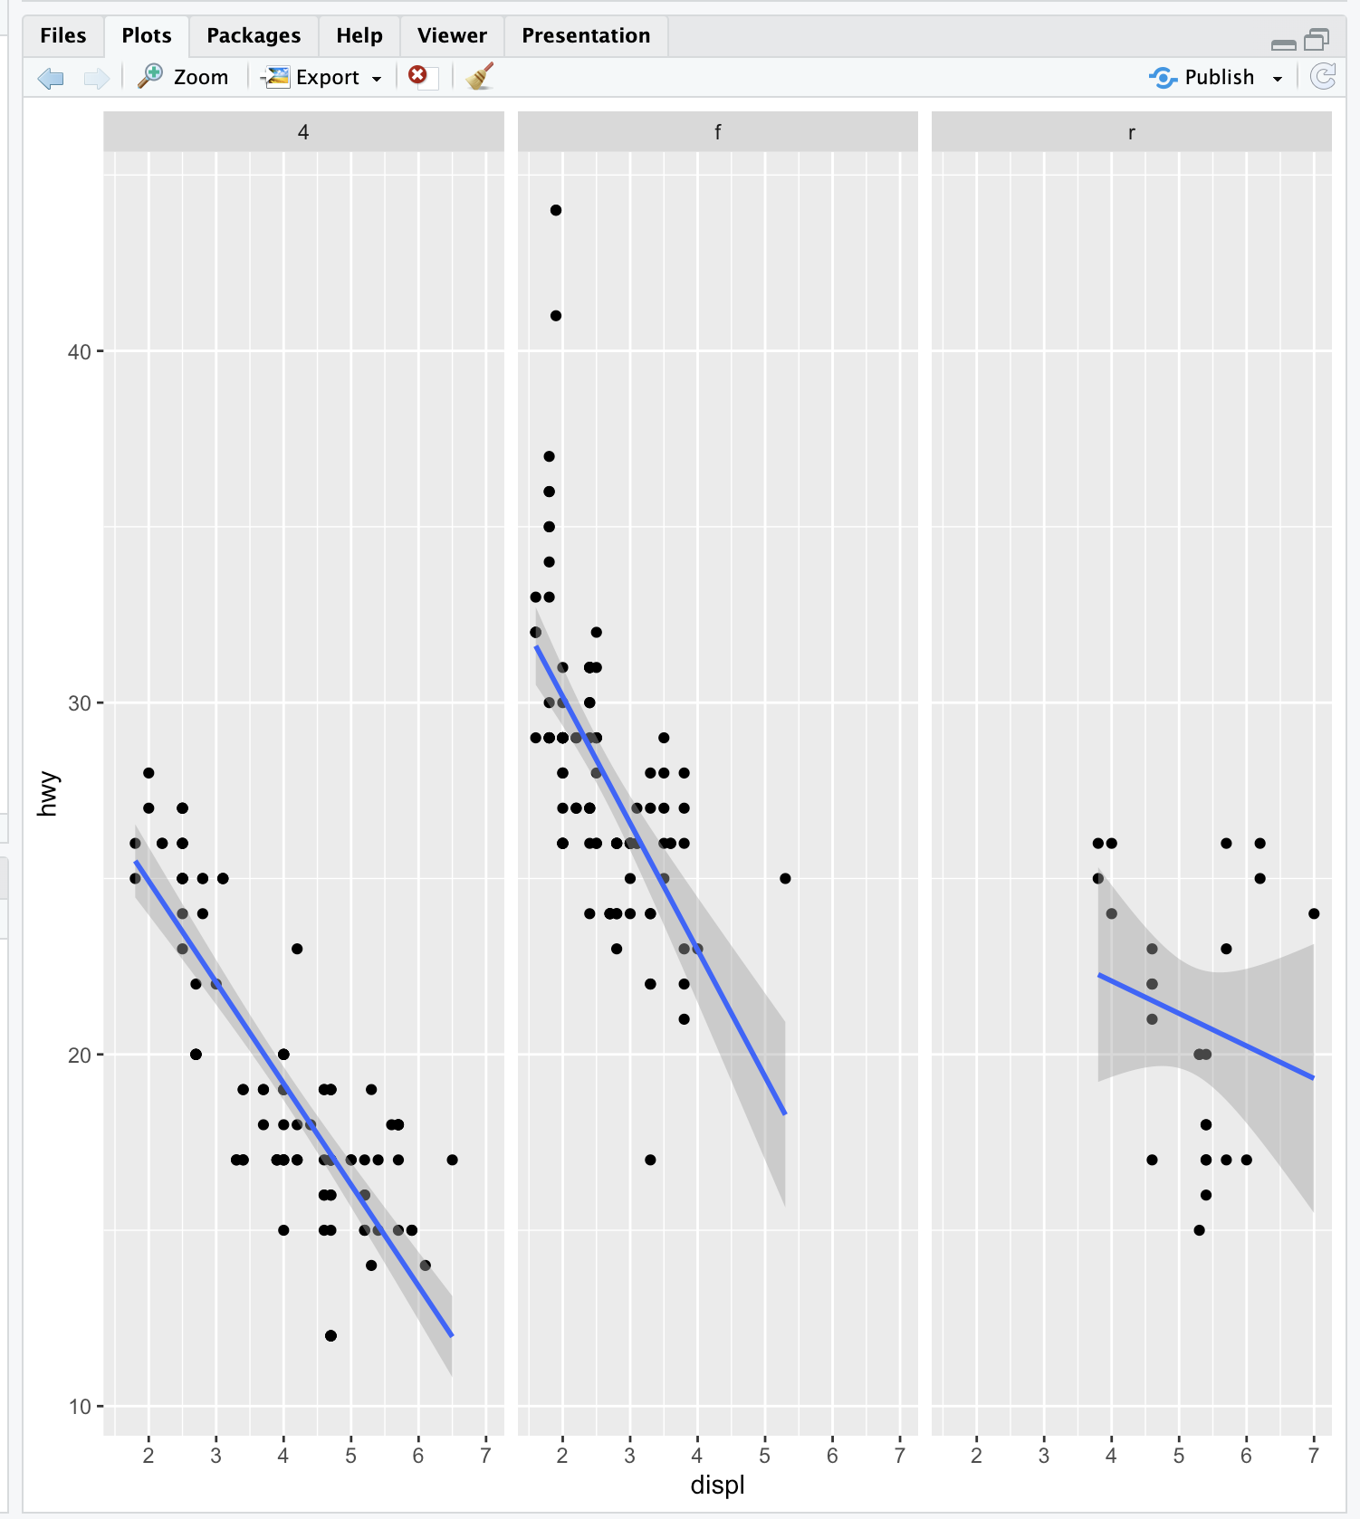

`geom_smooth()` using formula = 'y ~ x'

| You are really on a roll!

|============================= | 38%

| Notice how each panel is labeled with the appropriate factor. All the data associated

| with 4-wheel drive cars is in the leftmost panel, front-wheel drive data is shown in

| the middle panel, and rear-wheel drive data in the rightmost. Notice that this is

| similar to the plot you created at the start of the lesson using qplot. (We used a

| different smoothing function than previously.)

|=============================== | 40%

| So far you've just used the default labels that ggplot provides. You can add your own

| annotation using functions such as xlab(), ylab(), and ggtitle(). In addition, the

| function labs() is more general and can be used to label either or both axes as well

| as provide a title. Now recall the expression you just typed and add a call to the

| function ggtitle with the argument "Swirl Rules!".

> g+geom_point()+geom_smooth(method="lm") + facet_grid(.~drv)+ ggtitle("Swirl Rules!")

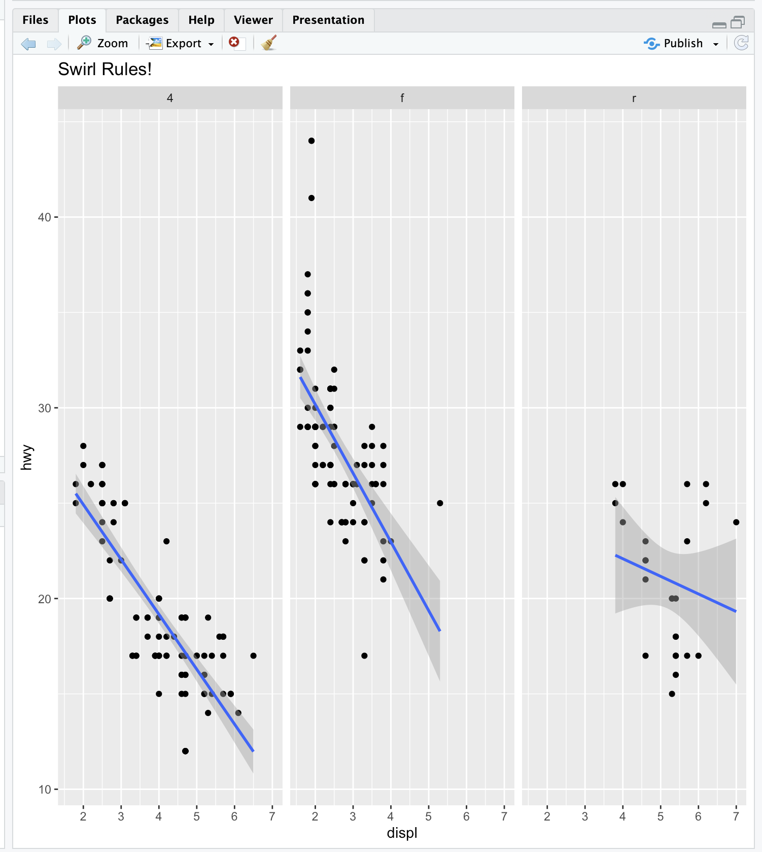

`geom_smooth()` using formula = 'y ~ x'

| That's the answer I was looking for.

|================================ | 42%

| Now that you've seen the basics we'll talk about customizing. Each of the “geom”

| functions (e.g., _point and _smooth) has options to modify it. Also, the function

| theme() can be used to modify aspects of the entire plot, e.g. the position of the

| legend. Two standard appearance themes are included in ggplot. These are theme_gray()

| which is the default theme (gray background with white grid lines) and theme_bw()

| which is a plainer (black and white) color scheme.

|================================== | 44%

| Let's practice modifying aesthetics now. We'll use the graphic object g that we

| already filled with mpg data and add a call to the function geom_point, but this time

| we'll give geom_point 3 arguments. Set the argument color equal to "pink", the

| argument size to 4, and the argument alpha to 1/2. Notice that all the arguments are

| set equal to constants.

> g+geom_point(color="pink",size=4,alpha=1/2)

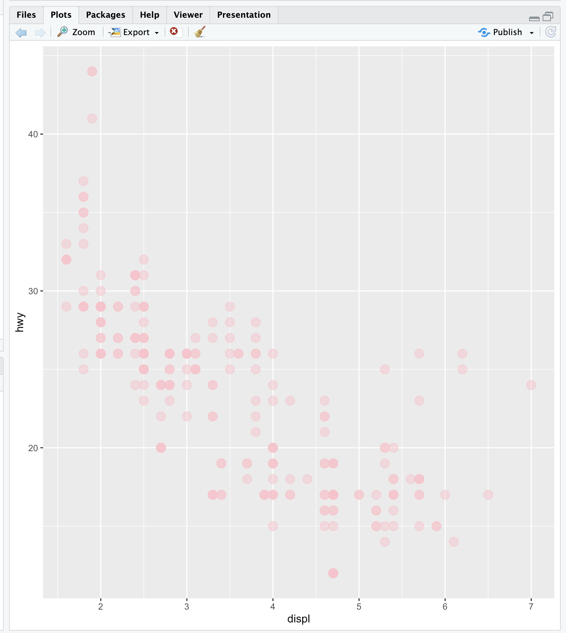

| All that practice is paying off!

|==================================== | 46%

| Notice the different shades of pink? That's the result of the alpha aesthetic which

| you set to 1/2. This aesthetic tells ggplot how transparent the points should be.

| Darker circles indicate values hit by multiple data points.

|===================================== | 48%

| Now we'll modify the aesthetics so that color indicates which drv type each point

| represents. Again, use g and add to it a call to the function geom_point with 3

| arguments. The first is size set equal to 4, the second is alpha equal to 1/2. The

| third is a call to the function aes with the argument color set equal to drv. Note

| that you MUST use the function aes since the color of the points is data dependent

| and not a constant as it was in the previous example.

> g + geom_point(aes(color = drv), size = 4, alpha = 1/2)

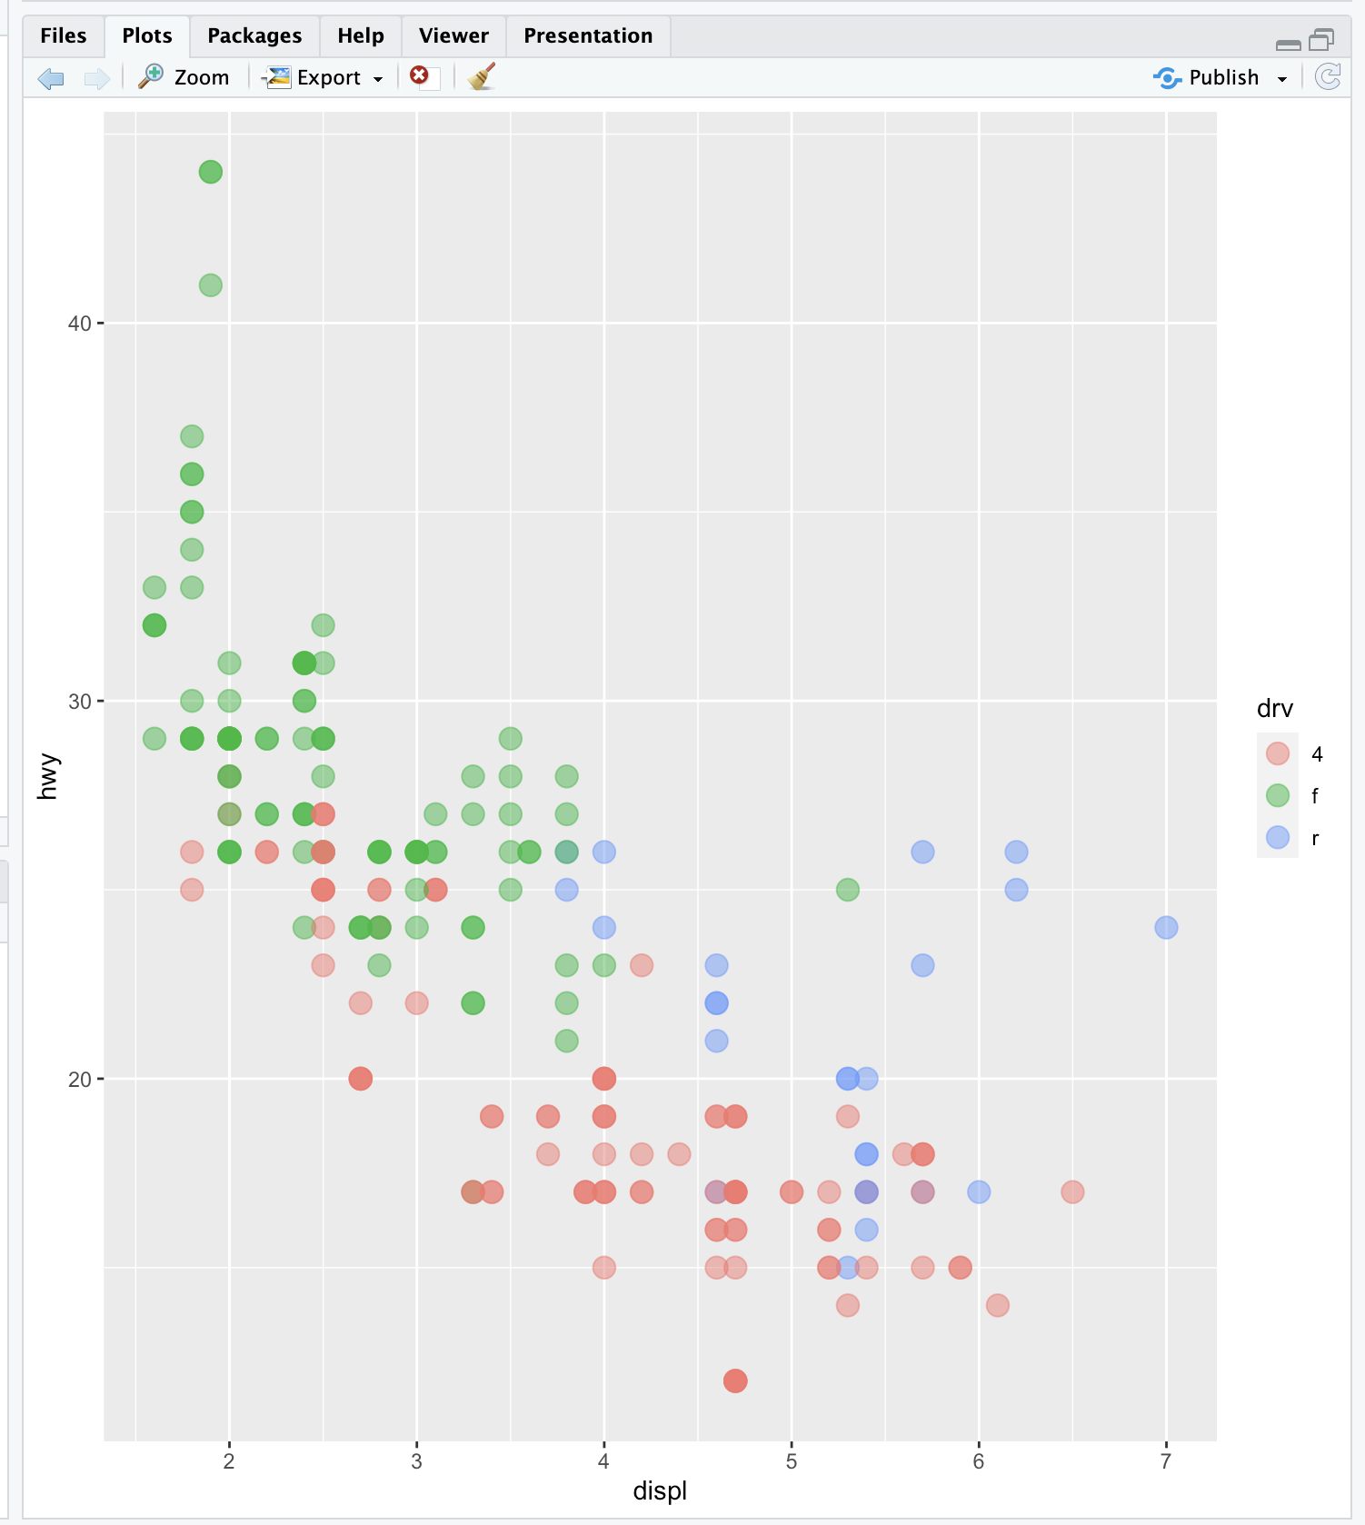

| Your dedication is inspiring!

|======================================= | 50%

| Notice the helpful legend on the right decoding the relationship between color and

| drv.

|========================================= | 52%

| Now we'll practice modifying labels. Again, we'll use g and add to it calls to 3

| functions. First, add a call to geom_point with an argument making the color

| dependent on the drv type (as we did in the previous example). Second, add a call to

| the function labs with the argument title set equal to "Swirl Rules!". Finally, add a

| call to labs with 2 arguments, one setting x equal to "Displacement" and the other

| setting y equal to "Hwy Mileage".

> g + geom_point(aes(color = drv)) + labs(title="Swirl Rules!") + labs(x="Displacement", y="Hwy Mileage")

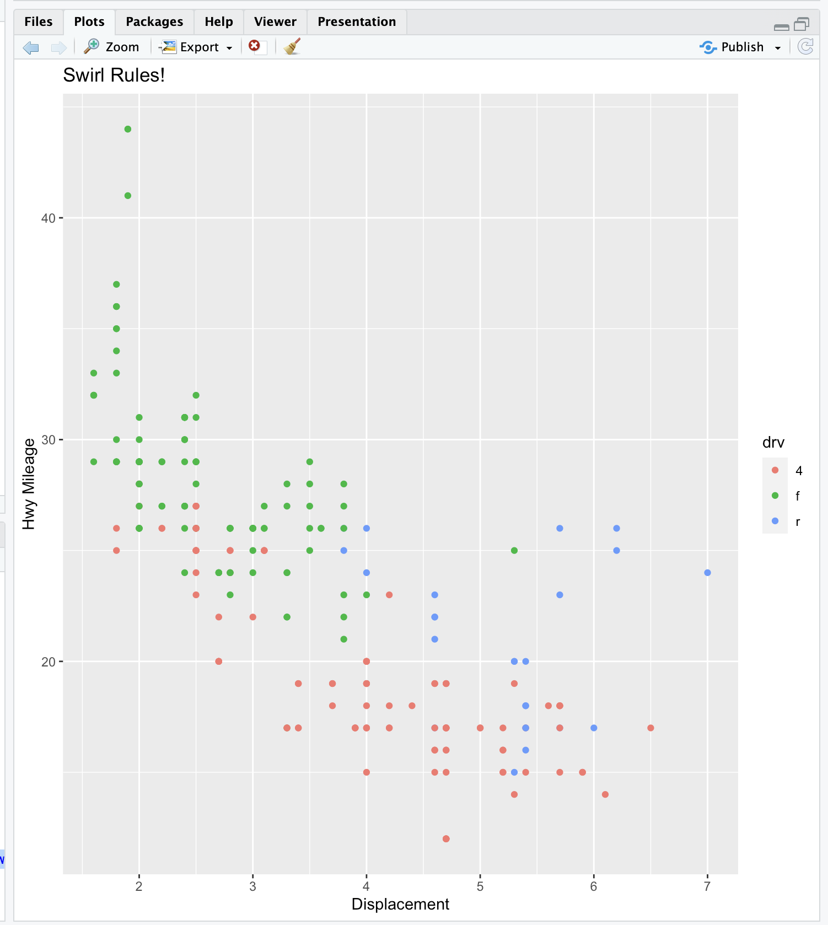

| That's a job well done!

|========================================== | 54%

| Note that you could have combined the two calls to the function labs in the previous

| example. Now we'll practice customizing the geom_smooth calls. Use g and add to it a

| call to geom_point setting the color to drv type (remember to use the call to the aes

| function), size set to 2 and alpha to 1/2. Then add a call to geom_smooth with 4

| arguments. Set size equal to 4, linetype to 3, method to "lm", and se to FALSE.

> g + geom_point(aes(color = drv),size=2,alpha=1/2) + geom_smooth(size=4,linetype=3,method="lm",se=FALSE)

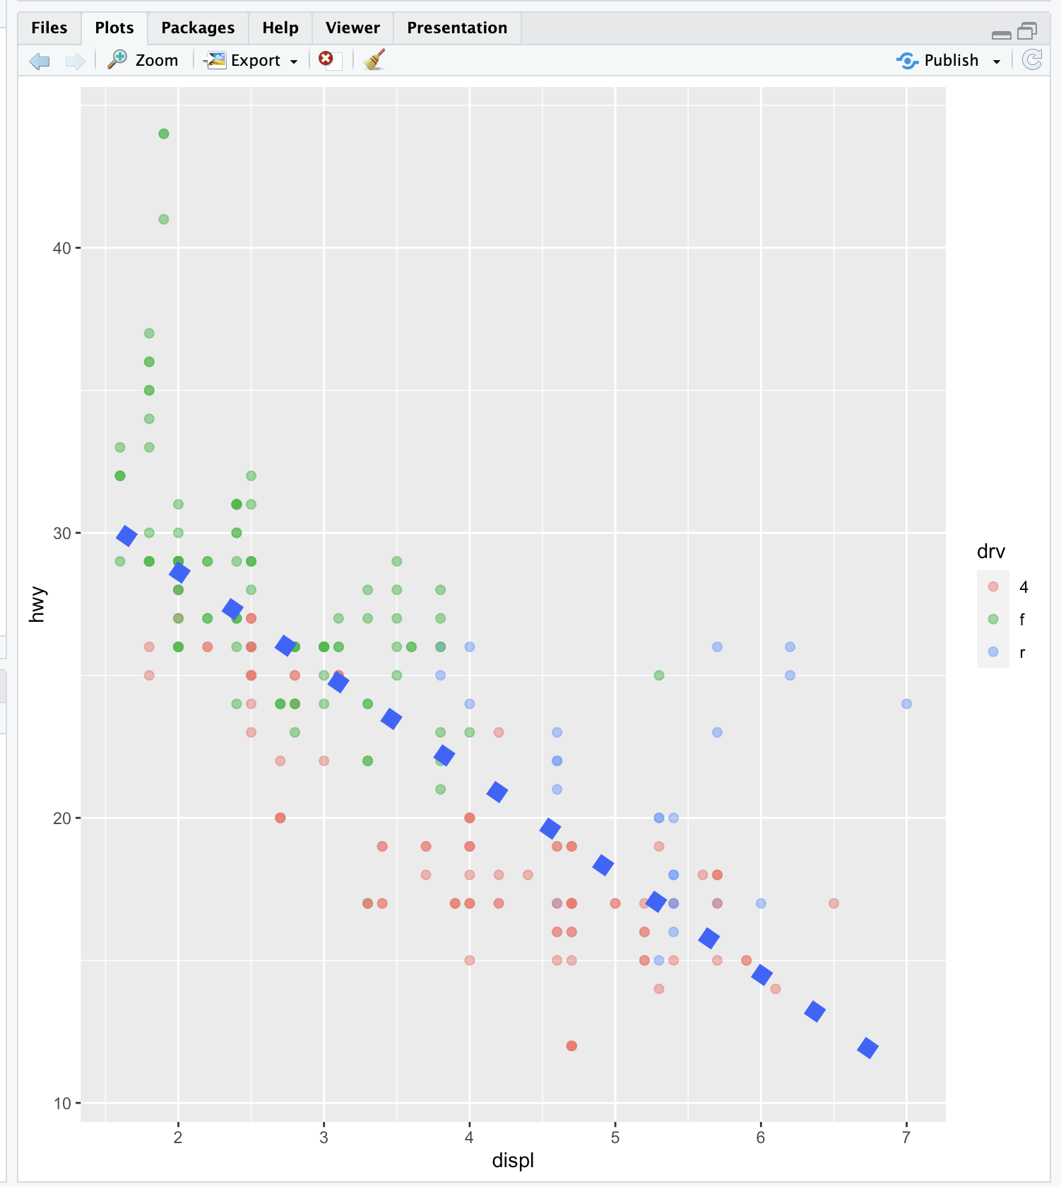

`geom_smooth()` using formula = 'y ~ x'

Warning message:

Using `size` aesthetic for lines was deprecated in ggplot2 3.4.0.

ℹ Please use `linewidth` instead.

This warning is displayed once every 8 hours.

Call `lifecycle::last_lifecycle_warnings()` to see where this warning was generated.

| That's the answer I was looking for.

|============================================ | 56%

| What did these arguments do? The method specified a linear regression (note the

| negative slope indicating that the bigger the displacement the lower the gas

| mileage), the linetype specified that it should be dashed (not continuous), the size

| made the dashes big, and the se flag told ggplot to turn off the gray shadows

| indicating standard errors (confidence intervals).

|============================================= | 58%

| Finally, let's do a simple plot using the black and white theme, theme_bw. Specify g

| and add a call to the function geom_point with the argument setting the color to the

| drv type. Then add a call to the function theme_bw with the argument base_family set

| equal to "Times". See if you notice the difference.

> g + geom_point(aes(color = drv)) + theme_bw(base_family="Times")

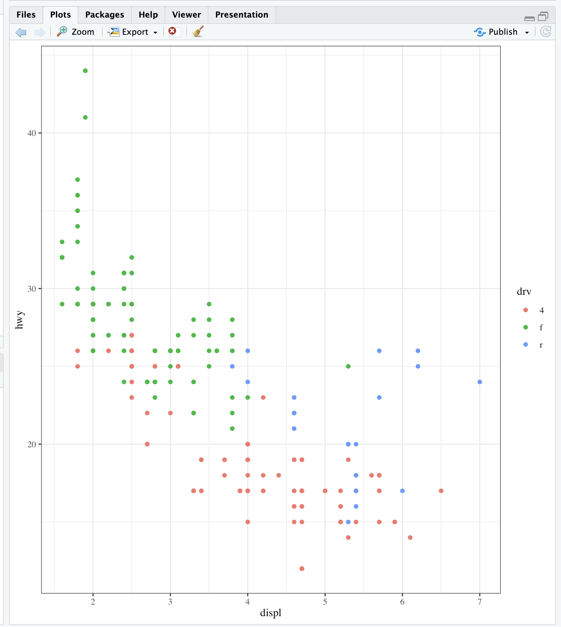

| Keep up the great work!

|=============================================== | 60%

| No more gray background! Also, if you have good eyesight, you'll notice that the font

| in the labels changed.

|================================================= | 62%

| One final note before we go through a more complicated, layered ggplot example, and

| this concerns the limits of the axes. We're pointing this out to emphasize a subtle

| difference between ggplot and the base plotting function plot.

...

|================================================== | 65%

| We've created some random x and y data, called myx and myy, components of a dataframe

| called testdat. These represent 100 random normal points, except halfway through, we

| made one of the points be an outlier. That is, we set its y-value to be out of range

| of the other points. Use the base plotting function plot to create a line plot of

| this data. Call it with 4 arguments - myx, myy, type="l", and ylim=c(-3,3). The

| type="l" tells plot you want to display the data as a line instead of as a

| scatterplot.

> plot(myx, myy, type = "l", ylim = c(-3,3))

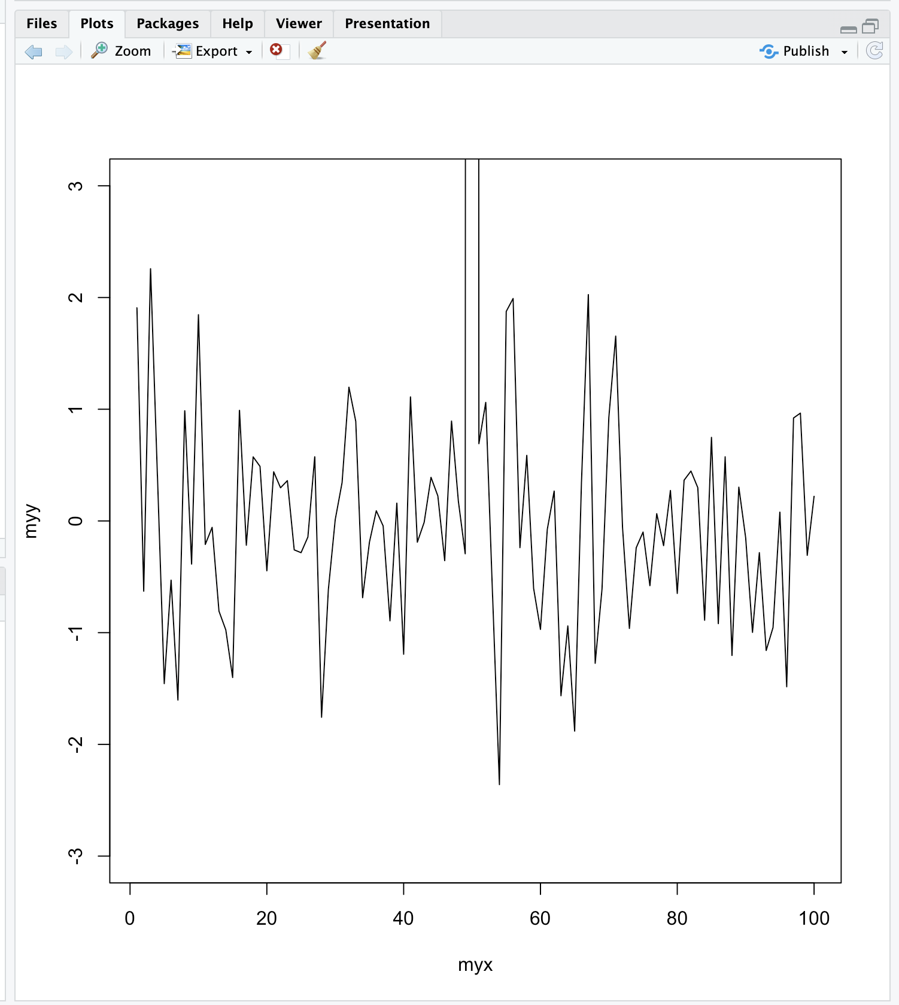

| Nice work!

|==================================================== | 67%

| Notice how plot plotted the points in the (-3,3) range for y-values. The outlier at

| (50,100) is NOT shown on the line plot. Now we'll plot the same data with ggplot.

| Recall that the name of the dataframe is testdat. Create the graphical object g with

| a call to ggplot with 2 arguments, testdat (the data) and a call to aes with 2

| arguments, x set equal to myx, and y set equal to myy.

> g <- ggplot(testdat, aes(x = myx, y = myy))

| That's correct!

|====================================================== | 69%

| Now add a call to geom_line with 0 arguments to g.

> g+geom_line()

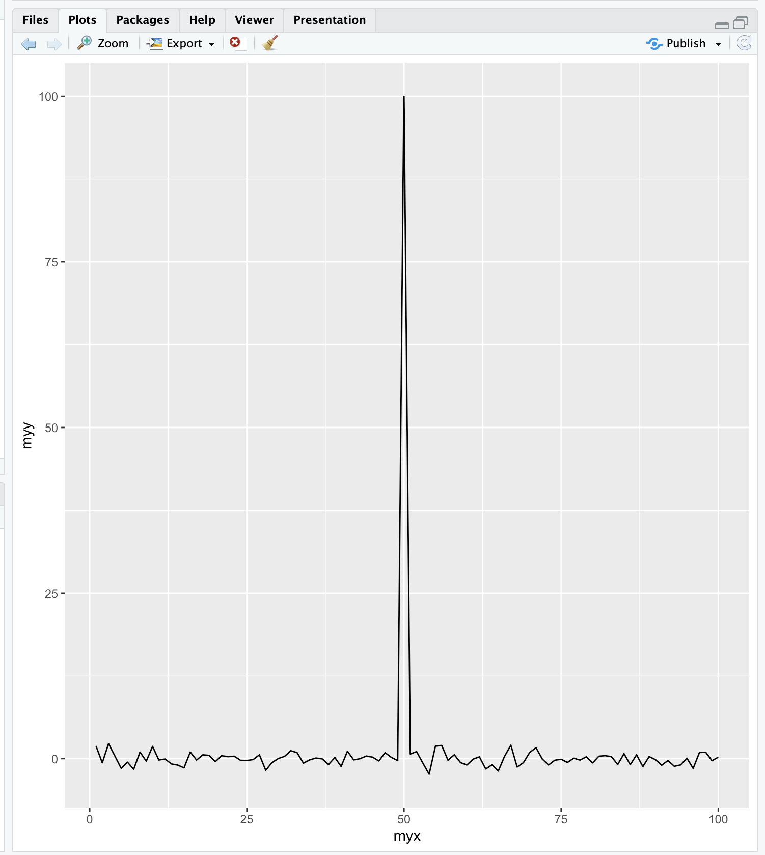

| Keep up the great work!

|======================================================= | 71%

| Notice how ggplot DID display the outlier point at (50,100). As a result the rest of

| the data is smashed down so you don't get to see what the bulk of it looks like. The

| single outlier probably isn't important enough to dominate the graph. How do we get

| ggplot to behave more like plot in a situation like this?

|========================================================= | 73%

| Let's take a guess that in addition to adding geom_line() to g we also just have to

| add ylim(-3,3) to it as we did with the call to plot. Try this now to see what

| happens.

> g + geom_line() + ylim(-3,3)

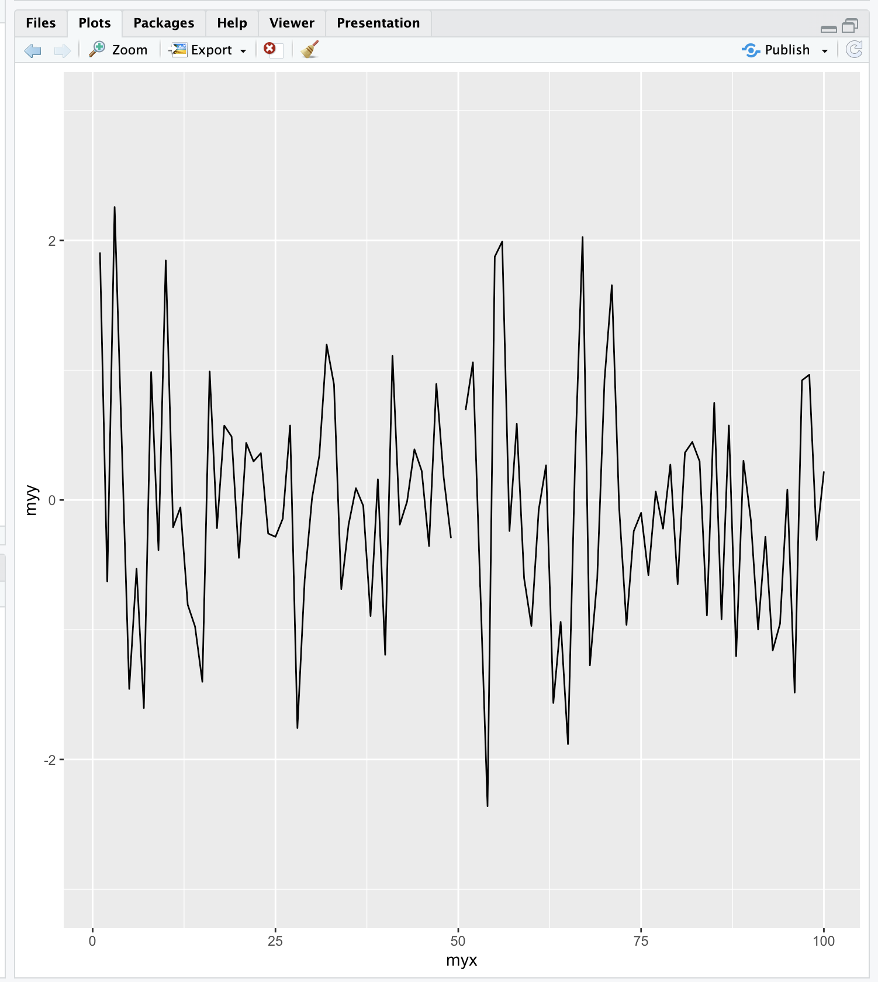

| That's the answer I was looking for.

|========================================================== | 75%

| Notice that by doing this, ggplot simply ignored the outlier point at (50,100).

| There's a break in the line which isn't very noticeable. Now recall that at the

| beginning of the lesson we mentioned 7 components of a ggplot plot, one of which was

| a coordinate system. This is a situation where using a coordinate system would be

| helpful. Instead of adding ylim(-3,3) to the expression g+geom_line(), add a call to

| the function coord_cartesian with the argument ylim set equal to c(-3,3).

> g + geom_line() + coord_cartesian(ylim = c(-3, 3))

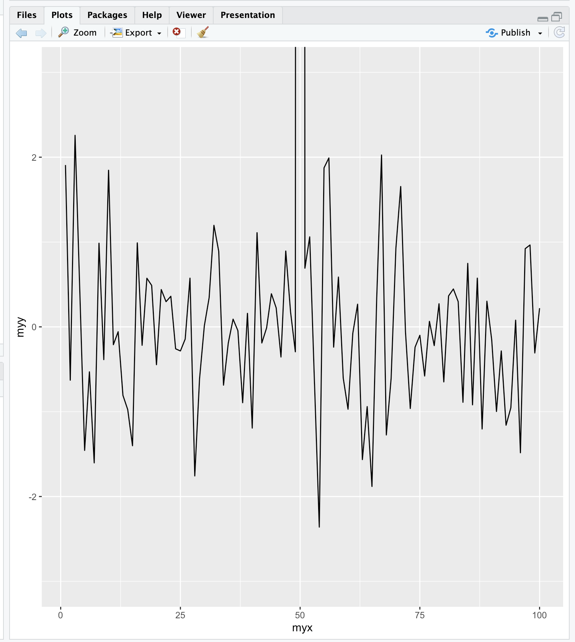

| Your dedication is inspiring!

|============================================================ | 77%

| See the difference? This looks more like the plot produced by the base plot function.

| The outlier y value at x=50 is not shown, but the plot indicates that it is larger

| than 3.

|============================================================== | 79%

| We'll close with a more complicated example to show you the full power of ggplot and

| the entire ggplot2 package. We'll continue to work with the mpg dataset.

...

|=============================================================== | 81%

| Start by creating the graphical object g by assigning to it a call to ggplot with 2

| arguments. The first is the dataset and the second is a call to the function aes.

| This call will have 3 arguments, x set equal to displ, y set equal to hwy, and color

| set equal to factor(year). This last will allow us to distinguish between the two

| manufacturing years (1999 and 2008) in our data.

> g <- ggplot(mpg, aes(x = displ, y = hwy, color = factor(year)))

| You are quite good my friend!

|================================================================= | 83%

| Uh oh! Nothing happened. Does g exist? Of course, it just isn't visible yet since you

| didn't add a layer.

...

|=================================================================== | 85%

| If you typed g at the command line, what would happen?

1: R would return an error in red

2: I would have to try this to answer the question

3: a scatterplot would appear with 2 colors of points

Selection: 1

| You are quite good my friend!

|==================================================================== | 88%

| We'll build the plot up step by step. First add to g a call to the function

| geom_point with 0 arguments.

> g + geom_point()

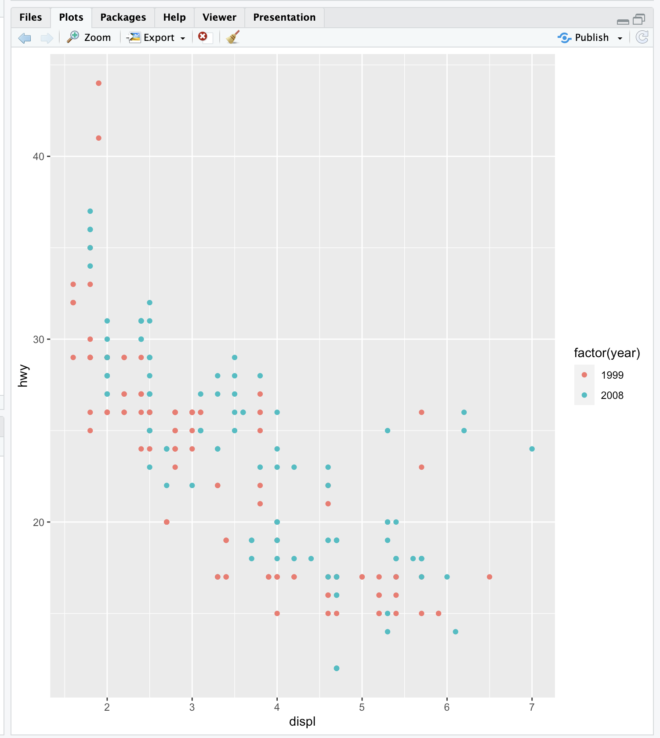

| You are really on a roll!

|====================================================================== | 90%

| A simple, yet comfortingly familiar scatterplot appears. Let's make our display a 2

| dimensional multi-panel plot. Recall your last command (with the up arrow) and add to

| it a call the function facet_grid. Give it 2 arguments. The first is the formula

| drv~cyl, and the second is the argument margins set equal to TRUE. Try this now.

> g + geom_point() + facet_grid(drv~cyl, margins = TRUE)

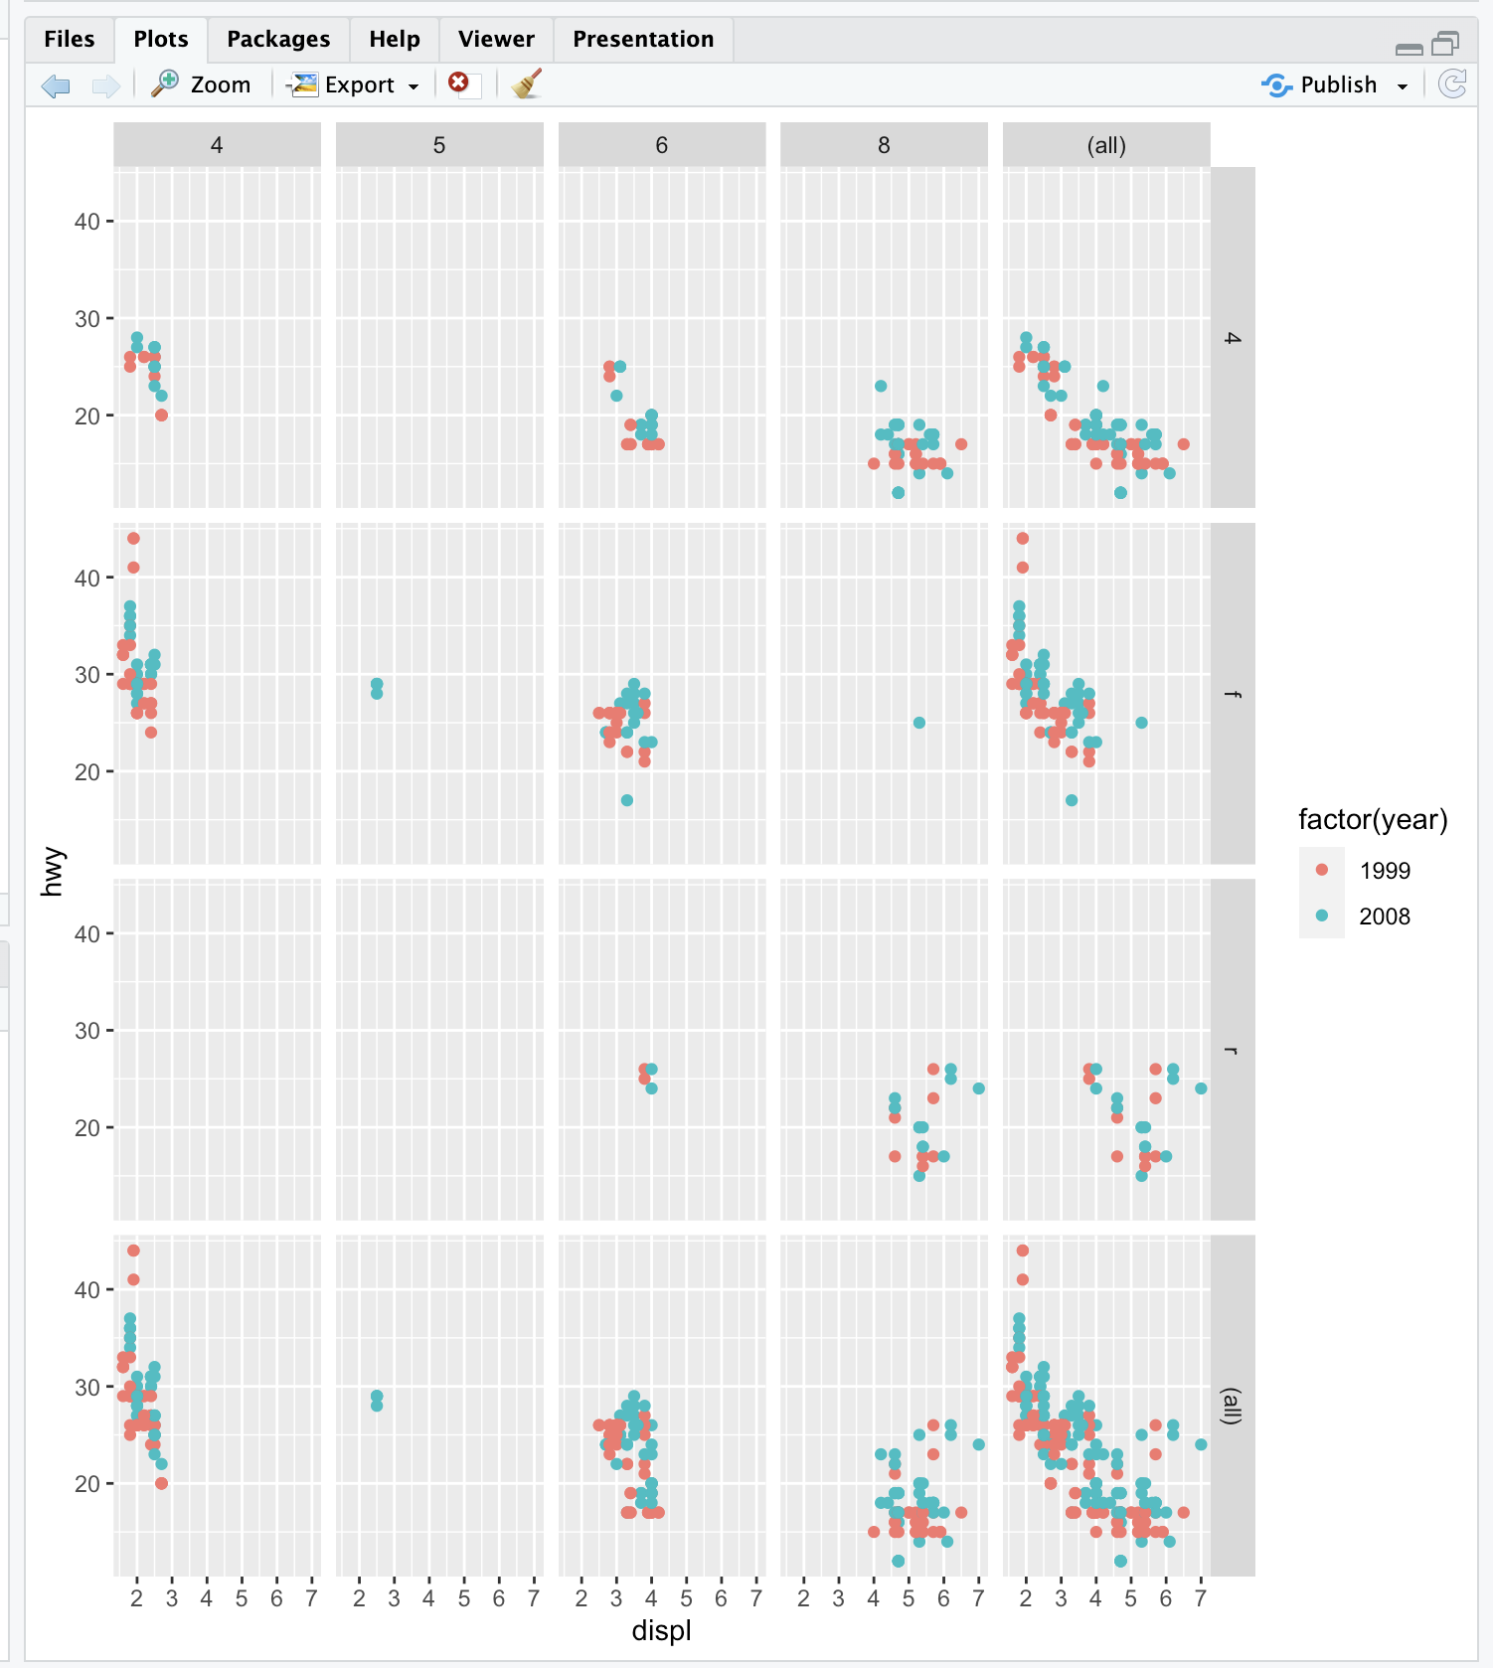

| You are doing so well!

|======================================================================== | 92%

| A 4 by 5 plot, huh? The margins argument tells ggplot to display the marginal totals

| over each row and column, so instead of seeing 3 rows (the number of drv factors) and

| 4 columns (the number of cyl factors) we see a 4 by 5 display. Note that the panel in

| position (4,5) is a tiny version of the scatterplot of the entire dataset.

|========================================================================= | 94%

| Now add to your last command (or retype it if you like to type) a call to geom_smooth

| with 4 arguments. These are method set to "lm", se set to FALSE, size set to 2, and

| color set to "black".

> g + geom_point() + facet_grid(drv~cyl, margins = TRUE) + geom_smooth(method = "lm", se = FALSE, size = 2, color = "black")

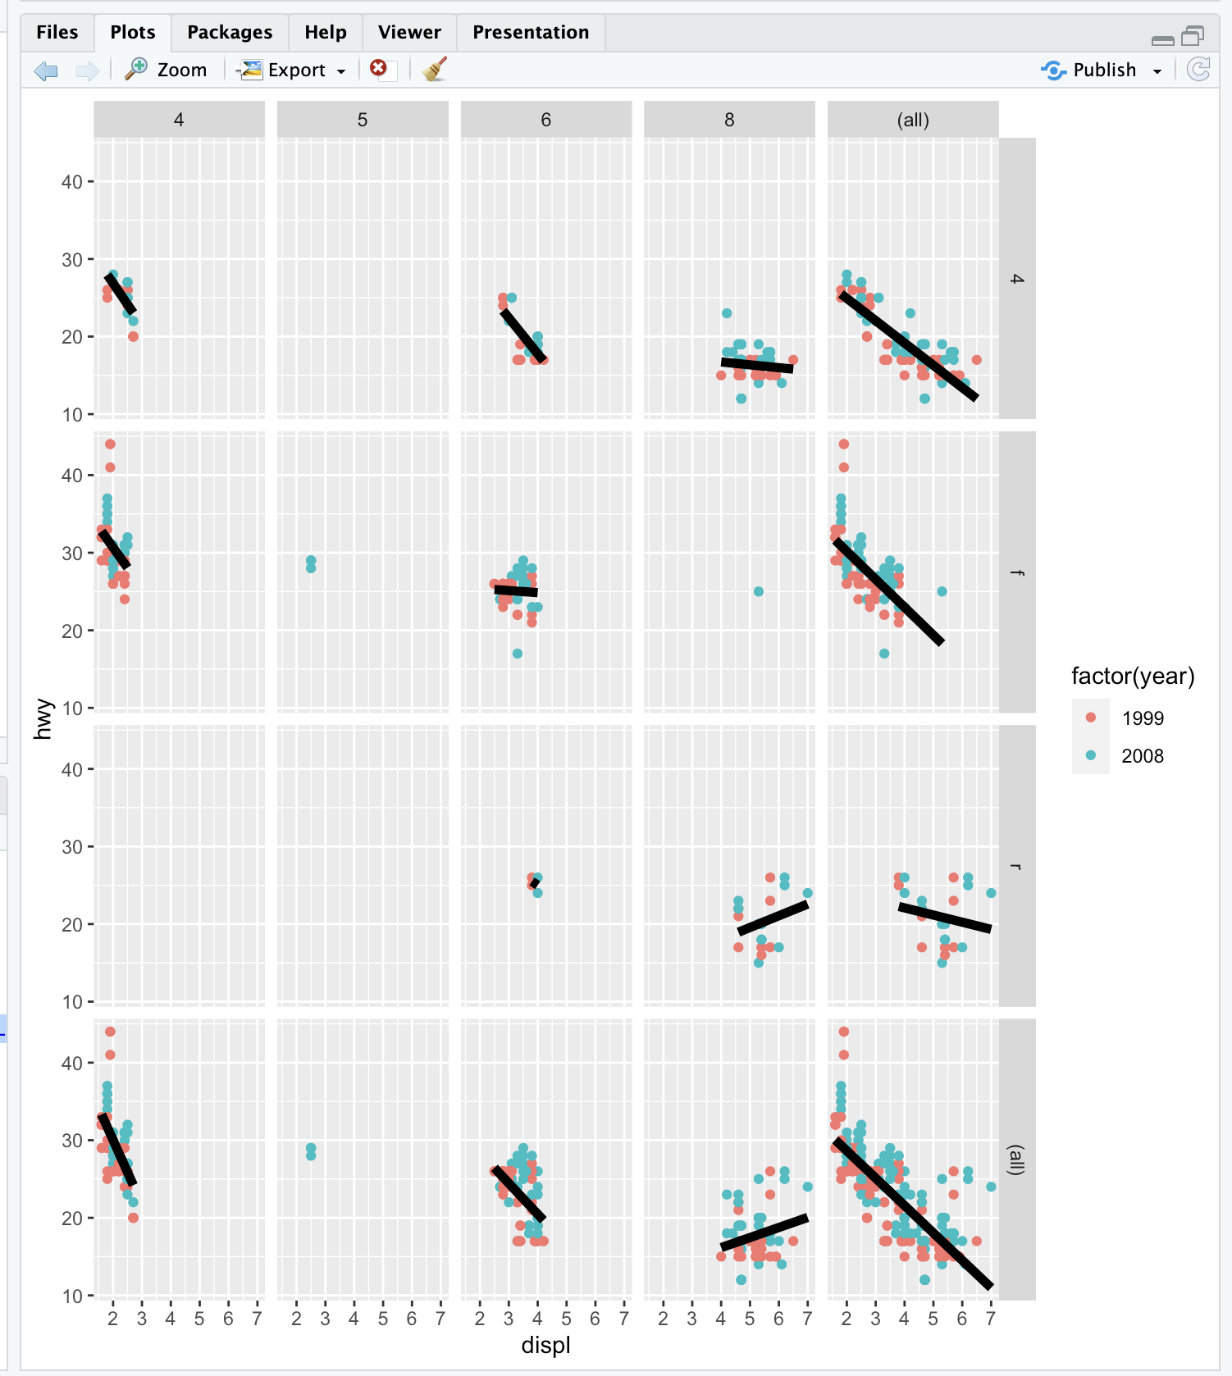

`geom_smooth()` using formula = 'y ~ x'

| You got it right!

|=========================================================================== | 96%

| Angry Birds? Finally, add to your last command (or retype it if you like to type) a

| call to the function labs with 3 arguments. These are x set to "Displacement", y set

| to "Highway Mileage", and title set to "Swirl Rules!".

>g + geom_point() + facet_grid(drv ~ cyl, margins = TRUE) + geom_smooth(method = "lm", size = 2, se = FALSE, color = "black") + labs(x = "Displacement", y = "Highway Mileage", title = "Swirl Rules!")

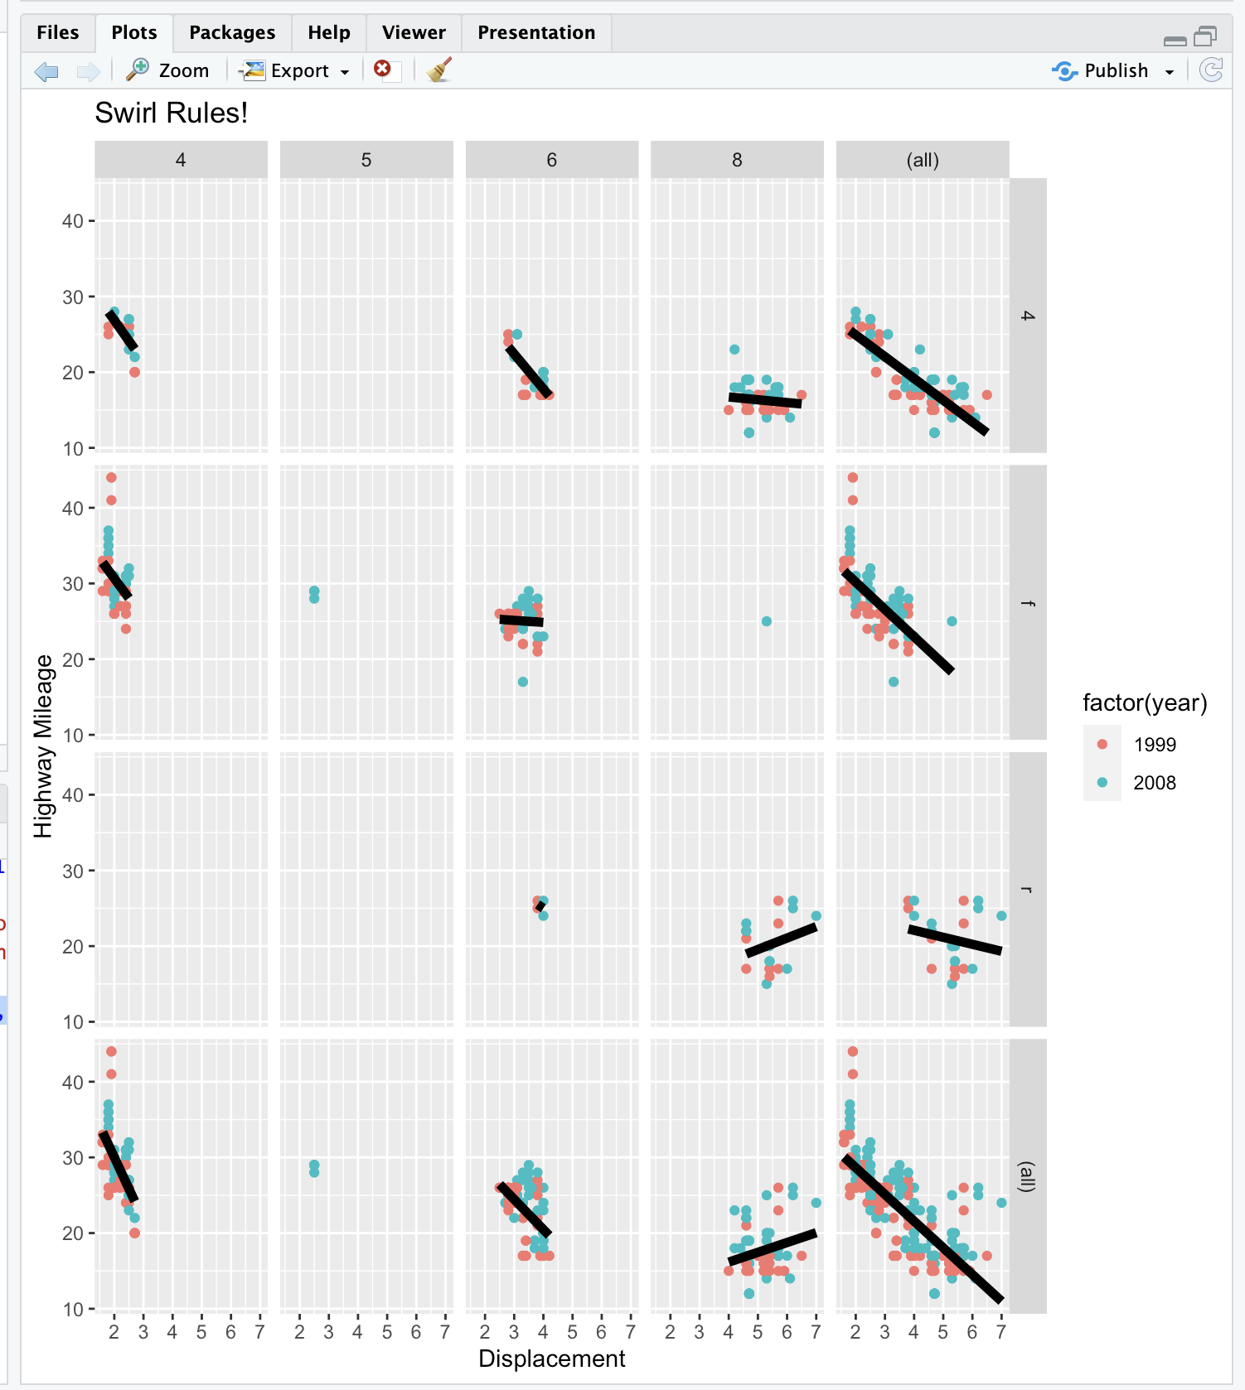

`geom_smooth()` using formula = 'y ~ x'

| All that practice is paying off!

|============================================================================ | 98%

| You could have done these labels with separate calls to labs but we thought you'd be

| sick of this by now. Anyway, congrats! You've concluded part 2 of ggplot2. We hope

| you got enough mileage out of the lesson. If you like ggplot2 you can do some extras

| with the extra lesson.

|==============================================================================| 100%

| Would you like to receive credit for completing this course on Coursera.org?

1: Yes

2: No

Selection: 2

| You are quite good my friend!

| You've reached the end of this lesson! Returning to the main menu...

| Please choose a course, or type 0 to exit swirl.

1: Exploratory Data Analysis

2: Take me to the swirl course repository!

Selection: 1

| Please choose a lesson, or type 0 to return to course menu.

1: Principles of Analytic Graphs 2: Exploratory Graphs

3: Graphics Devices in R 4: Plotting Systems

5: Base Plotting System 6: Lattice Plotting System

7: Working with Colors 8: GGPlot2 Part1

9: GGPlot2 Part2 10: GGPlot2 Extras

11: Hierarchical Clustering 12: K Means Clustering

13: Dimension Reduction 14: Clustering Example

15: CaseStudy

Selection: 10

| Attempting to load lesson dependencies...

| Package ‘ggplot2’ loaded correctly!

| | 0%

| GGPlot2_Extras. (Slides for this and other Data Science courses may be found at

| github https://github.com/DataScienceSpecialization/courses/. If you care to use

| them, they must be downloaded as a zip file and viewed locally. This lesson

| corresponds to 04_ExploratoryAnalysis/ggplot2.)

|= | 2%

| In this lesson we'll go through a few more qplot examples using diamond data which

| comes with the ggplot2 package. This data is a little more complicated than the mpg

| data and it contains information on various characteristics of diamonds.

...

|=== | 4%

| Run the R command str with the argument diamonds to see what the data looks like.

> str(diamonds)

tibble [53,940 × 10] (S3: tbl_df/tbl/data.frame)

$ carat : num [1:53940] 0.23 0.21 0.23 0.29 0.31 0.24 0.24 0.26 0.22 0.23 ...

$ cut : Ord.factor w/ 5 levels "Fair"<"Good"<..: 5 4 2 4 2 3 3 3 1 3 ...

$ color : Ord.factor w/ 7 levels "D"<"E"<"F"<"G"<..: 2 2 2 6 7 7 6 5 2 5 ...

$ clarity: Ord.factor w/ 8 levels "I1"<"SI2"<"SI1"<..: 2 3 5 4 2 6 7 3 4 5 ...

$ depth : num [1:53940] 61.5 59.8 56.9 62.4 63.3 62.8 62.3 61.9 65.1 59.4 ...

$ table : num [1:53940] 55 61 65 58 58 57 57 55 61 61 ...

$ price : int [1:53940] 326 326 327 334 335 336 336 337 337 338 ...

$ x : num [1:53940] 3.95 3.89 4.05 4.2 4.34 3.94 3.95 4.07 3.87 4 ...

$ y : num [1:53940] 3.98 3.84 4.07 4.23 4.35 3.96 3.98 4.11 3.78 4.05 ...

$ z : num [1:53940] 2.43 2.31 2.31 2.63 2.75 2.48 2.47 2.53 2.49 2.39 ...

| You got it right!

|==== | 6%

| From the output, how many characteristics of diamonds do you think this data

| contains?

1: 53950

2: 53940

3: 10

4: 5394

Selection: 3

| That's correct!

|====== | 7%

| From the output of str, how many diamonds are characterized in this dataset?

1: 5394

2: 53940

3: 53950

4: 10

Selection: 2

| Your dedication is inspiring!

|======= | 9%

| Now let's plot a histogram of the price of the 53940 diamonds in this dataset. Recall

| that a histogram requires only one variable of the data, so run the R command qplot

| with the first argument price and the argument data set equal to diamonds. This will

| show the frequency of different diamond prices.

> qplot(price, data = diamonds)

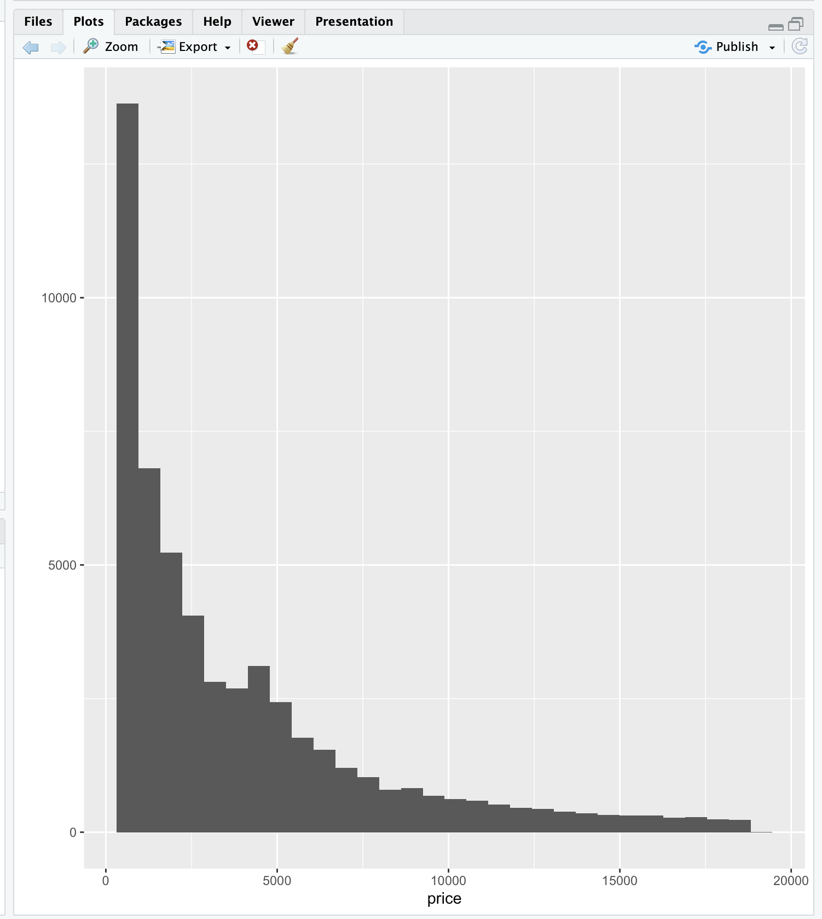

`stat_bin()` using `bins = 30`. Pick better value with `binwidth`.

| Perseverance, that's the answer.

|========= | 11%

| Not only do you get a histogram, but you also get a message about the binwidth

| defaulting to range/30. Recall that range refers to the spread or dispersion of the

| data, in this case price of diamonds. Run the R command range now with diamonds$price

| as its argument.

> range(diamonds$price)

[1] 326 18823

| Your dedication is inspiring!

|========== | 13%

| We see that range returned the minimum and maximum prices, so the diamonds vary in

| price from $326 to $18823. We've done the arithmetic for you, the range (difference

| between these two numbers) is $18497.

...

|============ | 15%

| Rerun qplot now with 3 arguments. The first is price, the second is data set equal to

| diamonds, and the third is binwidth set equal to 18497/30). (Use the up arrow to save

| yourself some typing.) See if the plot looks familiar.

> qplot(price, data = diamonds, binwidth = 18497/30)

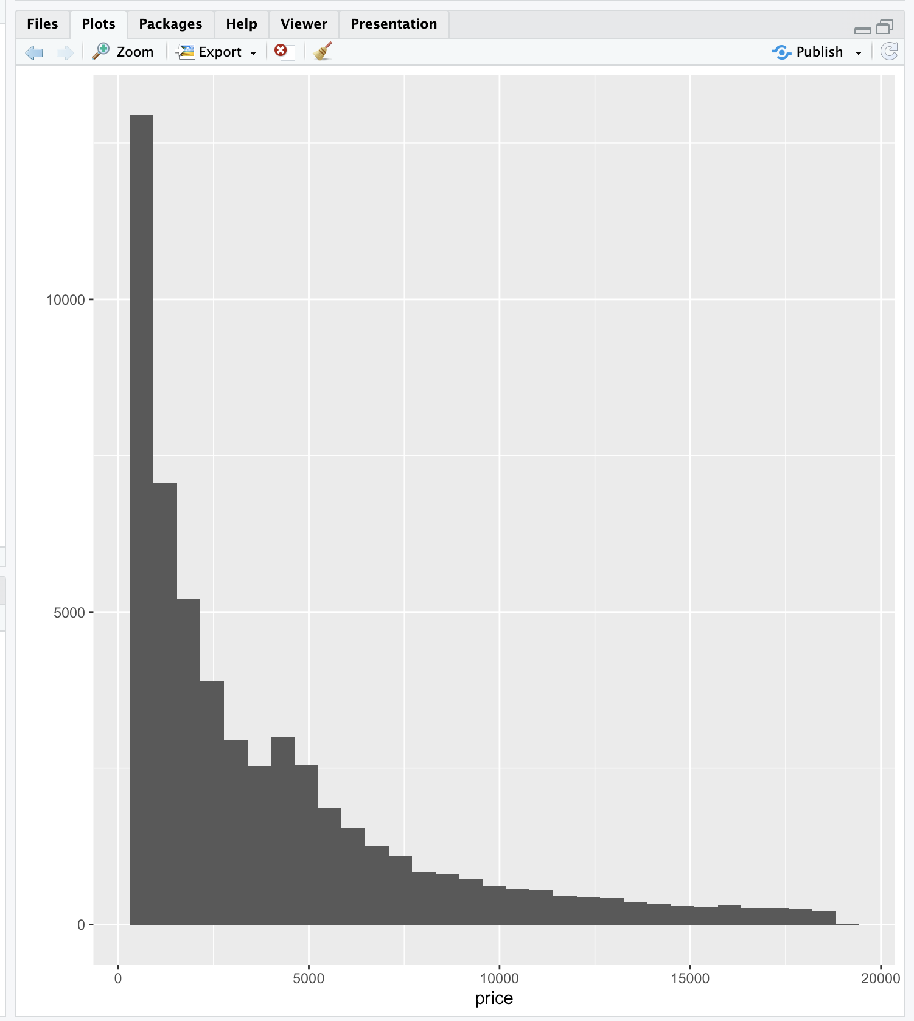

| Keep up the great work!

|============= | 17%

| No more messages in red, but a histogram almost identical to the previous one! If you

| typed 18497/30 at the command line you would get the result 616.5667. This means that

| the height of each bin tells you how many diamonds have a price between x and x+617

| where x is the left edge of the bin.

|============== | 19%

| We've created a vector containing integers that are multiples of 617 for you. It's

| called brk. Look at it now.

> brk

[1] 0 617 1234 1851 2468 3085 3702 4319 4936 5553 6170 6787 7404 8021

[15] 8638 9255 9872 10489 11106 11723 12340 12957 13574 14191 14808 15425 16042 16659

[29] 17276 17893 18510 19127

| You nailed it! Good job!

|================ | 20%

| We've also created a vector containing the number of diamonds with prices between

| each pair of adjacent entries of brk. For instance, the first count is the number of

| diamonds with prices between 0 and $617, and the second is the number of diamonds

| with prices between $617 and $1234. Look at the vector named counts now.

> counts

[1] 4611 13255 5230 4262 3362 2567 2831 2841 2203 1666 1445 1112 987 766

[15] 796 655 606 553 540 427 429 376 348 338 298 305 269 287

[29] 227 251 97

| That's correct!

|================= | 22%

| See how it matches the histogram you just plotted? So, qplot really works!

...

|=================== | 24%

| You're probably sick of it but rerun qplot again, this time with 4 arguments. The

| first 3 are the same as the last qplot command you just ran (price, data set equal to

| diamonds, and binwidth set equal to 18497/30). (Use the up arrow to save yourself

| some typing.) The fourth argument is fill set equal to cut. The shape of the

| histogram will be familiar, but it will be more colorful.

> qplot(price, data = diamonds, binwidth = 18497/30, fill = cut)

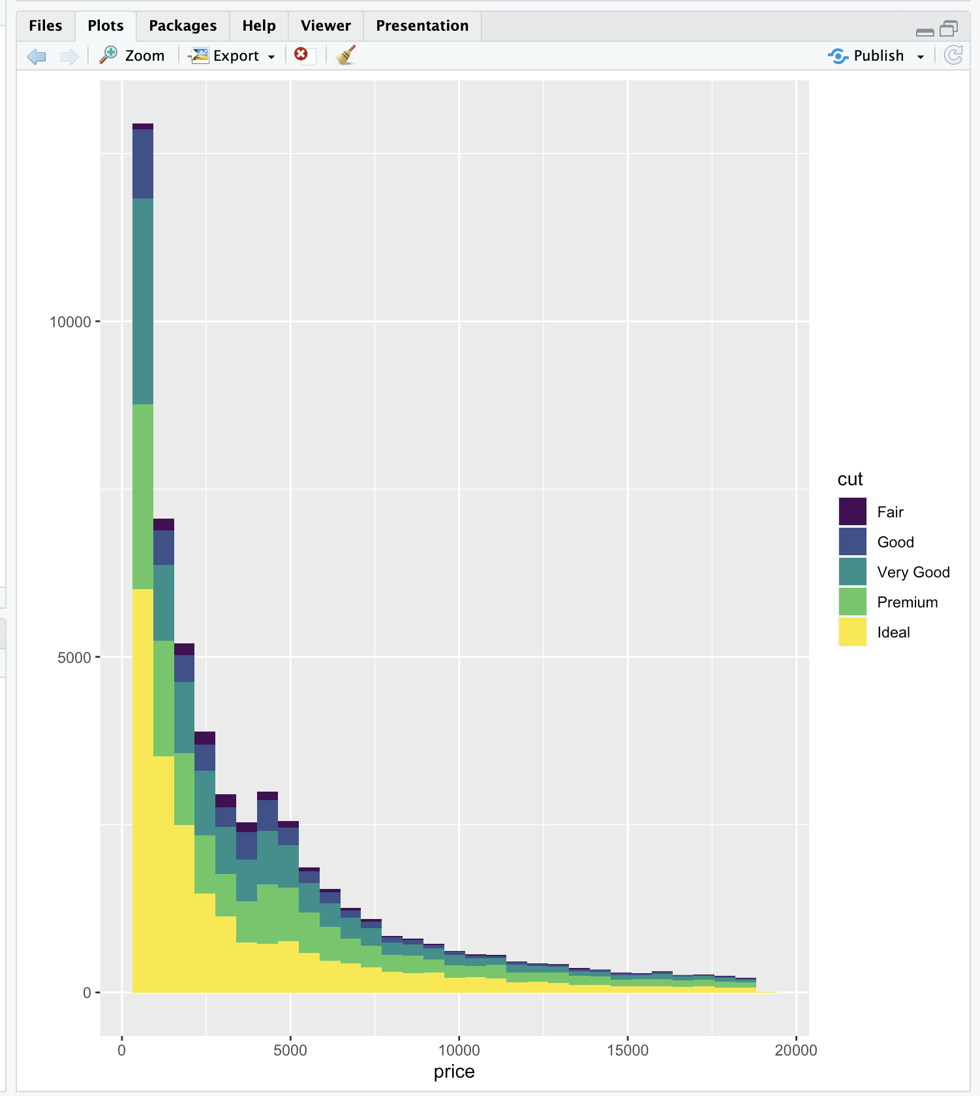

| Great job!

|==================== | 26%

| This shows how the counts within each price grouping (bin) are distributed among the

| different cuts of diamonds. Notice how qplot displays these distributions relative to

| the cut legend on the right. The fair cut diamonds are at the bottom of each bin, the

| good cuts are above them, then the very good above them, until the ideal cuts are at

| the top of each bin. You can quickly see from this display that there are very few

| fair cut diamonds priced above $5000.

|====================== | 28%

| Now we'll replot the histogram as a density function which will show the proportion

| of diamonds in each bin. This means that the shape will be similar but the scale on

| the y-axis will be different since, by definition, the density function is

| nonnegative everywhere, and the area under the curve is one. To do this, simply call

| qplot with 3 arguments. The first 2 are price and data (set equal to diamonds). The

| third is geom which should be set equal to the string "density". Try this now.

> qplot(price,data=diamonds,geom="density")

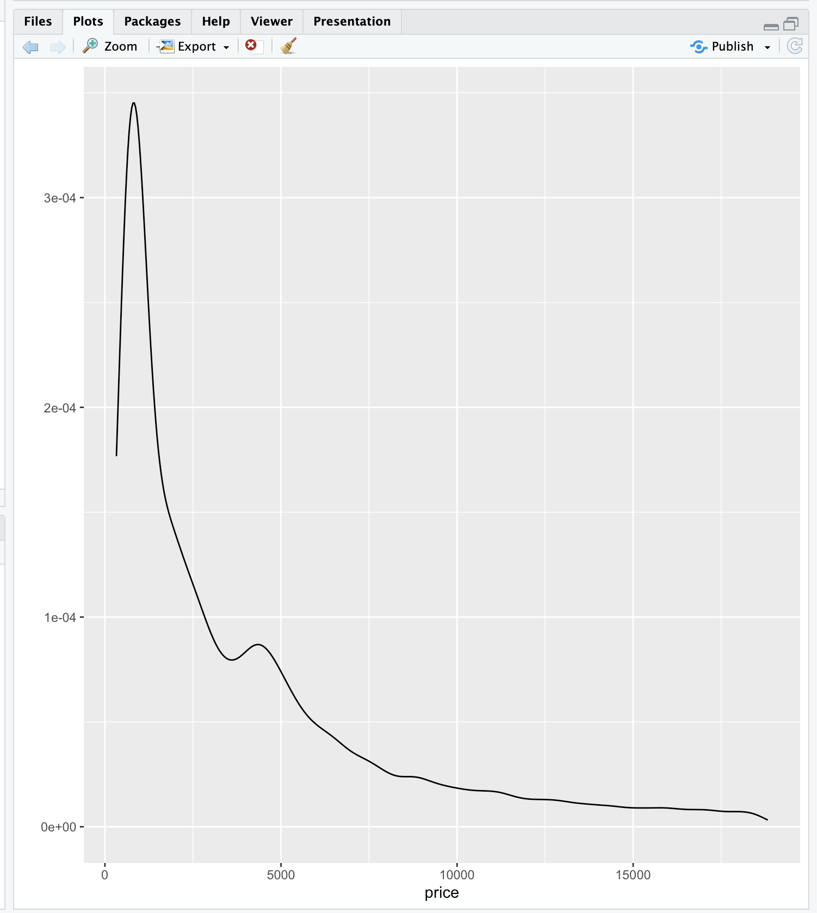

| Excellent job!

|======================= | 30%

| Notice that the shape is similar to that of the histogram we saw previously. The

| highest peak is close to 0 on the x-axis meaning that most of the diamonds in the

| dataset were inexpensive. In general, as prices increase (move right along the

| x-axis) the number of diamonds (at those prices) decrease. The exception to this is

| when the price is around $4000; there's a slight increase in frequency. Let's see if

| cut is responsible for this increase.

|========================= | 31%

| Rerun qplot, this time with 4 arguments. The first 2 are the usual, and the third is

| geom set equal to "density". The fourth is color set equal to cut. Try this now.

> qplot(price,data=diamonds,geom="density", color = cut)

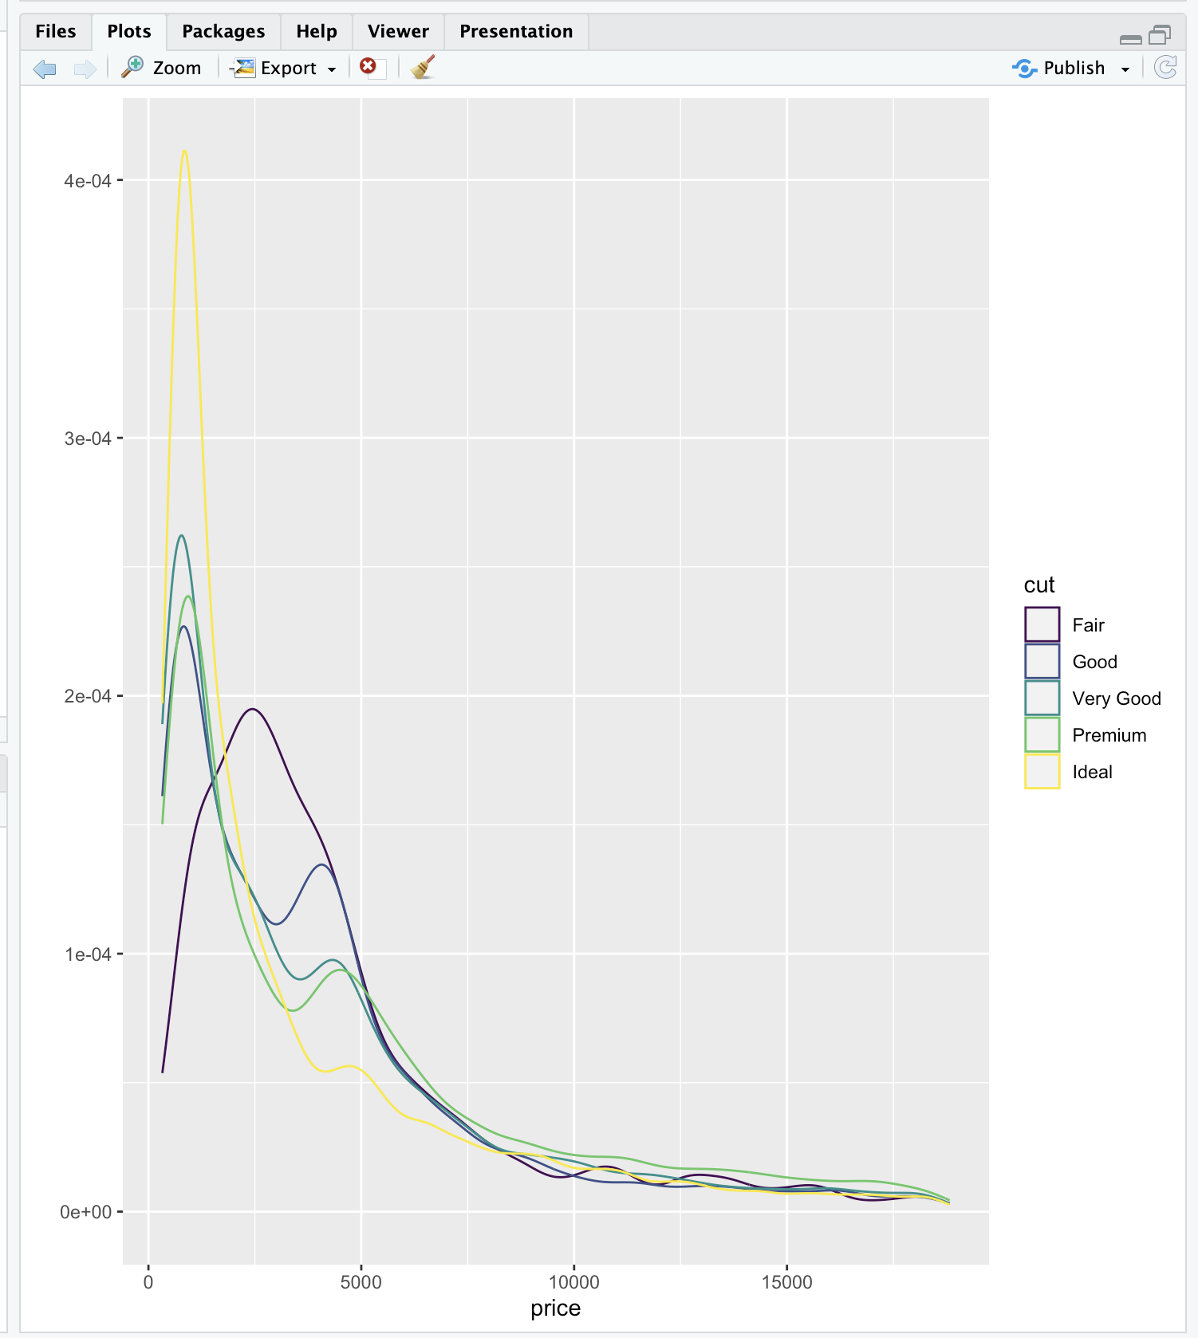

| You are really on a roll!

|========================== | 33%

| See how easily qplot did this? Four of the five cuts have 2 peaks, one at price $1000

| and the other between $4000 and $5000. The exception is the Fair cut which has a

| single peak at $2500. This gives us a little more understanding of the histogram we

| saw before.

|=========================== | 35%

| Let's move on to scatterplots. For these we'll need to specify two variables from the

| diamond dataset.

...

|============================= | 37%

| Let's start with carat and price. Use these as the first 2 arguments of qplot. The

| third should be data set equal to the dataset. Try this now.

> qplot(carat, price, data = diamonds)

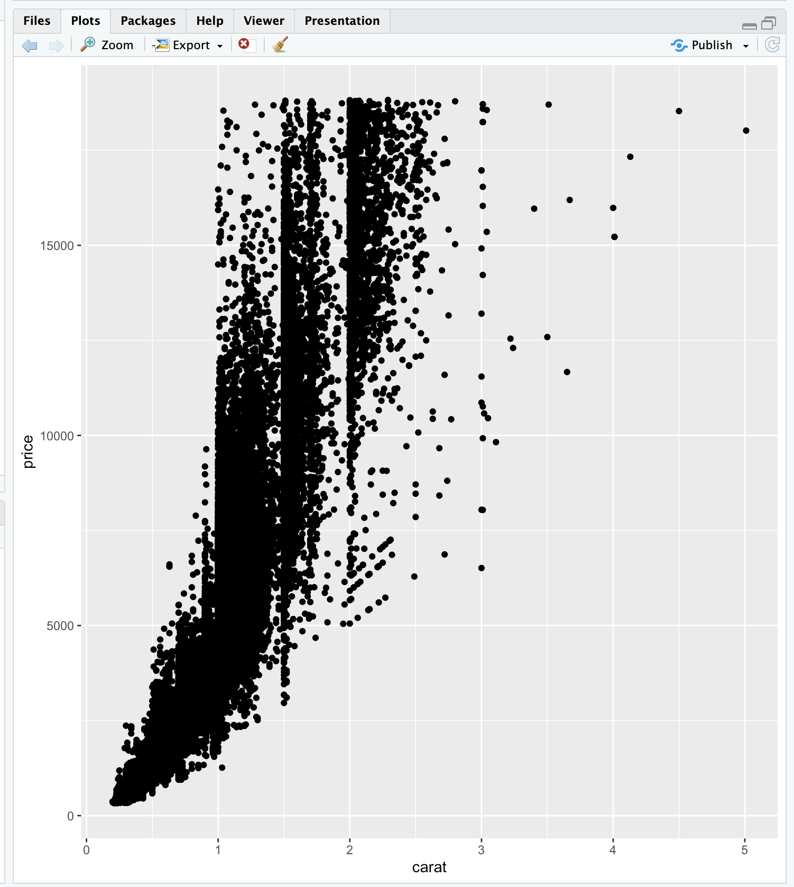

| You got it!

|============================== | 39%

| We see the positive trend here, as the number of carats increases the price also goes

| up.

...

|================================ | 41%

| Now rerun the same command, except add a fourth parameter, shape, set equal to cut.

> qplot(carat, price, data = diamonds, shape = cut)

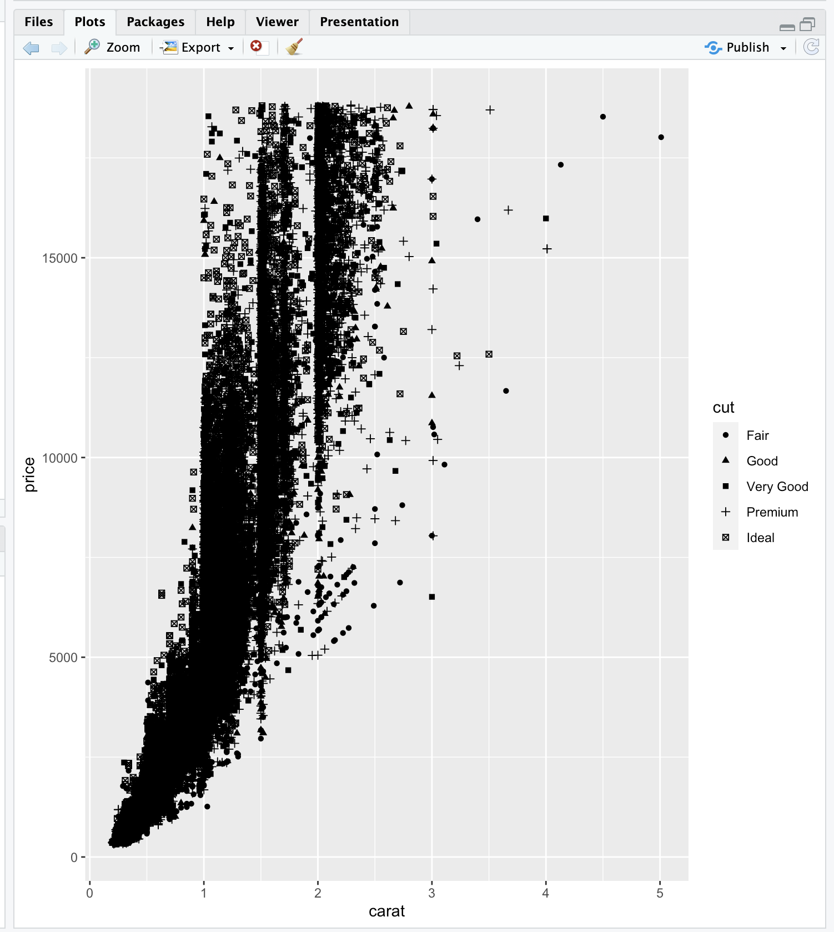

Warning message:

Using shapes for an ordinal variable is not advised

| That's a job well done!

|================================= | 43%

| The same scatterplot appears, except the cuts of the diamonds are distinguished by

| different symbols. The legend at the right tells you which symbol is associated with

| each cut. These are small and hard to read, so rerun the same command, except this

| time instead of setting the argument shape equal to cut, set the argument color equal

| to cut.

> qplot(carat, price, data = diamonds, color = cut)

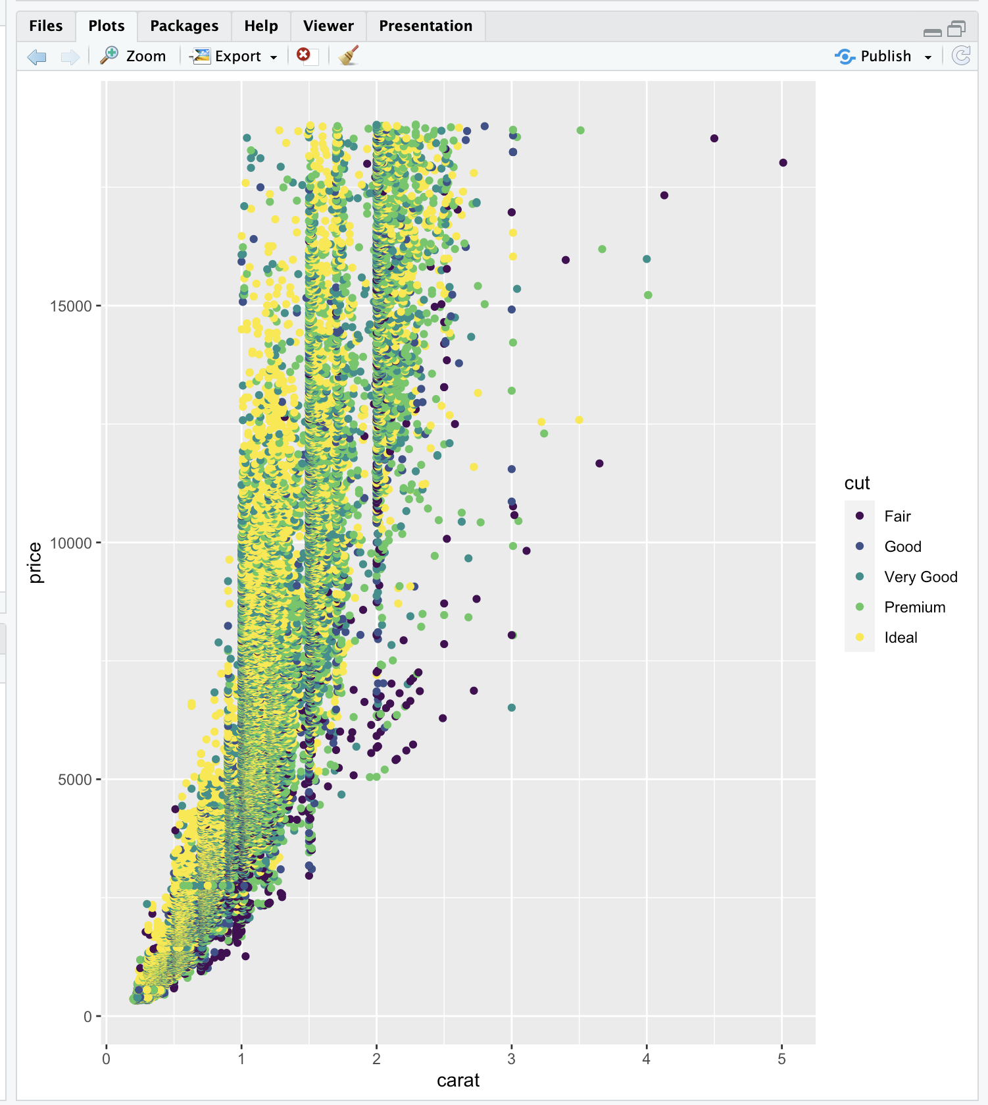

| You are quite good my friend!

|=================================== | 44%

| That's easier to see! Now we'll close with two, more complicated scatterplot

| examples.

|==================================== | 46%

| We'll rerun the plot you just did (carat,price,data=diamonds and color=cut) but add

| an additional parameter. Use geom_smooth with the method set equal to the string

| "lm".

> qplot(carat, price, data = diamonds, color = cut) + geom_smooth(method = "lm")

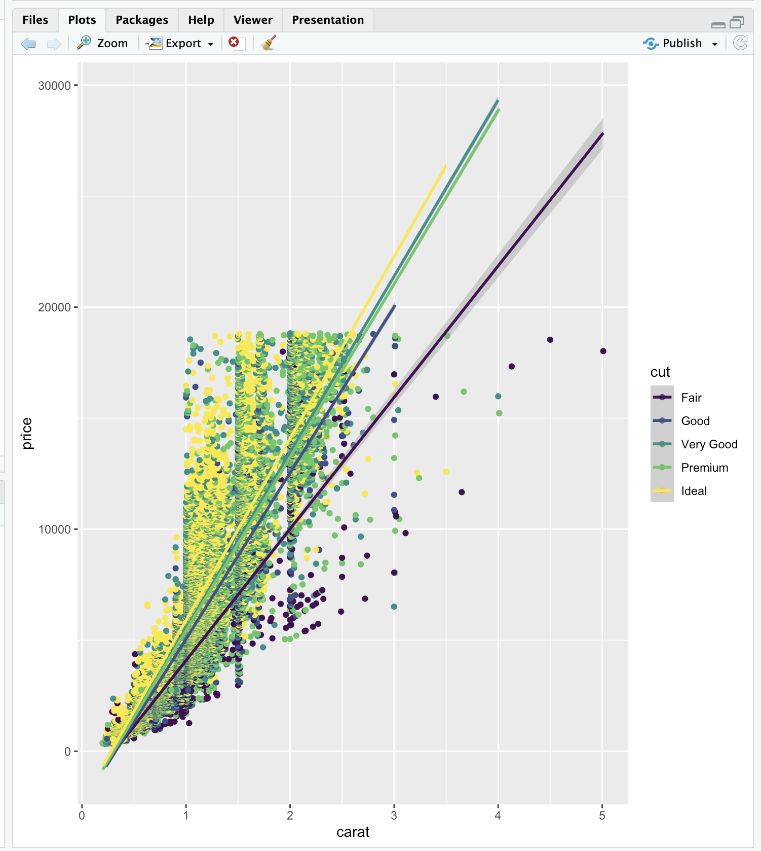

`geom_smooth()` using formula = 'y ~ x'

| You are really on a roll!

|====================================== | 48%

| Again, we see the same scatterplot, but slightly more compressed and showing 5

| regression lines, one for each cut of diamonds. It might be hard to see, but around

| each line is a shadow showing the 95% confidence interval. We see, unsurprisingly,

| that the better the cut, the steeper (more positive) the slope of the lines.

|======================================= | 50%

| Finally, let's rerun that plot you just did qplot(carat,price,data=diamonds,

| color=cut) + geom_smooth(method="lm") but add one (just one) more argument to qplot.

| The new argument is facets and it should be set equal to the formula .~cut. Recall

| that the facets argument indicates we want a multi-panel plot. The symbol to the left

| of the tilde indicates rows (in this case just one) and the symbol to the right of

| the tilde indicates columns (in this five, the number of cuts). Try this now.

> qplot(carat, price, data = diamonds, color = cut, facets = .~cut) + geom_smooth(method = "lm")

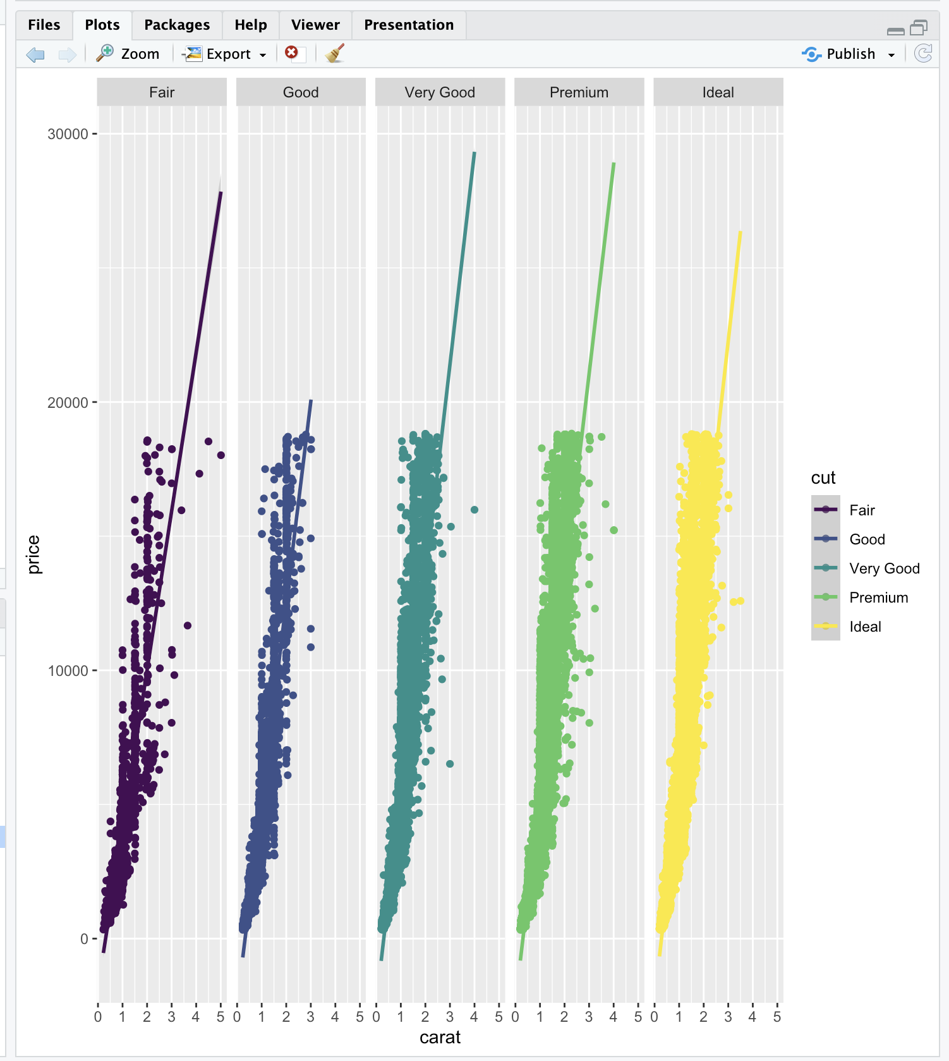

`geom_smooth()` using formula = 'y ~ x'

| You are quite good my friend!

|======================================== | 52%

| Pretty good, right? Not too difficult either. Let's review what we learned!

...

|========================================== | 54%

| Which types of plot does qplot plot?

1: all of the others

2: histograms

3: box and whisker plots

4: scatterplots

Selection:

Enter an item from the menu, or 0 to exit

Selection: 1

| You got it right!

|=========================================== | 56%

| Any and all of the above choices work; qplot is just that good. What does the gg in

| ggplot2 stand for?

1: good grief

2: good graphics

3: grammar of graphics

4: goto graphics

Selection: 3

| You got it right!

|============================================= | 57%

| True or False? The geom argument takes a string for a value.

1: True

2: False

Selection: 1

| Nice work!

|============================================== | 59%

| True or False? The method argument takes a string for a value.

1: False

2: True

Selection: 2

| Excellent work!

|================================================ | 61%

| True or False? The binwidth argument takes a string for a value.

1: True

2: False

Selection: 2

| All that hard work is paying off!

|================================================= | 63%

| True or False? The user must specify x- and y-axis labels when using qplot.

1: False

2: True

Selection: 1

| That's a job well done!

|=================================================== | 65%

| Now for some ggplots.

...

|==================================================== | 67%

| First create a graphical object g by assigning to it the output of a call to the

| function ggplot with 2 arguments. The first is the dataset diamonds and the second is

| a call to the function aes with 2 arguments, depth and price. Remember you won't see

| any result.

> g <- ggplot(diamonds,aes(depth,price))

| You got it!

|===================================================== | 69%

| Does g exist? Yes! Type summary with g as an argument to see what it holds.

> summary(g)

data: carat, cut, color, clarity, depth, table, price, x, y, z [53940x10]

mapping: x = ~depth, y = ~price

faceting: <ggproto object: Class FacetNull, Facet, gg>

compute_layout: function

draw_back: function

draw_front: function

draw_labels: function

draw_panels: function

finish_data: function

init_scales: function

map_data: function

params: list

setup_data: function

setup_params: function

shrink: TRUE

train_scales: function

vars: function

super: <ggproto object: Class FacetNull, Facet, gg>

| Excellent job!

|======================================================= | 70%

| We see that g holds the entire dataset. Now suppose we want to see a scatterplot of

| the relationship. Add to g a call to the function geom_point with 1 argument, alpha

| set equal to 1/3.

> g + geom_point(alpha = 1/3)

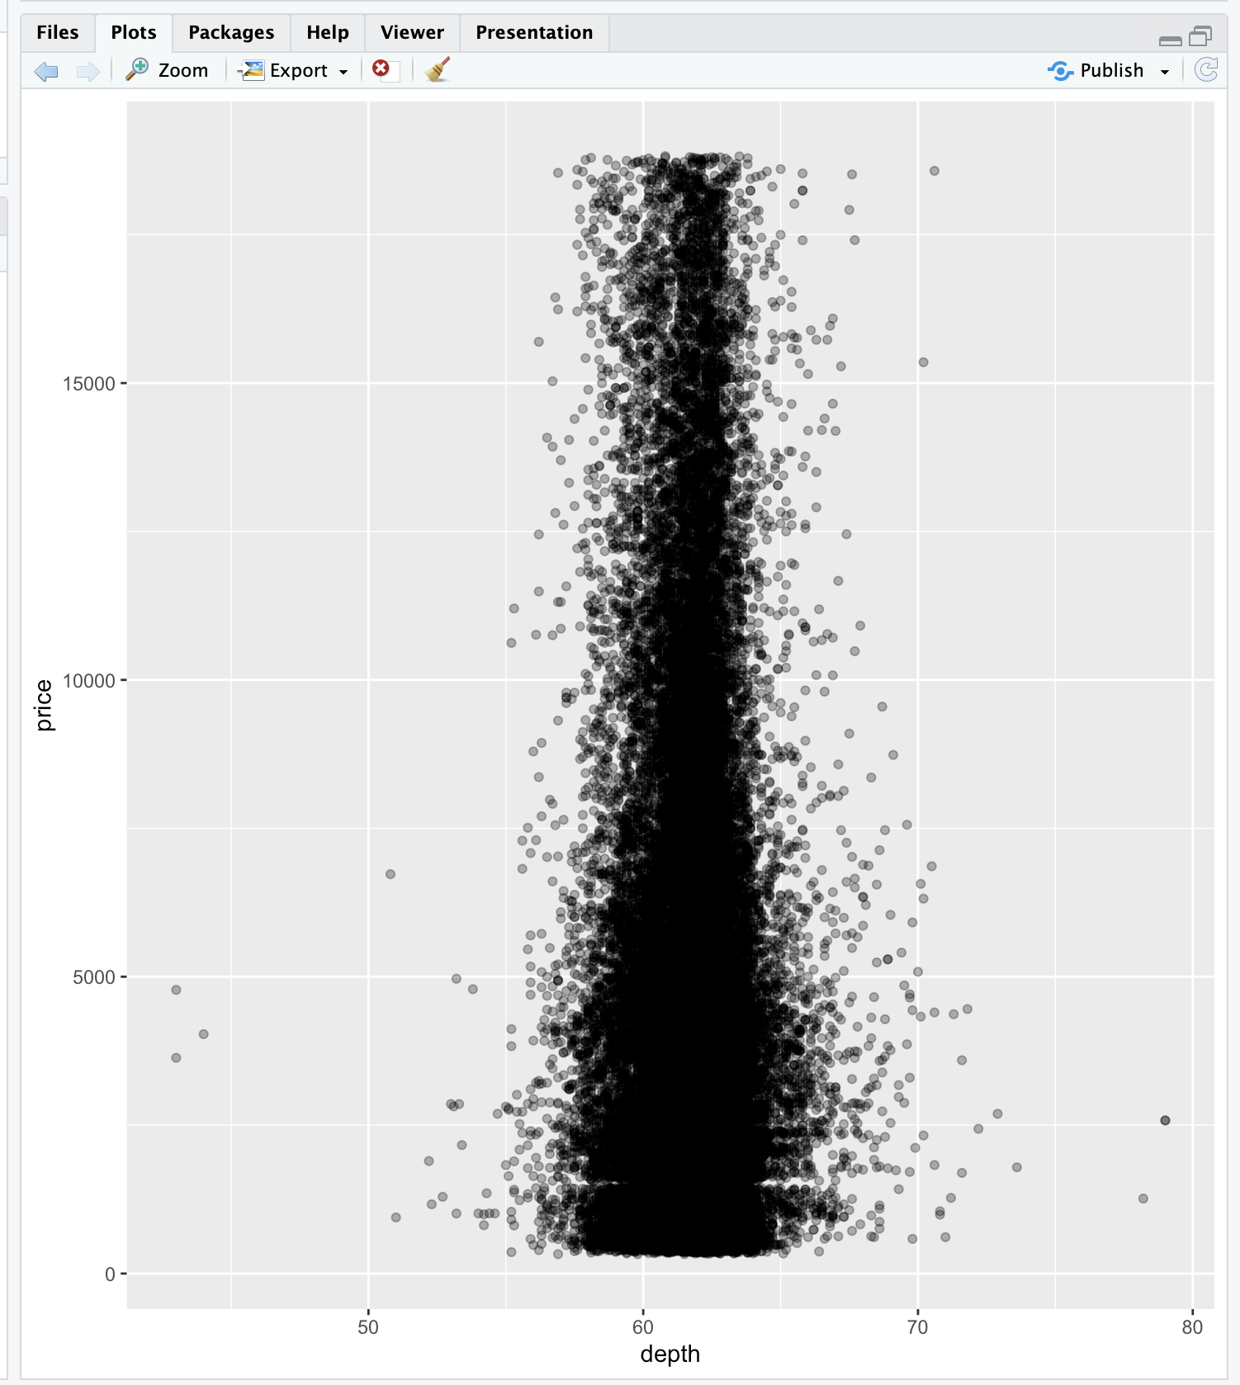

| Great job!

|======================================================== | 72%

| That's somewhat interesting. We see that depth ranges from 43 to 79, but the densest

| distribution is around 60 to 65. Suppose we want to see if this relationship (between

| depth and price) is affected by cut or carat. We know cut is a factor with 5 levels

| (Fair, Good, Very Good, Premium, and Ideal). But carat is numeric and not a discrete

| factor. Can we do this?

...

|========================================================== | 74%

| Of course! That's why we asked. R has a handy command, cut, which allows you to

| divide your data into sets and label each entry as belonging to one of the sets, in

| effect creating a new factor. First, we'll have to decide where to cut the data.

...

|=========================================================== | 76%

| Let's divide the data into 3 pockets, so 1/3 of the data falls into each. We'll use

| the R command quantile to do this. Create the variable cutpoints and assign to it the

| output of a call to the function quantile with 3 arguments. The first is the data to

| cut, namely diamonds$carat; the second is a call to the R function seq. This is also

| called with 3 arguments, (0, 1, and length set equal to 4). The third argument to the

| call to quantile is the boolean na.rm set equal to TRUE.

> cutpoints <- quantile(diamonds$carat, seq(0, 1, length = 4),na.rm = TRUE)

| Excellent work!

|============================================================= | 78%

| Look at cutpoints now to understand what it is.

> cutpoints

0% 33.33333% 66.66667% 100%

0.20 0.50 1.00 5.01

| You got it right!

|============================================================== | 80%

| We see a 4-long vector (explaining why length was set equal to 4). We also see that

| .2 is the smallest carat size in the dataset and 5.01 is the largest. One third of

| the diamonds are between .2 and .5 carats and another third are between .5 and 1

| carat in size. The remaining third are between 1 and 5.01 carats. Now we can use the

| R command cut to label each of the 53940 diamonds in the dataset as belonging to one

| of these 3 factors. Create a new name in diamonds, diamonds$car2 by assigning it the

| output of the call to cut. This command takes 2 arguments, diamonds$carat, which is

| what we want to cut, and cutpoints, the places where we'll cut.

> diamonds$car2 <- cut(diamonds$carat, cutpoints);

| That's a job well done!

|================================================================ | 81%

| Now we can continue with our multi-facet plot. First we have to reset g since we

| changed the dataset (diamonds) it contained (by adding a new column). Assign to g the

| output of a call to ggplot with 2 arguments. The dataset diamonds is the first, and a

| call to the function aes with 2 arguments (depth,price) is the second.

> g <- ggplot(diamonds, aes(depth, price))

| You are really on a roll!

|================================================================= | 83%

| Now add to g calls to 2 functions. This first is a call to geom_point with the

| argument alpha set equal to 1/3. The second is a call to the function facet_grid

| using the formula cut ~ car2 as its argument.

> g + geom_point(alpha = 1/3) + facet_grid(cut ~ car2)

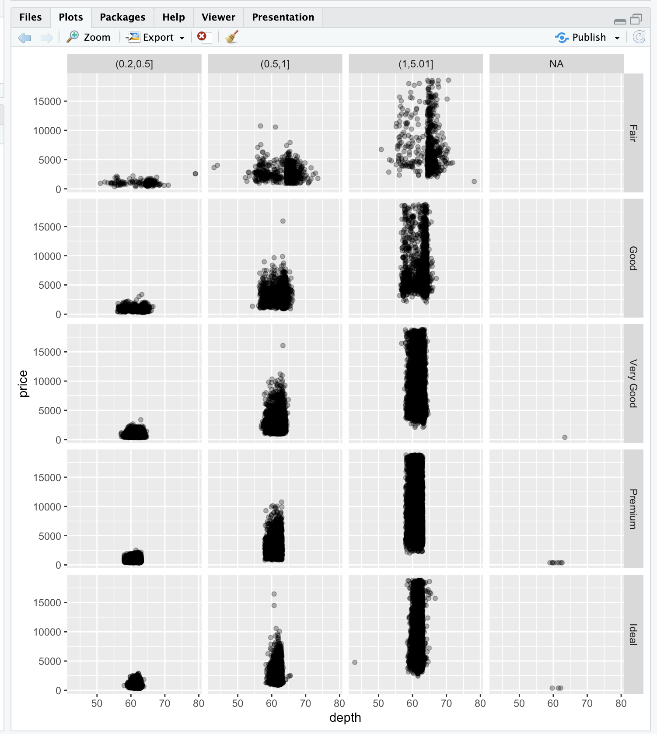

| You nailed it! Good job!

|================================================================== | 85%

| We see a multi-facet plot with 5 rows, each corresponding to a cut factor. Not

| surprising. What is surprising is the number of columns. We were expecting 3 and got

| 4. Why?

...

|==================================================================== | 87%

| The first 3 columns are labeled with the cutpoint boundaries. The fourth is labeled

| NA and shows us where the data points with missing data (NA or Not Available)

| occurred. We see that there were only a handful (12 in fact) and they occurred in

| Very Good, Premium, and Ideal cuts. We created a vector, myd, containing the indices

| of these datapoints. Look at these entries in diamonds by typing the expression

| diamonds[myd,]. The myd tells R what rows to show and the empty column entry says to

| print all the columns.

>

> diamonds[myd,]

# A tibble: 12 × 11

carat cut color clarity depth table price x y z car2

<dbl> <ord> <ord> <ord> <dbl> <dbl> <int> <dbl> <dbl> <dbl> <fct>

1 0.2 Premium E SI2 60.2 62 345 3.79 3.75 2.27 NA

2 0.2 Premium E VS2 59.8 62 367 3.79 3.77 2.26 NA

3 0.2 Premium E VS2 59 60 367 3.81 3.78 2.24 NA

4 0.2 Premium E VS2 61.1 59 367 3.81 3.78 2.32 NA

5 0.2 Premium E VS2 59.7 62 367 3.84 3.8 2.28 NA

6 0.2 Ideal E VS2 59.7 55 367 3.86 3.84 2.3 NA

7 0.2 Premium F VS2 62.6 59 367 3.73 3.71 2.33 NA

8 0.2 Ideal D VS2 61.5 57 367 3.81 3.77 2.33 NA

9 0.2 Very Good E VS2 63.4 59 367 3.74 3.71 2.36 NA

10 0.2 Ideal E VS2 62.2 57 367 3.76 3.73 2.33 NA

11 0.2 Premium D VS2 62.3 60 367 3.73 3.68 2.31 NA

12 0.2 Premium D VS2 61.7 60 367 3.77 3.72 2.31 NA

| All that hard work is paying off!

|===================================================================== | 89%

| We see these entries match the plots. Whew - that's a relief. The car2 field is, in

| fact, NA for these entries, but the carat field shows they each had a carat size of

| .2. What's going on here?

...

|======================================================================= | 91%

| Actually our plot answers this question. The boundaries for each column appear in the

| gray labels at the top of each column, and we see that the first column is labeled

| (0.2,0.5]. This indicates that this column contains data greater than .2 and less

| than or equal to .5. So diamonds with carat size .2 were excluded from the car2

| field.

...

|======================================================================== | 93%

| Finally, recall the last plotting command

| (g+geom_point(alpha=1/3)+facet_grid(cut~car2)) or retype it if you like and add

| another call. This one to the function geom_smooth. Pass it 3 arguments, method set

| equal to the string "lm", size set equal to 3, and color equal to the string "pink".

> g + geom_point(alpha = 1/3) + facet_grid(cut ~ car2) + geom_smooth(method = "lm", size = 3, color = "pink")

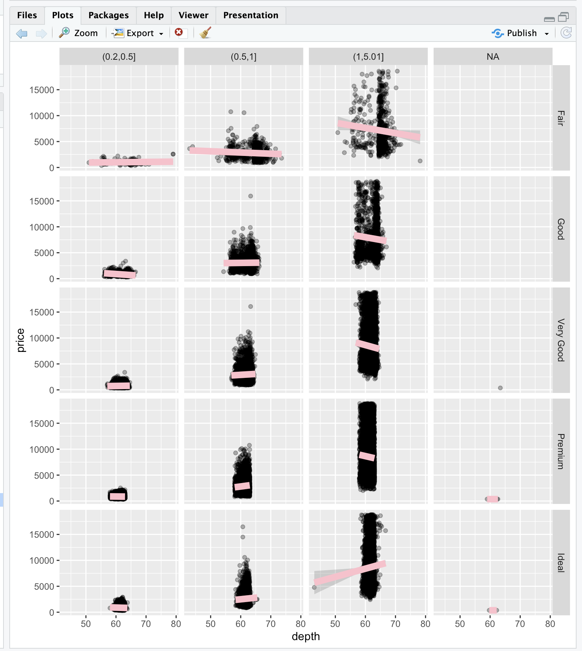

`geom_smooth()` using formula = 'y ~ x'

| All that practice is paying off!

|========================================================================== | 94%

| Nice thick regression lines which are somewhat interesting. You can add labels to the

| plot if you want but we'll let you experiment on your own.

...

|=========================================================================== | 96%

| Lastly, ggplot2 can, of course, produce boxplots. This final exercise is the sum of 3

| function calls. The first call is to ggplot with 2 arguments, diamonds and a call to

| aes with carat and price as arguments. The second call is to geom_boxplot with no

| arguments. The third is to facet_grid with one argument, the formula . ~ cut. Try

| this now.

> ggplot(diamonds, aes(carat, price)) + geom_boxplot() + facet_grid(.~cut)

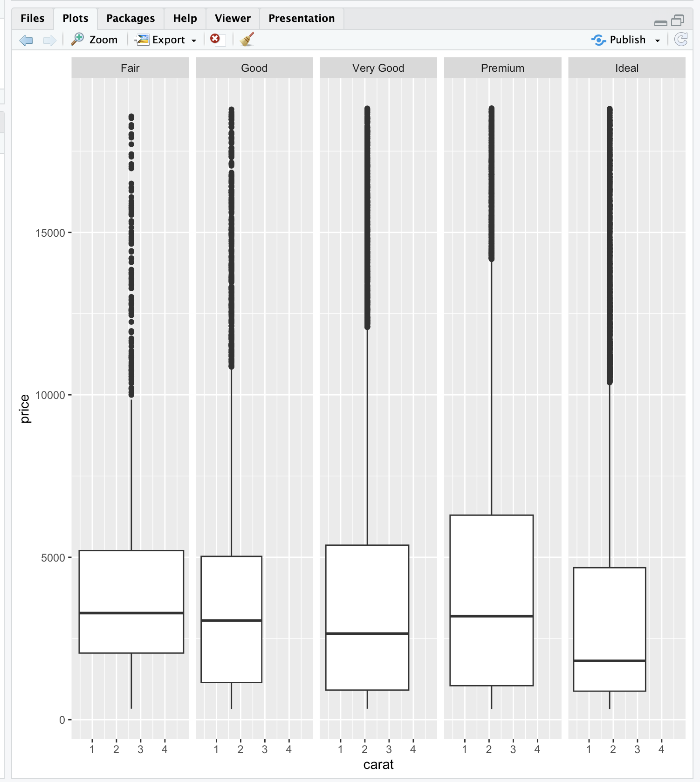

Warning message:

Continuous x aesthetic

ℹ did you forget `aes(group = ...)`?

| Your dedication is inspiring!

|============================================================================= | 98%

| Yes! A boxplot looking like marshmallows about to be roasted. Well done and

| congratulations! You've finished this jewel of a lesson. Hope it paid off!

...

|==============================================================================| 100%

| Would you like to receive credit for completing this course on Coursera.org?

1: Yes

2: No

Selection: 2

| Your dedication is inspiring!

| You've reached the end of this lesson! Returning to the main menu...

| Please choose a course, or type 0 to exit swirl.

1: Exploratory Data Analysis

2: Take me to the swirl course repository!

Selection: 0

| Leaving swirl now. Type swirl() to resume.